4.1 Vectors and Lines

Scalar quantities are defined by just one number. Examples of scalars are time, length, electric charge, speed, mass and density.

If a quantity requires information on magnitude and direction, then it is a vector. Examples of vectors are displacement, velocity, magnetic intensity and force.

Two vectors are equal if and only if they have equal magnitudes and the same directions.

Example 4.1.1

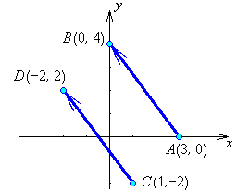
Points A, B, C, D are in the xy-plane as shown.

is the geometric vector from A to B.

A is the tail and B is the tip of vector .

is the geometric vector from C to D.

But both geometric vectors represent the same displacement (3 units left and 4 up).

They are both representations of the same underlying vector .

The length (or magnitude or norm) of a vector is .
In this example, and
.

A geometric vector may be placed anywhere in space.

The position vector of point P (x, y, z) is ,

where O is the origin (0,0,0).
Some properties of vectors

Equality:
if and only if (x₁ = x₂ and y₁ = y₂ and z₁ = z₂);

Length (or “norm”):

(and the direction of is undefined)
If then is a unit vector (often written as )
The unique unit vector in the same direction as a non-zero vector is .
For any scalar a and any vector v,
In particular,
Two non-zero vectors are parallel iff one of them is a non-zero scalar multiple a of the other. They point in the same direction if a > 0, in opposite directions if a < 0.

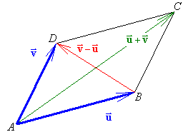
Parallelogram Law

Vectors can be added “tip to tail”:

Consider the vectors in this parallelogram.
has the same length and is in the same direction as . Therefore .

The diagonal vector that shares the same tail as both vectors is clearly the sum .

The other diagonal is

The diagram also illustrates the fact that vector addition is commutative:
For any two points P₁(x₁, y₁, z₁) and P₂(x₂, y₂, z₂),
and

Example 4.1.2

Find the vector from point A(5, 1, –4) to point B(–3, 10, 8), find the distance d between these two points, find the unit vector in the direction and find the coordinates of the point P three quarters of the way from A to B .

and
⇒ d = 17

Therefore P is at (–1, 7.75, 5).

More generally, if we wish to find a point P that divides a line segment AB in the ratio
r : s, we can proceed as follows.

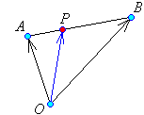

Vectors are parallel

But and

Therefore the position vector of P is

At the midpoint M : r = s = 1 and

In Example 4.1.2,

Vector Equation of a Line

A line needs two vectors to define it: the position of a point known to be on the line and the orientation of the line in space.

Let be a vector parallel to the line L .
[ must be a non-zero vector.]
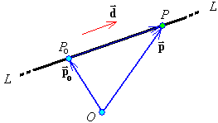
To get from the origin O to a general point P on the line, we follow vectors via a point P_{o} known to be on the line.

But any vector along the line L is parallel to

, for some value of the scalar t .
As the value of the parameter t varies along the entire range of the real numbers, so the point P sweeps along the entire length of the line L .

The vector parametric equation of the line is therefore

where is the position vector of a point P_{o} known to be on the line and is a non-zero vector parallel to the line.

This single vector equation generates three Cartesian equations.
The line through with direction vector is also defined by

A point P(x, y, z) is on this line if and only if a scalar t exists that satisfies all three equations simultaneously.

Example 4.1.3

Find the equations of the line that passes through the points A(1,3,5) and B(2,6,9).

Either of the points A or B may be taken as the point P_{o} that is known to be on the line.
Set .

Vector is certainly parallel to the line.
Set .
The vector parametric equation of the line is

.

The corresponding Cartesian parametric equations are

x = 1 + t , y = 3 + 3 t, z = 5 + 4 t .

By making t the subject of all three equations, we arrive at the Cartesian symmetric form of the equations of the line:

Note how the elements of the line direction vector are in the denominators and the coordinates of a point on the line are in the numerator.

Example 4.1.4

Find the points of intersection (if any) of the pair of lines

and

At any point of intersection the x coordinates on the two lines must be the same:
x = 5 + 2s = 6 + t
and the y coordinates on the two lines must be the same:
y = 2 + s = –2 – t
and the z coordinates on the two lines must be the same:
z = 2 = 8 + 2t

The last equation yields t = (2 – 8) / 2 = –3
Substituting into the other two equations:
5 + 2s = 6 – 3 ⇒ 2s = –2 ⇒ s = –1
and
2 + s = –2 + 3 ⇒ s = –1

(or one may reduce the linear system to row-echelon form.)

The system of equations is consistent, with the unique solution s = –1, t = –3.
⇒ x = 5 + 2s = 5 – 2 = 3 ,
y = 2 + s = 2 – 1 = 1 ,
z = 2

The unique point of intersection is (x, y, z) = (3, 1, 2) .

Example 4.1.5

Find the points of intersection (if any) of the pair of lines

and

Matching the coordinates at any point of intersection:

From the latter two equations,
1 – t = t ⇒ 2t = 1 ⇒ t = 1/2 ⇒ s = –1/2

⇒ x = 3 + s = 3 – 1/2 = 5/2 and x = 2 – t = 2 – 1/2 = 3/2
which is inconsistent.

The lines therefore do not meet anywhere.

Or use row operations to carry to the row-echelon form ,
which is inconsistent.

The lines are not parallel (their direction vectors are [ 1 1 1 ]^{T} and [ –1 –1 1 ]^{T}).
They are skew.

Example 4.1.6 (Textbook, exercises 4.1, pages 167-168, question 34)

The line from a vertex of a triangle to the midpoint of the opposite side is called a median of the triangle. If the vertices of a triangle have position vectors , show that the point on each median that is a third of the way from the midpoint to the vertex has position vector . Conclude that the point C with position vector lies on all three medians. This point C is called the centroid of the triangle.

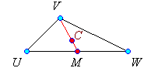

C is one third of the way from M to V

A corresponding result holds for the other two medians.

For example, the position vector of the point one third of the way from the midpoint of side VW to vertex U is .
Therefore the point C lies on all three medians.

4.2 Projections and Planes

In section 2.2 matrix multiplication of an (m×p) matrix A by a (p×n) matrix B was introduced as an array of dot products of row vectors with column vectors:
The dot product of two vectors is similarly defined as

Because the dot product of two vectors is a number (a scalar), it is also known as the scalar product.

Example 4.2.1

Properties of the dot product

Let denote vectors in (or ) and k be any scalar. Then
(the dot product is a real number)
(the dot product is commutative)
(zero vector)
(length²)
(scalar multiplication)
(the dot product is distributive over addition)
Angle between Two Vectors
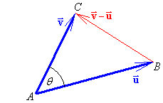
Let be the angle between vectors .

Apply the law of cosines to the triangle.

But

and the angle between non-zero vectors can be found from

Recall that, for an acute angle (first quadrant),

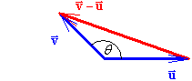
and for an obtuse angle (second quadrant),

If the dot product is negative, then
the angle between the two vectors is obtuse.
The vectors are pointing away (approximately) from each other.

If two non-zero vectors are at right angles, then .

If then are orthogonal and
either or the angle between the vectors is .

Example 4.2.2

Points A(3,0,1), B(5,1,0) and C(9,2,2) define a triangle ABC.
Show that the triangle contains an obtuse angle.

The vectors with tails at point B are

the angle at B is obtuse.
[One can quickly deduce that and ,
so that the angles at A and at C are both acute.]

Example 4.2.3

Find all real numbers x such that [ x 1 2 ] ^{T} and [ x –3 –x ] ^{T} are orthogonal.

For orthogonality, (x + 3)(x – 1) = 0 ⇒ x = –3 or x = 1.

One can quickly check that [ –3 1 2 ] ^{T} and [ –3 –3 –3 ] ^{T} are orthogonal and that
[ 1 1 2 ] ^{T} and [ 1 –3 1 ] ^{T} are orthogonal.

Projections
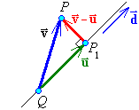
In this diagram, is the shadow of vector on the line L that passes through Q and whose line direction vector is the non-zero vector .

is parallel to .
is orthogonal to .

The vector has therefore been decomposed into a pair of orthogonal vectors, one parallel to the line and the other orthogonal to the line.

The “shadow” vector is the projection of on , denoted by .

for some scalar t.

, (which requires ).

Another way of writing the projection, in terms of the unit vector parallel to the line, is

and the vector is orthogonal to .

Example 4.2.4

Express the vector as , where is parallel to and is orthogonal to .

and

and should be orthogonal. Checking our answers:

Distance of a Point from a Line
The distance r of a point P from the line through Q
with direction vector is clearly ,
where .

Example 4.2.5

Find the distance from the point P(3, –1, 4) to the line through the points Q(0, 1, 3) and R(2, 2, 7).

The line direction vector is

Also the location of the nearest point P₁ on the line to the point P can be found:
Equations of Planes

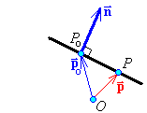
A plane, like a line, requires two vectors to define it: one vector for its orientation in space, the other to fix the location of any one point P_{o} known to be on the plane.

Unlike a line, the vector that defines a plane in is its normal (any non-zero vector that is orthogonal to all vectors lying in or parallel to the plane).

If and only if the point P lies in the plane, then the vector is orthogonal to the plane’s normal vector . But .

Therefore the vector equation of the plane is

Another way to look at the equation of a plane is to note that the projections of vectors and in the direction of the normal vector will be equal if and only if point P is on the plane. The equation of the plane is then

If the normal vector to the plane is , then the equation of the plane becomes
or, defining a new constant d as , the equation of a plane with normal vector is

Example 4.2.6

Find the equation of the plane that is orthogonal to the line and passes through the point (1, 1, 1).

Any normal vector to the plane is parallel to the direction vector of the line.
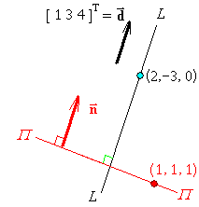
Therefore let .
The plane passes through the point (1, 1, 1)
Also note that
Therefore the equation of the plane is or

Example 4.2.7

Find the equation of the plane that is parallel to the plane 4x – 3y + 5z = 10 and passes through the point (3, 7, 2).

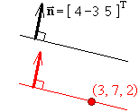
The two planes are parallel
⇒ their normal vectors are parallel.
Therefore let .
The plane passes through the point (3, 7, 2)

Therefore the equation of the plane is or

Coordinate Basis Vectors

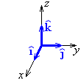
In Cartesian coordinates in , the basis vectors are
(or just i), a unit vector pointing along the x axis,
(or j), a unit vector pointing along the y axis and
(or k), a unit vector pointing along the z axis.

Any position vector can be written as .

Cross Product

The normal vector to a plane is orthogonal to all vectors lying in that plane.
If we know two non-parallel non-zero vectors in the plane, then any function of those vectors that results in a non-zero vector at right angles to both of them will provide a normal vector to the plane. The cross product provides such an orthogonal vector.

For any two vectors the cross product of u and v is defined by

Expanding down column 1,
This vector is orthogonal to both u and v. Proof for u:

The proof for v is similar.
Equation of a Plane using the Cross Product
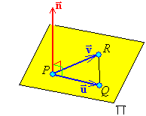
If P, Q, R are three points in a plane, not all on the same line, then a normal vector to that plane is .

Either of the other pairs of vectors can be used instead:
or . In general the magnitudes of these three cross product vectors will be different, but they will all be parallel to each other and normal to the plane.

Example 4.2.8

Find the equation of the plane that passes through the points P(0, 2, 1), Q(3, 2, 4) and R(1, 5, 7).

and

Any non-zero multiple of a normal vector is also a normal vector.
Therefore take
For the vector any of could be used. Choosing P,

Therefore the equation of the plane is or

4.3 The Cross Product

Quoting from section 4.2,

For any two vectors the cross product of u and v is defined by

From this it follows that is obtained from by interchanging columns 2 and 3 of the determinant. But this interchange introduces a change of sign. Therefore
- the cross product is anti-symmetric (and therefore is not commutative).
Setting = any multiple k of , we have
Therefore the cross product of any pair of parallel vectors is the zero vector.
Also

Lagrange identity:

But , where θ is the angle between the two vectors

Therefore a coordinate-free geometrical interpretation of the cross product is

The scalar triple product of vectors , and
is , where is the matrix with as its columns.

Note that the cross product has to be evaluated first. The cross product of a scalar with a vector is not defined. Therefore and .
Also
Proof:
Expanding down column 1:

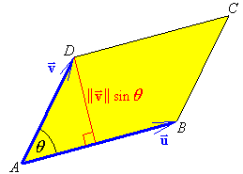
Geometric interpretations:

The area of the parallelogram ABCD
defined by vectors is
A = (base) × (perpendicular height)

Therefore

and it also follows that the area of triangle ABD is .

Example 4.3.1

Find the area of the triangle whose vertices are at the points P(0, 2, 1), Q(3, 2, 4) and R(1, 5, 7).

, and
The cross product of any two of these three vectors may be used to evaluate the area.
Selecting and ,
Repeating some of the work from Example 4.2.8:

The scalar triple product also has a geometric interpretation.

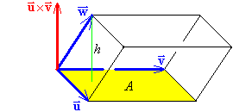
A parallelepiped is a six-sided object all six of whose faces are parallelograms, with pairs of opposite faces being congruent. It can be generated from a cube by repeated stretching and shearing parallel to the edges.

The volume of any parallelepiped is the product of the area of any face and the distance from that face to the opposite face:
V = Ah

But the area of the base is just .
The height h is the magnitude of the projection of on the normal vector to the base :
Therefore the volume of the parallelepiped is just the magnitude of the scalar triple product of the three vectors that define it.
Example 4.3.2

Find the volume of the parallelepiped defined by the vectors , and .

Example 4.3.3 (Textbook, page 185, exercises 4.3, question 8)
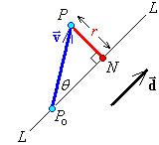
Another method to find the distance r of a point P from the line through point P_{o} with line direction vector :

Let be the angle between vectors and .

But

.

However, if one wishes to find the location of the nearest point N on the line to the point P, then the projection of on is required:

