4.4 Additional Examples for Chapter 4

Example 4.4.1

Prove that the line joining the midpoints of two sides of a triangle is parallel to and exactly half as long as the third side of that triangle.

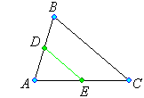
We need to prove that .

and

Example 4.4.2

Find the coordinates of the point P that is one-fifth of the way from A(1, –2, 3) to
B(7, 4, –9).

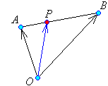

P splits the line segment AB in the ratio r:s = 1:4.
The general formula for the location of such a point is
[Page 4.04 of these lecture notes]
Therefore
OR
Therefore the point P is located at .
Example 4.4.3

The points P(2, 3, 1), Q(4, 7, 2), R(1, 5, 3) and S are the four vertices of a parallelogram PQSR, with sides PQ and PR meeting at vertex P. Find the coordinates of point S.

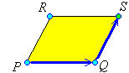
Following the path OQS:

Therefore the point S is at (3, 9, 4).

[One could follow the path ORS instead.]

Example 4.4.4

Find the parametric and symmetric equations of the line L that passes through the points Q(1, –5, 3) and R(4, 7, –1). Find the distance r of the point P(2, –17, 10) from the line and find the coordinates of the nearest point N on the line to the point P.

The line direction vector is

Either Q or R may serve as the known point on the line.
Choosing Q, the vector equation of the line is
The Cartesian parametric equations are
from which the symmetric form follows:

Example 4.4.4 (continued)
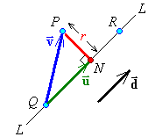

The vector from Q (a known point on the line) to P is

The shadow of this vector on the line is the projection

OR

Triangle PNQ is right-angled at N

The location of N can be found from
[or one may use instead]
Therefore the point N is at (–2, –17, 7).

Example 4.4.5

Show that the lines and are skew and find the distance between them.

Line L₁ has line direction vector
and passes through point P₁ (–1, 1, 2).

Line L₂ has line direction vector
and passes through point P₂ (1, 0, 1).

Clearly is not a multiple of . Therefore the two lines are not parallel.

OR

The angle between the lines,, is also the acute angle between the direction vectors of the lines.

,

The lines are therefore at an angle of

Upon finding a non-zero distance between the lines, we will complete the proof that these lines are skew.
Example 4.4.5 (continued)
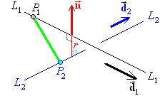
The vector is orthogonal to both lines.

The length of the projection of onto is the distance r between the lines.

Therefore the distance between the two non-parallel lines is
and the two lines are skew.

Example 4.4.6

Find two non-zero vectors that are orthogonal to each other and to .

It is easy to construct a non-zero vector whose dot product with is zero:
For the third vector, just take the cross product of the first two vectors:
Therefore .
Example 4.4.7

Find the Cartesian equation of the plane that passes through the points A(3, 0, 0),
B(2, 4, 0) and C(1, 5, 3) and find the coordinates of the nearest point N on the plane to the origin and find the distance of the plane from the origin.

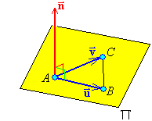
Two vectors in the plane are and
.
A normal to the plane is

Therefore a normal vector to the plane is
The Cartesian equation of the plane is

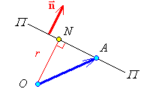
The displacement vector for N is the projection of the displacement vector of any point on the plane onto the plane’s normal vector.
Therefore N is the point and

Example 4.4.8

Find all vectors that are orthogonal to both .

One vector that is orthogonal to both is
Any multiple of this vector is also orthogonal to both .
Therefore the set of vectors is .

Check:
and

Example 4.4.9

The vertices of a triangle ABC are at A(1, 0, 1), B(–2, –1, 1) and C(3, 2, 2) .
Find the angle at vertex A (correct to the nearest degree).

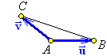

Let be the angle at vertex A, then

Example 4.4.10 (Textbook, page 179, exercises 4.2, question 18)

Show that every plane containing the points P(1, 2, –1) and Q(2, 0, 1) must also contain the point R(–1, 6, –5).

and

Points P and Q are in a plane
⇒ all points on the line through P and Q are in any plane containing P and Q .
But point R is on the line through P and Q
Therefore every plane containing the points P and Q must also contain the point R.

Example 4.4.11 (Textbook, page 180, exercises 4.2, question 44(a))

Prove the Cauchy-Schwarz inequality .

Let be the angle between vectors and .
, but

Example 4.4.12
Find the point of intersection of the lines and
.

Line 1:
Line 2:
At the point of intersection

Solving the over-determined linear system for s and t,

Unique solution ⇒ a single point of intersection does exist.

Therefore the two lines intersect at the point (1, 2, 1).

