Example 8.01:

“Exact lifetime” is a continuous random quantity, but
“Measured lifetime to the nearest minute” is a discrete random quantity.

In a bar chart, the height of each bar represents the probability. Note that as the measurements become more precise, the number of intervals increases and the width, probability and height of each bar decrease. The visual effect is misleading: it appears that the total probability is decreasing to zero as the number of intervals increases to infinity.

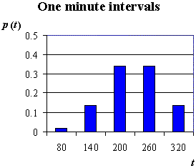
T = lifetime of a test wire in seconds.
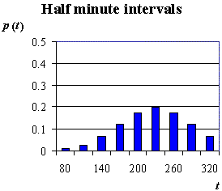
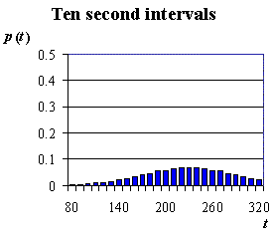

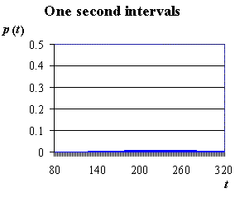

Much more natural is the probability histogram, where the area of each bar represents the probability that the random quantity lies in the interval covered by the width of the bar. The total area thus remains 1 even as the number of intervals → ∞.

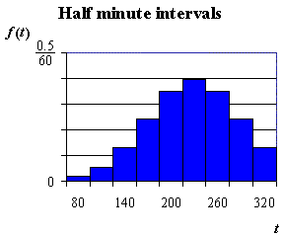
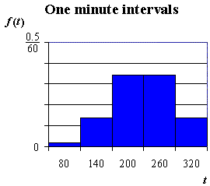

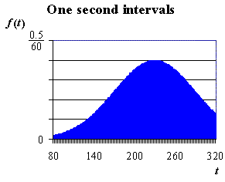
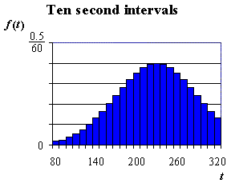
In the probability histogram,

$\text{Bar height} = \frac{p(x)}{\text{Bar width}} =$ “Probability density”

As the bar width → 0, bar height → f(x) = the probability density function (p.d.f.) .

The total area remains 1.

Thus two conditions for a function f(x) of a continuous variable x to be a valid probability density function are:

1)
[non-negative probability mass]

2)
[coherence]

From a discrete probability histogram,
P[a < X ≤ b] = the sum of the areas of the bars from x = a to x = b
(excluding x = a but including x = b),
= (c.d.f. at x = b) − (c.d.f. at x = a)
and P[X = a] = the area of the single bar centered on x = a.

For a continuous probability distribution, it then follows that

$P[a<X<b] = \int_{a}^{b}{f(x) \text{dx}}$

and P[X = a] = 0

Example 8.02

Verify that is a legitimate probability density function and find $P\left[ −\frac{1}{2} < X < \frac{1}{2}\right]$ .
Note that, by default, f (x) = 0 for all values of x not mentioned in the definition.

On 0 ≤ x ≤ 1 , f (x) = 2x ≥ 0 . Elsewhere f (x) = 0. ∴ f (x) ≥ 0 ∀x .

$\int_{−∞}^{ ∞}{f(x) \text{dx} = }\int_{−∞}^{ 0}{0 \text{dx} + }\int_{0}^{ 1}{2x \text{dx} + \int_{1}^{ ∞}{0 \text{dx} = }}0 + {\left[x^{2}\right]}_{ 0}^{ 1} + 0 = 1$

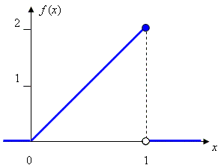
OR:

The total area under the graph of f (x)

= (area of the triangle, width 1,
height 2 )
= ½ (1)(2) = 1

Therefore f (x) is a valid p.d.f.
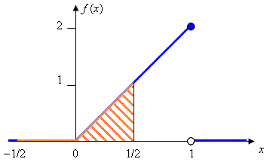

$P\left[ −\frac{1}{2} < X < \frac{1}{2}\right]$ = area under f (x)
between x = − ½ and x = ½

= (area of triangle, width ½, height 1)

= ½ (½) 1 = ¼ .

OR:

$P\left[−\frac{1}{2} < X < \frac{1}{2}\right] = \int_{{−1}/2}^{ 1/2}{f(x) \text{dx} = }\int_{{−1}/2}^{0}{0 \text{dx} + }\int_{0}^{ 1/2}{2x \text{dx} = }0 + {\left[x^{2}\right]}_{ 0}^{ 1/2} = \frac{1}{4}$
The cumulative distribution function (c.d.f.) is defined by

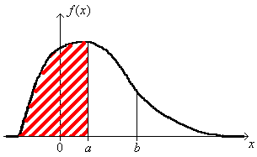
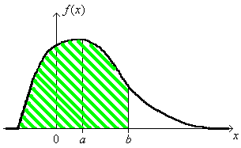

−

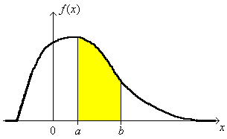

=

$P\left[a < X < b\right] = F\left(b\right) − F\left(a\right)$

F (−∞) = 0 F (+∞) = 1 0 ≤ F (x) ≤ 1 for all x.

The c.d.f. is a non-decreasing function of x and $\frac{d}{\text{dx}}\left(F(x)\right) = f(x) ≥ 0$ ∀x.
[Many c.d.f.s look like this:]
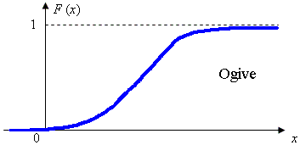

Example 8.02 (continued)

Find the cumulative distribution function for .
[Note that f (x) is assumed to be zero for any x not mentioned in the definition]

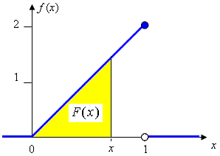

Graphical method:

x < 0 ⇒ F (x) = 0

0 ≤ x ≤ 1 ⇒ F (x) = ½(x)(2x) = x²

x > 1 ⇒ F (x) = ½(1)(2) = 1

Calculus method: $F(x) = \int_{−∞}^{x}{f(t) \text{dt}}$

x < 0 ⇒ F (x) =
0 ≤ x ≤ 1 ⇒ F (x) =

x > 1 ⇒ F (x) =

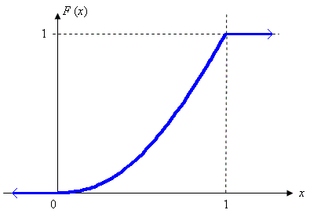

Note how the c.d.f. is a non-decreasing continuous function between F = 0 and F = 1.

[ The sharp corner at x = 1 on the c.d.f. corresponds to the finite discontinuity at
x = 1 on the p.d.f. ]

Example 8.03 The Continuous Uniform Distribution

Find the p.d.f. and the c.d.f.

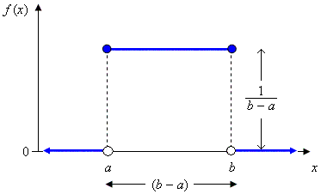
The probability density function is

The cumulative distribution function is

$F(x) = \int{f(t) \text{dt}}$ . When x < a , F (x) = 0

When x > b , F (x) = 1
When a ≤ x ≤ b , F (x) = OR

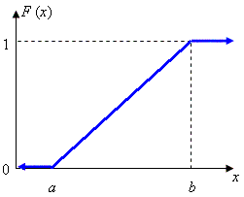
Therefore

Population Mean and Population Variance for Continuous Probability Distributions

The discrete probability point masses p_{i} are “smeared out” into infinitely many elementary masses f (x) dx covering infinitesimal intervals dx . The expression for the population mean (expected value) of the random variable X thus evolves from the discrete case $E[X] = \sum_{∀i}{p_{i}x_{i}}$ to the continuous equivalent

$$μ = E[X] = \int_{−∞}^{∞}{x f(x) \text{dx}}$$

The expression for the population variance is amended in a similar manner, from $σ^{2} = V[X] = \sum_{∀i}{{p_{i}\left(x_{i}−μ\right)}^{2}}$ to
$$σ^{2} = V[X] = \int_{−∞}^{∞}{(x−μ)^{2}} f(x) \text{dx} = E\left[X^{2}\right] − {\left(E[X]\right)}^{2}$$

Example 8.03 (continued)

Find the population mean and variance for the continuous uniform distribution U(a, b) .

$E[X] = \int_{−∞}^{∞}{x f(x) \text{dx}} = \int_{−∞}^{a}{0 \text{dx}} + \int_{a}^{b}{x \left(\frac{1}{b−a}\right) \text{dx}} + \int_{b}^{∞}{0 \text{dx}}$=

$V[X] = 0 + \int_{a}^{b}{{ \left\{x−\left(\frac{a+b}{2}\right)\right\}}^{2}} \left(\frac{1}{b−a}\right) \text{dx} + 0 = \left(\frac{1}{b−a}\right) {\left[\frac{1}{3} {\left\{x−\left(\frac{a+b}{2}\right)\right\}}^{3}\right]}_{ a}^{ b}$$= \frac{1}{3} \left(\frac{1}{b−a}\right) \left\{{\left(\frac{b−a}{2}\right)}^{3} − {\left(\frac{a−b}{2}\right)}^{3} \right\} = \frac{1}{3} \frac{(b−a)^{3}}{(b−a)} \frac{2}{8}$
$∴ σ^{2} = \frac{(b−a)^{2}}{\text{12}}$ and $σ = \frac{(\text{range})}{\sqrt{\text{12}}}$ .

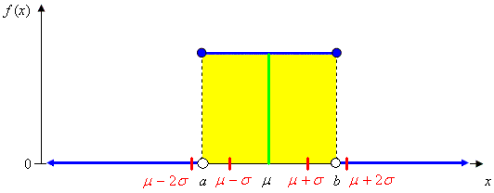

[It is absolutely certain that the random quantity X will lie less than two standard deviations away from the population mean. The entire distribution lies within √3 (≈ 1.732) standard deviations of the mean.]

The Exponential Distribution

This continuous probability distribution often arises in the consideration of lifetimes or waiting times and is a close relative of the discrete Poisson probability distribution.

The probability density function is
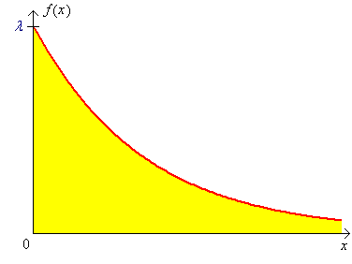
The cumulative distribution function is

F (x) = P[ X ≤ x ] = $\int_{−∞}^{x}{f(t) \text{dt}}$ =

⇒ P[ X > x ] =

Also μ = E[X] = and σ = μ
Reason:

V[X] = E[X²] − (E[X])²

OR

Example 8.04

The random quantity X follows an exponential distribution with parameter λ = 0.25 .
Find μ , σ and P[X > 4] .

≈ .368

Note: For any exponential distribution, P[X > μ] ≈ .368 .

Example 8.05

The waiting time T for the next customer follows an exponential distribution with a mean waiting time of five minutes. Find the probability that the next customer waits for at most ten minutes.

P[ T ≤ 10 ] = F (10) =

∴ P[T < 10] ≈ .865

Note:

P[ X > μ + 2σ ] = e^{−λ(μ + 2σ)} = e^{−λ((1/λ)+(2/λ))} = e⁻³ = .049787

Therefore P[ X > μ + 2σ ] ≈ 5.0% for all exponential distributions.

Also μ − σ = $\frac{1}{λ} − \frac{1}{λ}$ = 0 ⇒ P[ X < μ − σ ] = 0 = P[ X < μ − 2σ ]

Therefore P[ | X − μ | > 2σ ] ≈ 5.0% , a result similar to the normal distribution, except that all of the probability is in the upper tail only.

For reference purposes, here are some other continuous probability density functions:

Weibull distribution (parameters α and β; textbook section 4.5, pages 163-166):

$f(x; α, β) = \frac{α}{β^{α}} x^{α−1} e^{−(x/β)^{α}} , x≥0$

Gamma distribution (parameters α and β; textbook section 4.4, pages 159-161):

$f(x; α, β) = \frac{1}{β^{α} Γ(α)} x^{α−1} e^{{−x}/β} , x≥0$, where Γ(α) is the
gamma function $\int_{ 0}^{ ∞}{x^{α−1} e^{−x} \text{dx}}$. When n is a positive integer, Γ(n) = (n−1)!
The gamma function is therefore a generalization of the factorial function.
The exponential distribution is a special case of
- the Weibull distribution when α = 1. (λ = 1/β ).
- the gamma distribution when α = 1. (λ = 1/β ).
However, neither of the Weibull and gamma distributions is a subset of the other.
Another special case of the gamma distribution, with α = ν /2 and β = 2
(where ν = a natural number = “degrees of freedom”) is the Chi-squared distribution:
$f(x; ν) = \frac{1}{2^{ν/2} Γ(ν/2)} x^{(ν/2)−1} e^{{−x}/2} , x≥0$
Another distribution is the beta distribution (pages 167-168):
$f(x; α, β, A, B) = \frac{1}{B−A} \frac{Γ(α+β)}{Γ(α)Γ(β)} {\left(\frac{x−A}{B−A}\right)}^{α−1} {\left(\frac{B−x}{B−A}\right)}^{β−1}$ , A ≤ x ≤ B .

If Y = ln(X) and Y ~ N (μ, σ²), then X has a lognormal distribution (pages 166-167).

Other p.d.f.s can be found in any good textbook on probability and statistics.
The Gaussian or normal probability distribution is the single most important probability distribution. It was first described by Abraham de Moivre in 1733 but bears the name of Karl Friedrich Gauss, who arrived at this distribution in 1809 when examining the distribution of errors in the measurement of the diameters of lunar craters. It arises naturally in many other situations (especially the Central Limit Theorem).

If a continuous random quantity X has a normal distribution with population mean μ and population variance σ² , then its probability density function is
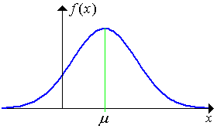
$$f(x) = \frac{1}{σ\sqrt{2π}} e^{−\left\{\frac{{\left(x−μ\right)}^{2}}{2σ^{2}}\right\}}$$

which is positive for all x .

The cumulative distribution function for the normal distribution is [Note that the points of inflection are at
$F(x) = \int_{−∞}^{x}{f(t) \text{dt}}$ x = μ ± σ ]
which cannot be evaluated exactly in closed form except for certain special choices for x.

Notation:

X ~ N(μ, σ² )

μ = E[X] = population mean σ² = V[X] = population variance
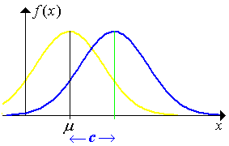

Adding a constant c to X :

moves the probability curve
c units to the right

Influence of the variance σ² on the
shape of the normal probability curve:
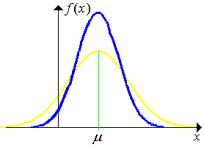
Low σ² High σ²

high peak low peak

most values values more
near μ spread out
(prop’l to σ)
Because there is no closed algebraic form for the c.d.f. F(x) , the values are tabulated for one special choice of mean and variance: μ = 0 , σ² = 1 .

Notation:

Z ~ N (0, 1) is the standard normal distribution,

with p.d.f. = φ (z) and c.d.f. = Φ (z) .

Conversion from X ~ N(μ, σ²) to Z ~ N (0, 1) requires a linear shift of μ and a change of scale by a factor of σ .

F (x) = P[X ≤ x] =

= P[Z < z]

where Z ~ N(0, 1).

Thus $P\left[x_{1} < X < x_{2}\right] = Φ\left(z_{2}\right) − Φ\left(z_{1}\right)$ where $z = \frac{x−μ}{σ}$ .

Symmetry ⇒
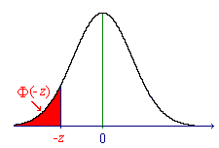
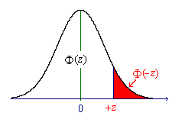

Φ(−z) = 1 − Φ(+z)

A table of values of the standard normal distribution is on the inside front cover of the textbook (Devore, Table A.3).
A more precise table is available as an Excel spreadsheet file, on the course web site, at
"www.engr.mun.ca/~ggeorge/3423/demos/zTables.xls".
and also in Chapter 15 of these notes.
For all normal distributions,
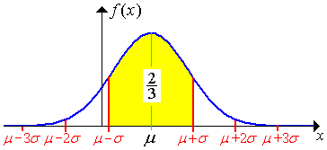

[Approximate "rules of thumb":]
$P\left[ \left|X−μ\right| > 1σ \right] ≈ \frac{1}{3}$ $P\left[ \left|X−μ\right| > 2σ \right] ≈ \frac{1}{\text{20}}$

$$P\left[ \left|X−μ\right| > 3σ \right] < \frac{1}{\text{300}}$$

Example 8.06

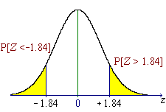
The weights of boxes of nails are known to be normally distributed to an excellent approximation, with mean 454 grammes and standard deviation 25 grammes. What proportion of boxes weighs more than 500 grammes?

X ~ N(454, 25 ² )

Part of Table A.3 (also page 15-03):

z .00 .01 .02 .03 .04 ...



−1.9 0.02872 0.02807 0.02743 0.02680 0.02619 ...

−1.8 0.03593 0.03515 0.03438 0.03362 0.03288 ...

−1.7 0.04457 0.04363 0.04272 0.04182 0.04093 ...

−1.6 0.05480 0.05370 0.05262 0.05155 0.05050 ...

−1.5 0.06681 0.06552 0.06426 0.06301 0.06178 ...



The proportion of boxes weighing > 500 g is 3.3% (to 2 s.f.)

Example 8.07

Find the probability that a normally distributed random quantity is more than two and a half standard deviations away from its mean in either direction.
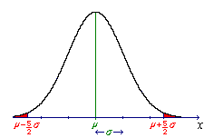

$P\left[ \left|X−μ\right| > \left(212\right) σ\right] = P\left[X−μ > \frac{5}{2} σ \text{OR} X−μ < −\frac{5}{2} σ\right]$

= 2 × .00621

Therefore

Example 8.08

The strength of a set of steel bars is known to be normally distributed with a population mean of 5 kN and a population variance of (50 N)² . A client requires that at least 99% of all of these bars be stronger than 4,900 N. Has this requirement been met?

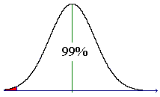
First convert μ to the same units as σ .

μ = 5000 N σ = 50 N

= P[Z > −2] = P[Z < +2]
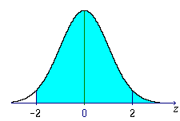
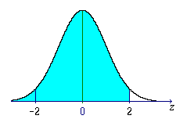

=

= Ф(+2.00)

= .977 25 < 99%

Therefore the requirement is NOT satisfied.

Note that Ф(z) = .99000 ⇒ z ≈ 2.33

⇒ x ≈ μ − 2.33 σ

= 5000 − 2.33×50

= 4883

99% of all bars are stronger than 4,883 N (approximately).

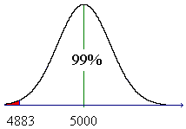

Example 8.09

Given that the random quantity X is normally distributed, find c such that

P[ X > c ] = 1% .

(That is, find the 99th percentile.)
$P\left[X>c\right] = P\left[Z>\frac{c−μ}{σ}\right]$ = .01 .
Notation: z_{α} = the (1 − α)×100th percentile of the standard normal distribution.

$$P\left[Z>z_{α}\right] = α = Φ\left(−z_{α}\right)$$
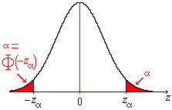
Here, α = .01 .
Φ(−z_{.01}) = .01
To find z_{.01} we need to look in
table A.3 for the value Φ = .01000 .

Φ(−2.32) = .01017
Φ(−2.33) = .00990
⇒ z_{.01} = 2.33 (to 2 d.p.)

Using linear interpolation (which will not be required in tests or the exam):

.01000 is 17/27 of the way from Φ(−2.32) to Φ(−2.33).

Thus −z_{.01} ≈ −2.32 + (17/27) × (−0.01) ≈ −2.326 .
[The true value is −2.326, correct to three decimal places].

⇒ c = μ + z_{.01} σ ≈ μ + 2.326 σ .

Note: By symmetry, the fiftieth percentile (z_{.50} = $\tilde{μ}$ = the median) is at z = 0 .
Φ(0) = .5000 ⇒ $\tilde{μ}$ = μ + 0 σ .
Example 8.10

Find the quartiles for any normal distribution.

X ~ N (μ, σ²)

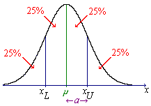

By symmetry,
x_{L} = μ − a and

x_{U} = μ + a where

a = SIQR (the semi-interquartile range).

F(x_{U}) = .75 ⇒

But Φ (0.67) = .74857 and Φ (0.68) = .75175 .

⇒ (to 2 s.f.) SIQR = 0.67 σ

Linear interpolation:
∴ x_{U} − μ = 0.6745 σ

⇒ x_{U} = μ + 0.6745 σ

By symmetry,
x_{L} = μ − 0.6745 σ
and
SIQR = 0.6745 σ .

