**AMOUNT OF RAIN PREDICTION IN PLANNING HYDRO-POWER GENERATION**

**BY**

**ANAND M. SHARAN PROFESSOR**

**PROFESSOR**

**MECHANICAL ENGINEERING DEPARTMENT**

**FACULTY OF ENGINEERING, MEMORIAL UNIVERSITY OF NEWFOUNDLAND, ST. JOHN’S, NEWFOUNDLAND, CANADA A1B 3X5; FAX : ( 709 ) 864 - 4042**

**E-MAIL: asharan@ mun.ca**

**ABSTRACT**

**The 102-year-old central-California hydroelectric power this year has been severely wiped clean due to lack of rain.**

**Similarly, there are large parts of the world being affected by global warming.**

**This research predicts rainfall in coming monsoon season well ahead - about 8 months ahead of the season.**

**The study includes the area of Vidarbha in India which has erratic monsoon rains, and the results come very close to the actual figures.**

**The problem, at first, is solved using two independent methods and then the predicted value is arrived at by attaching weights to these two results.**

1. **INTRODUCTION**

**In drought years, reduced power is generated due to partial filling of reservoirs. It results in rationing of the available power during summer months.**

**In California, the Shasta Dam, which is more than 600 feet tall and is the gatekeeper of the largest man-made lake in California, was designed to perform two crucial functions: Store water and generate power.**

**For decades, it has channeled water to cities and farms while generating up to 710 megawatts of hydropower, enough to provide electricity for more than 532,000 homes.**

**But, due to four years of drought, the reservoir is drained to 50% of capacity, cutting the dam's power production by about a third.**

**The story is the same at many dams across California, where electricity production at some - is expected to be less than 20% of normal because of low water levels.**

**The same kind of news comes from other parts of the world such as Brazil, India etc. [1-5].**

**The drought affects many different groups of populations such as farmers, water suppliers ( municipalities ) etc.**

**One has to remember that agriculture constitutes a significant portion of Gross Domestic Product ( GDP ) of a country and lack of rainfall creates havoc amongst the masses such as suicides by farmers when the crops fail [6,7].**

**Therefore, it is desirable if we know many months in advance as to how much rainfall a given place is likely to have in this era of global warming when the rainfall has become erratic.**

**It should be emphasized that the global warming effects are not only experienced in the tropics only but extend to both south and north poles where huge amounts of ice is melting.**

**In Canada, places like James Bay or Labrador can also get affected and thereby it may adversely affect the hydropower generations of power plants in these regions.**

**In the present work, monsoon rain in Vidarbha, India is predicted 7 months in advance.**

**The predicted and actual rainfall amounts are compared for the year 2015.**

**The monsoon rains include rains during the months of June to September.**

**The rainfall in Vidarbha is selected because the rain pattern is extremely difficult and erratic; it poses serious challenges to the scientists involved in the rain prediction. Vidarbha lies in the Central India as shown in Fig. 1.**

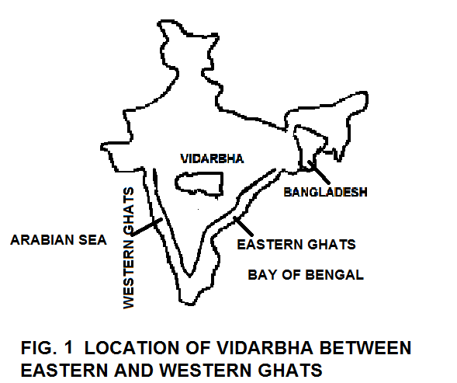

**2. RAIN PREDICTION IN INDIA**

**India’s primary information about rain comes from India Meteorological Department (IMD) [8] .**

**India has emphasized fair amount on research on rain predictions.**

**It is known that monsoon is predicted either by statistical models based on analysis of historical data to determine the relationship of Indian Summer Monsoon Rainfall (ISMR) , to a variety of atmospheric and oceanic variables over different parts of the world before the summer monsoon season, or by dynamical models based on the laws of physics [ 9,10] (Gadgil, and Srinivasan,2012 ; Delsole, Shukla, 2012).**

**It has been found that Irrespective of methods used above, their validity over large tract of land area have not been found as reliable because of their dependence merely on atmospheric and ocean parameters.**

**In India there are lands quite far away from oceans and hence the monsoon clouds reach these lands after spreading over large land area.**

**The convective conditions over the land areas are very different. Secondly, the mountain ranges between the ocean and the location of interest alter the rain pattern. In Fig. 1, both the Western and Eastern Ghats along the ocean alter the rain pattern in Vidarbha. Therefore, the accuracy of such models is not dependable.**

**In view of the above argument, there is a need to have an alternate and reliable method of prediction so that one gets sufficient time in advance to plan for power availability in the future.**

**In India, about 90% of the annual rainfall takes place during the monsoon months ( June to September ) in most of the places.**

1. **RAIN DATA AND ANALYSIS**

**Fig. 2 shows rains for all these months ( June to September ) in combined form.**

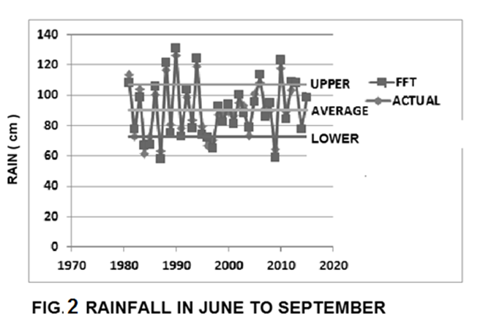

**This record (Fig. 2) has on an average or the mean value of 84.8 centimeters of rain.**

**Indian Meteorological Department (IMD) defines normal rain if the values lie between plus or minus 19% of the mean value.**

**One can clearly see that the plot ( Fig. 2 ) has many ups and downs.**

**However, low amount of rain causes drought conditions such as in 2009 in Fig. 2.**

**This rainfall data’s statistical distribution was plotted and the result is shown in Fig. 3 ) which shows a normal distribution. This was further checked using chi squared test using software called MATLAB.**

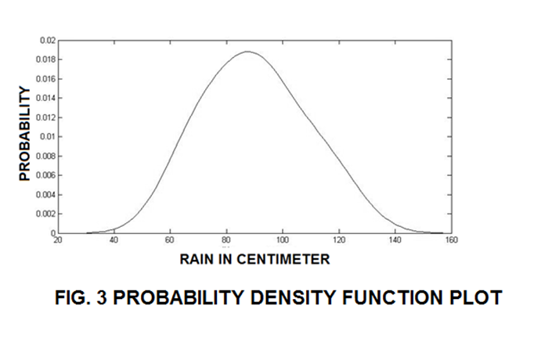

**The same data that is shown in Fig. 2, was analyzed in the frequency domain using Fast Fourier Transforms (FFT), and the results are shown in Fig. 4 [11,12]]**

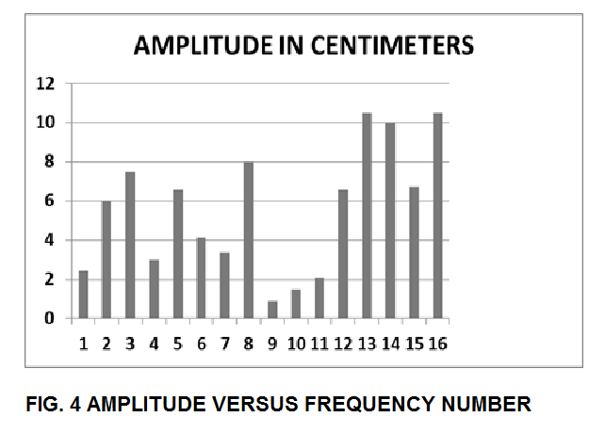

**It shows frequency numbers which are quite significant are 3, 8, 13, 14, and 16.**

**The number 3, does point to the El Nino or its counterpart La Nina effect which occur every 10.67 years.**

**Remarkable fact is that numbers 13, 14, and 16 having much higher frequencies have greater amplitudes. This shows that the change in rain amount will be very rapid from year to year.**

**This rapid fluctuation in the amount of rain throws off the planning for the crops.**

**Similarly, it will affect hydropower generation.**

**Fig. 2 shows plots of the actual data and the results of FFT method i.e. after obtaining Fourier coefficients using FFT; the time dependent results were calculated using the Fourier series. It shows a very close match between the two (actual and its FFT model).**

**Thus the FFT model quite accurately fits the rain pattern in Vidarbha.**

1. **RAINFALL PREDICTION**

**It was not possible for the author to obtain data beyond 2012.**

**For Year 2013 onwards, the rain data for Vidarbha were not posted on its IMD’s web i.e. region by region data on IMD website was not posted.**

**The rainfall predictions were made using Fourier series method and Time Series which uses Moving Average Method of rainfall and linear regression analysis.**

**The weightage ratio of 3:1 between the two methods was selected because the FFT method fitted the actual rain data very well.**

**The Time Series method generally predicted lower values.**

**The author’s prediction was based on weighted average ratio of 3:1 between the results obtained by FFT and Time Series methods. This is shown in Table 1 This Table shows the values predicted by IMD ( second column ) and the author ( fourth column )**

**TABLE 1: PREDICTED RESULTS IN CENTIMETERS FOR THE MONTHS OF JUNE TO SEPTEMBER COMBINED FOR YEAR 2015**

|  |  |  |  |
| --- | --- | --- | --- |
| **(JUNE-SEPT) 2015** | **IMD** | **ACTUAL** | **SHARAN** |
| **TIME SERIES** |  |  | **75.2** |
| **FFT** |  |  | **98.6** |
| **PREDICTION** | **95.5** | **84.8** | **(75.2+3x98.6)/4 =92.7** |
| **AVERAGE** | **84.8** |  | **84.8** |
| **UPPER** | **89.9** | **89.9** | **89.9** |
| **LOWER** | **72.9** | **72.9** | **72.9** |
| **CLASSIFICATION** | **NORMAL** | **NORMAL** | **NORMAL** |

**The total rain values are shown in Table 1 which shows that if the total values are considered then it would be normal rain in the Year 2015.**

**This Table also shows the values predicted by IMD and the actual rain data.**

**The results show that the author’s prediction was quite accurate for the year 2015**

1. **CONCLUSIONS**

**In this work, the historical rain data showed that Vidarbha has had slightly decreasing trend in rainfall (Time Series method).**

**At first, a suitable model was searched for and it was found necessary to analyze the possible causes of the rainfall variations by looking at the frequency spectrum.**

**The identified frequencies included the El Nino and La Nina effects amongst the others.**

**The dominant frequencies were 3, 8, 13, 14 and 16 – mainly the higher frequencies.**

**These higher frequencies give rise to rapid changes in rainfall about the mean value.**

**Based on this analysis, the prediction for the Year 2015 was that there would be normal rain.**

**The predicted value by the author was quite close to the actual value.**

**On the other hand, the value predicted by IMD shows slightly higher deviation as compared to the author’s .**

**The difference was that the IMD based its predictions on data up to 2014 whereas the author was disadvantaged due to the unavailability of the data for the years 2013, and 2014 yet the author came out with slightly better result besides the author had already predicted in November 2014 whereas the IMD had to wait until May 2015 ( hence shorter notice period for planning ) to get enough confidence in its predictions.**

1. **REFERENCES**
2. **Drought cuts power production of California dams, ,** [**http://www.latimes.com/local/california/la-me-drought-hydro-20150517-story.html**](http://www.latimes.com/local/california/la-me-drought-hydro-20150517-story.html)
3. **California Drought Cuts Hydroelectric Generation in Half ,** [**http://ecowatch.com/2014/10/07/eia-california-drought-cuts-hydroelectric/**](http://ecowatch.com/2014/10/07/eia-california-drought-cuts-hydroelectric/)
4. **Tanzania cuts power production after drought hits hydro plants ,** [**https://ca.news.yahoo.com/tanzania-cuts-power-production-drought-hits-hydro-plants-150010206--business.html**](https://ca.news.yahoo.com/tanzania-cuts-power-production-drought-hits-hydro-plants-150010206--business.html)
5. **Brazil drought stokes worries over energy shortages**

**,** [**http://www.bbc.com/news/world-latin-america-21055803**](http://www.bbc.com/news/world-latin-america-21055803)

1. **Karnataka's power problems get worse,** [**http://www.business-standard.com/article/economy-policy/karnataka-s-power-problems-get-worse-115092801288_1.html**](http://www.business-standard.com/article/economy-policy/karnataka-s-power-problems-get-worse-115092801288_1.html)
2. **Farmer’s Suicide in Vidarbha : Everybody’s Concern . http://medind.nic.in/jaw/t09/i2/jawt09i2piii.pdf**
3. **Farmers’ suicides in the Vidarbha Region of Maharashtra, India a Qualitative Exploration of Their Causes.** [**http://www.ncbi.nlm.nih.gov/pmc/articles/PMC3291283/**](http://www.ncbi.nlm.nih.gov/pmc/articles/PMC3291283/)
4. **Rainfall Projections.** [**http://www.imdpune.gov.in/endofseasonreport2013.pdf**](http://www.imdpune.gov.in/endofseasonreport2013.pdf)
5. **Delsole, T. and Shukla, J. (2012). Climate Models Produce Skillful Predictions of Indian Summer Monsoon Rainfall. Geophys. Res. Lett Volume 39, Issue 9, May**
6. **Gadgil, S and Srinivasan, J (2012). Monsoon Prediction: Are Dynamical Models Getting Better Than Statistical Models?”, J Current Science VOL. 103, NO. 3, 10 August**
7. **Excel - Time Series Forecasting.** [**http://www.youtube.com/watch?v=gHdYEZA50KE**](http://www.youtube.com/watch?v=gHdYEZA50KE)
8. **Frequency Domain Using Excel. http://online.sfsu.edu/jtai/downloads/ENGR%20302/Excel.FFT.pdf**

**TABLE 1: PREDICTED RESULTS IN CENTIMETERS FOR THE MONTHS OF JUNE TO SEPTEMBER COMBINED FOR YEAR 2015**

|  |  |  |  |
| --- | --- | --- | --- |
| **(JUNE-SEPT ) 2015** | **IMD** | **ACTUAL** | **SHARAN** |
| **TIME SERIES** |  |  | **75.2** |
| **FFT** |  |  | **98.6** |
| **PREDICTION** | **95.5** | **84.8** | **(75.2+3x98.6)/4 =92.7** |
| **AVERAGE** | **84.8** |  | **84.8** |
| **UPPER** | **89.9** | **89.9** | **89.9** |
| **LOWER** | **72.9** | **72.9** | **72.9** |
| **CLASSIFICATION** | **NORMAL** | **NORMAL** | **NORMAL** |





