ON TRACING THE ORIGIN OF THE PYTHAGORAS THEOREM
By
Anand M. Sharan
Professor, Mechanical Engineering Department
Memorial University, St. John’s, Newfoundland, Canada A1B 3X5
E-Mail : asharan@mun.ca
JULY 31, 2016

ABSTRACT
In the present work, a search for the original source of the Pythagoras Theorem has been carried out. It is found that Pythagoras himself did not come up with this theorem but acquired it away from Greece. He lived in Egypt for a long time then in Babylon and possibly in India. The original source was found to be in India where it is mentioned in Baudhayana Sutras dating back to 8th to 7th century BC.

KEYWORDS: Pythagoras theorem; Ancient mathematics; Indian origin

- THE EARLY HISTORY OF THE PYTHAGORAS THEOREM
The Pythagoras theorem is very famous among engineers and scientists where these people use it quite extensively. Many have wondered about its origin and are curious to know about its earliest documentation that can be found. The life of Pythagoras can be seen or studied in [1-4]. The question after going through these references arises as to how Pythagoras could have acquired this knowledge? This question arises because the following paragraph mentioned in reference 2:
“ Since the fourth century AD, Pythagoras has commonly been given credit for discovering the Pythagorean theorem, a theorem in geometry that states that in a right-angled triangle the area of the square on the hypotenuse (the side opposite the right angle) is equal to the sum of the areas of the squares of the other two sides—that is,
a² + b² = c²
While the theorem that now bears his name was known and previously utilized by the Babylonians and Indians, he, or his students, are often said to have constructed the first proof. It must, however, be stressed that the way in which the Babylonians handled Pythagorean numbers implies that they knew that the principle was generally applicable, and knew some kind of proof, which has not yet been found in the (still largely unpublished) cuneiform sources. [65] Because of the secretive nature of his school and the custom of its students to attribute everything to their teacher, there is no evidence that Pythagoras himself worked on or proved this theorem. For that matter, there is no evidence that he worked on any mathematical or meta-mathematical problems. Some attribute it as a carefully constructed myth by followers of Plato over two centuries after the death of Pythagoras, mainly to bolster the case for Platonic meta-physics, which resonate well with the ideas they attributed to Pythagoras. This attribution has stuck down the centuries up to modern times. [66] The earliest known mention of Pythagoras's name in connection with the theorem occurred five centuries after his death, in the writings of Cicero and Plutarch.”
Going through references 3, and 4, it is clear that original source for this theorem cannot be found from the Babylonian sources. So, one is left to search for it amongst the Indian sources. The author found its original source [5, 6] where it exists in the form of a verse in Sanskrit from Baudhayana Sutras having its origin in 8th to 7th centuries BCE. The verses in Sanskrit can be shown as [5].

“dīrghasyākṣaṇayā rajjuH pārśvamānī, tiryaDaM mānī, cha yatpṛthagbhUte kurutastadubhayāṅ karoti.”
दीर्घचतुरश्रस्याक्ष्णया रज्जु: पार्श्र्वमानी तिर्यग् मानी च यत् पृथग् भूते कुरूतस्तदुभयं करोति ॥

The English translation is:
A rope stretched along the length of the diagonal produces an area which the vertical and horizontal sides make together.
In Hindi, it can be written as [7]:
*अर्थात् दीर्घ आयत के अक्ष यानी केन्द्र पर स्थित रज्जु -सरल रेखा जो आरी और तिरछी होगी (यानी विकर्ण) वह **उतना ही क्षेत्र इकट्ठा बनाती है जितने कि उसकी लम्बाई और चौड़ाई अलग-अलग बनाती हैं।*

Using references 5-7, one can see that the conceptualization of this theorem was geometrical not in terms of pure numbers which (in form of numbers) we use very extensively these days. The geometrical figure can be seen in Fig. 1.
Since a rope has been used here, it shows that they had integers as well as fractions or decimals in mind for the validity of this theorem i.e. a, b, c could take values between 0 to infinity. What is meant is that a rope can be of any length where one can satisfy this statement.

- KNOWLEDGE OF THE THEOREM TO PYTHAGORAS
The next thing which can be discussed here is: How did it become known to the Babylonians or to Pythagoras?
Pythagoras (570 BC -495 BC) travelled widely - went to Egypt and lived there for a long time around 22 years. Around 522 BC, Egypt was defeated by the Persian king Cambyses II or Kambiz II (son of Cyrus the Great). Table 1 shows the names and times of various Persian kings. As a result of this defeat, Pythagoras was captured and taken to Babylon where he came across the scientific knowledge (astronomy and mathematics) which the Babylonians had. At this time, the Persian Empire extended into India - west of the Indus River as shown in Fig. 2 where the famous Taxila (Takshashila) University was located at [8]. Famous grammarian Panini (520 BC -460 BC) was born in Shalatula (near Attock). He taught at the Takshashila University. Since Takshashila was close to the Silk Road as well as had access to all the places within India through Uttara path, and Dakshina paths (Northern and Southern Roads), many Indians attended the Takshashila University (see Fig. 3). It can also be seen that both Panini and Pythagoras were contemporaries.
The knowledge behind the Pythagoras theorem could have been easily acquired at Takshashila or this this knowledge could have been available to the Babylonians through Takshashila.

- CONCLUSIONS
In this work, a search for the earliest existence of the Pythagoras Theorem was made.
- It was seen that it was not discovered by Pythagoras himself rather he acquired this knowledge while travelling to Egypt or in the Persian Empire of his time.
- The earliest source found was in India in Baudhayana Sutras dated around 8th to 7th centuries BC.
- The possible location was Takshashila (Taxila) University from where the knowledge transfer took place.
- The famous Sanskrit grammarian Panini was a contemporary of Pythagoras.

- REFERENCES
- Pythagoras, “http://www.mathopenref.com/pythagoras.html “
- Pythagoras,” https://en.wikipedia.org/wiki/Pythagoras”
- The Life of Pythagoras https://www.youtube.com/watch?v=o4Sh7IczM8I
- The Contributions of Pythagoras, https://www.youtube.com/watch?v=OcocYtGe8ec
- Tirthji, S.,B.,K., 1988, ” Vedic Mathematics”, Motilal Banarasidas, Delhi, India, pp 349-351
- Baudhayana Sutras,” https://mysteriesexplored.wordpress.com/2011/08/31/baudhayana-pythagoras-theorem-world-guru-of-mathematics-part-8/
- Jha, B.,2016,” Personal Communications With the Author “.
- Cambyses II,” https://en.wikipedia.org/wiki/Cambyses_II”
- Taxila ,” http://www.ancient.eu/taxila/

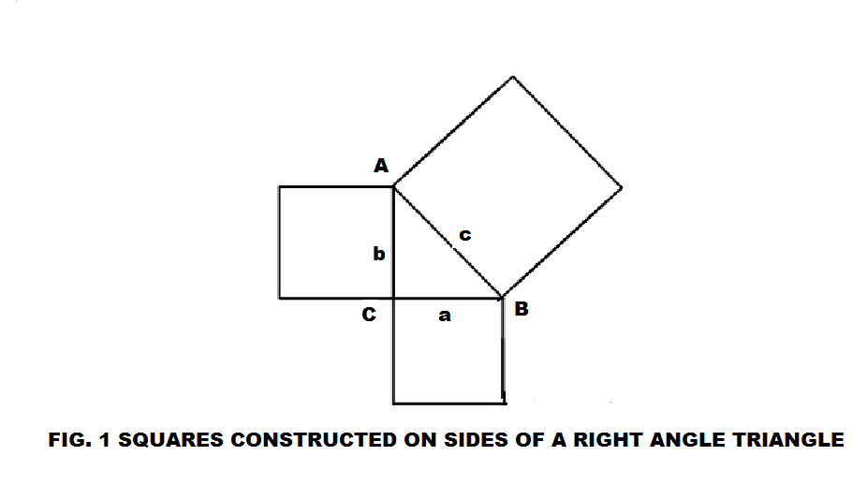

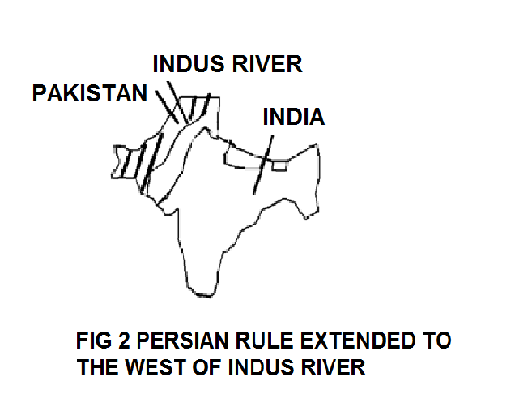

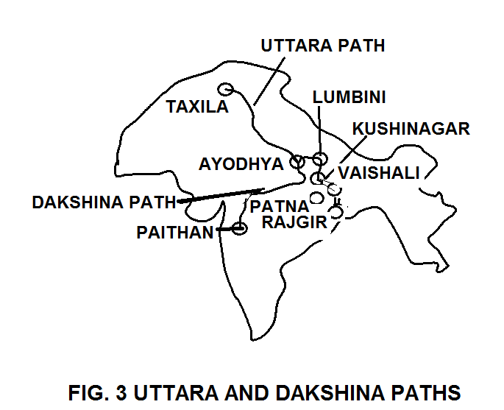
TABLE 1: THE ACHAEMENID EMPIRE
NO | NAME
1 | Cyrus the Great, 559BC - 530BC
2 | Kambiz II, 530BC - 522BC0
3 | Darius I the Great, 522BC - 486BC
4 | Xerxes I (Khashyar), 486BC - 465BC
5 | Artaxerxes I , 465BC - 425BC
6 | Xerxes II, 425BC - 424BC (45 days)
7 | Darius II, 423BC - 404BC
8 | Artaxerxes II, 404BC - 359BC
9 | Artaxerxes III, 359BC - 339BC
10 | Arses, 338BC - 336BC
11 | Darius III, 336BC - 330BC

