LAB NUMBER 2

ELASTIC PROPERTIES OF RUBBER

INSTRUCTIONS FOR EXPERIMENTS

ANAND M. SHARAN
SEPT 18, 2009

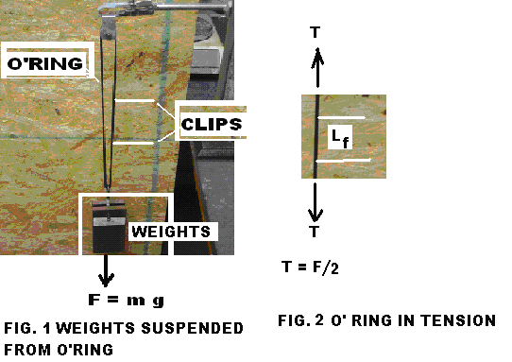

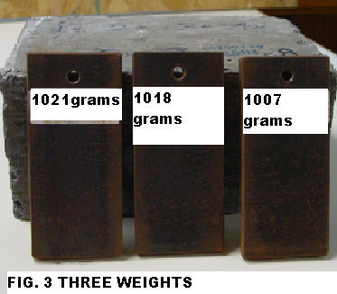

EXPERIMENTAL DESCRIPTION

1. Fig. 1 shows weights suspended from O Ring.

2. The suspended weights cause stretching or the lengthening of the O-Ring . The Weight or the vertical force , F = m g , is balanced by tension = 2T in the both parts of the O-Ring

3. There are three weights ( masses ) of magnitudes shown in Fig. 3.

4 Start without any of the masses suspended and attach Two clips to the O-Ring as shown in Fig. 1.

5. Measure the length between the clips using a Vernier Caliper ( mm ) , and the diameter of the O- Ring ( mm ) using a micrometer

6 Add masses one at a time and correspondingly - measure the length between the clips and diameter of the O-Ring and enter the data in the table below.

Number | Masses Added  ( g ) | Total Mass  ( g ) | Distance Between Clips  ( mm ) | Diameter of O-Ring  ( mm )
1 | 0 | 53 (Mass of the Assembly )
2 | 1007 | 1060
3 | 1018
4 | 1021
5 | -1021
6 | -1018
7 | -1007

Resolution of the Mass = 1 gram.

- Enter Your data ( ONLY IN THE SHADED AREA ) in the Computer Software. Your data should be different from those already in the computer . There are two worksheets in this software. The first one is ‘ data ‘ and the second one is called ‘ calculation ‘.

8 Pl be careful to enter your the uncertainty values in the second ( calculation ) worksheet

Data Worksheet

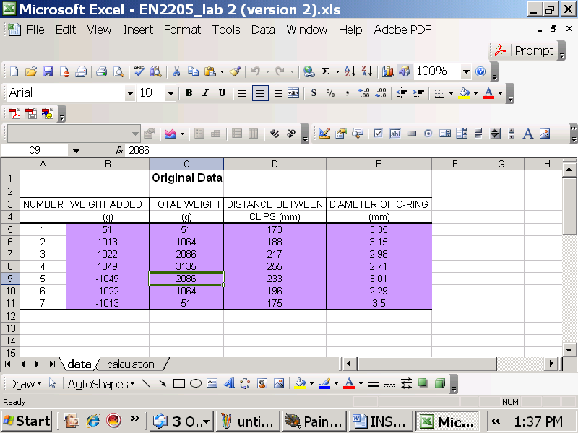

Calculation Worksheet

Uncertainty of the Measurement tool for Diameter | 0.002 | (mm)
Uncertainty of the Measurement tool for Length | 1 | (mm)
Uncertainty of the Measurement tool for Length | 0.0098 | (N)

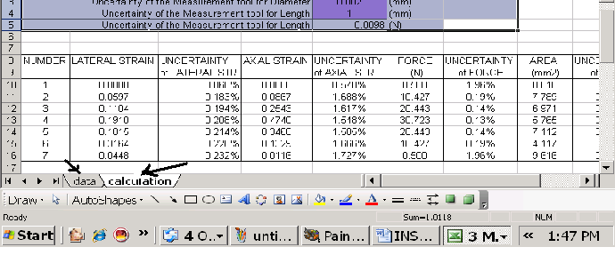

- Carry out one set of sample calculations

- Report on ( a ) Modulus of Elasticity, E, ( b ) Poisson’s Ratio ν, using the plotted graphs and ( c ) Uncertainties associated with each of the two ( E, and ν )

- Report Conclusions

