CHAPTER 3

***THE STRUCTURE OF CRYSTALLINE SOLIDS***

**ASSIGNMENT 2 > 3-5 , 3-18 , 3-32 , AND 3-51**

3.5 *Show that the atomic packing factor for BCC is 0.68.*

3.18 *Zinc has an HCP crystal structure, a c/a ratio of 1.856, and a density of 7.13 g/cm3. Compute the atomic radius for Zn.*

3.32 *Determine the indices for the directions shown in the following cubic unit cell:*

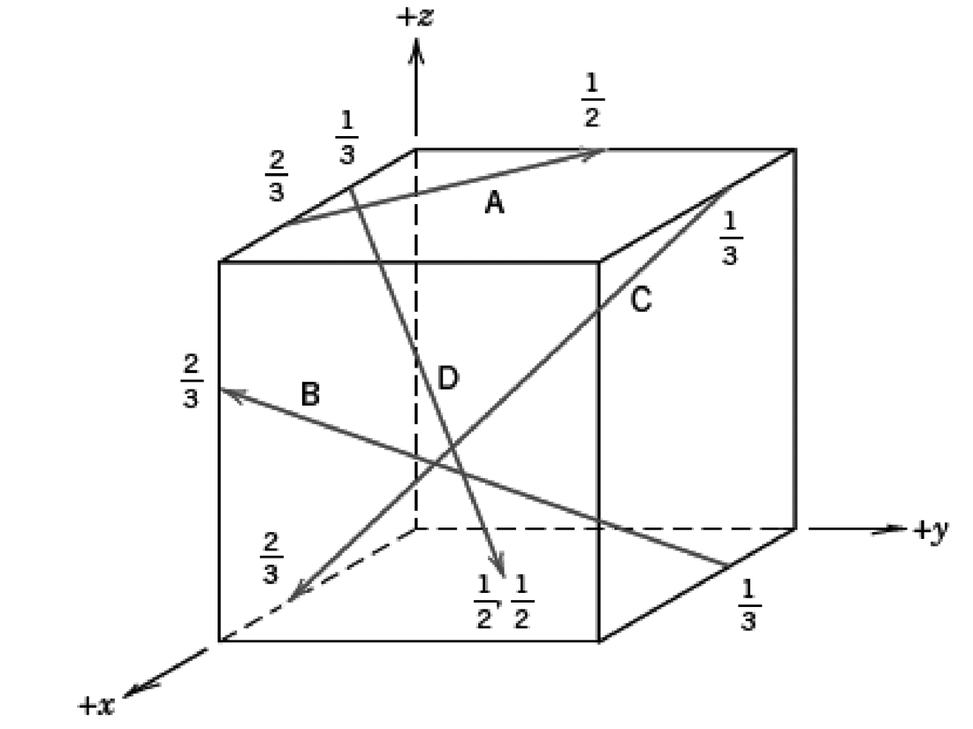

3.55 *(a)**Derive planar density expressions for BCC* (*100*) *and* (*110*) *planes in terms of the atomic radius R.*

*(b)**Compute and compare planar density values for these same two planes for vanadium.*

3.51 *Sketch the  and  planes in a hexagonal unit cell.*