4.32 (a) Using the intercept method, determine the average grain size, in millimeters, of the specimen whose microstructure is shown in Figure 4.14(b); use at least seven straight-line segments.
(b) Estimate the ASTM grain size number for this material.

Solution
(a) Below is shown the photomicrograph of Figure 4.14(b), on which seven straight line segments, each of which is 60 mm long has been constructed; these lines are labeled “1” through “7”.

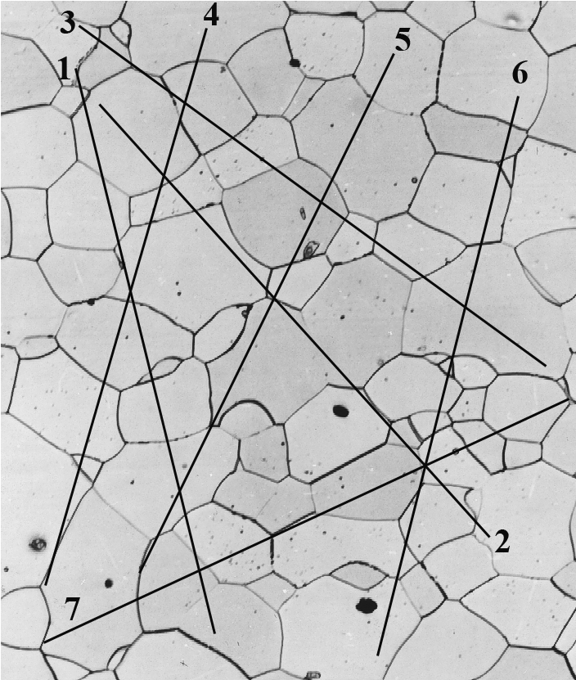

In order to determine the average grain diameter, it is necessary to count the number of grains intersected by each of these line segments. These data are tabulated below.

Line Number No. Grains Intersected
1 11
2 10
3 9
4 8.5
5 7
6 10
7 8

The average number of grain boundary intersections for these lines was 9.1. Therefore, the average line length intersected is just

$$\frac{\text{60}\text{mm}}{9\text{.}1}\text{= 6}\text{.}\text{59 mm}$$

Hence, the average grain diameter, d, is

$$d\text{ = }\frac{\text{ave}\text{.}\text{line}\text{length}\text{intersected}}{\text{magnification}}\text{ = }\frac{6\text{.}\text{59}\text{mm}}{\text{100}}\text{= 6}\text{.}\text{59 }´{\text{ 10}}^{−2}\text{ mm}$$

(b) This portion of the problem calls for us to estimate the ASTM grain size number for this same material. The average grain size number, n, is related to the number of grains per square inch, N, at a magnification of 100× according to Equation 4.16. In as much as the magnification is 100×, the value of N is measured directly from the micrograph. The photomicrograph on which has been constructed a square 1 in. on a side is shown below.

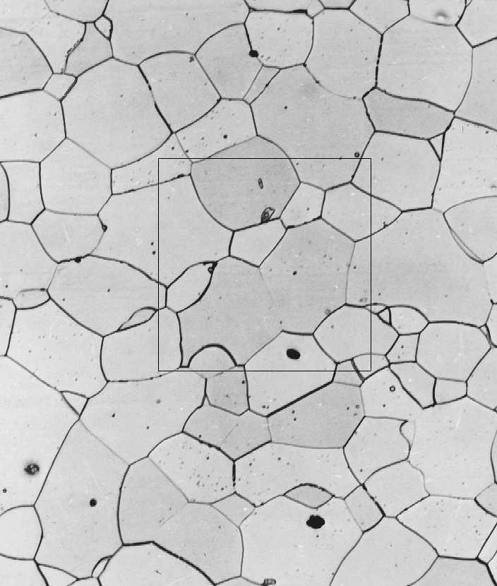

The total number of complete grains within this square is approximately 10 (taking into account grain fractions). Now, in order to solve for n in Equation 4.16, it is first necessary to take logarithms as
N= 2^{n -1 (Equation) 4.16}

N = Number of grains per sq inch at 100 magnification
N = ASTM Grain Size Number

$$\text{log}N=(n−1)\text{log}2$$

From which n equals

$$n=\frac{\text{log}N}{\text{log}2}+1$$

$$=\frac{\text{log}\text{10}}{\text{log}2}+1=4\text{.}3$$

