CLASS PROBLEM 10.24

10.24 Figure 10.40 shows the continuous cooling transformation diagram for a 1.13 wt% C iron-carbon alloy. Make a copy of this figure and then sketch and label continuous cooling curves to yield the following microstructures:
(a) Fine pearlite and proeutectoid cementite
(b) Martensite
(c) Martensite and proeutectoid cementite
(d) Coarse pearlite and proeutectoid cementite
(e) Martensite, fine pearlite, and proeutectoid cementite

Solution
Below is shown a continuous cooling transformation diagram for a 1.13 wt% C iron-carbon alloy, with continuous cooling paths that will produce (a) fine pearlite and proeutectoid cementite; (b) martensite; (c) martensite and proeutectoid cementite; (d) coarse pearlite and proeutectoid cementite; and (e) martensite, fine pearlite, and proeutectoid cementite.

(a) Fine pearlite and proeutectoid cementite
(b) Martensite
(c) Martensite and proeutectoid cementite
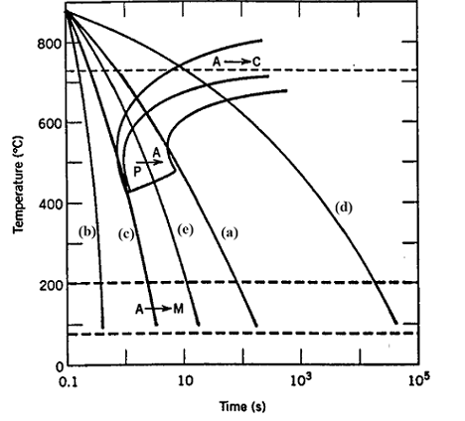
(d) Coarse pearlite and proeutectoid cementite
(e) Martensite, fine pearlite, and proeutectoid cementite

