CLASS_SOLUTION_CH8
8.14 A fatigue test was conducted in which the mean stress was 50 MPa (7250 psi) and the stress amplitude was 225 MPa (32,625 psi).
(a) Compute the maximum and minimum stress levels.
(b) Compute the stress ratio.
(c) Compute the magnitude of the stress range.

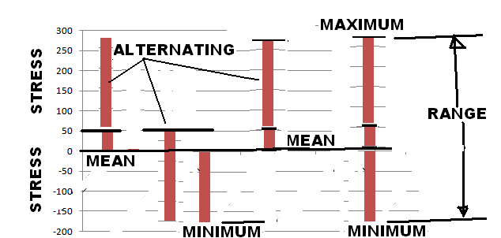

Solution
(a) Given the values of σm (50 MPa) and σa (225 MPa) we are asked to compute σmax and σmin. From Equation 8.14

$$s_{m}=\frac{s_{\text{max}}+s_{\text{min}}}{2}=\text{50}\text{ MPa}$$
Or,

σmax + σmin = 100 MPa

Furthermore, utilization of Equation 8.16 yields

$$s_{a}=\frac{s_{\text{max}}−s_{\text{min}}}{2}=\text{225}\text{ MPa}$$

Or,

σmax – σmin = 450 MPa

Simultaneously solving these two expressions leads to

$$s_{\text{max}}=\text{275}\text{ MPa }(\text{40,000 }\text{psi})$$
$$s_{\text{min}}=−\text{175}\text{ MPa }(−\text{25,500 }\text{psi})$$

(b) Using Equation 8.17 the stress ratio R is determined as follows:

$$R=\frac{s_{\text{min}}}{s_{\text{max}}}=\frac{−\text{175}\text{MPa}}{\text{275}\text{MPa}}=−0\text{.}\text{64}$$

(c) The magnitude of the stress range σr is determined using Equation 8.15 as

$$s_{r}=s_{\text{max}}−s_{\text{min}}=\text{275 }\text{MPa }−(−\text{175}\text{ MPa})=\text{450 }\text{MPa }(\text{65,500}\text{ psi})$$

