9.51 Consider 2.5 kg of austenite containing 0.65 wt% C, cooled to below 727°C (1341°F).
(a) What is the proeutectoid phase?
(b) How many kilograms each of total ferrite and cementite form?
(c) How many kilograms each of pearlite and the proeutectoid phase form?
(d) Schematically sketch and label the resulting microstructure.

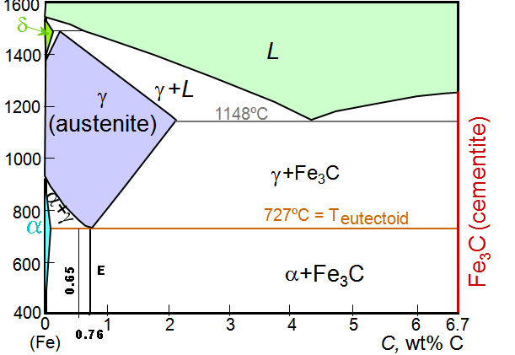
Solution
(a) Ferrite is the proeutectoid phase since 0.65 wt% C is less than 0.76 wt% C.
(b) For this portion of the problem, we are asked to determine how much total ferrite and cementite form. For ferrite, application of the appropriate lever rule expression yields
$$W_{α}=\frac{C_{{\text{Fe}}_{3}C}−C_{0}}{C_{{\text{Fe}}_{3}C}−C_{α}}=\frac{6\text{.}\text{70}−0\text{.}\text{65}}{6\text{.}\text{70}−0\text{.}\text{022}}=0\text{.}\text{91}$$
which corresponds to (0.91)(2.5 kg) = 2.27 kg of total ferrite.
Similarly, for total cementite,
$$W_{{\text{Fe}}_{3}C}=\frac{C_{0}−C_{α}}{C_{{\text{Fe}}_{3}C}−C_{α}}=\frac{0\text{.}\text{65}−0\text{.}\text{022}}{6\text{.}\text{70}−0\text{.}\text{022}}=0\text{.}\text{09}$$
Or (0.09)(2.5 kg) = 0.23 kg of total cementite form.
(c) Now consider the amounts of pearlite and proeutectoid ferrite. Using Equation 9.20
$$W_{p}=\frac{C_{0}^{{}_{'}}}{0\text{.}\text{74}}=\frac{0\text{.}\text{65}−0\text{.}\text{022}}{0\text{.}\text{74}}=0\text{.}\text{85}$$
This corresponds to (0.85)(2.5 kg) = 2.12 kg of pearlite.
Also, from Equation 9.21,
$$W_{α'}=\frac{0\text{.}\text{76}−0\text{.}\text{65}}{0\text{.}\text{74}}=0\text{.}\text{15}$$
Or, there are (0.15)(2.5 kg) = 0.38 kg of proeutectoid ferrite.

(d) Schematically, the microstructure would appear as:

