3. Ordinary Differential Equations

Equations involving only one independent variable and one or more dependent variables, together with their derivatives with respect to the independent variable, are ordinary differential equations (ODEs). Similar equations involving derivatives and more than one independent variable are partial differential equations (to be studied in a later term).

3.1 Classification; Separation of Variables

Example 3.1.1
Unconstrained population growth can be modelled by

(current rate of increase) is proportional to (current population level).

With x(t) = number in the population at time t,

This is a first order, first degree ODE that is both linear and separable.

The order of an ODE is that of the highest order derivative present.
The degree of an ODE is the exponent of the highest order derivative present.
An ODE is linear if each derivative that appears is raised to the power 1 and is not multiplied by any other derivative (but possibly by a function of the independent variable), that is, if the ODE is of the form
A first order ODE is separable if it can be re-written in the form
f (y) dy = g(x) dx
The solution of a separable first order ODE follows from
Solution of Example 3.1.1:
Example 3.1.1 (continued)

Example 3.1.2

One of the simplest constrained growth (or predator-prey) models assumes that the rate of increase in x, (the population as a fraction of the maximum population), is directly proportional to both the current population and the current level of resources (or room to grow). In turn, the level of resources is assumed to be complementary to the population:
resources α 1 − x.

This leads to the constrained population growth model

Classification of this ODE:
Example 3.1.2 (continued)

In this course, the only first order ODEs to be considered will have the general form

M(x, y) dx + N(x, y) dy = 0

with the following classification:

Type | Feature
Separable | M(x, y) = f (x) g(y)  and  N(x, y) = h(x) k(y)
Reducible to separable | M(tx, ty) = t^{n} M(x, y)  and  N(tx, ty) = t^{n} N(x, y)  for the same n
Exact
Linear | M/N = P(x)y − R(x)  or  N/M = Q(y)x − S(y)
Bernoulli | M/N = P(x)y − R(x)y^{n}  or  N/M = Q(y)x − S(y)x^{n}
[Only the separable, exact and linear types will be examinable.]

Example 3.1.3 Terminal Speed

A particle falls under gravity from rest through a viscous medium such that the drag force is proportional to the square of the speed. Find the speed v(t) at any time t > 0 and find the terminal speed v∞.
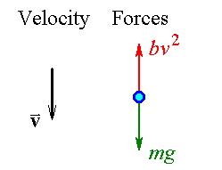

Example 3.1.3 (continued)

Example 3.1.3 (continued)

3.2 Exact First Order ODEs

Method:

The solution to the first order ordinary differential equation

M(x, y) dx + N(x, y) dy = 0

can be written in the implicit form

u(x, y) = c , (where c is a constant)
.

If M(x, y) and N(x, y) can be written as the first partial derivatives of some function u with respect to x and y respectively, then Clairaut’s theorem,
leads to the test for an exact ODE:

from which either
(and use u_{y} = N to find the arbitrary function of integration f (y) )

or
.
(and use u_{x} = M to find the arbitrary function of integration g(x) )

Note that these anti-derivatives are partial:
In , treat y as though it were constant during the integration.

In , treat x as though it were constant during the integration.

After suitable rearrangement, a separable first order ODE is also exact,
(but not all exact ODEs are separable).
Example 3.2.1
Find the general solution of .

Example 3.2.1 (alternative method)
Find the general solution of .

Rewrite as

The test for an exact ODE is positive:

Example 3.2.2

A separable first order ODE is also exact (after suitable rearrangement).

f (x) g(y) dx + h(x) k(y) dy = 0

However, the converse is false: an exact first order ODE is not necessarily separable.

Example 3.2.3

Find the equation of the curve that passes through the point (1, 2) and whose slope at any point (x, y) is 2y / x .

Solution by the method of separation of variables:

Solution starting with the recognition of an exact ODE:

Example 3.2.3 (continued)

In general, if an exact ODE is seen to be separable, (or separable after suitable rearrangement), then a solution using the method of separation of variables is usually much faster.
Some Practice Questions

Example 3.2.4

Find the complete solution of
3x²y⁴ dx + 4x³y³ dy = 0 , y = 2 when x = ½.

Example 3.2.5

Solve
(2xy + 2x) dx + (x² + 1) dy = 0

Example 3.2.6

Solve

3.3 Integrating Factor

Before introducing the general method, let us examine a specific example.

Example 3.3.1

Convert the first order ordinary differential equation

2y dx + x dy = 0

into exact form and solve it, (without direct use of the method of separation of variables).
[Note, this ODE is different from Example 3.2.3.]

The ODE is separable and we can therefore rearrange it quickly into an exact form:

However, let us seek a more systematic way of converting a non-exact form into an exact form.

Let I(x, y) be an integrating factor, such that {(the ODE) × I(x, y)} is exact:

Example 3.3.1 (continued)

Multiplying the original ODE by I (x), we obtain the exact ODE (different from the separable-and-exact form)

2y Ax dx + A x² dy = 0

A is an arbitrary constant of integration. Any non-zero choice for A allows us to divide the new ODE by that choice, to leave us with the equivalent exact ODE

2xy dx + x² dy = 0

Therefore, upon integrating to find the integrating factor I (x), we can safely ignore the arbitrary constant of integration.

If we notice that
and
then we can immediately conclude that

u = x²y = c

so that the general solution of the original ODE is
Example 3.3.1 (continued)

If we fail to spot the form for the potential function u, then we are faced with one of the two longer methods:

Either

But N = x² ⇒ f '(y) = 0 ⇒ f (y) = c₁

⇒ u = x²y + c₁ = c₂ ⇒ x²y = A

or

But M = 2xy ⇒ g'(x) = 0 ⇒ g(x) = c₁

⇒ u = x²y + c₁ = c₂ ⇒ x²y = A

The functional form for the integrating factor for an ODE is not unique.
In example 3.3.1, I(x, y) = Ax^{2n+1}y^{n} is also an integrating factor, for any value of n and for any non-zero value of A.

Proof:
ODE 2y dx + x dy = 0 becomes
Example 3.3.1 (continued)

One can show that the corresponding potential function is
both of which lead to

Checking our solution:

Integrating Factor – General Method:

Occasionally it is possible to transform a non-exact first order ODE into exact form.
Suppose that
P dx + Q dy = 0
is not exact, but that
IP dx + IQ dy = 0
is exact, where I (x, y) is an integrating factor.

Then, using the product rule,

and

From the exactness condition

If we assume that the integrating factor is a function of x alone, then

This assumption is valid only if is a function of x only.

If so, then the integrating factor is

[Note that the arbitrary constant of integration can be omitted safely.] Then

If we assume that the integrating factor is a function of y alone, then
This assumption is valid only if a function of y only.

If so, then the integrating factor is and

Example 3.3.2

Solve the first order ordinary differential equation

Example 3.3.2 (continued)

Example 3.3.3

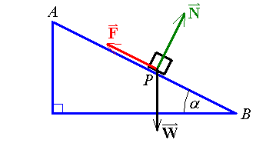
A block is sliding down a slope of angle α, as shown, under the influence of its weight, the normal reaction force and the dynamic friction (which consists of two components, a surface term that is proportional to the normal reaction force and an air resistance term that is proportional to the speed). The block starts sliding from rest at A. Find the distance s(t) travelled down the slope after any time t (until the block reaches B).

AP = s(t)

AB = L

Friction = surface + air

Starts at rest from A ⇒

Forces down-slope:

Separation of variables method:

Example 3.3.3 (continued)

OR

Integrating factor method:

Example 3.3.3 (continued)

Example 3.3.3 (continued)

The terminal speed v∞ is

The object will not begin to move unless

For a 10 kg block sliding down a slope of angle 30°, with , with
g ≈ 9.81 ms⁻², the terminal speed is just over 24.51 ms⁻¹ and the graphs of speed and position are

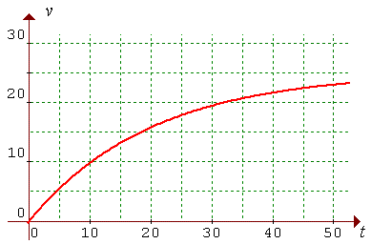
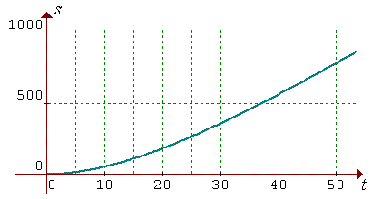

Example 3.3.4

Find the solution of
x + y + y' = 0
that passes through the origin.

3.4 First Order Linear ODEs

The general form of a first order linear ordinary differential equation is
[or, in some cases,
]

Rearranging the first ODE into standard form,

(P(x) y − R(x)) dx + 1 dy = 0

Written in the standard exact form with an integrating factor in place, the first equation becomes
I (x) (P(x) y − R(x)) dx + I (x) dy = 0

Compare this with the exact ODE
du = M(x, y) dx + N(x, y) dy = 0

The exactness condition

and the integrating factor is
.
The ODE becomes the exact form
e^{h} (Py − R) dx + e^{h} dy = 0

Therefore the general solution of is

A note on the arbitrary constant of integration in :

then

Therefore we may set the arbitrary constant in to any value we wish, including zero, without affecting the general solution of the ODE at all.
Example 3.4.1

Solve
y' + 2y = 6e^{x}

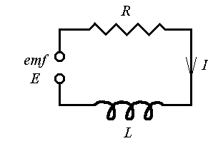
Example 3.4.2 : Find the current I (t) flowing through this simple RL circuit at any time t.

The electromotive force is sinusoidal:

E(t) = E_{o}sin ωt

The voltage drop across the resistor is

The voltage drop across the inductor is

Therefore the ODE to be solved is

The integrating factor is therefore e^{h} =

A two-step integration by parts and some algebraic simplification lead to
Details:

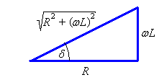
Introducing the phase angle δ , such that ωL = R tan δ , leads to
and
Also
sin ωt cos δ − cos ωt sin δ ≡ sin(ωt − δ)
Therefore

The general solution
then becomes
For most realistic circuits, the current reaches 99% of its steady state value in just a few microseconds.
Example 3.4.3

Find the general solution of the ODE

y' − y = sinh x

⇒ Integrating factor is e^{h} =

Therefore

Example 3.4.4

Solve the ODE

OR

Example 3.4.4 Alternative Method:

Review for the solution of first order first degree ODEs:

P dx + Q dy = 0

1. Is the ODE separable? If so, use separation of variables. If not, then

2. Can the ODE be re-written in the form y' + P(x) y = R(x) ?
If so, it is linear.
Else

3. Is P_{y} = Q_{x} ? If so, then the ODE is exact.
Seek u such that .
The solution is u = c.
Else

4. Is a function of x only?
If so, the integrating factor is
Then solve the exact ODE I P dx + I Q dy = 0 .
Else,

5. Is a function of y only?
If so, the integrating factor is
Then solve the exact ODE I P dx + I Q dy = 0 .

A first order ODE that does not fall into one of the five classes above is beyond the scope of this course.

3.5 Reduction of Order

Occasionally a second order ordinary differential equation can be reduced to a pair of first order ordinary differential equations.
If the ODE is of the form
f (y", y', x) = 0
(that is, no y term), then the ODE becomes the pair of linked first order ODEs
f (p', p, x) = 0 , p = y'
If the ODE is of the form
g (y", y', y) = 0
(that is, no x term), then the ODE becomes the pair of linked first order ODEs
where the chain rule ⇒

Example 3.5.1

Find the general solution of the second order ordinary differential equation

x y" + 2y' = 4x³

Example 3.5.1 (continued)

Note that the number of arbitrary constants of integration in the general solution matches the order of the ordinary differential equation.

Example 3.5.2
.
This second order ODE can be solved by either of the two methods of reduction of order.

Method 1: The ODE becomes

Example 3.5.2 (continued)

Method 2: The ODE becomes

Example 3.5.3

Solve
y" = 2 y y'

We need to quote some standard integrals:

and
Example 3.5.3 (continued)

3.6 Applications
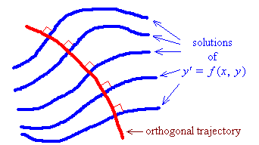
Orthogonal trajectories

A family of curves in ² can be represented by the ODE

Any curve, whose intersection with any member of that family occurs at right angles, must satisfy the ODE

.

Another family of curves, all of which intersect each member of the first family only at right angles, must also satisfy the ODE

.

Example 3.6.1

Find the orthogonal trajectories to the family of curves

xy = c

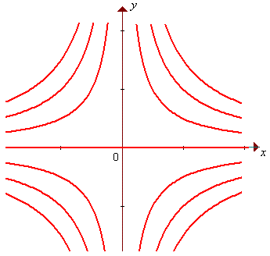

Example 3.6.2

Find the orthogonal trajectories to the equipotentials of the electric field,
where .

Lines of force and equipotential curves are examples of orthogonal trajectories. Taking the inverse case to Example 3.6.2, for a central force law, the lines of force are radial lines y = k x. All of these lines satisfy the ODE . The equipotential curves must then be solutions of the ODE
The general solution can be re-written as x² + y² = r² , which is clearly the equations of a family of concentric circles.
Other Applications

Newton’s Law of Cooling

If t = time, Θ(t) = temperature and Θ_{f} = ambient [surrounding] temperature, then the rate at which the temperature of an object decreases, when it is immersed in some other substance whose steady temperature is Θ_{f} , is proportional to the temperature difference:

Example 3.6.3

An object is removed from boiling water (at 100°C) and is left in air at room temperature (20°C). After ten minutes, its temperature has fallen to 60°C. Find its temperature Θ(t).

Example 3.6.4

A right circular cylindrical tank is oriented with its axis of symmetry vertical. Its circular cross-sections have an area A (m²). Water enters the tank at the rate Q (m³s⁻¹). Water leaves through a hole, of area a , in the base of the tank. The initial height of the water is h_{o}. Find the height h(t) and the steady-state height h∞.

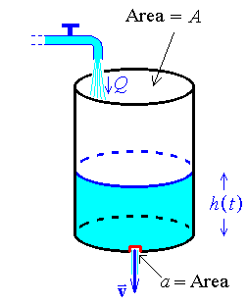
Torricelli:

Change of volume:

Example 3.6.4 (continued)

Also see other examples in problem sets and in past tests and examinations.

END OF CHAPTER 3

