5.01 Transforms

In some situations, a difficult problem can be transformed into an easier problem, whose solution can be transformed back into the solution of the original problem. For example, an integrating factor can sometimes be found to transform a non-exact first order first degree ordinary differential equation into an exact ODE:
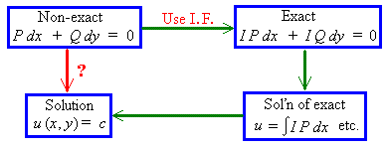

One type of first order ODE [not considered in this semester] is the Bernoulli ODE,
y' + P y = R y ^{u} , which, upon a transformation of the dependent variable, becomes a linear ODE:
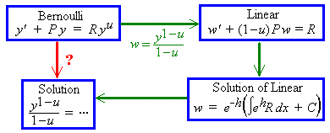

An initial value problem is an ordinary differential equation together with sufficient initial conditions to determine all of the arbitrary constants of integration. A Laplace transform will convert an initial value problem into a much easier algebra problem. The solution of the original problem is then the inverse Laplace transform of the solution to the algebra problem.
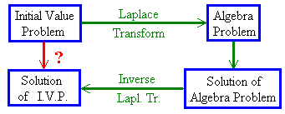
Uses of Laplace transforms include:
1) the solution of some ordinary differential equations
2) the solution of some integro-differential equations, such as
.
5.02 Some Laplace Transforms

If f (t) is
- defined on t > 0,
- piece-wise continuous on t > 0
(that is, only a finite number of finite discontinuities) and
- of exponential order
[ | f (t) | < k e^{αt} for all t > 0 and for some positive constants k and α ],
then
exists and
the Laplace transform of f (t) is

Example 5.2.1

Find L{ 1 } .

Example 5.2.2

Find L{ t } .

Linearity Property of Laplace Transforms

L { a f (t) + b g(t) } (where a, b are constants):

=
Example 5.2.3

Find L { 2t − 3 } .

Example 5.2.4

Find L { t^{n} } .
Example 5.2.5

Find L { t ⁴ + 2t ³ − 3 } .

5.03 Laplace Transforms of Derivatives

Continuing this pattern, we can deduce the Laplace transform for any higher derivative of f (t):

or

This result allows us to find the Laplace transform of an entire initial value problem.
Example 5.3.1

Find the Laplace transform of the initial value problem

y" + y = t , y(0) = 1 , y'(0) = 0

and hence find the complete solution.

Let Y(s) = L{ y(t) }, then

L{ y" + y } =

Therefore the Laplace transform of the initial value problem is

which is an algebra problem for Y(s), (the Laplace transform of the complete solution).
Solving the algebra problem:

In section 5.04 we shall see how to find the inverse Laplace transforms
The complete solution to the initial value problem is therefore

5.04 First Shifting Theorem;
Transforms of Exponential, Cosine and Sine Functions

The first shifting theorem then follows:

Example 5.4.1

Find L {t ³e ^{5t} } .

Example 5.4.2

Find L { e ^{at} } .

Example 5.4.3

Find L { cos ωt } .

Example 5.4.4

Find L { sin ωt } .

It then follows that
and
Example 5.4.5

Find L { sin ωt } directly, from the definition of a Laplace transform.

Example 5.4.6

Find L { sin ωt } , using L { cos ωt }.

Example 5.4.7

Find L { e^{at} sin ωt } .

Using the first shift theorem, we have, immediately,

Similarly,

Example 5.4.8

Find L { tan ωt } .

Example 5.4.9

Find L { sinh at } .

Similarly,
Summary so far:

Definition:

Linearity:

Polynomial functions:

First Shift Theorem:
and

Trigonometric Functions:

Hyperbolic Functions:

Derivatives:
etc.

When trying to find the inverse Laplace transform of a rational function F (s), one usually attempts to break the function up into its partial fractions, with real linear and quadratic denominators, so that one may read the inverses from the table on this page.

5.05 Applications to Initial Value Problems

Example 5.5.1

Solve the initial value problem

y" − 5y' + 6y = 0 , y(0) = 1, y'(0) = 0

Let Y(s) = L{ y(t) } .

L{ y" } =

L{ y' } =

Taking the Laplace transform of the entire initial value problem:

L{ y" − 5y' + 6y } = L{ 0 } ⇒

Check 1:

Example 5.5.1 (continued)

Check 2:

Solution by Chapter 4 method:

y" − 5y' + 6y = 0

Example 5.5.2

Solve the initial value problem

y" + 4y' + 13y = 26 e^{−4t} , y(0) = 5, y'(0) = −29

Let Y(s) = L{ y(t) } .

L{ y" } =

L{ y' } =

Taking the Laplace transform of the entire initial value problem:

Recall the three standard inverse Laplace transforms:

Example 5.5.2 (continued)

We need to express Y(s) in partial fractions and to complete the square in the quadratic denominator.

Example 5.5.2 (by a Chapter 4 method)

y" + 4y' + 13y = 26 e^{−4t} , y(0) = 5, y'(0) = −29

5.06 Laplace Transform of an Integral

f (0) =

Example 5.6.1

Find the function f (t) whose Laplace transform is .

Example 5.6.1 (Alternative solution, using partial fractions)

Example 5.6.2

Find the function f (t) whose Laplace transform is .

Alternative method, using partial fractions:

5.07 Heaviside Function; Second Shift Theorem

The Heaviside function H(t − a) (also known as the unit step function u(t − a) ) is defined by
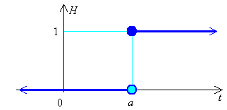

The Laplace transform of the Heaviside function is:

If
then
[The function h(t) is “switched on” and g(t) is “switched off” at time t = a.]
Example 5.7.1 (This is part of a question on Problem Set 9)

Express the function
in a single line definition.

Answer: f (x) = 2x + (4 − 2x) H(x − 2)

The Second Shift Theorem

The result of shifting the graph y = f (t) (defined only for t > 0) a units to the right, is the graph y = f (t − a) H(t − a):

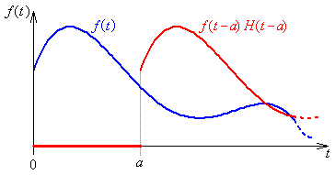

The Laplace transform of the shifted function of t is:

The second shift theorem (for a > 0) is

Another way to express the second shift theorem is:

Example 5.7.2

Find L{ H(t − 4) (t − 4)³ } .

L{ H(t − 4) (t − 4)³ } =

Example 5.7.3

Find the function whose Laplace transform is .

Example 5.7.4

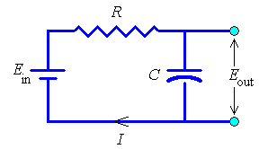
In the RC circuit shown here, there is no charge on the capacitor and no current flowing at the time t = 0.

The input voltage E_{in} is a constant E_{o} during the time t₁ < t < t₂ and is zero at all other times.

Find the output voltage E_{out} for this circuit.

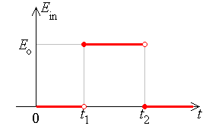
Initial conditions:
q(0) = i(0) = 0

⇒ E_{in} =

Equating voltage drops around the circuit with E_{in} :

Let Q(s) = L{ q(t) }. Taking the Laplace transform of this initial value problem:

Example 5.7.4 (continued)

Graph of the output voltage against time:
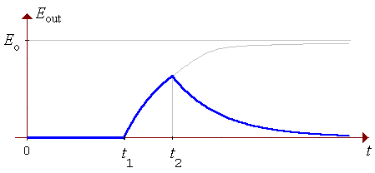

Example 5.7.5

Find the complete solution of the initial value problem

Let Y(s) = L{ y(t) }

Example 5.7.5 (continued)

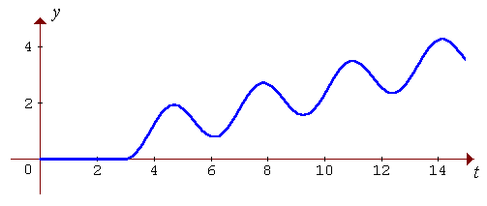
5.08 The Dirac Delta Function
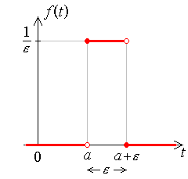

Also

Define the Dirac delta function to be
then

Therefore (for a > 0)

and

Also, for a > 0, the total area under the graph is 1 (even in the limit as ε → 0⁺), so

For g(t) = any function that is continuous everywhere on [0, ∞),

(which is the sifting property of the Dirac delta function).

Example 5.8.1

A damped mass-spring system, (with damping constant = c = 3m and spring modulus = k = 2m, where m is the mass), is at rest in its equilibrium position, until an impulse of 1 Ns is applied at time t = 1 s. Find the response y(t).

One can anticipate some features of the response. The forcing function is zero until t = 1. Thus there is nothing to disturb the system until that instant. We can deduce that y(t) ≡ 0 during t < 1. The mass-spring system is set into motion abruptly by the arrival of the impulse at the instant t = 1, but the forcing term is again zero thereafter. The damping force will asymptotically restore the system to its equilibrium state. The only question remaining is whether the system is under-damped or not (see the diagram on the next page).

Example 5.8.1 (continued)

Anticipated response:

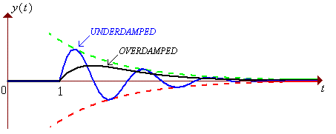

The auxiliary equation is λ ² + 3λ + 2 = 0. The discriminant is

Solution, using Laplace transforms:

y" + 3y' + 2y = δ (t − 1)

y'(0) = y(0) = 0

Let Y(s) = L{ y(t) }

Example 5.8.1 (continued)

From the first shift theorem:

The second shift theorem states:

Therefore

or, equivalently,

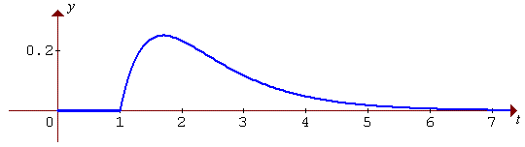

5.09 Periodic Functions

If the constant p > 0 and f (t + p) = f (t) for all t > 0, then
f (t) is a periodic function of t, with period p.

Example of a periodic function (with one finite discontinuity in each period):
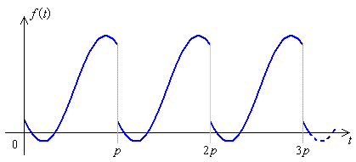

Define a new set of functions g_{n}(t), each of which captures only a single period of f (t):
Then
Let F(s) = L{ f (t) } , then

Therefore, for a periodic function f (t) with fundamental period p,

Example 5.9.1

Use the formula above to verify the Laplace transform of f (t) = sin ωt .

Example 5.9.2 The Square Wave

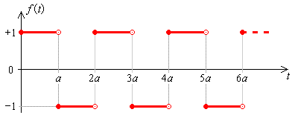

The square wave is periodic, with fundamental period p = 2a .

In the “zeroth” period (0 < t < 2a),
The Laplace transform F(s) of the square wave f (t) then follows.

Example 5.9.3 The Saw-tooth Wave

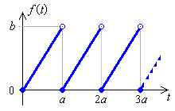
The saw-tooth wave is periodic, with fundamental period p = a .

In the “zeroth” period (0 < t < a),
The Laplace transform F(s) of the saw-tooth wave f (t) then follows.

Example 5.9.4

Find the function f (t) whose Laplace transform is
(where a is a constant).

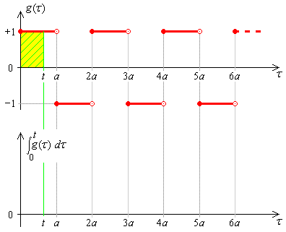

5.10 The Derivative of a Laplace Transform

Example 5.10.1

Find F(s) = L { t cos ωt }.

Method via an ODE:

Let f (t) = t cos ωt

Then f '(t) =

and f "(t) =

Also f (0) = 0

f '(0) = 1 − 0 = 1

Taking the Laplace transform of this initial value problem,

Using Leibnitz differentiation of an integral [section 1.9]:
Therefore
⇒
Example 5.10.1 (again)

Find F(s) = L { t cos ωt }.

Method via the derivative of a transform:

Let g(t) = cos ωt

Example 5.10.2

Find F(s) = L { t sin ωt }.

5.11 Convolution

If L{ f (t) } = F(s)
and L{ g(t) } = G(s)
then the convolution of f (t) and g(t) is denoted by (f * g)(t), is defined by

and the Laplace transform of the convolution of two functions is the product of the separate Laplace transforms:

An equivalent identity is

Convolution is commutative:

Example 5.11.1

Find the inverse Laplace transform of

Example 5.11.1 (continued)

Note:

This inverse transform can also be found using partial fractions or the division of another Laplace transform by s. Both of these alternatives are in example 5.6.2.

Example 5.11.2

Find

The alternative methods that were available in example 5.11.1 are not available here. The only obvious way to proceed is via convolution.

Transfer Function

For a second order linear ordinary differential equation with constant coefficients, when both initial conditions are zero, the complete solution can be expressed as a convolution.

y" + by' + cy = r(t) and y(0) = y' (0) = 0

⇒ (s ² + bs + c) Y(s) = R(s)

⇒ Y(s) = Q(s) R(s) , where Q(s) is the transfer function:

The complete solution is just y(t) = q(t) * r(t) , where

Example 5.11.3

A unit impulse is delivered at time t = 1 to an harmonic system (with c/m = 4) that is in equilibrium until that instant. Find the response y(t).

Some More Identities involving Convolution

Integro-Differential Equations

Example 5.11.4

Find the solution y(t) of the integro-differential equation

Example 5.11.5

Solve the system of simultaneous integral equations

Taking the Laplace transform of the entire system of integral equations,

Example 5.11.5 (continued)

These are the currents in the circuit
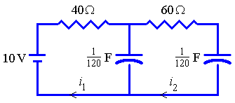
with initial conditions i₁(0) = 1/4, i₂(0) = 0.

END OF CHAPTER 5

