1.1 Equation of a Plane

A non-zero vector in ³ will fix the orientation of a plane, to be at right angles to .
Let P be a point that is known to be on the plane. Let the Cartesian coordinates of P be (x_{o}, y_{o}, z_{o}). Its position vector, , allows us to pick out exactly one plane from the infinite set of parallel planes that share the same orientation defined by the plane normal vector .
The two vectors, together, allow us to define a single plane completely.

Let be the position vector of a general point R, with Cartesian coordinates (x, y, z), in ³.
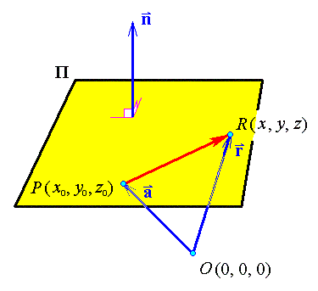

Note that the normal vector n is at right angles to any vector lying in the plane Π.
("perpendicular to")

OR

which is the vector equation of a plane.
Let , (so that A, B, C are the Cartesian components of the normal vector), then

The vector equation of the plane, , then leads to the
Cartesian equation of the plane:

Example 1.1.1

Find an equation for the plane through the point (3, −2, 4), which is normal to the vector

Therefore the Cartesian equation of the required plane is

Example 1.1.2

Find a unit vector orthogonal to the plane
x − 2y + 2z = 7

From the Cartesian equation of a plane, one may read off the Cartesian coordinates of a vector that is at right angles to that plane.

Therefore a unit normal is

[Note that there is one other acceptable final answer, namely the unit vector that points in the opposite direction, .]

Equations of a Line

A line L is determined uniquely by two vectors, a line direction vector, v, which orients the line in ³, and the position vector, a, of a point P known to be on that line.

Let R be a general point, with Cartesian coordinates (x, y, z), that is constrained to lie on the line L.
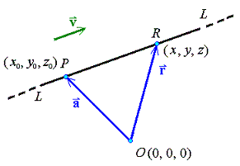

But the line L is parallel to the direction vector v.

for some value of t.

Therefore the parametric vector equation of the line is

[Note that there is one free parameter, t, which can be any real number. The number of free parameters (one) matches the dimension of the geometric object (the line is a one-dimensional object).]

The Cartesian equations of the line can be found from the vector parametric form.

Example 1.1.3

Find the Cartesian equations of the line that passes through the point (3, 1, 2) and that is parallel to the vector

The vector parametric form is

Making t the subject of all three simultaneous equations
x = 3 + t ,
y = 1 − 2t
and z = 2 + 3t ,

we obtain the Cartesian symmetric form for the equations of the line:

General case:

A line which passes through the point (x_{o}, y_{o}, z_{o}) and is parallel to the vector , (where v₁, v₂, v₃ are all non-zero) has a Cartesian symmetric form

If v₁ = 0, then separate out the equation x = x_{o}.
If v₂ = 0, then separate out the equation y = y_{o}.
If v₃ = 0, then separate out the equation z = z_{o}.

Example 1.1.4

Find the Cartesian equations of the line through (1, 1, −1) that is perpendicular to the plane 2x + 3z = 1.

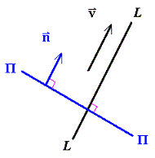

The normal vector n to the plane is at right angles to the plane Π .
The line L is also at right angles to the plane Π .
Therefore the line’s direction vector v must be parallel to n.

The vector parametric form is

Making t the subject of the equations where possible (for x and z ), the Cartesian symmetric form then follows:

More Equations of Lines and Planes

Three non-collinear points, A, B, C, define a plane.
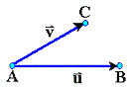

The three vectors joining the three points to each other lie in that plane. Any two of them may be used as the basis for a coordinate grid that can be laid out on the entire plane.
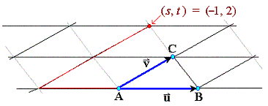

The vector parametric equation of the plane then follows:

where

The other vector equation for the plane can be recovered from this form:
Vectors and are both in the plane
is normal to the plane.
Let R be a general point in space, with Cartesian coordinates (x, y, z).
If and only if point R lies in the plane, then
Example 1.1.5

Find the Cartesian equation of the plane that passes through the points A(1, 0, 0),
B(2, 3, 4) and C(−1, 2, 1).

Let R be a general point in ³, with Cartesian coordinates (x, y, z). Then
For R to be on the plane,
⇒ (x − 1)(−5) + y(−9) + z(8) = 0
⇒ −5x − 9y + 8z = 5
or

Alternative solution (next page):

Alternative Solution to Example 1.1.5:

The plane Π is Ax + By + Cz + D = 0
This equation must be true at all three points on the plane.
An under-determined linear system of three equations for the four unknown coefficients then follows:
A B C D
(1, 0, 0) on Π: [ 1 0 0 1 | 0 ]
(2, 3, 4) on Π: [ 2 3 4 1 | 0 ]
(−1, 2, 1) on Π: [ −1 2 1 1 | 0 ]

Row reduction leads to the reduced row echelon form

[ 1 0 0 1 | 0 ]
[ 0 1 0 9/5 | 0 ]
[ 0 0 1 −8/5 | 0 ]

Select a convenient non-zero value for D that leaves all four coefficients as integers and makes at least two of A, B and C non-negative. Therefore select D = − 5:

Example 1.1.6

Find the angle between the line
and the plane .
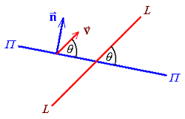

Therefore

Example 1.1.7

Find the intersection of the planes
Π ₁ : x − 2y + z = 1 and
Π ₂ : 3x − 5y + 2z = 4.

Solve the under-determined linear system

x y z
Π ₁ [ 1 −2 1 | 1 ]
Π ₂ [ 3 −5 2 | 4 ]

R₂ ← R₂ − 3 R₁ : [ 1 −2 1 | 1 ]
[ 0 1 −1 | 1 ]

R₁ ← R₁ + 2 R₂ : [ 1 0 −1 | 3 ]
[ 0 1 −1 | 1 ]

⇒ x = t + 3 ,
y = t + 1 ,
z = t , t  
Example 1.1.7 (continued)

The intersection is a LINE.
In vector parametric form, it is

r = a + t v , with a = 3, 1, 0 and v = 1, 1, 1 .

Summary for Lines and Planes:

 | Vector forms | Cartesian form
Line | a = point on line,  v = direction vector
Plane | ,  a = point on plane,  u, v = vectors in plane  OR  , where | Ax + By + Cz + D = 0 ,

1.3 Area, Arc Length, Tangents and Normals, Curvature

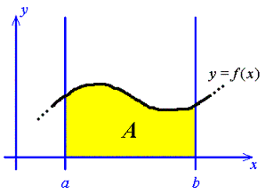
With parameterization:

where x(t_{a}) = a , x(t_{b}) = b , a < b and f (x) > 0 on [a, b].

Example 1.3.1

Find the area enclosed in the first quadrant by the circle x² + y² = 4.
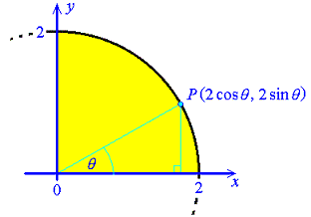
x = 2 cos θ , y = 2 sin θ .
Example 1.3.1 (continued)

Therefore

Check: The area is the interior of a quarter-circle.


Review of the Tangent:

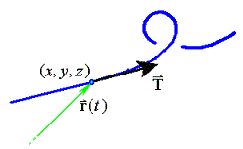

The unit tangent is

Arc Length
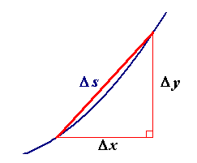
In ²:

In ³:

The vector points in the direction of the tangentto the curve defined parametrically by r = r(t).

Example 1.3.2

(a) Find the arc length along the curve defined by
, from the point where t = 0 to the point where t = 4π.
(b) Find the unit tangent .

(a)

Therefore

(b)
. Therefore

[Note that, in this example, | t | itself is the arc length from the point (0, 1/4, 0), (where t = 0). There are very few curves for which the parameterization is this convenient!]
Review of Normal and Binormal:

(Note: a unit vector can never be zero).

Select the principal normal to be the direction in which the unit tangent is, instantaneously, changing:

The unit principal normal then follows:

The binormal is at right angles to both tangent and principal normal:
Curvature:

The derivative of the unit tangent with respect to distance travelled along a curve is the principal normal vector, . Its direction is the unit principal normal . Its magnitude is a measure of how rapidly the curve is turning and is defined to be the curvature:

The radius of curvature is .
The radius of curvature at a point on the curve is the radius of the circle which best fits the curve at that point.

Example 1.3.2 (continued)

(c) Find the curvature κ(s) at any point for which s > 0, for the curve
where s is the arc length from the point (0, 1/4, 0).

From part (b):

Another formula for curvature:

Example 1.3.3

Find the curvature and the radius of curvature for the curve, given in parametric form by
x = cos t , y = sin t , z = t . Assume SI units.

Let c = cos t , s = sin t .

Therefore
and

1.4 Conic Sections

All members of the family of curves known as conic sections can be generated, (as the name implies), from the intersections of a plane and a double cone. The Cartesian equation of any conic section is a second order polynomial in x and y. The only cases that we shall consider in this course are such that any axis of symmetry is lined up along a coordinate axis. For all such cases, the Cartesian equation is of the form
A x² + C y² + D x + E y + F = 0
where A, C, D, E and F are constants. There is no “xy” term, so B = 0.

The slope of the intersecting plane is related to the eccentricity, e of the conic section.
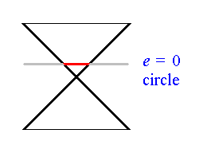
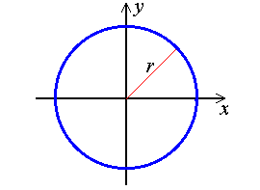

x² + y² = r²

A parametric form is
(x, y) = (r cos θ, r sin θ ), (0 < θ < 2π).
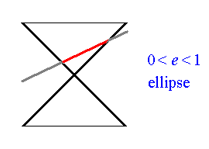
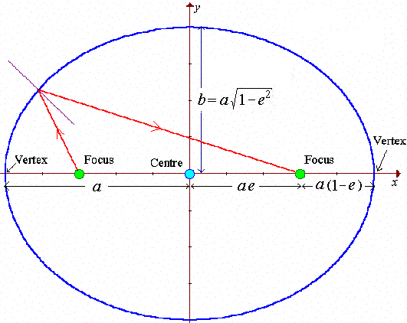

The circle is clearly a special case of the ellipse, with e = 0 and b = a = r.
The longest diameter is the major axis (2a). The shortest diameter is the minor axis (2b).
If a mirror is made in the shape of an ellipse, then all rays emerging from one focus will, after reflection, converge on the other focus.

A parameterization for the ellipse is .

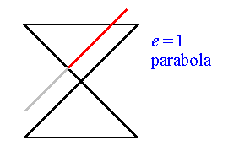
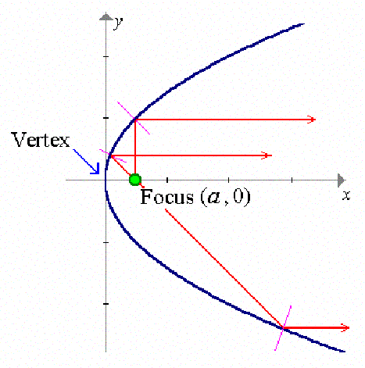

y² = 4ax

One vertex is at the origin.
The centre and the other vertex and focus are at infinity.

If a mirror is made in the shape of a parabola, then all rays emerging from the focus will, after reflection, travel in parallel straight lines to infinity (where the other focus is). The primary mirrors of most telescopes follow a paraboloid shape.

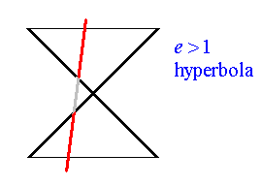
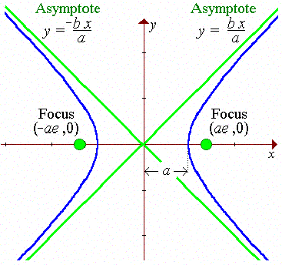

The hyperbola has two separate branches.
As the curve retreats towards infinity, the curve approaches the asymptotes
The distance between the two vertices is the major axis (2a).
If a mirror is made in the shape of an hyperbola, then all rays emerging from one focus will, after reflection, appear to be diverging from the other focus.

Circles and ellipses are closed curves. Parabolas and hyperbolas are open curves.
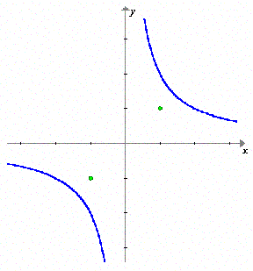
A special case of the hyperbola occurs when the eccentricity is and it is rotated 45 from the standard orientation. The asymptotes line up with the coordinate axes, the graph lies entirely in the first and third quadrants and the Cartesian equation is xy = k.

This is the rectangular hyperbola.

Degenerate conic sections arise when the intersecting plane passes through the apex of the cone. Two cases are:

point at the origin.

line pair through the origin.

Another degenerate case is
nothing !

Example 1.4.1

Classify the conic section whose Cartesian equation is 3y² = x² + 3 .

Rearranging into standard form,
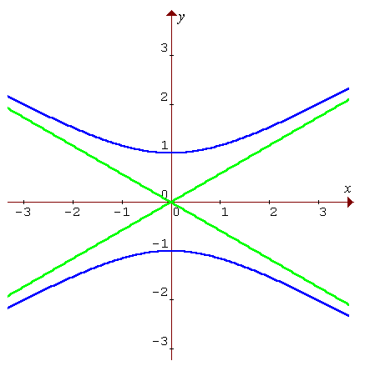
Compare with
Therefore this is an hyperbola,
rotated through 90°,
with vertices at (0, ±1) and
asymptotes

[The asymptotes make angles of 30° with the x axis.]

Example 1.4.2

Classify the conic section whose Cartesian equation is 21x² + 28y² = 168x + 168y .

Rearranging into standard form, first complete the square.
21x² + 28y² − 168x − 168y = 0
⇒ 21(x² − 8x) + 28(y² − 6y) = 0
⇒ 21((x − 4)² − 16) + 28((y − 3)² − 9) = 0
⇒ 21(x − 4)² + 28(y − 3)² = 588
Compare this with the standard form
The conic section is therefore an ellipse,
semi major axis , semi minor axis ,
(from which the eccentricity can be found to be exactly e = 1/2),
centre (4, 3).
It happens to pass exactly through the origin.
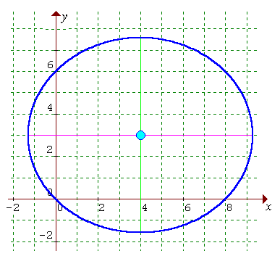

Moving up to three dimensions, we have the family of quadric surfaces.

1.5 Classification of Quadric Surfaces

Again, we shall consider only the simplest cases, where any planes of symmetry are located on the Cartesian coordinate planes. In nearly all cases, this eliminates “cross-product terms”, such as xy, from the Cartesian equation of a surface. Except for the paraboloids, the Cartesian equations involve only x², y², z² and constants.

The five main types of quadric surface are:

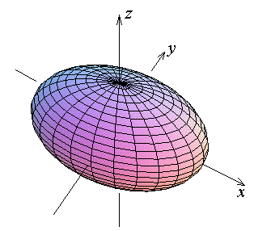
The ellipsoid (axis lengths a, b, c)

$\frac{x^{2}}{a^{2}} + \frac{y^{2}}{b^{2}} + \frac{z^{2}}{c^{2}} = 1$

The axis intercepts are at
(±a, 0, 0), (0, ±b, 0) and (0, 0, ±c).

All three coordinate planes are
planes of symmetry.

The cross-sections in the three
coordinate planes are all ellipses.

Special cases:
a = b > c : oblate spheroid (a “squashed sphere”)
a = b < c : prolate spheroid (a “stretched sphere” or cigar shape)
a = b = c : sphere

Hyperboloid of One Sheet (Ellipse axis lengths a , b ; aligned along the z axis)
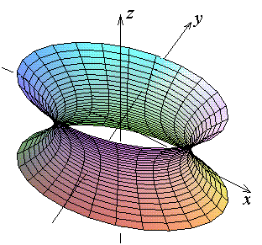
$\frac{x^{2}}{a^{2}} + \frac{y^{2}}{b^{2}} − \frac{z^{2}}{c^{2}} = 1$

For hyperboloids, the central axis is
associated with the “odd sign out”.

In the case illustrated, the hyperboloid is aligned along the z axis.

The axis intercepts are at
(±a, 0, 0) and (0, ±b, 0).
The vertical cross sections in the x-z and y-z planes are hyperbolae.
All horizontal cross sections are ellipses.

Hyperboloid of Two Sheets (Ellipse axis lengths b , c ; aligned along the x axis)
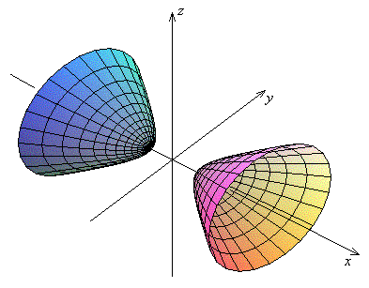
$\frac{x^{2}}{a^{2}} − \frac{y^{2}}{b^{2}} − \frac{z^{2}}{c^{2}} = 1$

For hyperboloids, the central axis is associated with the “odd sign out”.

In the case illustrated, the hyperboloid is aligned along the x axis.

The axis intercepts are at
(±a, 0, 0) only.

Vertical cross sections parallel to the y-z plane are either ellipses or null.

All cross sections containing the x axis are hyperbolae.

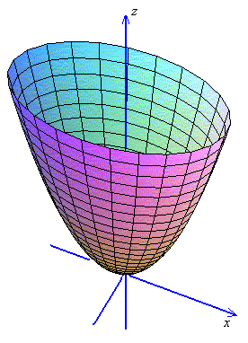
Elliptic Paraboloid
(Ellipse axis lengths a , b ;
aligned along the z axis)

$\frac{z}{c} = \frac{x^{2}}{a^{2}} + \frac{y^{2}}{b^{2}}$

For paraboloids, the central axis is
associated with the “odd exponent out”.

In the case illustrated, the paraboloid is aligned along the z axis.

The only axis intercept is at the origin.

The vertical cross sections in the x-z and y-z planes are parabolae.
All horizontal cross sections are ellipses (for z > 0).

Hyperbolic Paraboloid (Hyperbola axis length a ; aligned along the z axis)
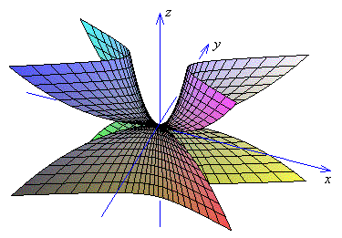
$\frac{z}{c} = \frac{x^{2}}{a^{2}} − \frac{y^{2}}{b^{2}}$

For paraboloids, the central axis is associated with the “odd exponent out”.

In the case illustrated, the paraboloid is aligned along the z axis.

The only axis intercept is at the origin.

The vertical cross section in the x-z plane is an upward-opening parabola.
The vertical cross section in the y-z plane is a downward-opening parabola.
All horizontal cross sections are hyperbolae, (except for a point at z = 0).

The plots of the five standard quadric surfaces shown here were generated in the software package Maple. The Maple worksheet is available from a link at
"http://www.engr.mun.ca/~ggeorge/2422/programs/index.html".

Degenerate Cases:

$\frac{x^{2}}{a^{2}} + \frac{y^{2}}{b^{2}} + \frac{z^{2}}{c^{2}} = 0$ : A single POINT at the origin.

$\frac{x^{2}}{a^{2}} + \frac{y^{2}}{b^{2}} − \frac{z^{2}}{c^{2}} = 0$ : Elliptic CONE, aligned along the z axis;
[asymptote to both types of hyperboloid].

$\frac{x^{2}}{a^{2}} + \frac{y^{2}}{b^{2}} + \frac{z^{2}}{c^{2}} = −1$ : NOTHING

$\frac{x^{2}}{a^{2}} + \frac{y^{2}}{b^{2}} = 1$ : ELLIPTIC CYLINDER, aligned along the z axis.

$\frac{x^{2}}{a^{2}} − \frac{y^{2}}{b^{2}} = 1$ : HYPERBOLIC CYLINDER, aligned along the z axis.

$\frac{y}{b} = \frac{x^{2}}{a^{2}}$ : PARABOLIC CYLINDER, vertex line on the z axis.

$\frac{x^{2}}{a^{2}} + \frac{y^{2}}{b^{2}} = 0$ : LINE (the z axis)

$\frac{x^{2}}{a^{2}} + \frac{y^{2}}{b^{2}} = −1$ : NOTHING

$\frac{x^{2}}{a^{2}} − \frac{y^{2}}{b^{2}} = 0$ : PLANE PAIR (intersecting along the z axis)

$\frac{x^{2}}{a^{2}} = 1$ : Parallel PLANE PAIR

$\frac{x^{2}}{a^{2}} = 0$ : Single PLANE (the y-z coordinate plane)

$\frac{x^{2}}{a^{2}} = −1$ : NOTHING

Example 1.5.1

Classify the quadric surface, whose Cartesian equation is 2x = 3y² + 4z² .

Rearranging into standard form,
Compare to the standard form
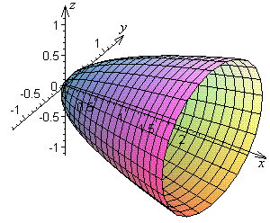

The quadric surface is therefore an elliptic paraboloid, aligned along the x axis, with its vertex at the origin.

Example 1.5.2

Classify the quadric surface, whose Cartesian equation is z² = 1 + x² .
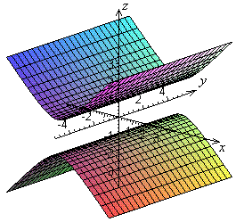
Rearranging into standard form,
z² − x² = 1
Compare to the standard form
The quadric surface is therefore one of the degenerate cases.
It is a hyperbolic cylinder, centre at the origin, aligned along the y axis.

Example 1.5.3

Classify the quadric surface, whose Cartesian equation is x² − y² + z² + 1 = 0 .

Rearranging into standard form,
y² − x² − z² = 1
Compare to the standard form
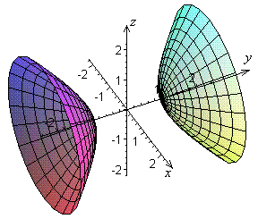
The quadric surface is therefore an
hyperboloid of two sheets,
centre at the origin,
aligned along the y axis.
1.6 Surfaces of Revolution

Consider a curve in the x-y plane, defined by the equation y = f (x).
If it is swept once around the line y = c , then it will generate a surface of revolution.
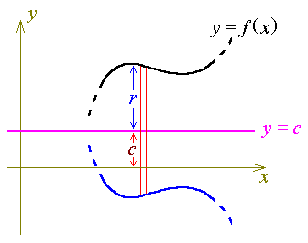
At any particular value of x, a thin cross-section through that surface, parallel to the y-z plane, will be a circular disc of radius r, where

Let us now view the circular disc face-on, (so that the x axis and the axis of rotation are both pointing directly out of the page and the page is parallel to the y-z plane).
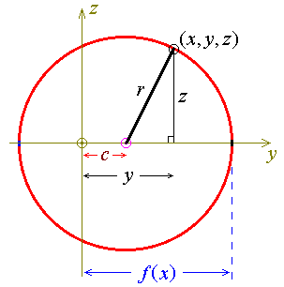

Let (x, y, z) be a general point on the surface of revolution.

From this diagram, one can see that

r² = (y − c)² + z²

Therefore, the equation of the surface generated, when the curve y = f (x) is rotated once around the axis y = c , is

Special case: When the curve y = f (x) is rotated once around the x axis, the equation of the surface of revolution is
or
Example 1.6.1

Find the equation of the surface generated, when the parabola y ² = 4ax is rotated once around the x axis.

The solution is immediate:

y² + z² = 4ax ,

which is the equation of an elliptic paraboloid,
(actually a special case, a circular paraboloid).

The Curved Surface Area of a Surface of Revolution

For a rotation around the x axis,

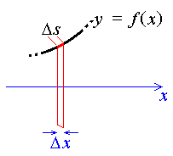
the curved surface area swept out by the element of arc length Δs is approximately the product of the circumference of a circle of radius y with the length Δs.

Integrating along a section of the curve y = f (x) from x = a to x = b, the total curved surface area is

For a rotation of y = f (x) about the axis y = c, the curved surface area is
and
Therefore
Example 1.6.2

Find the curved surface area of the circular paraboloid generated by rotating the portion of the parabola y ² = 4cx (c > 0) from x = a ( > 0) to x = b about the x axis.

Therefore

1.7 Hyperbolic Functions

When a uniform inelastic (unstretchable) perfectly flexible cable is suspended between two fixed points, it will hang, under its own weight, in the shape of a catenary curve. The equation of the standard catenary curve is most concisely expressed as the hyperbolic cosine function, y = cosh x, where

The solutions to some differential equations can be expressed conveniently in terms of hyperbolic functions.

The other five hyperbolic functions are
,

Unlike the trigonometric functions, the hyperbolic functions are not periodic.
However, parity is preserved:
Of the six trigonometric function, only cos θ and sec θ are even functions.
Of the six hyperbolic functions, only cosh θ and sech θ are even functions.
The other functions are odd.
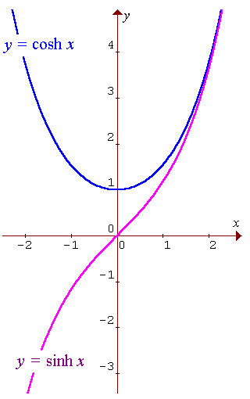

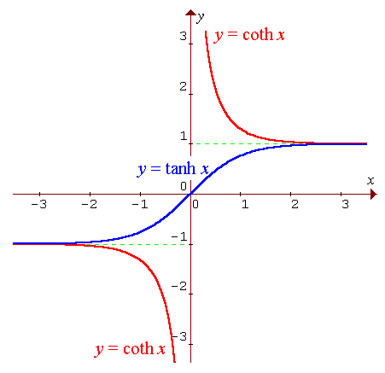
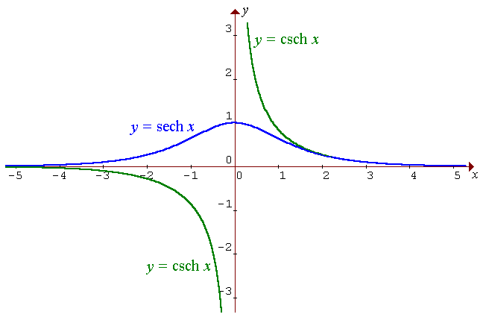

There is a close relationship between the hyperbolic and trigonometric functions.

From the Euler form for e ^{jθ} , e ^{jθ} = cos θ + j sin θ ,
⇒ e ^{–jθ} = cos θ – j sin θ

Identities:

Let x = jθ :
sin²θ + cos²θ ≡ 1 ⇒

cosh²x − sinh²x ≡ 1

1 + tan²θ ≡ sec²θ ⇒
1 − tanh²x ≡ sech²x

etc.
Derivatives

Therefore

Therefore
[Note the different sign from the trigonometric version, (cos x) ' = − sin x .]

Therefore

OR

Let x = jθ , then θ = −jx

tanh(jθ) = j tan θ

⇒ tanh x = j tan(−jx)

= sech²(jθ) = sech²x .

Therefore

Therefore
etc.

A list of identities and derivatives for hyperbolic functions is presented in the suggestions for a formula sheet, in Appendix A to these lecture notes.
1.8 Integration by Parts

Review:
Let u(x) and v(x) be functions of x. Then, by the product rule of differentiation,

Integrating with respect to x :

This leads to the formula for integration by parts:

Example 1.8.1

Find .

[v' must be identified with a factor of the integrand that can be antidifferentiated easily.]

Therefore

Example 1.8.2 [Repeated use of integration by parts]

Find .

u = x² v' = cos x

⇒ u' = 2x v = sin x

Using integration by parts again, with u = 2x and v' = sin x ,

u' = 2 v = − cos x

= x²sin x + 2x cos x − 2 sin x + C

Therefore

Check:

I' = 2x sin x + (x² − 2) cos x + 2 cos x − 2x sin x + 0

= x² cos x 

Shortcut (a tabular form for repeated integrations by parts):

:
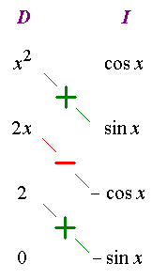

Reading off the diagonals,
Note:

There are three ways the table can end:

1) column 'D' reduces to 0 (as in the examples on this page);

2) the product across a row is easy to integrate;

3) the product across a row is a constant multiple of the original integrand. (ex. 1.8.4 next page)
I = x²sin x + 2x cos x − 2 sin x + C

Example 1.8.3

Find .
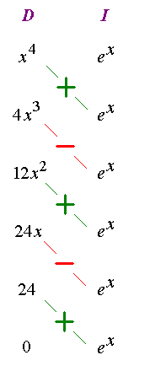

Therefore

I = (x⁴ − 4x³ + 12x² − 24x + 24) e^{x} + C

Check:

I' = (x⁴ − 4x³ + 12x² − 24x + 24
+ 4x³ − 12x² + 24x − 24 + 0) e^{x}
= x⁴ e^{x} 
Example 1.8.4 (recursive use of integration by parts)

Find .

Either
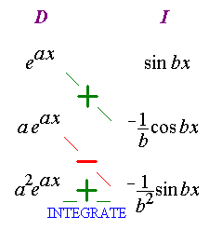

or
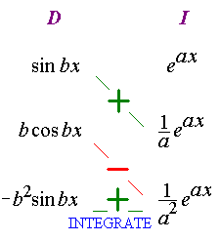

Therefore

Check:

Let s = sin bx and c = cos bx , then s' = bc , c' = −bs and


1.9 Leibnitz Differentiation of a Definite Integral

If the limits of integration are both constant, then just differentiate the integrand with respect to x, treating all other terms as constants.

Example 1.9.1

Evaluate

Using Leibnitz differentiation:

Directly:

See Problem Set 3 and Section 5.10 for more practical examples of Leibnitz differentiation.

End of Chapter 1

