1.2 Polar Coordinates

The description of the location of an object in ² relative to the observer is not very natural in Cartesian coordinates: “the object is three metres to the east of me and four metres to the north of me”, or (x, y) = (3, 4). It is much more natural to state how far away the object is and in what direction: “the object is five metres away from me, in a direction approximately 53° north of due east”, or (r, θ) = (5, 53°).

Radar also operates more naturally in plane polar coordinates.
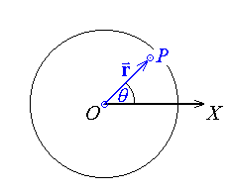
r = range

θ = azimuth

O is the pole

OX is the polar axis (where θ = 0)

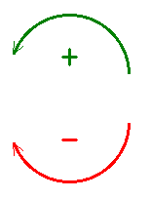
Anticlockwise rotations are positive.

[Nautical bearings are very different:
positive rotation is measured clockwise,
from zero at due north !]

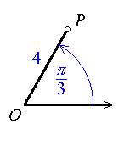
Example 1.2.01

The point P with the polar coordinates (r, θ) = (4, π / 3)

also has the polar coordinates
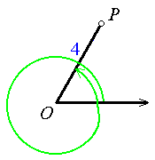
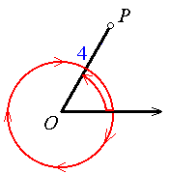

or

Example 1.2.01 (continued)

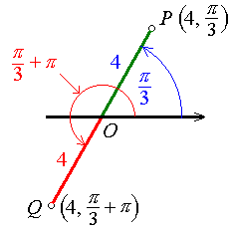

The point is at P.

So also is .

In general, if the polar coordinates of a point are (r, θ), then

and

(n = any integer)
also describe the same point.

The polar coordinates of the pole are (0, θ) for any θ.

In some situations, we impose restrictions on the range of the polar coordinates, such as
r > 0 , −π < θ < +π for the principal value of a complex number in polar form.

Conversion between Cartesian and polar coordinates:
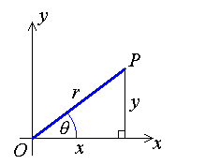

Inverse:

Therefore

More information is needed in order to select the correct quadrant.

Example 1.2.02

Find the polar coordinates for the point whose Cartesian coordinates are (−3, 4).

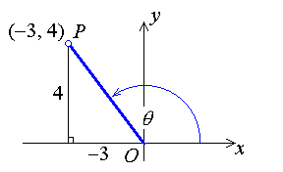
x = −3 , y = 4

r ² = 9 + 16 = 25

⇒ r = ± 5

(−3, 4) is in the second quadrant.

If we choose r > 0, then one value of θ is θ = −Tan⁻¹(4/3) + π ≈ 2.21 rad.

One possibility: (r, θ) = (5, 2.21) (to 3 s.f.)

Therefore, to 3 s.f.,

(r, θ) = (5, 2.21 + 2nπ) or (−5, 2.21 + (2n+1)π) ,

Example 1.2.03

Find the Cartesian coordinates for

Therefore

Polar Curves r = f (θ)

The representation (x, y) of a point in Cartesian coordinates is unique. For a curve defined implicitly or explicitly by an equation in x and y, a point (x, y) is on the curve if and only if its coordinates (x, y) satisfy the equation of the curve.

The same is not true for plane polar coordinates. Each point has infinitely many possible representations, and (where n is any integer). A point lies on a curve if and only if at least one pair (r, θ) of the infinitely many possible pairs of polar coordinates for that point satisfies the polar equation of the curve. It doesn’t matter if other polar coordinates for that same point do not satisfy the equation of the curve.

Example 1.2.04

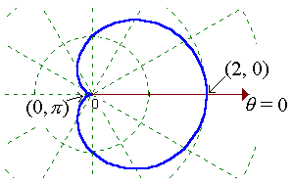
The curve whose polar equation is
r = 1 + cos θ
is a cardioid
(literally, a “heart-shaped” curve).

{ r = 2, θ = 2nπ }
(where n is any integer)
satisfies the equation r = 1 + cos θ .

⇒ (r, θ) = (2, 2nπ) is on the cardioid curve.

But (2, 2nπ) is the same point as (−2, (2n+1)π).

θ = (2n+1)π ⇒ 1 + cos θ = 0 ≠ r .

Yet the point whose polar coordinates are (−2, (2n+1)π) is on the curve!

Example 1.2.05

Convert to polar form the equation
.

r ² = r + 3r sin θ

⇒ r ( r − 1 − 3 sin θ ) = 0

⇒ r = 0 or r = 1 + 3 sin θ

But is a solution of r = 1 + 3 sin θ

⇒ r = 0 is included in r = 1 + 3 sin θ .

Therefore the polar equation of the curve is
r = 1 + 3 sin θ
(which is a limaçon).

Note that there is no restriction on the sign of r ; it can be negative.
Example 1.2.06

Convert to Cartesian form the equation of the cardioid curve r = 1 + cos θ .

⇒ r ² = r + x

⇒ r ² − x = r

⇒ (r ² − x)² = r²

Therefore
(x ² + y ² − x) ² = x ² + y ²

Tangents to r = f (θ)

x = r cos θ = f (θ) cos θ

y = r sin θ = f (θ) sin θ

By the chain rule for differentiation:
This leads to a general expression for the slope anywhere on a curve r = f (θ) :

horizontal tangent at (r, θ) .

vertical tangent at (r, θ) .

At the pole (r = 0):

If r → 0 but as θ → θ_{o} , then
the radial line θ = θ_{o} is a tangent at the pole.
[This can be of some help when sketching polar curves.]

Example 1.2.07

Sketch the curve whose equation in polar form is r = cos 2θ .

Two methods will be demonstrated here. The first method is a direct transfer from a Cartesian plot of r against θ (as though the curve were y = cos 2x). The second method is a systematic tabular method, involving investigation of the behaviour of the curve in intervals of θ between consecutive critical points (where r and/or its derivative is/are zero or undefined).

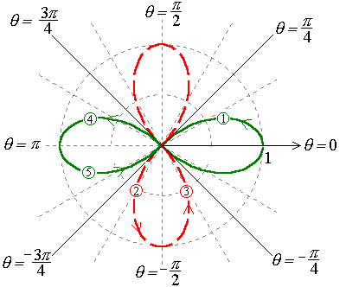
Method 1.
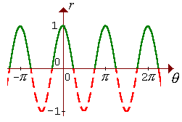

Method 2.

r = cos 2θ = 0 at 2θ = (any odd multiple of π/2)
⇒ r = 0 at θ = (any odd multiple of π/4)
(any integer multiple of π)
⇒ r' = 0 at θ = (any integer multiple of π/2)

Therefore tabulate in intervals bounded by θ = (consecutive integer multiples of π/4).

2θ | 0 → π/2 | π/2 → π | π → 3π/2 | 3π/2 → 2π | 2π → 5π/2 | ...
θ | 0 → π/4 | π/4 → π/2 | π/2 → 3π/4 | 3π/4 → π | π → 5π/4 | ...
r | 1 → 0 | 0 → −1 | −1 → 0 | 0 → 1 | 1 → 0 | ...
Region in sketch | (1) | (2) | (3) | (4) | (5)

This leads to the same sketch as in Method 1 above.

You can follow a plot of r = cos nθ by Method 1 (for n = 1, 2, 3, 4, 5 and 6) on the web site. See the link at "http://www.engr.mun.ca/~ggeorge/2422/programs/".

The distinct polar tangents are

Length of a Polar Curve

If r = f (θ) (for α < θ < β), then

x = f (θ) cos θ and y = f (θ) sin θ

Let r = f (θ) , r' = f ' (θ), c = cos θ and s = sin θ , then

and

= (r') ²(c ² + s ²) + 0 + r ²(s ² + c ²)

Therefore the length L along the curve r = f (θ) from θ = α to θ = β is

Example 1.2.08

Find the length L of the perimeter of the cardioid r = 1 + cos θ .
α = 0 , β = 2π .

r = 1 + cos θ = 1 + c

1 + 2c + c ² + s ² = 2 + 2c
Example 1.2.08 (continued)

But 1 + cos 2x = 2 cos ²x . Set θ = 2x.

Using symmetry in the horizontal axis,

Therefore the perimeter of the cardioid curve is L = 8.

Note:
For π < θ < 2π ,
and

Example 1.2.09

Find the arc length along the spiral curve r = a e^{θ} (a > 0), from θ = α to θ = β .
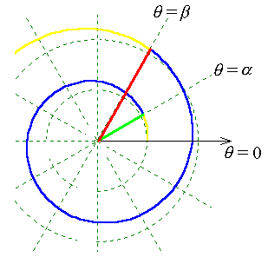

Area Swept Out by a Polar Curve r = f (θ)

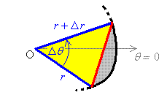
ΔA ≈ Area of triangle

But the angle Δθ is small, so that sin Δθ ≈ Δθ
and the increment Δr is small compared to r.
Therefore

Example 1.2.10

Find the area of a circular sector, radius r , angle θ .

r = constant, β = α + θ

Therefore

Full circle: θ = 2π and A = πr ² .

Example 1.2.11

Find the area swept out by the polar curve r = a e^{θ} over α < θ < β ,
(where a > 0 and α < β < α + 2π ).
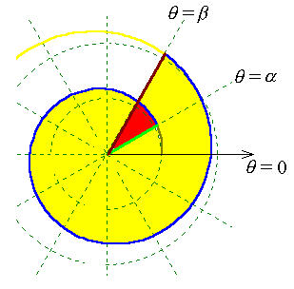
The condition (α < β < α + 2π )
prevents the same area being swept
out more than once.

If β > α + 2π then one needs to
subtract areas that have been
counted more than once
[the red area in the diagram]

Therefore

In general, the area bounded by two polar curves r = f (θ) and r = g(θ) and the radius vectors θ = α and θ = β is

See the problem sets for more examples of polar curve sketching and the calculation of the lengths and areas swept out by polar curves.

Radial and Transverse Components of Velocity and Acceleration

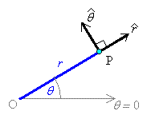

At any point P (not at the pole), the unit radial vector points directly away from the pole. The unit transverse vector is orthogonal to and points in the direction of increasing θ. These vectors form an orthonormal basis for ².

Only if θ is constant will and be constant unit vectors, (unlike the Cartesian i and j).

The derivatives of these two non-constant unit vectors can be shown to be

and

Using the “overdot” notation to represent differentiation with respect to the parameter t, these results may be expressed more compactly as

The radial and transverse components of velocity and acceleration then follow:

The transverse component of acceleration can also be written as
Example 1.2.12

A particle follows the path r = θ , where the angle at any time is equal to the time:
θ = t > 0. Find the radial and transverse components of acceleration.

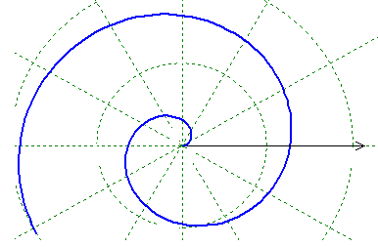
r = θ = t

Therefore

a_{r} = −t and a_{tr} = 2

Example 1.2.13

For circular motion around the pole, with constant radius r and constant angular velocity , the velocity vector is purely tangential, , and the acceleration vector is

which matches the familiar result that “centrifugal” or “centripetal” force = r ω ², directed radially inward.

