1.A Examples for the Sketching of Parametric Curves

A curve in is a one-dimensional object. To locate any point on that curve requires the value of just one parameter (a real number). The Cartesian parametric equations of any curve are therefore
, where t is any real number.
The Cartesian vector parametric equation is
, where t is any real number.

If the parameter t is the time, then r(t) describes the location of a particle at any time t.
The velocity of the particle is just .
The acceleration is .

Example 1.A.1

Sketch the curve in whose Cartesian equation in parametric form is
x = t cos t , y = t sin t

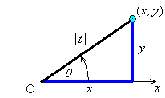
(distance from O) = | t |

(for t > 0)

Example 1.A.1 (continued)

Therefore the curve is a spiral outwards from O, with period 2π.

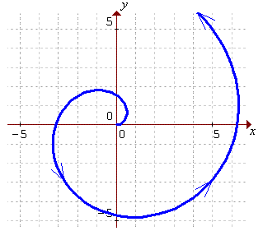

Incorporating negative values of the parameter t yields a mirror image of this curve:

⇒ reflection in y axis of t > 0 is t < 0.

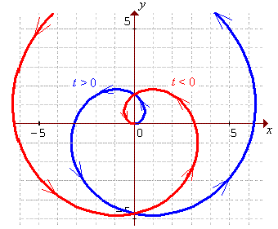

In polar coordinates (section 1.2), the equation of this spiral is just .

Example 1.A.2

The parametric form of the Cartesian equation of a curve in is

(a) Sketch the curve.
(b) What happens to the principal unit tangent at the origin?

(a)
The only value of t at which any of is zero is t = 0.
Therefore, for t < 0, the curve is moving up and left through the fourth quadrant, arriving at the origin at t = 0. Thereafter, the curve is moving up and right through the first quadrant. No part of the curve is to the left of the y-axis.

There must therefore be a horizontal tangent (and a cusp) at the origin.
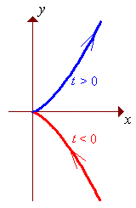
Sketch of :

Example 1.A.2 (continued)

Examination of concavity will help to confirm the behaviour near the origin.

The curve is therefore concave down everywhere in the fourth quadrant (t < 0)
and concave up everywhere in the first quadrant (t > 0).

(b) The tangent vector is
The unit tangent vector, everywhere on the curve except at the origin, is
t > 0 ⇒ | t | = t ⇒ t / | t | = +1
t < 0 ⇒ | t | = –t ⇒ t / | t | = –1
The unit tangent therefore is undefined at the origin.
It flips direction abruptly, from –i to +i, as the curve passes through the cusp at the origin;
the curve reverses direction suddenly at the cusp.

Example 1.A.3

For the curve whose Cartesian equation in parametric form is

(a) Find the tangents at the point (x, y) = (3, 0).
(b) Sketch the curve.

(a)
and
The curve therefore passes through the point (3, 0) twice.

The two slopes are distinct.
The curve therefore crosses itself at (3, 0).
In Cartesian coordinates, the equations of the two tangents to the curve at the point (3, 0) are

Example 1.A.3 (continued)

(b)

x = 0 at t = 0

x > 0 elsewhere.

is undefined at t = 0.

The values of t , at which at least one of are zero, are
:

Construct a table to aid in sketching the curve:

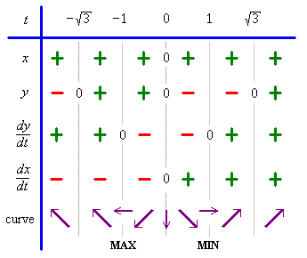

Example 1.A.3 (continued)

Sketch of :
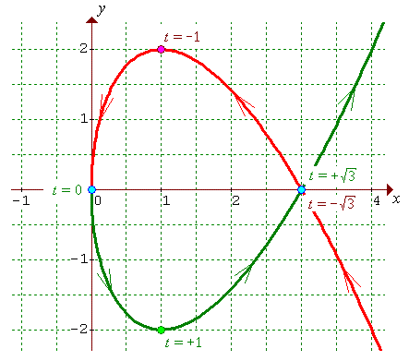

Concavity:

The curve is therefore concave up for t > 0
and concave down for t < 0.
This confirms the sketch.

Example 1.A.4

Determine the shape of the curve whose Cartesian equation in parametric form is

Examine the projections of the curve onto the three coordinate planes:

In the x-y plane z = 0 and
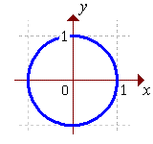
which is a circle, centre O, radius 1. Top view:

In the y-z plane x = 0 and y = sin t = sin z

In the x-z plane y = 0 and x = cos t = cos z

Side views:
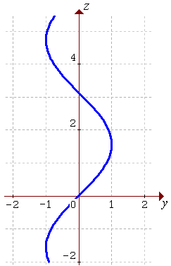
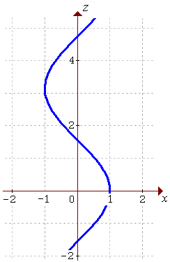

The curve is therefore a helix, centred on the z axis, radius 1, rotating once around the z axis for every change of 2π in z.

Example 1.A.4 (continued)

Modified Maple plot:
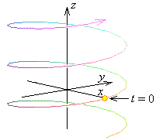

A Maple file that generates a plot of this helix is available from the course web site, in the programs directory:
"http://www.engr.mun.ca/~ggeorge/2422/programs/".

1.B Tangential and Normal Components of Velocity and Acceleration

The tangent vector to a curve r(t) is
If the parameter t is the time, then the tangent vector is also the velocity vector v(t).
The tangential component v_{T} of velocity v(t) is just the speed v(t).
There is no component of velocity in the normal plane.

The speed v(t) is a scalar quantity:
But the arc length (distance measured along the curve) s is defined by
Therefore the speed
and the unit tangent vector is
.
As seen in Example 1.A.2 above, is ill-defined where .

As a curve travels through , its tangent vector points straight ahead, defining a normal plane at right angles to that tangent vector.

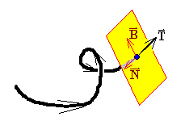
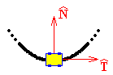
Imagine that a roller coaster car is travelling along the curve, with the front in the direction of travel and oriented so that the side doors are in the direction in which the car is instantaneously turning. Then the direction in which is changing defines the principal unit normal , (except where the curve is straight or has a point of inflexion).
By definition, the magnitude of any unit vector is 1 and therefore is absolutely constant. Only the direction of a unit vector can change. The natural parameter to use for any curve (though usually not the most convenient in practice) is the distance travelled along the curve: the arc length s. Therefore define the principal normal vector to be the derivative of the unit tangent vector with respect to arc length:

from which it follows that the unit principal normal vector is

The magnitude of the principal normal vector is a measure of how sharply the curve is turning. It is therefore the curvature,

and .
The tangent and principal normal vectors are orthogonal to each other everywhere on the curve. A third unit vector, orthogonal everywhere to both and , is the unit binormal vector, defined simply as

These three unit vectors form an orthonormal set of vectors at every point on the curve where they are defined.
Example 1.B.1

Find the unit tangent, normal and binormal vectors everywhere on the helix

[The unit principal normal therefore points directly towards the z axis at all times.]

One can easily show that
[all three vectors are orthogonal]
and that
[all three vectors are unit vectors]

We know that the velocity vector is purely tangential: .

The acceleration vector is therefore

But

The tangential and normal components of acceleration are therefore

and

An alternative form for the normal component of acceleration is

There is no binormal component of acceleration.
Example 1.B.2

Find the tangential and normal components of velocity and acceleration everywhere on the helix

OR

OR

Therefore

and

