2.1 Partial Derivatives

Example 2.1.1

At a particular instant, a cone has a height of h = 2 m and a base radius of r = 1 m.
The base radius is increasing at a rate of 1 mm/s. The height is constant.
How fast is the volume V increasing at this time?
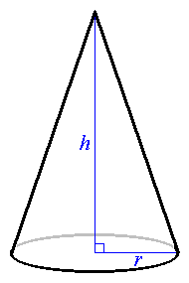

.

h = const. ⇒ V is a function of r only.

Therefore

how do we find
We shall return to this question later.
Graph of V against r and h :

Plotting z = V (where V = πr²h/3) against both x = r and y = h yields
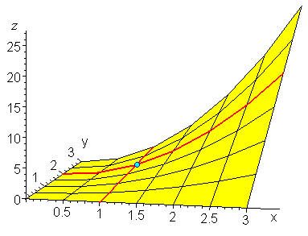

The cross-section of this surface in the vertical plane h = 2 is
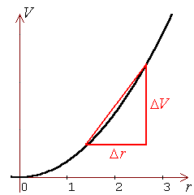

The cross-section of this surface in the vertical plane r = 1 is
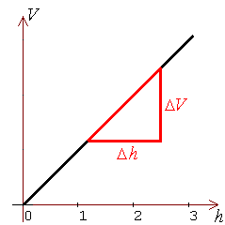

The tangent line to the surface in a cross-section (h = constant) has a slope of .
The tangent line to the surface in a cross-section (r = constant) has a slope of .
At each point on the surface, these two tangent lines define a tangent plane.

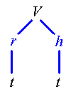
V is a function of r and h, each of which in turn is a function of t only.
In this case, the chain rule becomes

In example 2.1.1,

r = 1, h = 2, ,

Alternative notations:

If w = f (x, y, z), then , etc.

A Maple worksheet, used to generate the graph of , is available at
"http://www.engr.mun.ca/~ggeorge/2422/programs/conevolume.mws".

Open this worksheet in Maple and click on the graph.
Then, by dragging the mouse (with left button down), one can change the direction of view of the graph as one wishes. Other features of the graph may be changed upon opening a menu with a right mouse click on the graph or by using the main menu at the top of the Maple window.

Example 2.1.2

.
Find f_{z}(0, 3, 4)
[the first partial derivative of f with respect to z, evaluated at the point (0, 3, 4)].

OR

f ² = x ² + y ² + z ²

Using implicit differentiation,

In this example,

f = (distance of the point (x, y, z) from the origin).

Example 2.1.3

u = x^{y/z}

Find the three first partial derivatives, u_{x}, u_{y}, u_{z}.

OR

2.2 Higher Partial Derivatives

etc.

Example 2.2.1

u = x e^{−t} sin y

Find the second partial derivatives u_{xy}, u_{yx}, u_{xx} and the third partial derivative u_{ttt}.

u_{x} = e^{−t} sin y

u_{y} = x e^{−t} cos y

u_{t} = −x e^{−t} sin y = −u

u_{xx} = 0
u_{t} = − u

⇒ u_{tt} = (−u)_{t} = + u

⇒ u_{ttt} = (+u)_{t} = − u

Therefore

u_{ttt} = −x e^{−t} sin y

Clairaut’s Theorem

If, on a disk D containing the point (a, b), f is defined and both of the partial derivatives f_{xy} and f_{yx} are continuous, (which is the case for most functions of interest), then

that is, the order of differentiation doesn’t matter.

One of the most important partial differential equations involving second partial derivatives is Laplace’s equation, which arises naturally in many applications, including electrostatics, fluid flow and heat conduction:
or its equivalent in ³:

Example 2.2.2

Does satisfy Laplace’s equation?

u is symmetric with respect to x, y.

Therefore, to find u_{yy}, interchange x, y in u_{xx} .

⇒ u_{xx} + u_{yy} = 0
Therefore u does satisfy Laplace’s equation (except at (0,0)).

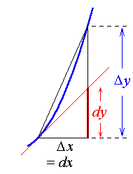
2.3 Differentials

In ², let a curve have the Cartesian equation y = f (x).

The small change in y, (Δy), caused by travelling along the curve for a small horizontal distance Δx, may be approximated by the change dy that is caused by travelling for the same horizontal distance Δx along the tangent line instead.

The exact form is Δy = f (x + Δx) − f (x) .

The approximation to Δy is
Δy ≈ dy = f '(x) dx
where the differential dx has been replaced by the increment Δx.
The approximation improves as Δx decreases towards zero.

Stepping up one dimension, let a surface have the Cartesian equation z = f (x, y).
The change in the dependent variable z caused by small changes in the independent variables x and y has the exact value
Δz = f (x + Δx, y + Δy) − f (x, y) .

The approximation to Δz is

Example 2.3.1

A rectangle has quoted dimensions of 30 cm for length and 24 cm for width.
However, there may be an error of up to 1 mm in the measurement of each dimension.
Estimate the maximum error in the calculated area of the rectangle.
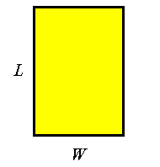

Let A = area, L = length and W = width.

Length = (30 ± 0.1) cm ⇒ L = 30 and ΔL = 0.1
Width = (24 ± 0.1) cm ⇒ W = 24 and ΔW = 0.1

A = LW

Example 2.3.1 (continued)

Let dL = dW = 0.1, then

max(error) = ΔA ≈ dA

= 24 × 0.1 + 30 × 0.1

= 5.4 cm² .

Compare this to a direct calculation:

max(error) = max{ (A_{max} − A), (A − A_{min}) }

A − A_{min} = 30 × 24 − (30 − 0.1)(24 − 0.1)

= 5.39 cm² .

A_{max} − A = (30 + 0.1)(24 + 0.1) − 30 × 24

= 5.41 cm² .

Therefore

max(error) = 5.41 cm² .

Relative error:

max(error in L) = L / 300

max(error in W) = W / 240

A = LW

⇒ dA = W dL + L dW

and 0.75% of A = 720 cm² is 5.4 cm² .
Chain Rule
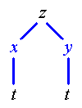
z = f (x, y).
If x and y are both functions of t only, then, by the chain rule,

If z = f (x, y) and y in turn is a function of x only, then
replace t by x in the formula above.

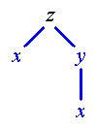
and
Note the distinction between the total derivative and the partial derivative .

Example 2.3.2

In the study of fluid dynamics, one approach is to follow the motion of a point in the fluid. In that approach, the velocity vector is a function of both time and position, while position, in turn, is a function of time. v = v(r, t) and r = r(t).

The acceleration vector is then obtained through differentiation following the motion of the fluid:
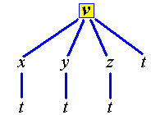
or, equivalently,
[The gradient operator, ☹, will be introduced later, on page 2-20.]
Further analysis of an ideal fluid of density ρ at pressure p subjected to a force field F leads to Euler’s equation of motion
This application of partial differentiation will be explored in some disciplines in a later semester. As a simple example here, suppose that then find the acceleration vector.

First note that the velocity vector is the derivative of the displacement vector, so that

[One can show that x(t) = ln | t + c | , where c is a constant.]
Generalized Chain Rule
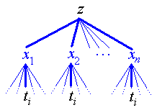
Let z be a function of n variables { x₁, x₂, ... , x_{n} },
each of which, in turn, is a function of m variables
{ t₁, t₂, ... , t_{m} }, so that
z = f (x₁(t₁, t₂, ... , t_{m}), x₂(t₁, t₂, ... , t_{m}), ...
... , x_{n}(t₁, t₂, ... , t_{m}) ).
To find ,
trace all paths that start at z and end at t_{i} , via all of the { x_{j} } variables.

Example 2.3.3:

u = xy + yz + zx, x = st, y = e^{st} and z = t² .
Find u_{s} in terms of s and t only. Find the value of u_{s} when s = 0 and t = 1.

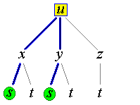
[There is no z term because z is not a function of s.]
= t ( (e^{st} + t²) + (st + t²) e^{st})

= t³ + t (1 + st + t²) e^{st}

This derivative could also be found directly by replacing x, y and z by the respective functions of s and t before differentiating u:

u = (st) e^{st} + (e^{st}) t² + (t²)st

⇒ u_{s} = (st² + t) e^{st} + (e^{st}) t³ + t³ = t³ + t (1 + st + t²) e^{st}

u_{s} (0, 1) = 1 + 1(1+0+1)e⁰ = 1 + 2 = 3 .

Implicit functions:

If z is defined implicitly as a function of x and y by F (x, y, z) = c , then
dF = F_{x} dx + F_{y} dy + F_{z} dz = 0
Example 2.3.4:

Find the change in z when x and y both increase by 0.2 from the point (1, 2, 2) on the sphere x² + y² + z² = 9.
Note:
If y is a function of x only, then

However, if x and y are independent of each other, then is ill-defined.
The only derivative of z with respect to x that we can then define is .
. [End note]

Solution − Approximate motion on the sphere by motion on the tangent plane:

x = 1 , y = z = 2 , dx ≈ Δx = 0.2 , dy ≈ Δy = 0.2 .

Therefore z decreases by [approximately] 0.3

Exact:

Therefore Δz = −0.3507...
Curves of Intersection

Example 2.3.5:
Find both partial derivatives with respect to z on the curve of intersection of the sphere centre the origin, radius 5, and the circular cylinder, central axis on the y-axis, radius 3.

Sphere: f = x² + y² + z² = 25

Cylinder: g = x² + z² = 9

⇒ df = 2x dx + 2y dy + 2z dz = 0

and dg = 2x dx + 2z dz = 0

which leads to the linear system

Therefore
[The intersection is the pair of circles x² + z² = 9, y = ±4 .
Because y never changes on each circle, x is actually a function of z only.]

Example 2.3.6

A surface is defined by f (x, y, z) = xz + y²z + z = 1 . Find .

Implicit method:

0 = z dx + 2yz dy + (x + y² + 1) dz

But f = 1 ⇒ (x + y² + 1) z = 1

In the slice in which the partial derivative is evaluated, x is constant ⇒ dx = 0.

Explicit method:

In general, if a dx + b dy = c dz then
(because y is constant and dy = 0 in the slice in which is evaluated) and
(because x is constant and dx = 0 in the slice in which is evaluated).
2.4 The Jacobian

The Jacobian is a conversion factor for a differential of area or volume between one orthogonal coordinate system and another.

Let (x, y) , (u, v) be related by the pair of simultaneous equations

f (x, y, u, v) = c₁
g(x, y, u, v) = c₂

⇒ df = f_{x} dx + f_{y} dy + f_{u} du + f_{v} dv = 0
and dg = g_{x} dx + g_{y} dy + g_{u} du + g_{v} dv = 0

which leads to

where the Jacobian is

The Jacobian for the transformation from (x, y) to (u, v) is also the magnitude of the cross product of the tangent vectors that define the boundaries of the element of area, so that
Example 2.4.1

Transform the element of area dA = dx dy to plane polar coordinates.

x = r cos θ , y = r sin θ .

f = x − r cos θ = 0

g = y − r sin θ = 0

⇒ df = dx − cos θ dr + r sin θ dθ = 0

and dg = dy − sin θ dr − r cos θ dθ = 0

Therefore
dA = r dr dθ

If x, y can be written as explicit functions of (u, v), then an explicit form of the Jacobian is available:

The Jacobian can also be used to express an element of volume in terms of another orthogonal coordinate system:
Spherical Polar Coordinates – a reminder.

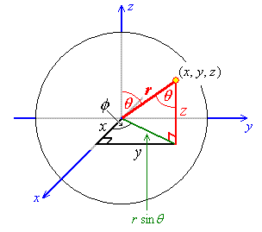
The “declination” angle θ is the angle between the positive z axis and the radius vector r. 0 < θ < π.

The “azimuth” angle φ is the angle on the x-y plane, measured anticlockwise from the positive x axis, of the shadow of the radius vector. 0 < φ < 2π.

z = r cos θ .

The shadow of the radius vector on the x-y plane has length r sin θ.

It then follows that

x = r sin θ cos φ and y = r sin θ sin φ .

Example 2.4.2

Express the element of volume dV in spherical polar coordinates,

Using the explicit form,

Expanding along the last row of the determinant,

= | r²sin θ (cos² θ + sin² θ) | = r²sin θ

Note that sin θ > 0 because 0 < θ < π .

Therefore
dV = r²sin θ dr dθ dφ
For a transformation from Cartesian to plane polar coordinates in ²,
$$\frac{∂\left(x, y\right)}{∂\left(r, θ\right)} = r \text{so} \text{that} \text{dA} = \text{dx} \text{dy} = r \text{dr} dθ$$
For cylindrical polar coordinates in ³,
$$\frac{∂\left(x, y, z\right)}{∂\left(r, θ, z\right)} = r ⇒ \text{dV} = r \text{dr} dθ \text{dz}$$

Explicit method for plane polar coordinates:
x = r cos θ , y = r sin θ
$$⇒ \frac{∂\left(x, y\right)}{∂\left(r, θ\right)} = \text{ABS}\left(\text{det} \left[\begin{matrix}\frac{∂x}{∂r} & \frac{∂x}{∂θ} \\ \frac{∂y}{∂r} & \frac{∂y}{∂θ}\end{matrix}\right] \right) = \left\| \begin{matrix}\text{cos}θ & −r \text{sin}θ \\ \text{sin}θ & r \text{cos}θ\end{matrix} \right\|$$
= r cos²θ + r sin²θ = r .

Implicit method for plane polar coordinates: [which is a repeat of page 2-17.]
f = x − r cos θ = 0 ⇒ df = dx − cos θ dr + r sin θ dθ = 0
g = y − r sin θ = 0 ⇒ dg = dy − sin θ dr − r cos θ dθ = 0
$$⇒ \underset{A}{\underbrace{\left[ \begin{matrix}1 & 0 \\ 0 & 1\end{matrix} \right]}}⋅\left[ \begin{matrix}\text{dx} \\ \text{dy}\end{matrix} \right] = \underset{B}{\underbrace{\left[ \begin{matrix}\text{cos}θ & −r \text{sin}θ \\ \text{sin}θ & r \text{cos}θ\end{matrix} \right]}}⋅\left[ \begin{matrix}\text{dr} \\ dθ\end{matrix} \right]$$
$$⇒ \frac{∂\left(x, y\right)}{∂\left(r, θ\right)} = \left| \frac{\left| B \right|}{\left| A \right|} \right| = \left| \frac{r {\text{cos}}^{2}θ+r {\text{sin}}^{2}θ}{1} \right| = \left| r \right| = r$$

2.5 The Gradient Vector
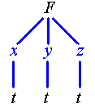
Let F = F(r) and r = r(t) .

= “del” or “nabla” = gradient operator

= gradient vector

Directional Derivative

The rate of change of the function F at the point P_{o} in the direction of the vector
is

The maximum value of the directional derivative of F at any point P_{o} occurs when
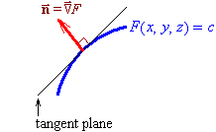
the vector a is parallel to the gradient vector .

Also, the vector is normal
to the surface defined by F(r) = constant.

[Interpretation of the gradient vector:
The gradient vector is in the plane of
the dependent variables.
Its direction at any point is the direction in which one must travel in order to experience the greatest possible rate of increase of the dependent variable at that point.
Its magnitude is that greatest possible rate of increase.]
Example 2.5.1

The temperature in a region within 10 units of the origin follows the form
Find the rate of temperature change at the point (−1, −1, +1) in the direction of the vector
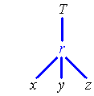
T and r are symmetric with respect to (x, y, z).

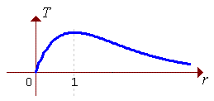

By symmetry, it then follows that

[Note that, in this example, the temperature distribution is spherically symmetric about the origin, with a minimum of zero at the origin, rising to a maximum of 1/e = 0.368... one metre away from the origin and falling asymptotically back to zero as r → ∞.
Outside the r = 1 sphere, the gradient vector points radially inwards. At (−1, −1, 1) the gradient vector has a magnitude of approximately 0.104 K m⁻¹.]
Central Force Law

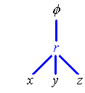
If φ(r) is the potential function for some force per unit mass or force per unit charge F(r), then F = −∇φ . For a central force law, the potential function is spherically symmetric and is dependent only on the distance r from the origin. When the central force law is a simple power law, φ = k r^{n} .

By symmetry,

Therefore

Examples include the inverse square laws, for which n = −1:

Electromagnetism:

Gravity:

Applications of the Directional Derivative and the Gradient:

(1) The directional derivative D at the point P_{o} = (x_{o}, y_{o}, z_{o}) is maximized by choosing a to be parallel to ∇F at P_{o}, so that $D_{\hat{a}}F|_{P_{o}} = {\left| ∇F\left(\vec{r}\right) \right|}_{P_{o}}$.

(2) A normal vector to the surface F(x, y, z) = c at the point P_{o} = (x_{o}, y_{o}, z_{o}) is
$\vec{N} = {\left[∇F\left(\vec{r}\right)\right]}_{P_{o}}$.

(3) The equation of the line normal to the surface F(x, y, z) = c at the point
P_{o} = (x_{o}, y_{o}, z_{o}) is $\vec{r} = \left[\vec{{\text{OP}}_{o}}\right]+t {\left[∇F\right]}_{P_{o}} = {\vec{r}}_{o}+t {\left[∇F\right]}_{P_{o}}$

(4) The equation of the tangent plane to the surface F(x, y, z) = c at the point
P_{o} = (x_{o}, y_{o}, z_{o}) is $\left[\vec{r}−\vec{{\text{OP}}_{o}}\right]⋅{\left[∇F\right]}_{P_{o}} = \left[\vec{r}−r_{o}\right]{\left[∇F\right]}_{P_{o}} = 0$

(5) If the point P_{o} = (x_{o}, y_{o}, z_{o}) lies on both of the surfaces F(x, y, z) = c and
G(x, y, z) = k, then the angle of intersection θ of the surfaces at the point is given by
$$\text{cos} θ = \frac{{\left[∇F\right]}_{P_{o}}⋅{\left[∇G\right]}_{P_{o}}}{{\left|∇F\right|}_{P_{o}}{\left|∇G\right|}_{P_{o}}}$$

2.6 Maxima and Minima

Much of differential calculus in the study of maximum and minimum values of a function of one variable carries over to the case of a function of two (or more) variables. In order to visualize what is happening, we shall restrict our attention to the case of functions of two variables, z = f (x, y).

For a function f (x, y) defined on some domain D in ², the point P(x_{o}, y_{o}) is a critical point [and the value f (x_{o}, y_{o}) is a critical value] of f if
1) P is on any boundary of D; or
2) f (x_{o}, y_{o}) is undefined; or
3) f_{x} and/or f_{y} is undefined at P; or
4) f_{x} and f_{y} are both zero at P (⇒ ∇f = 0 at P).

A local maximum continues to be equivalent to a “hilltop”,
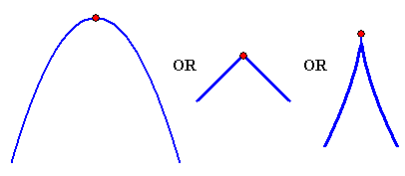
while a local minimum continues to be equivalent to a “valley bottom”.
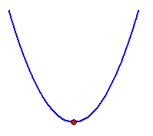

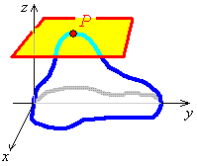
“Local extremum” is a collective term for local maximum or local minimum.

Instead of tangent lines being horizontal at critical points of type (4), we now have tangent planes being horizontal at critical points of type (4).

At any local extremum at which f (x, y) is differentiable, the tangent plane is horizontal, f_{x} = f_{y} = 0 and ∇f = 0 .
The converse is false.
∇f = 0 does not guarantee a local extremum. There could be a saddle point (the higher dimensional equivalent of a point of inflection) instead.

Example 2.6.1

Find and identify the nature of the extrema of f (x, y) = x² + y² + 4x − 6y .

Polynomial functions of x and y are defined and are infinitely differentiable on all of ².
Therefore the only critical points are of type (4).

But f (x, y) = (x + 2)² − 4 + (y − 3)² − 9

> 0 − 4 + 0 − 9 = −13 = f (−2, 3)

Therefore the only local extremum is a minimum value of −13 at (−2, 3).

It is also an absolute minimum.

To determine the nature of a critical point:
1) Examine the values of f in the neighbourhood of P; or
2) [First derivative test:] Examine the changes in f_{x} and f_{y} at P; or
3) Use the second derivative test:

At all points (a, b) where ∇f = 0 , find all second partial derivatives, then find
$$D = \left| \begin{matrix}f_{\text{xx}} & f_{\text{xy}} \\ f_{\text{yx}} & f_{\text{yy}}\end{matrix} \right|$$
and evaluate D at (x, y) = (a, b).
D(a, b) > 0 and f_{xx}(a, b) > 0 ⇒ a relative minimum of f is at (a, b)
D(a, b) > 0 and f_{xx}(a, b) < 0 ⇒ a relative maximum of f is at (a, b)
D(a, b) < 0 ⇒ a saddle point of f is at (a, b)
D(a, b) = 0 ⇒ test fails (no information).

Example 2.6.1 (again):

Find all extrema of f (x, y) = x² + y² + 4x − 6y .

Any critical points will be of type (4) only.

f_{xx} = 2, f_{xy} = 0, f_{yy} = 2

D > 0 and f_{xx} > 0 at (−2, 3) ⇒ there is a relative minimum at (−2, 3) and
the minimum value is f (−2, 3) = −13.

As there are no other critical points, f (x, y) has an absolute minimum value of −13 at (−2, 3) and has no maxima.

[z = f (x, y) is a circular paraboloid, vertex at (−2, 3, −13) and axis of symmetry parallel to the z-axis.]

Example 2.6.2
Find all extrema of f (x, y) = 2x³ + xy² + 5x² + y² .

Any critical points will be of type (4) only.

6x² + 10x + y² = 0 (1)

2y (x + 1) = 0 (2)

(2) ⇒ y = 0 or x = −1

y = 0 in (1) ⇒ 2x (3x + 5) = 0

x = −1 in (1) ⇒ 6 − 10 + y² = 0

⇒ y² = 4 ⇒ y = ± 2

Critical points are (x, y) = (0, 0), (−5/3, 0), (−1, −2) and (−1, +2).

f_{x} = 6x² + 10x + y² and f_{y} = 2y (x + 1)

⇒ f_{xx} = 12x + 10

f_{xy} = 2y

and f_{yy} = 2 (x + 1)

Example 2.6.2 (continued)

(0, 0): z = f (0, 0) = 0

D > 0 and f_{xx} = 10 > 0 ⇒ minimum

D > 0 and f_{xx} < 0 ⇒ maximum

(−1, ± 2): z = f (−1, ± 2) = 2(−1) + (−1)(± 2)² + 5(−1)² + (± 2)²

= −2 − 4 + 5 + 4 = 3

D < 0 ⇒ saddle point
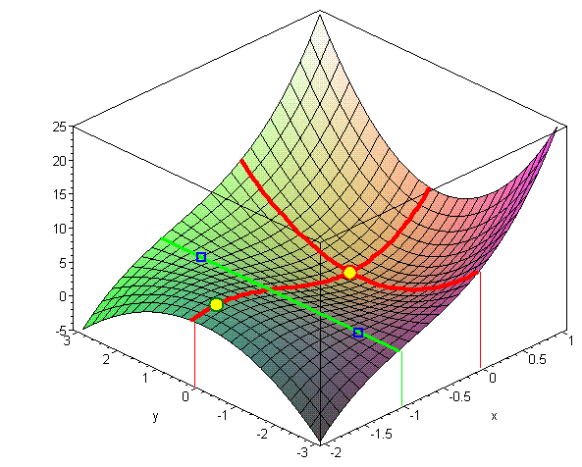
Therefore the critical points are

Minimum at (0, 0, 0)
Maximum at
Saddle points at (−1, −2, 3) and (−1, 2, 3)

Example 2.6.3

Find all extrema of z = f (x, y) = x² − y²

(x, y) = (0, 0) only.

f (0, 0) = 0

Therefore the only critical point is a saddle point at (0, 0, 0).

The surface is an hyperbolic paraboloid.

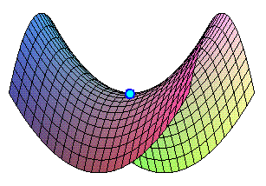
Example 2.6.4

Find and identify the nature of the extrema of .

The domain of f (x, y) is the circle x² + y² = 1 and all points inside it.

Inside the domain, f and its partial derivatives are well defined everywhere,
except that the gradient diverges everywhere on the boundary.
Therefore the only critical points to consider are types (1), (3) and (4).

Type (4) [zero gradient]:
Inside the domain, ∇f = 0 ⇒ (x, y) = (0, 0) only.
f (0, 0) = 1

However, 0 < 1 − x² − y² < 1 everywhere else in the domain
⇒ f (x, y) < f (0, 0) everywhere else in the domain.
⇒ there is an absolute maximum at (0, 0, 1).

Types (3) [undefined gradient] and (1) [the boundary]:
Everywhere on the boundary, 1 − x² − y² = 1 − 1 = 0
and 0 < f (x, y) everywhere else in the domain.

⇒ the absolute minima are all points on the circle x² + y² = 1, z = 0.

[The surface is the upper half of the sphere x² + y² + z² = 1 .]

2.7 Lagrange Multipliers

In order to obtain an appreciation for the geometric foundation for the method of Lagrange multipliers, we shall begin with an example that could be solved in another way.

Example 2.7.1

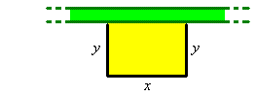
A farmer wishes to enclose a rectangle of land. One side is a straight hedge, more than 30 m long. The farmer has a total length of 12 m of fencing available for the other three sides. What is the greatest area that can be enclosed by the available fencing?

The function to be maximized is the area enclosed by the fencing and the hedge:

A(x, y) = x y

The constraint is the length of fencing available:

L(x, y) = x + 2y = 12

There are additional constraints. Neither length may be a negative number.
Therefore any solution is confined to the first quadrant of the (x, y) graph.

Superimpose the graph of the constraint function L(x, y) = 12 on the contour graph of the function z = A(x, y) :

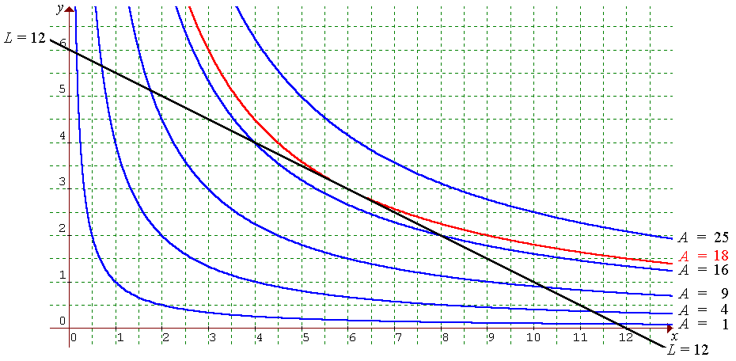

The least value of A(x, y) is zero, on the coordinate axes.
At (0, 6), two 6-metre segments of fence are touching, enclosing zero area.
At (12, 0), all of the fence is up against the hedge, enclosing zero area.
As one travels along the constraint line L = 12 from one absolute minimum at (0, 6) to the other absolute minimum at (12, 0), the line first passes through increasing contours of A(x, y),

A(4, 4) = 16

until, somewhere in the vicinity of (6, 3), the area reaches a maximum value, then declines, (for example, A(8, 2) = 16), back to the other absolute minimum at (12, 0).

At the maximum, the graph of L(x, y) = 12 just touches a contour of A(x, y).

The two graphs share a common tangent there.

⇒ gradients are parallel

Therefore solve the system of simultaneous equations

y = λ

x = 2λ

x + 2y = 12 (the constraint)

Solution: (x, y) = (6, 3).

From the graph, A is a maximum at (6, 3).

A_{max} = A(6, 3) = 6×3 = 18 m² .

λ is the Lagrange multiplier.
To maximize f (x, y) subject to the constraint g(x, y) = k:

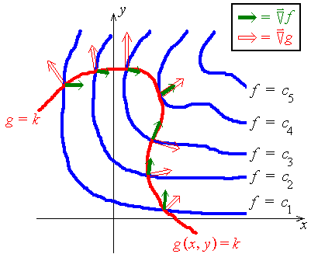
As one travels along the constraint curve g(x, y) = k, the maximum value of f (x, y) occurs only where the two gradient vectors are parallel. This principle can be extended to the case of functions of more than two variables.

General Method of Lagrange Multipliers

To find the maximum or minimum value(s) of a function f (x₁, x₂, ... , x_{n}) subject to a constraint g(x₁, x₂, ... , x_{n}) = k, solve the system of simultaneous (usually non-linear) equations in (n + 1) unknowns:
∇f = λ ∇g
g = k
where λ is the Lagrange multiplier.
Then identify which solution(s) gives a maximum or minimum value for f.

This can also be extended to the case of more than one constraint:

In the presence of two constraints g(x₁, x₂, ... , x_{n}) = k and h(x₁, x₂, ... , x_{n}) = c , solve the system in (n + 2) unknowns:
∇f = λ ∇g + μ ∇h
g = k
h = c

Example 2.7.2

Find the points, on the curve of intersection of the surfaces x + y − 2z = 6 and
2x² + 2y² = z² , that are nearest / farthest from the origin.

The maximum and minimum values of distance d occur at the same place as the maximum and minimum values of d². [Differentiation of d² will be much easier than differentiation of d.]

The function to be maximized/minimized is

f (x, y, z) = d² = x² + y² + z²

The constraints are

g(x, y, z) = x + y − 2z = 6
and
h(x, y, z) = 2x² + 2y² − z² = 0
Note that f, g and h are all symmetric with respect to (x, y). It then follows that, at any critical point,
y = x .

Equation (2) is redundant, which allows for a faster solution than is shown here.

⇒ 2x(1 − 2μ) = λ (1)

2y(1 − 2μ) = λ (2)

2z(1 + μ) = −2λ (3)

x + y − 2z = 6 (4)

and 2x² + 2y² − z² = 0 (5)

(1) − (2) ⇒ 2(x − y)(1 − 2μ) = 0

⇒ y = x or 2μ = 1.

Case 2μ = 1:

(1) or (2) ⇒ λ = 0

(3) ⇒ z = 0 [or μ = −1, which contradicts 2μ = 1.]

(5) ⇒ 2(x² + y²) = 0 ⇒ (x, y) = (0, 0) only.

Example 2.7.2 (continued)

But (4) ⇒ 0 + 0 − 0 = 6 - impossible!

Therefore 2μ ≠ 1.

Case y = x:

(4) ⇒ 2x − 2z = 6 ⇒ z = x − 3 (6)

(5) ⇒ 4x² − (x − 3)² = 0

⇒ 4x² − x² + 6x − 9 = 0

⇒ 3(x² + 2x − 3) = 0

⇒ 3(x + 3) (x − 1) = 0

⇒ x = −3 or x = 1.

x = −3 ⇒ y = −3

(6) ⇒ z = −6

f (−3, −3, −6) = (−3)² + (−3)² + (−6)²

⇒ d² = 9(1 + 1 + 4) = 54.

x = 1 ⇒ y = 1

(6) ⇒ z = −2

f (1, 1, −2) = 1² + 1² + (−2)²

⇒ d² = 1 + 1 + 4 = 6.

These are the only critical points. Therefore
The nearest point is (1, 1, −2) and the farthest point is (−3, −3, −6).

[The surfaces are a plane and a right circular cone.
The curve of intersection is an ellipse.]
2.8 Miscellaneous Additional Examples

Example 2.8.1

A window has the shape of a rectangle surmounted by a semicircle. Find the maximum area of the window, when the perimeter is constrained to be 8 m.
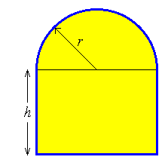

The function to be maximized is

The constraint is the perimeter function

Single variable method:

The only other critical points are on the domain boundaries, at
r = 0 (when A = 0, clearly an absolute minimum) and at h = 0 (when A = ½πr²).

Inside the domain, r > 0 and h > 0 ⇒ A > 0 (and A is differentiable throughout).

Therefore A must be at either a maximum or a point of inflexion at .

Example 2.8.1 (continued)

At the maximum,

The maximum area occurs when

Lagrange Multiplier Method:

⇒ 2h + πr = λ (π + 2) (1)

2r = 2λ (2)

and 2h + (π + 2)r = 8 (3)
Example 2.8.1 (continued)

(2) ⇒ λ = r ⇒ (1) becomes

2h + πr = r (π + 2)
⇒ 2h = 2r
⇒ h = r .

(3) ⇒ (π + 4) r = 8

Therefore
At this critical point,

The ends of the constraint line are at .

At B, A = A_{min} = 0

A > 0 and differentiable at all points between B and C.

Therefore the maximum area of occurs at
Example 2.8.2

Find the local and absolute extrema of the function

By symmetry,

f is continuous on all of ²,
(therefore there is no boundary to check and no critical points of types (1) or (2)), but
| f_{x} | → ∞ and | f_{y} | → ∞ as (x, y) → (0, 0) (critical point of type (3)).
f_{x} ≠ 0 and f_{y} ≠ 0 everywhere else (no critical points of type (4)).

Therefore (0, 0) is the only critical point.

But f (0, 0) = 0 and f (x, y) > 0 for all (x, y) except (0, 0).

Therefore the only critical point is an absolute minimum value of 0 at (0, 0).

[There is a cusp at the origin.]

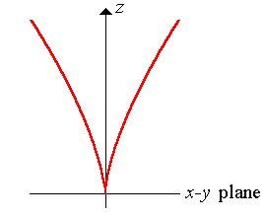

[Any vertical cross-section containing the z axis.]
Example 2.8.3

Find the maximum and minimum values of the function
V (x, y) = 48xy − 32x³ − 24y²
in the unit square 0 < x < 1 , 0 < y < 1 .

[The full solution to this question is available on the course web site, at
"www.engr.mun.ca/~ggeorge/2422/notes/c2maxex1.html".]

−32 ≤ V(x, y) ≤ +2 ,

with the absolute maximum of V at (x, y) = (½, ½)

and the absolute minimum of V at (x, y) = (1, 0).

Example 2.8.4

A hilltop is modelled by the part of the elliptic paraboloid
that is above the x-y plane. At the point P(500, 300, 3390), in which direction is the steepest ascent?

Therefore the steepest ascent is in the direction of the vector

Note that this vector does not point directly at the summit.
The summit is on the z axis.
From the point P(500, 300, 3390), the summit is in the direction ⟨−5, −3⟩.

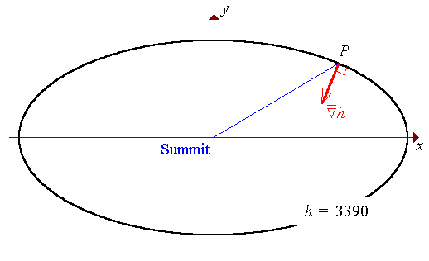
Example 2.8.5

Show that satisfies .

Let r = x − ct

and s = x + ct

Then
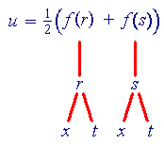

Therefore u_{tt} = c² u_{xx} .

[Thus u(x, t) = ½(f (x − ct) + f (x + ct)) satisfies the wave equation
- and f (r) can be any twice differentiable function of r !

This function models a pair of identical wave forms, moving at speed c in opposite directions.]

[End of Chapter 2]

