3. Ordinary Differential Equations

Equations involving only one independent variable and one or more dependent variables, together with their derivatives with respect to the independent variable, are ordinary differential equations (ODEs). Similar equations involving derivatives and more than one independent variable are partial differential equations (to be studied in a later term).

3.1 Classification; Separation of Variables

Example 3.1.1
Unconstrained population growth can be modelled by

(current rate of increase) is proportional to (current population level).

With x(t) = number in the population at time t,

This is a first order, first degree ODE that is both linear and separable.

The order of an ODE is that of the highest order derivative present.
The degree of an ODE is the exponent of the highest order derivative present.
An ODE is linear if each derivative that appears is raised to the power 1 and is not multiplied by any other derivative (but possibly by a function of the independent variable), that is, if the ODE is of the form
A first order ODE is separable if it can be re-written in the form
f (y) dy = g(x) dx
The solution of a separable first order ODE follows from
Solution of Example 3.1.1:

Let A = e^{C}, then the general solution is
x(t) = A e^{kt} (A > 0) - unconstrained exponential growth
The value of the arbitrary constant A can be found if the value of x is known at any one value of t. Often this information is provided as an initial condition: A = x(0).

Example 3.1.1 (continued)

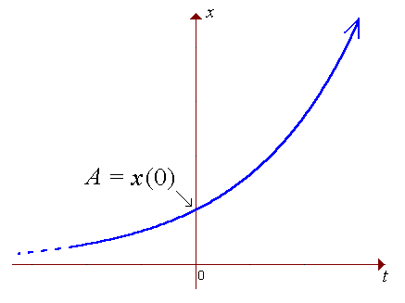

x(t) = A e^{kt} (A > 0) .

Example 3.1.2

One of the simplest constrained growth (or predator-prey) models assumes that the rate of increase in x, (the population as a fraction of the maximum population), is directly proportional to both the current population and the current level of resources (or room to grow). In turn, the level of resources is assumed to be complementary to the population:
resources α 1 − x.

This leads to the constrained population growth model

Classification of this ODE: 1st order, 1st degree, non-linear, separable.

Partial fractions:

Using the cover-up rule:

Example 3.1.2 (continued)

The graph is the logistic curve, (for constrained population growth).

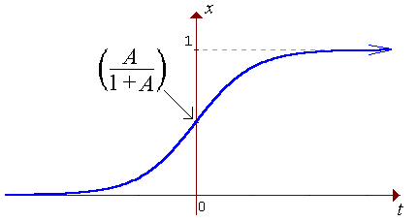

In this course, the only first order ODEs to be considered will have the general form

M(x, y) dx + N(x, y) dy = 0

with the following classification:

Type | Feature
Separable | M(x, y) = f (x) g(y)  and  N(x, y) = h(x) k(y)
Reducible to separable | M(tx, ty) = t^{n} M(x, y)  and  N(tx, ty) = t^{n} N(x, y)  for the same n
Exact
Linear | M/N = P(x)y − R(x)  or  N/M = Q(y)x − S(y)
Bernoulli | M/N = P(x)y − R(x)y^{n}  or  N/M = Q(y)x − S(y)x^{n}
[Only the separable, exact and linear types will be examinable.]

Example 3.1.3 Terminal Speed

A particle falls under gravity from rest through a viscous medium such that the drag force is proportional to the square of the speed. Find the speed v(t) at any time t > 0 and find the terminal speed v∞.
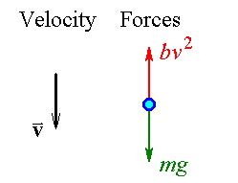
Newton’s Second Law:

(Net force = weight − drag force)
In standard form,
∴ type separable.
Example 3.1.3 (continued)

Partial fractions:

⇒ v − k = v A e^{−pt} + k A e^{−pt}

⇒ v (1 − A e^{−pt}) = k (1 + A e^{−pt})

Example 3.1.3 (continued)

General solution:

Initial condition: v(0) = 0

Complete solution:

Terminal speed v∞:

Graph of speed against time:

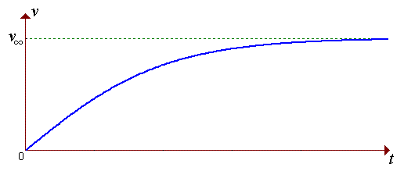
[For a 90 kg person in air, b ≈ 1 kg m⁻¹ → k ≈ 30 ms⁻¹ ≈ 100 km/h.
v(t) is approximately linear at first, but air resistance builds quickly.
One gets within 10 km/h of terminal velocity very fast, in just a few seconds.]
3.2 Exact First Order ODEs

Method:

The solution to the first order ordinary differential equation

M(x, y) dx + N(x, y) dy = 0

can be written in the implicit form

u(x, y) = c , (where c is a constant)
.

If M(x, y) and N(x, y) can be written as the first partial derivatives of some function u with respect to x and y respectively, then Clairaut’s theorem,
leads to the test for an exact ODE:

from which either
(and use u_{y} = N to find the arbitrary function of integration f (y) )

or
.
(and use u_{x} = M to find the arbitrary function of integration g(x) )

Note that these anti-derivatives are partial:
In , treat y as though it were constant during the integration.

In , treat x as though it were constant during the integration.

After suitable rearrangement, a separable first order ODE is also exact,
(but not all exact ODEs are separable).
Example 3.2.1
Find the general solution of .

Rewrite as

The test for an exact ODE is positive:

where f (y) is an arbitrary function of integration.

But N(x, y) = e^{x} ⇒ f'(y) = 0 ⇒ f (y) = c₁

Therefore

The general solution is

Check:

⇒ y' + y = x e^{−x}

⇒ (y' + y) e^{x} = x 

Example 3.2.1 (alternative method)
Find the general solution of .

Rewrite as

The test for an exact ODE is positive:

where g(x) is an arbitrary function of integration.

But M = y e^{x} − x ⇒ g'(x) = −x

Example 3.2.2

separable.

But
Therefore the ODE is also exact.

⇒ u_{y} = 0 + f '(y)

But N = −y ⇒ f '(y) = −y

Check:

⇒ xy y' = 1 

A separable first order ODE is also exact (after suitable rearrangement).

f (x) g(y) dx + h(x) k(y) dy = 0

Therefore exact !

However, the converse is false: an exact first order ODE is not necessarily separable.

A single counter-example is sufficient to establish this.
Example 3.2.1:

(y' + y) e^{x} = x

is exact, but not separable.

Example 3.2.3

Find the equation of the curve that passes through the point (1, 2) and whose slope at any point (x, y) is 2y / x .

Solution by the method of separation of variables:

This ODE is separable.

⇒ y = A x² (family of parabolae).

But (1, 2) is on the curve

⇒ 2 = A (1)²

Therefore y = 2 x²

Solution starting with the recognition of an exact ODE:

which is not exact.

However, is exact:

Example 3.2.3 (continued)

⇒ u_{y} = 0 + f '(y)

⇒ f (y) = − ln y + c₁

⇒ u(x, y) = 2 ln x − ln y + c₁ = c₂

⇒ ln y = ln x² + C = ln (A x²)

⇒ y = A x² (as before).

In general, if an exact ODE is seen to be separable, (or separable after suitable rearrangement), then a solution using the method of separation of variables is usually much faster.
Some Practice Questions

Example 3.2.4

Find the complete solution of
3x²y⁴ dx + 4x³y³ dy = 0 , y = 2 when x = ½.

P = 3x²y⁴ and Q = 4x³y³ are both of the type f (x) g(y).

Therefore the ODE is separable.
⇒ 4 ln y = C − 3 ln x

⇒ ln y⁴ = C + ln x⁻³ = ln (A x⁻³)

⇒ y⁴ = A x⁻³ or x³y⁴ = A

OR

P_{y} = 12x²y³ = Q_{x}

Therefore the ODE is exact.

Exact method:

Seek u(x, y) such that
⇒ u = x³y⁴ + c₁ = c₂

The [implicit] general solution is

x³y⁴ = A

But (0.5, 2) lies on the curve

Complete solution:

x³y⁴ = 2
Example 3.2.5

Solve
(2xy + 2x) dx + (x² + 1) dy = 0

P = 2xy + 2x = 2x(y + 1) and Q = x² + 1 are both of the type f (x) g(y).

Therefore the ODE is separable.

Therefore the general solution is

(x² + 1)(y + 1) = A

OR

P_{y} = 2x = Q_{x}

Therefore the ODE is exact.

Exact method:

Seek u(x, y) such that

⇒ u = (x² + 1)(y + 1) = A

If one cannot spot the functional form for u(x, y), then

⇒ u_{y} = x² + f '(y)

But N = x² + 1 ⇒ f '(y) = 1 ⇒ f (y) = y + c₁

⇒ u = x²(y + 1) + y + c₁ = c₂

Let A = c₂ − c₁ + 1 , then (x² + 1)(y + 1) = A
Example 3.2.6

Solve

cos (x − y) cannot be expressed in the form f (x) g(y).

This ODE is not separable.

P = cos (x − y) + y sin (x − y)

⇒ P_{y} = +1 sin (x − y) + 1 sin (x − y) − y cos (x − y)

Q = −2 cos (x − y) − y sin (x − y)

⇒ Q_{x} = +2 sin (x − y) − y cos (x − y) = P_{y}

Therefore the ODE is exact.

Seek u(x, y) such that

⇒ u = sin (x − y) − y cos (x − y) = A

3.3 Integrating Factor

Before introducing the general method, let us examine a specific example.

Example 3.3.1

Convert the first order ordinary differential equation

2y dx + x dy = 0

into exact form and solve it, (without direct use of the method of separation of variables).
[Note, this ODE is different from Example 3.2.3.]

The ODE is separable and we can therefore rearrange it quickly into an exact form:

However, let us seek a more systematic way of converting a non-exact form into an exact form.

Let I(x, y) be an integrating factor, such that {(the ODE) × I(x, y)} is exact:

M_{y} = 2I + 2y I_{y}

N_{x} = I + x I_{x}

We need a simplifying assumption (in order to avoid dealing with partial differential equations).

Suppose that I = I (x), then

I_{y} = 0 and I_{x} = I' (x)

M_{y} = N_{x} ⇒ 2I + 0 = I + x I' (x)

Example 3.3.1 (continued)

⇒ ln I = ln x + C = ln (Ax)

⇒ I (x) = Ax

Multiplying the original ODE by I (x), we obtain the exact ODE (different from the separable-and-exact form)

2y Ax dx + A x² dy = 0

A is an arbitrary constant of integration. Any non-zero choice for A allows us to divide the new ODE by that choice, to leave us with the equivalent exact ODE

2xy dx + x² dy = 0

Therefore, upon integrating to find the integrating factor I (x), we can safely ignore the arbitrary constant of integration.

If we notice that
and
then we can immediately conclude that

u = x²y = c

so that the general solution of the original ODE is
Example 3.3.1 (continued)

If we fail to spot the form for the potential function u, then we are faced with one of the two longer methods:

Either

But N = x² ⇒ f '(y) = 0 ⇒ f (y) = c₁

⇒ u = x²y + c₁ = c₂ ⇒ x²y = A

or

But M = 2xy ⇒ g'(x) = 0 ⇒ g(x) = c₁

⇒ u = x²y + c₁ = c₂ ⇒ x²y = A

The functional form for the integrating factor for an ODE is not unique.
In example 3.3.1, I(x, y) = Ax^{2n+1}y^{n} is also an integrating factor, for any value of n and for any non-zero value of A.

Proof:
ODE 2y dx + x dy = 0 becomes
Example 3.3.1 (continued)

One can show that the corresponding potential function is
both of which lead to

Checking our solution:

Dividing by x :

which is the original ODE. 
Integrating Factor – General Method:

Occasionally it is possible to transform a non-exact first order ODE into exact form.
Suppose that
P dx + Q dy = 0
is not exact, but that
IP dx + IQ dy = 0
is exact, where I (x, y) is an integrating factor.

Then, using the product rule,

and

From the exactness condition

If we assume that the integrating factor is a function of x alone, then

This assumption is valid only if is a function of x only.

If so, then the integrating factor is

[Note that the arbitrary constant of integration can be omitted safely.] Then

If we assume that the integrating factor is a function of y alone, then
This assumption is valid only if a function of y only.

If so, then the integrating factor is and

Example 3.3.2

Solve the first order ordinary differential equation

The ODE is not separable.

P_{y} = 3x² + 6x + y

Q_{x} = 6x + 0 ≠ P_{y}

Therefore the ODE is not exact.

P_{y} − Q_{x} = 3x² + y

[may ignore arbitrary constant of integration]

Therefore an exact form of the ODE is

Example 3.3.2 (continued)

M_{y} = (3x² + 6x + y) e^{x}

N_{x} = (6x + 0 + 3x² + y) e^{x} = M_{y}

Therefore the ODE is, indeed, exact.

If one cannot spot the potential function u(x, y) = (3x²y + ½y²) e^{x} , then the next fastest path to a solution is

[Note that an anti-differentiation of M with respect to x would involve an integration by parts.]

General solution:

Example 3.3.3

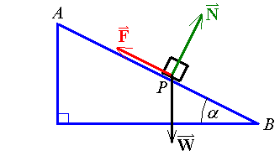
A block is sliding down a slope of angle α, as shown, under the influence of its weight, the normal reaction force and the dynamic friction (which consists of two components, a surface term that is proportional to the normal reaction force and an air resistance term that is proportional to the speed). The block starts sliding from rest at A. Find the distance s(t) travelled down the slope after any time t (until the block reaches B).

AP = s(t)

AB = L

W = mg

N = W cos α

Friction = surface + air

F = μN + kv

Starts at rest from A ⇒ v(0) = s(0) = 0

Forces down-slope:

Separation of variables method:

Example 3.3.3 (continued)

⇒ ln (a − bv) = − bt + C

⇒ a − bv = C₃ e^{− bt}

But v(0) = 0

Therefore

OR

Integrating factor method:

⇒ (bv − a) dt + dv = 0

This ODE is not exact.

Assume that the integrating factor is a function of t only: I = I (t).

P = bv − a ⇒ P_{v} = b

Q = 1 ⇒ Q_{t} = 0

Example 3.3.3 (continued)

The ODE becomes the exact form

(bv − a) e^{bt} dt + e^{bt} dv = 0

M = (bv − a) e^{bt} , N = e^{bt}

We want a function u(t, v) such that

One can easily spot that such a function is

But v(0) = 0

Therefore

But s(0) = 0

Therefore

or
Example 3.3.3 (continued)

The terminal speed v∞ is

The object will not begin to move unless F < W sin α

⇒ a > 0

⇒ tan α > μ .

[The slope has to be steep enough to overcome the force of static friction.]

For a 10 kg block sliding down a slope of angle 30°, with , with
g ≈ 9.81 ms⁻², the terminal speed is just over 24.51 ms⁻¹ and the graphs of speed and position are

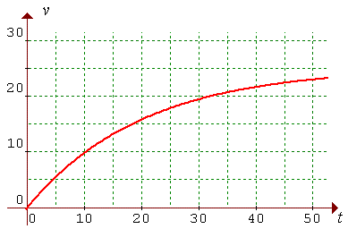
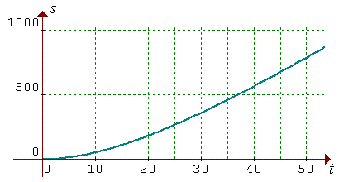

Example 3.3.4

Find the solution of
x + y + y' = 0
that passes through the origin.

The ODE is not separable.

P_{y} = 1 but Q_{x} = 0.

Therefore the ODE is not exact.

Try an integrating factor of the form I = I (x).

The ODE becomes the exact form

But (0, 0) is on the curve

⇒ 0 = 1 − 0 + A ⇒ A = −1

The complete solution is therefore
y = 1 − x − e^{−x}

Check:
x + y + y' = (x) + (1 − x − e^{−x}) + (0 − 1 + e^{−x} ) = 0 
3.4 First Order Linear ODEs

The general form of a first order linear ordinary differential equation is
[or, in some cases,
]

Rearranging the first ODE into standard form,

(P(x) y − R(x)) dx + 1 dy = 0

Written in the standard exact form with an integrating factor in place, the first equation becomes
I (x) (P(x) y − R(x)) dx + I (x) dy = 0

Compare this with the exact ODE
du = M(x, y) dx + N(x, y) dy = 0

The exactness condition

ln I (x) = h(x)

and the integrating factor is
.
The ODE becomes the exact form
e^{h} (Py − R) dx + e^{h} dy = 0

M = e^{h} (Py − R) , N = e^{h} and h' = P .

But N = e^{h} ⇒ f '(y) = 0

Therefore the general solution of is

A note on the arbitrary constant of integration in :

then

Therefore we may set the arbitrary constant in to any value we wish, including zero, without affecting the general solution of the ODE at all.
Example 3.4.1

Solve
y' + 2y = 6e^{x}

Compare with

y' + P(x) y = R(x)

The ODE is linear, with P(x) = 2 and R(x) = 6e^{x} .

Therefore the general solution is

y = 2 e^{x} + A e^{−2x}

Check:

y' = 2 e^{x} − 2A e^{−2x}



Example 3.4.2 :
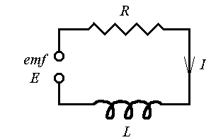
Find the current I (t) flowing through this simple RL circuit at any time t.

The electromotive force is sinusoidal:

E(t) = E_{o}sin ωt

The voltage drop across the resistor is RI .

The voltage drop across the inductor is .

Therefore the ODE to be solved is
- which is linear.

The integrating factor is therefore e^{h} = e^{Rt/L}

A two-step integration by parts and some algebraic simplification lead to
Details:
D |  | I
sin ωt |  | e^{Rt/L}
 | +
ω cos ωt
 | −
−ω² sin ωt | — + →  integrate

Example 3.4.2 (continued)

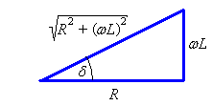
Introducing the phase angle δ , such that ωL = R tan δ , leads to
and
Also
sin ωt cos δ − cos ωt sin δ ≡ sin(ωt − δ)
Therefore

The general solution
then becomes
For most realistic circuits, the current reaches 99% of its steady state value in just a few microseconds.
Example 3.4.3

Find the general solution of the ODE

y' − y = sinh x

P = −1 R = sinh x

Therefore the ODE is linear.

⇒ Integrating factor is e^{h} = e^{−x}

[Note: integration by parts fails for this integral!]

Therefore

Note: this is equivalent to

[because e^{x} = cosh x + sinh x and e^{–x} = cosh x – sinh x ]
Example 3.4.4

Solve the ODE

The ODE is not separable.

Re-writing the ODE in standard form,

M_{y} = 2 e^{2y}

N_{x} = 2 e^{2y} − 0 = M_{y}

Therefore the ODE is exact.

⇒ f '(y) = −1 ⇒ f (y) = −y + c

⇒ u = x e^{2y} − y = A

Therefore the general solution is

x e^{2y} − y = A

OR

Example 3.4.4 Alternative Method:

Compare with

Therefore the ODE is linear (for x as a function of y).

Review for the solution of first order first degree ODEs:

P dx + Q dy = 0

1. Is the ODE separable? If so, use separation of variables. If not, then

2. Can the ODE be re-written in the form y' + P(x) y = R(x) ?
If so, it is linear.
Else

3. Is P_{y} = Q_{x} ? If so, then the ODE is exact.
Seek u such that .
The solution is u = c.
Else

4. Is a function of x only?
If so, the integrating factor is
Then solve the exact ODE I P dx + I Q dy = 0 .
Else,

5. Is a function of y only?
If so, the integrating factor is
Then solve the exact ODE I P dx + I Q dy = 0 .

A first order ODE that does not fall into one of the five classes above is beyond the scope of this course.

3.5 Reduction of Order

Occasionally a second order ordinary differential equation can be reduced to a pair of first order ordinary differential equations.
If the ODE is of the form
f (y", y', x) = 0
(that is, no y term), then the ODE becomes the pair of linked first order ODEs
f (p', p, x) = 0 , p = y'
If the ODE is of the form
g (y", y', y) = 0
(that is, no x term), then the ODE becomes the pair of linked first order ODEs
where the chain rule ⇒

Example 3.5.1

Find the general solution of the second order ordinary differential equation

x y" + 2y' = 4x³

Let p = y' then

x p' + 2p = 4x³

which is linear.

Example 3.5.1 (continued)

Note that the number of arbitrary constants of integration in the general solution matches the order of the ordinary differential equation.

Example 3.5.2
.
This second order ODE can be solved by either of the two methods of reduction of order.

Method 1: The ODE becomes

(provided p ≠ 0)

Case p ≠ 0:

The case p = 0 ( ⇒ y = A ) needs to be considered separately.

It is a [trivial] solution of the ODE but it is not included in the general solution.
Therefore we need to add the singular solution y = A to our general solution.
General solution:

y = B − ln(x + A) or y = A .
Example 3.5.2 (continued)

Method 2: The ODE becomes

The case p = 0 leads to a singular solution (y = A) as above.
Following the other branch:

which is separable.

This leads to the same general solution as before:

Example 3.5.3

Solve
y" = 2 y y'

p = 0 ⇒ y = A , which does satisfy the ODE y" = 2 y y'
.

The other branch is separable.

This is also separable.

We need to quote some standard integrals:

and

Example 3.5.3 (continued)

If A > 0 then

If A = 0 then

If A < 0 then | A | = −A and

The solution y = A does not fit into any of these categories.

Putting all four cases together, the general solution of y" = 2 y y' is:

3.6 Applications
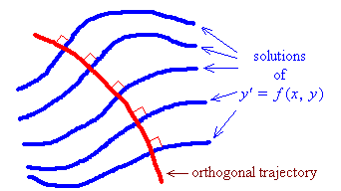
Orthogonal trajectories

A family of curves in ² can be represented by the ODE

Any curve, whose intersection with any member of that family occurs at right angles, must satisfy the ODE
.

Another family of curves, all of which intersect each member of the first family only at right angles, must also satisfy the ODE
.

Example 3.6.1

Find the orthogonal trajectories to the family of curves

xy = c
xy = c ⇒ 1y + xy' = 0
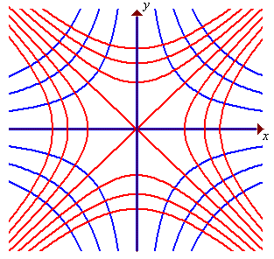

The orthogonal trajectories must satisfy the ODE

x² − y² = A
[blue: xy = c ; red = x² − y² = A ]
Example 3.6.2

Find the orthogonal trajectories to the equipotentials of the electric field,
where .

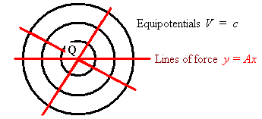

Orthogonal trajectories satisfy

⇒ ln y = ln x + C = ln x + ln A

⇒ y = Ax – a family of radial lines.

Lines of force and equipotential curves are examples of orthogonal trajectories. Taking the inverse case to Example 3.6.2, for a central force law, the lines of force are radial lines y = k x. All of these lines satisfy the ODE . The equipotential curves must then be solutions of the ODE
The general solution can be re-written as x² + y² = r² , which is clearly the equations of a family of concentric circles.
Other Applications

Newton’s Law of Cooling

If t = time, Θ(t) = temperature and Θ_{f} = ambient [surrounding] temperature, then the rate at which the temperature of an object decreases, when it is immersed in some other substance whose steady temperature is Θ_{f} , is proportional to the temperature difference:

Example 3.6.3

An object is removed from boiling water (at 100°C) and is left in air at room temperature (20°C). After ten minutes, its temperature has fallen to 60°C. Find its temperature Θ(t).

which is separable.
[Note that the negative sign has been absorbed into the unknown constant k.]

But Θ(0) = 100

⇒ 100 = 20 + A ⇒ A = 80

and Θ(10) = 60

⇒ 60 = 20 + 80 e^{10k}

Therefore Θ(t) = 20 + 80×2^{−t/10} = 20(1 + 2^{(2 − t/10)})
Example 3.6.4

A right circular cylindrical tank is oriented with its axis of symmetry vertical. Its circular cross-sections have an area A (m²). Water enters the tank at the rate Q (m³s⁻¹). Water leaves through a hole, of area a , in the base of the tank. The initial height of the water is h_{o}. Find the height h(t) and the steady-state height h∞.

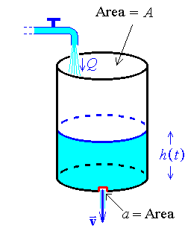
Torricelli:

Change of volume:

But V = A h

This ODE is separable.

Let u = h^{1/2} ⇒ du = (1/2) h^{−1/2} dh ⇒ dh = 2 u du

Therefore
Example 3.6.4 (continued)

t can be found as an explicit function of h, but not vice-versa.

Alternative method: In the steady state, flows in and out balance, so that .
Setting in the ODE:

Two additional resources are available on the web site:
More Examples of ODEs (at www.engr.mun.ca/~ggeorge/2422/notes/c3tutorl.html)
and
Examples of Partial Fractions (at www.engr.mun.ca/~ggeorge/2422/notes/partialFrac.html)

Also see other examples in problem sets and in past tests and examinations.

END OF CHAPTER 3

