5.01 Transforms

In some situations, a difficult problem can be transformed into an easier problem, whose solution can be transformed back into the solution of the original problem. For example, an integrating factor can sometimes be found to transform a non-exact first order first degree ordinary differential equation into an exact ODE:
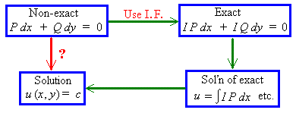

One type of first order ODE [not considered in this semester] is the Bernoulli ODE,
y' + P y = R y ^{u} , which, upon a transformation of the dependent variable, becomes a linear ODE:
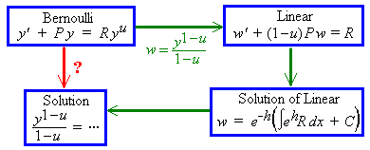

An initial value problem is an ordinary differential equation together with sufficient initial conditions to determine all of the arbitrary constants of integration. A Laplace transform will convert an initial value problem into a much easier algebra problem. The solution of the original problem is then the inverse Laplace transform of the solution to the algebra problem.
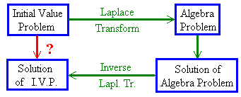
Uses of Laplace transforms include:
1) the solution of some ordinary differential equations
2) the solution of some integro-differential equations, such as
.
5.02 Some Laplace Transforms

If f (t) is
- defined on t > 0,
- piece-wise continuous on t > 0
(that is, only a finite number of finite discontinuities) and
- of exponential order
[ | f (t) | < k e^{αt} for all t > 0 and for some positive constants k and α ],
then
exists and
the Laplace transform of f (t) is

Example 5.2.1

Find L{ 1 } .

Example 5.2.2

Find L{ t } .

Integration by parts:

D |  | I
t
 | +
1
 | −
0

Linearity Property of Laplace Transforms

L { a f (t) + b g(t) } (where a, b are constants):

= a L { f (t) } + b L { g(t) } , (provided all of the integrals exist).

[Thus the Laplace transform of a linear combination of functions is the linear combination of the separate Laplace transforms.]
Example 5.2.3

Find L { 2t − 3 } .

Example 5.2.4

Find L { t^{n} } .

D |  | I
t ^{n}
 | +
n t ^{n − 1} | — − →  integrate

— a recurrence relation

Example 5.2.5

Find L { t ⁴ + 2t ³ − 3 } .

5.03 Laplace Transforms of Derivatives

(integration by parts)

Therefore

,

(provided f is continuous at t = 0).

Therefore

,

(provided f and f ' are continuous at t = 0).

Continuing this pattern, we can deduce the Laplace transform for any higher derivative of f (t):

or

This result allows us to find the Laplace transform of an entire initial value problem.
Example 5.3.1

Find the Laplace transform of the initial value problem

y" + y = t , y(0) = 1 , y'(0) = 0

and hence find the complete solution.

Let Y(s) = L{ y(t) }, then

L{ y" + y } = s ²Y − s y(0) − y' (0) + Y

Therefore the Laplace transform of the initial value problem is

which is an algebra problem for Y(s), (the Laplace transform of the complete solution).
Solving the algebra problem:

In section 5.04 we shall see how to find the inverse Laplace transforms
The complete solution to the initial value problem is therefore

y(t) = cos t + t − sin t

5.04 First Shifting Theorem;
Transforms of Exponential, Cosine and Sine Functions

The first shifting theorem then follows:

Example 5.4.1

Find L {t ³e ^{5t} } .

[using the first shift theorem]

Example 5.4.2

Find L { e ^{at} } .

[using the first shift theorem]

Example 5.4.3

Find L { cos ωt } .

Therefore

Example 5.4.4

Find L { sin ωt } .

Therefore

It then follows that
and
Example 5.4.5

Find L { sin ωt } directly, from the definition of a Laplace transform.
D |  | I
 |  | sin ωt
 | +
 | −
— + →
integrate

Example 5.4.6

Find L { sin ωt } , using L { cos ωt }.

Example 5.4.7

Find L { e^{at} sin ωt } .

Using the first shift theorem, we have, immediately,

Similarly,

Example 5.4.8

Find L { tan ωt } .

tan ωt is not of exponential order.
[Also, it has infinitely many infinite discontinuities.]
Therefore
L { tan ωt } does not exist.

Example 5.4.9

Find L { sinh at } .

Similarly,
Summary so far:

Definition:

Linearity:

Polynomial functions:

First Shift Theorem:
and

Trigonometric Functions:

Hyperbolic Functions:

Derivatives:
etc.

When trying to find the inverse Laplace transform of a rational function F (s), one usually attempts to break the function up into its partial fractions, with real linear and quadratic denominators, so that one may read the inverses from the table on this page.

5.05 Applications to Initial Value Problems

Example 5.5.1

Solve the initial value problem

y" − 5y' + 6y = 0 , y(0) = 1, y'(0) = 0

Let Y(s) = L{ y(t) } .

L{ y" } = s ² Y(s) − s y(0) − y'(0) = s ² Y(s) − s

L{ y' } = s Y(s) − y(0) = s Y(s) − 1

Taking the Laplace transform of the entire initial value problem:

L{ y" − 5y' + 6y } = L{ 0 } ⇒

Check 1:

y' = 6 e^{2t} − 6 e^{3t} ⇒ y" = 12 e^{2t} − 18 e^{3t}

⇒ y" − 5y' + 6y = (12 − 30 + 18) e^{2t} + (−18 + 30 −12) e^{3t} = 0 

and y(0) = 3 − 2 = 1  and y'(0) = 6 − 6 = 0 
Example 5.5.1 (continued)

Check 2:

Solution by Chapter 4 method:

y" − 5y' + 6y = 0

A.E.: λ ² − 5λ + 6 = 0

⇒ (λ − 2) (λ − 3) = 0 ⇒ λ = 2, 3.

C.F.: y_{C} = A e^{2t} + B e^{3t}

P.S.: y_{P} = 0

G.S. = C.F.

y' (t) = 2A e^{2t} + 3B e^{3t}

I.C.: y(0) = A + B = 1 ⇒ B = 1 – A

y'(0) = 2A + 3B = 2A + 3(1 – A) = 0

Therefore the complete solution is

y(t) = 3 e^{2t} − 2 e^{3t} 

Example 5.5.2

Solve the initial value problem

y" + 4y' + 13y = 26 e^{−4t} , y(0) = 5, y'(0) = −29

Let Y(s) = L{ y(t) } .

L{ y" } = s ² Y(s) − s y(0) − y'(0) = s ² Y(s) − 5s + 29

L{ y' } = s Y(s) − y(0) = s Y(s) − 5

Taking the Laplace transform of the entire initial value problem:

Recall the three standard inverse Laplace transforms:

Example 5.5.2 (continued)

We need to express Y(s) in partial fractions and to complete the square in the quadratic denominator.

This rearrangement allows us to see immediately that the solution is
We need to find the values of the numerators a, b and c:

Cover-up rule for a:

s = −2: 20 − 22 − 10 = 2(4 − 8 + 13) + 0 + 3c(2)

⇒ −12 − 18 = 6c ⇒ 6c = − 30 ⇒ c = −5

s = 0: −10 = 2(13) + 8b + 12(−5)

⇒ 8b = −10 − 26 + 60 = 24 ⇒ b = 3

Therefore

⇒

Example 5.5.2 (by a Chapter 4 method)

y" + 4y' + 13y = 26 e^{−4t} , y(0) = 5, y'(0) = −29

A.E.: λ ² + 4λ + 13 = 0

C.F.: y_{C} = e^{−2t} (A cos 3t + B sin 3t)

P.S.: Try y_{P} = d e^{−4t} [method of undetermined coefficients]

y"_{P} + 4y'_{P} + 13y_{P} = d e^{−4t} (16 − 16 + 13) = 26 e^{−4t}

⇒ d = 2

G.S.: y = y_{C} + y_{P} = e^{−2t} (A cos 3t + B sin 3t) + 2 e^{−4t}

⇒ y' = e^{−2t} (−3A sin 3t + 3B cos 3t − 2A cos 3t − 2B sin 3t) − 8 e^{−4t}

I.C.: y(0) = A + 2 = 5 ⇒ A = 3

y'(0) = 0 + 3B − 2(3) − 0 − 8 = −29 ⇒ 3B = −15 ⇒ B = −5

Complete solution:

5.06 Laplace Transform of an Integral

f (0) = 0 ,

g(t) = f '(t) and

[Division in the s domain corresponds to integration in the t domain.
If the initial conditions are all zero, then
Multiplication in the s domain corresponds to differentiation in the t domain.]

Also

Example 5.6.1

Find the function f (t) whose Laplace transform is .

Therefore
Example 5.6.1 (Alternative solution, using partial fractions)

Example 5.6.2

Find the function f (t) whose Laplace transform is .

Therefore

Alternative method, using partial fractions:

5.07 Heaviside Function; Second Shift Theorem

The Heaviside function H(t − a) (also known as the unit step function u(t − a) ) is defined by
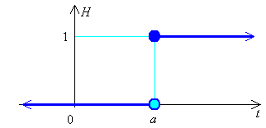

The Laplace transform of the Heaviside function is:

Therefore

If
then
[The function h(t) is “switched on” and g(t) is “switched off” at time t = a.]
Example 5.7.1 (This is part of a question on Problem Set 9)

Express the function
in a single line definition.

Answer: f (x) = 2x + (4 − 2x) H(x − 2)

The Second Shift Theorem

The result of shifting the graph y = f (t) (defined only for t > 0) a units to the right, is the graph y = f (t − a) H(t − a):

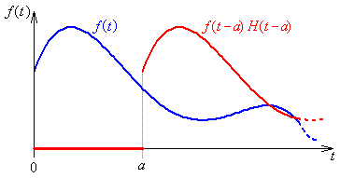

The Laplace transform of the shifted function of t is:

Let u = t − a ⇒ du = dt and
The second shift theorem (for a > 0) is

Another way to express the second shift theorem is:

Example 5.7.2

Find L{ H(t − 4) (t − 4)³ } .

L{ H(t − 4) (t − 4)³ } = e^{−4s} L{ t³ } (by the second shift theorem)

Example 5.7.3

Find the function whose Laplace transform is .

Example 5.7.4

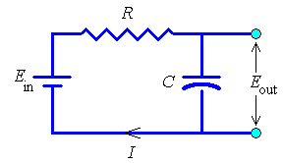
In the RC circuit shown here, there is no charge on the capacitor and no current flowing at the time t = 0.

The input voltage E_{in} is a constant E_{o} during the time t₁ < t < t₂ and is zero at all other times.

Find the output voltage E_{out} for this circuit.

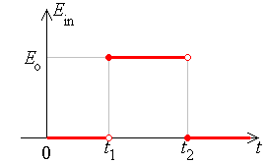
Initial conditions:
q(0) = i(0) = 0

⇒ E_{in} = E_{o} (H(t − t₁) − H(t − t₂) )

Equating voltage drops around the circuit with E_{in} :

Let Q(s) = L{ q(t) }. Taking the Laplace transform of this initial value problem:

Example 5.7.4 (continued)

Using the cover-up rule for the partial fractions:

Therefore, using the second shift theorem,

Graph of the output voltage against time:
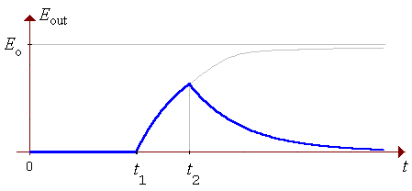
The capacitor charges from 0 at time t₁ then discharges from time t₂ onwards.
Example 5.7.5

Find the complete solution of the initial value problem

Let Y(s) = L{ y(t) }

f (t) = t H(t − 3) = (t − 3) H(t − 3) + 3 H(t − 3)
⇒ L{ f (t) } = e^{−3s} L{ t + 3} [second shift theorem]

L{ y" + 4y } = L{ f (t) }

⇒ 3s + 1 = as(s ² + 4) + b(s ² + 4) + c s ³ + 2d s ²

Matching coefficients of s ^{n}:

s ⁰ : 1 = 0 + 4b + 0 + 0 ⇒ b = 1/4

s ¹ : 3 = 4a + 0 + 0 + 0 ⇒ a = 3/4

s ² : 0 = 0 + 1/4 + 0 + 2d ⇒ d = −1/8

s ³ : 0 = 3/4 + 0 + c + 0 ⇒ c = −3/4

Example 5.7.5 (continued)

One version of the second shift theorem states

Therefore

or equivalently

[Note: an alternative to partial fractions is:

Quoting standard inverses, we obtain immediately

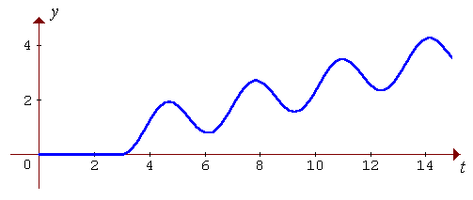
5.08 The Dirac Delta Function
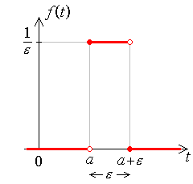

Also

Define the Dirac delta function to be
then

Therefore (for a > 0)

and .

Also, for a > 0, the total area under the graph is 1 (even in the limit as ε → 0⁺), so

For g(t) = any function that is continuous everywhere on [0, ∞),

= g(a)

Therefore

(which is the sifting property of the Dirac delta function).

Example 5.8.1

A damped mass-spring system, (with damping constant = c = 3m and spring modulus = k = 2m, where m is the mass), is at rest in its equilibrium position, until an impulse of 1 Ns is applied at time t = 1 s. Find the response y(t).

ODE: y" + 3y' + 2y = δ (t − 1)

I.C.: y'(0) = y(0) = 0

One can anticipate some features of the response. The forcing function is zero until t = 1. Thus there is nothing to disturb the system until that instant. We can deduce that y(t) ≡ 0 during t < 1. The mass-spring system is set into motion abruptly by the arrival of the impulse at the instant t = 1, but the forcing term is again zero thereafter. The damping force will asymptotically restore the system to its equilibrium state. The only question remaining is whether the system is under-damped or not (see the diagram on the next page).

Example 5.8.1 (continued)

Anticipated response:

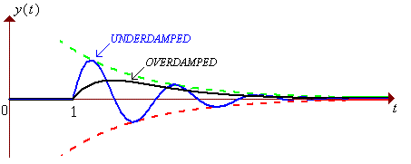

The auxiliary equation is λ ² + 3λ + 2 = 0. The discriminant is

D = B ² − 4C = 3 ² − 4(2) = 9 − 8 > 0

⇒ system is over-damped.

Solution, using Laplace transforms:

y" + 3y' + 2y = δ (t − 1)

y'(0) = y(0) = 0

Let Y(s) = L{ y(t) }

⇒ s ²Y + 3sY + 2Y = e^{−1s}

Example 5.8.1 (continued)

From the first shift theorem:

The second shift theorem states:

Therefore

or, equivalently,

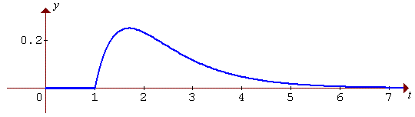

5.09 Periodic Functions

If the constant p > 0 and f (t + p) = f (t) for all t > 0, then
f (t) is a periodic function of t, with period p.

Example of a periodic function (with one finite discontinuity in each period):
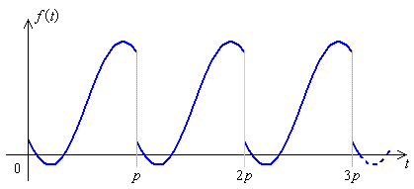

Define a new set of functions g_{n}(t), each of which captures only a single period of f (t):
Then
Let F(s) = L{ f (t) } , then

Let τ = t − np ⇒ dτ = dt and

Therefore, for a periodic function f (t) with fundamental period p,

Example 5.9.1

Use the formula above to verify the Laplace transform of f (t) = sin ωt .

= ... [after two integrations by parts and algebraic manipulation] ... =

Therefore

Example 5.9.2 The Square Wave

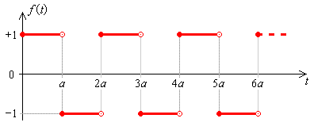

The square wave is periodic, with fundamental period p = 2a .

In the “zeroth” period (0 < t < 2a),
The Laplace transform F(s) of the square wave f (t) then follows.

Set 2x = as, then

Example 5.9.3 The Saw-tooth Wave

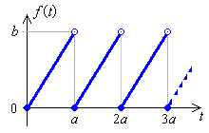
The saw-tooth wave is periodic, with fundamental period p = a .

In the “zeroth” period (0 < t < a),
The Laplace transform F(s) of the saw-tooth wave f (t) then follows.

Integration by parts:

D |  | I
t
 | +
1
 | −
0

Example 5.9.4

Find the function f (t) whose Laplace transform is
(where a is a constant).

then g(t) = L ⁻¹{ G(s) } = the square wave, of period p = 2a.

This integral can be developed graphically:
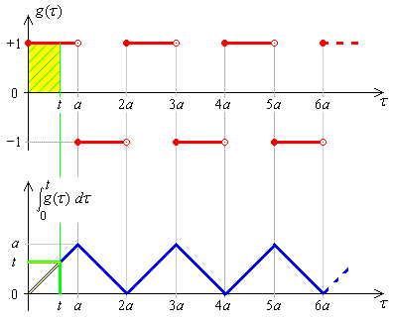

Therefore f (t) = triangular wave, period 2a, amplitude a.

Also:

5.10 The Derivative of a Laplace Transform

Example 5.10.1

Find F(s) = L { t cos ωt }.

Method via an ODE:

Let f (t) = t cos ωt

Then f '(t) = cos ωt − ωt sin ωt

and f "(t) = −ω sin ωt − (ω sin ωt + ω²t cos ωt) = −2ω sin ωt − ω² f (t)

Also f (0) = 0

f '(0) = 1 − 0 = 1

Taking the Laplace transform of this initial value problem,

Therefore

Using Leibnitz differentiation of an integral [section 1.9]:
Therefore
⇒
Example 5.10.1 (again)

Find F(s) = L { t cos ωt }.

Method via the derivative of a transform:

Let g(t) = cos ωt

Example 5.10.2

Find F(s) = L { t sin ωt }.

Therefore

5.11 Convolution

If L{ f (t) } = F(s)
and L{ g(t) } = G(s)
then the convolution of f (t) and g(t) is denoted by (f * g)(t), is defined by

and the Laplace transform of the convolution of two functions is the product of the separate Laplace transforms:

An equivalent identity is

Convolution is commutative:

Example 5.11.1

Find the inverse Laplace transform of

R = F G ⇒ r = f * g

Example 5.11.1 (continued)

Integration by parts:

D |  | I
t − τ
 | +
−1
 | −
0

Therefore

Note:

This inverse transform can also be found using partial fractions or the division of another Laplace transform by s. Both of these alternatives are in example 5.6.2 [on page 5.19].

Example 5.11.2

Find

The alternative methods that were available in example 5.11.1 are not available here. The only obvious way to proceed is via convolution.

R = F G ⇒ r = f * g

But sin A sin B = ½ (cos(A − B) − cos(A + B) )

Therefore

Transfer Function

For a second order linear ordinary differential equation with constant coefficients, when both initial conditions are zero, the complete solution can be expressed as a convolution.

y" + by' + cy = r(t) and y(0) = y' (0) = 0

⇒ (s ² + bs + c) Y(s) = R(s)

⇒ Y(s) = Q(s) R(s) , where Q(s) is the transfer function:

The complete solution is just y(t) = q(t) * r(t) , where

Example 5.11.3

A unit impulse is delivered at time t = 1 to an harmonic system (with c/m = 4) that is in equilibrium until that instant. Find the response y(t).

⇒ (s ² + 4) Y(s) = R(s)

⇒ Y(s) = Q(s) R(s) , where

The range of integration includes the infinite Dirac spike at τ = 1 only if t ≥ 1.
Using the sifting property of the Dirac delta function,

Some More Identities involving Convolution

[This is an identity that we saw established in another way in section 5.06.]

Therefore
and
Therefore

This leads to an alternate proof of the second shift theorem:

Integro-Differential Equations

Example 5.11.4

Find the solution y(t) of the integro-differential equation

y(t) = t ² + 1 − 9 t * y(t)

Let Y(s) = L{ y(t) } , then

Cover-up rule:

Matching coefficients:

s ²: 1 = 2/9 + b ⇒ b = 7/9

s ¹: 0 = 0 + 3c ⇒ c = 0

Example 5.11.5

Solve the system of simultaneous integral equations

Taking the Laplace transform of the entire system of integral equations,

det A = (4s + 12)(s + 4) − (−2)(−12) = ... = 4(s ² + 7s + 6)

Example 5.11.5 (continued)

These are the currents in the circuit
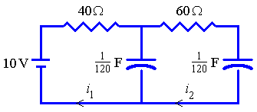
with initial conditions i₁(0) = 1/4, i₂(0) = 0.

END OF CHAPTER 5

