6. Multiple Integration

This chapter provides only a very brief introduction to the major topic of multiple integration. Uses of multiple integration include the evaluation of areas, volumes, masses, total charge on a surface and the location of a centre-of-mass.

6.1 Double Integrals (Cartesian Coordinates)

Example 6.1.1

Find the area shown (assuming SI units).
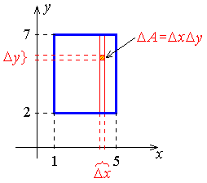

As Δx → 0 and Δy → 0, the summations become integrals:

The inner integral has no dependency at all on x, in its limits or in its integrand.
It can therefore be extracted as a “constant” factor from inside the outer integral.

Example 6.1.1 (continued)

Suppose that the surface density on the rectangle is σ = x ²y. Find the mass of the rectangle.

The element of mass is

Δm = σ ΔA = σ Δx Δy

Therefore the mass of the rectangle is m = 930 kg.

OR

We can choose to sum horizontally first:
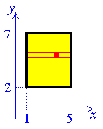

The inner integral has no dependency at all on y, in its limits or in its integrand. It can therefore be extracted as a “constant” factor from inside the outer integral.
which is exactly the same form as before, leading to the same value of 930 kg.
A double integral may be separated into a pair of single integrals if
- the region D is a rectangle, with sides parallel to the coordinate axes; and
- the integrand is separable: f (x, y) = g(x) h(y).
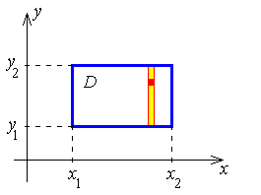

This was the case in Example 6.1.1.

Example 6.1.2

The triangular region shown here has surface density σ = x + y.
Find the mass of the triangular plate.
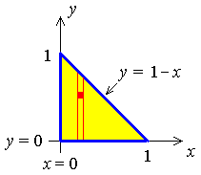
Element of mass:

Δm = σ ΔA = σ Δx Δy

Example 6.1.2 (continued)

OR

We can choose to sum horizontally first (re-iterate):
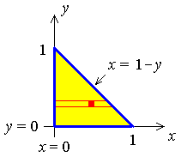

Generally:

In Cartesian coordinates on the xy-plane, the rectangular element of area is
ΔA = Δx Δy .
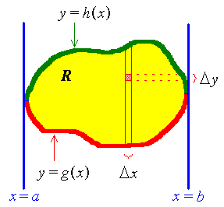
Summing all such elements of area along a vertical strip, the area of the elementary strip is
Summing all the strips across the region R, the total area of the region is:
In the limit as the elements Δx and Δy shrink to zero, this sum becomes
If the surface density σ within the region is a function of location, σ = f (x, y), then the mass of the region is
The inner integral must be evaluated first.
Re-iteration:
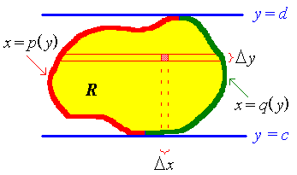
One may reverse the order of integration by summing the elements of area ΔA horizontally first, then adding the strips across the region from bottom to top. This generates the double integral for the total area of the region
The mass becomes
Choose the orientation of elementary strips that generates the simpler double integration.

For example,
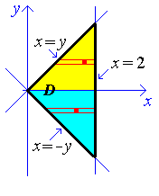
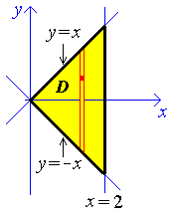

is preferable to .

=

Example 6.1.3

Evaluate
where R is the region enclosed by the parabola x = y² and the line x + y = 2.
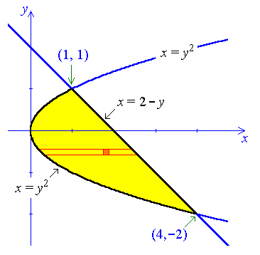
The upper boundary changes form at x = 1.
The left boundary is the same throughout R.
The right boundary is the same throughout R.
Therefore choose horizontal strips.
Therefore

6.2 Polar Double Integrals

The Jacobian of the transformation from Cartesian to plane polar coordinates (Example 2.4.1 on page 2-17) is

The element of area is therefore
dA = dx dy = r dr dθ

Example 6.2.1

Find the area enclosed by one loop of the curve r = cos 2θ .

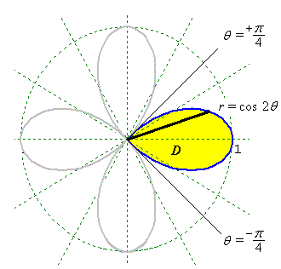
Boundaries:

Area:

Therefore

In general, in plane polar coordinates,
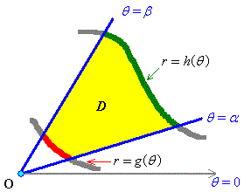

Example 6.2.2

Find the centre of mass for a plate of surface density , whose boundary is the portion of the circle x² + y² = a² that is inside the first quadrant. k and a are positive constants.

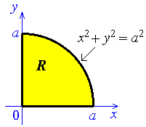
Use plane polar coordinates.
Boundaries:
The positive x-axis is the line θ = 0.
The positive y-axis is the line θ = π /2 .
The circle is r² = a² , which is r = a.

Mass:
Surface density .

Example 6.2.2 (continued)

First Moments about the x-axis:

Therefore the centre of mass is at

6.3 Triple Integrals

The concepts for double integrals (surfaces) extend naturally to triple integrals (volumes).
The element of volume, in terms of the Cartesian coordinate system (x, y, z) and another orthogonal coordinate system (u, v, w), is
and

The most common choices for non-Cartesian coordinate systems in are:

Cylindrical Polar Coordinates:
for which the differential volume is
Spherical Polar Coordinates:
for which the differential volume is
Example 6.3.1:

Verify the formula for the volume of a sphere of radius a.

Therefore

Example 6.3.2:

The density of an object is equal to the reciprocal of the distance from the origin.
Find the mass and the average density inside the sphere r = a .

Use spherical polar coordinates.
Density:

Mass:
Therefore

Average density =
Therefore

[Note that the mass is finite even though the density is infinite at the origin!]

Example 6.3.3:

Find the proportion of the mass removed, when a hole of radius 1, tangent to a diameter, is bored through a uniform sphere of radius 2.

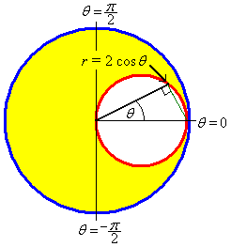
Cross-section at right angles to the axis of the hole:
Use cylindrical polar coordinates, with the z-axis aligned parallel to the axis of the cylindrical hole.
The plane polar equation of the boundary of the hole is then
r = 2 cos θ

The entire circular boundary is traversed once for

Cross-section parallel to the axis of the hole:

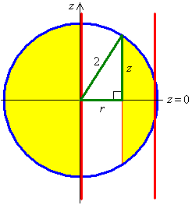
At each value of r , the distance from the equatorial plane to the point where the hole emerges from the sphere is
The element of volume for the hole is therefore
We cannot separate the two integrals,
because the upper limit of the inner integral, (r = 2 cos θ),
is a function of the variable of integration in the outer integral.

The geometry is entirely symmetric about θ = 0
Example 6.3.3 (continued)

Let u = cos θ , then du = – sin θ dθ .
The density is constant throughout the sphere. Therefore
Therefore the proportion of the sphere that is removed is

END OF CHAPTER 6

