Example 4.01: Roll two fair six-sided dice.

Let E₁ = “sum = 7” then

P[E₁] = n(E₁) × P[each sample point] = n(E₁) / n(S)

=

Let E₂ = “sum > 10” then

P[E₂] =

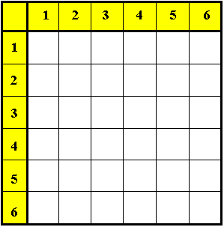

E₁ and E₂ have no common sample points (disjoint sets; mutually exclusive events) ⇒

P[E₁ OR E₂] = P[E₁] + P[E₂] =

Example 4.01 (continued)

Let E₃ = “at least one ‘6’ ” then

P[E₃] =

P[E₁ OR E₃] =

( common points counted twice)

= P[E₁] + P[E₃]  P[E₁ AND E₃]

Venn diagram Venn diagram
(each sample point shown): (# sample points shown):

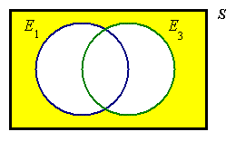

Venn diagram for probability:

Some general properties of set/event unions and intersections are listed here:

Commutative: A∪B = B∪A , A∩B = B∩A

Associative: (A∪B)∪C = A∪(B∪C) = A∪B∪C
(A∩B)∩C = A∩(B∩C) = A∩B∩C

Distributive: A∪(B∩C) = (A∪B)∩(A∪C)
A∩(B∪C) = (A∩B)∪(A∩C)

In each case, these identities are true for all sets (or events) A, B, C.

Example 4.01 (continued)
Find the probability of a total of 7 without rolling any sixes.

P[E₁  ~E₃ ] = P[E₁]  P[E₁  E₃] (total probability law)

Example 4.02:

Given the information that P[A ∨ B] = .9 , P[A] = .7 , P[B] = .6 ,
find P[exactly one of A, B occurs]

Incorrect labelling of the Venn diagram:
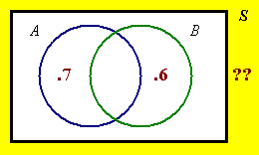
Correct version:
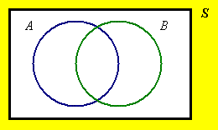
Example 4.03

Three cards, labelled A , B and C , are in an urn.
In how many ways can three cards be drawn
(a) with replacement?
(b) without replacement?
(c) without replacement (if the order of selection doesn’t matter)?

For part (a) of this question, the complete sample space is listed below.

AAA AAB AAC ABA ABB ABC ACA ACB ACC

BAA BAB BAC BBA BBB BBC BCA BCB BCC

CAA CAB CAC CBA CBB CBC CCA CCB CCC

For part (b) of this question, identify the reduced sample space:

AAA AAB AAC ABA ABB ABC ACA ACB ACC

BAA BAB BAC BBA BBB BBC BCA BCB BCC

CAA CAB CAC CBA CBB CBC CCA CCB CCC

(c)

Definitions – the factorial function:

The number of ways in which r objects can be drawn from n objects without replacement (with the order of selection being important) is the number of permutations:

The number of ways in which r objects can be drawn from n objects without replacement and with the order of selection being irrelevant is the number of combinations:
Example 4.04

Three cards, labelled A , B and C , are in an urn.
In how many ways can two cards be drawn
(a) with replacement?
(b) without replacement?
(c) without replacement (if the order of selection doesn’t matter)?

For part (a) of this question, the complete sample space is listed below.

AA AB AC BA BB BC CA CB CC

(a)

(b)

(c)

The combinations are

The permutations are

Example 4.05

Evaluate $\left( \begin{matrix}\text{11} \\ 6\end{matrix} \right)$

Example 4.06

Evaluate P _{2, 9}

Example 4.07

Simplify $\left( \begin{matrix}n \\ n − r\end{matrix} \right)$

Example 4.08

Simplify $\left( \begin{matrix}n \\ n\end{matrix} \right)$

Also note the identities

^{n}P₀ = P _{0, n} = ^{n}C₀ = $\left( \begin{matrix}n \\ 0\end{matrix} \right)$ = $\left( \begin{matrix}n \\ n\end{matrix} \right)$ = ^{n}C_{n} = 1 ,

^{n}P_{n} = P _{n, n} = n ! = P _{n−1 , n} = ^{n}P_{n−1}

and ^{n}P₁ = P _{1, n} = ^{n}C₁ = $\left( \begin{matrix}n \\ 1\end{matrix} \right)$ = $\left( \begin{matrix}n \\ n − 1\end{matrix} \right)$ = ^{n}C_{n−1} = n

Summary:

The number of ways to draw r objects from n distinguishable objects is:

[with replacement (ordered):] = n^{r}

[without replacement (ordered):] = ^{n}P_{r}

[without replacement (unordered):] = ^{n}C_{r}

The case “with replacement (unordered)” seldom arises in practice, but the number of ways of drawing r objects from n distinguishable objects in this case can be shown to be ^{n+ r − 1}C_{r} . See www.engr.mun.ca/~ggeorge/3423/demos/Counts.xls for an illustration of these values for some choices of r and n.

Example 4.09

(a) In how many ways can a team of three men and three women be chosen from a group of five men and six women?

(b) In how many ways can a team of three men and three women be chosen from a group of five men and six women when the team has one leader, one other member and a reserve for the men and likewise for the women?

[Space for the solution of Example 4.09]

Another counting technique – the maze.

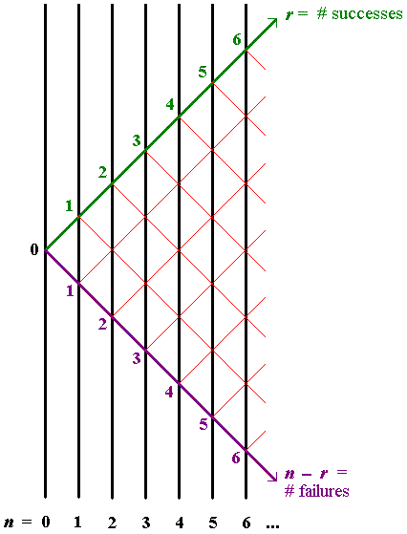

Pascal’s triangle for ^{n}C_{r} :
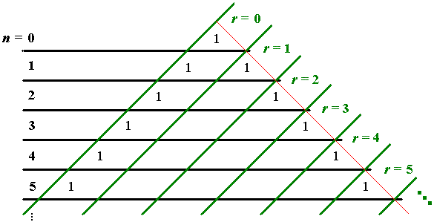

Example 4.10:
On the surface of the Earth a “degree square” from latitude θ degrees to latitude (θ + 1) degrees is, to a good approximation, a rectangle of sides 111.12 km (north-south) and 111.12×cos(θ +½) km (east-west).

Suppose that a ship of beam (width) b is crossing the degree square on a path of total length d. Suppose also that a stationary iceberg of width w is placed randomly on the degree square and that the ship’s crew fails to detect the iceberg.

(a) Find the probability that the ship will collide with the iceberg during its crossing of the degree square.
[Hint: look at the ratio of the area swept out along the ship’s path by an object of width (w + b) to the total area of the degree square.]

(b) Evaluate the probability in part (a) in the case when θ = 41 degrees, b = 28 m,
w = 110 m and d = 83.2 km,
(which are plausible values for the RMS Titanic in 1912).

(c) For the values given in part (b), find the probability, (correct to the nearest 1%) that there are no collisions after 100 crossings.

(d) For the values given in part (b), find the least number of crossings at which the probability of at least one collision rises above 50%.

111.12 cos(θ+½) km

111.12 km

d

[Space for the solution of Example 4.10]

