Example 5.01

Given that rolling two fair dice has produced a total of at least 10, find the probability that exactly one die is a ‘6’.

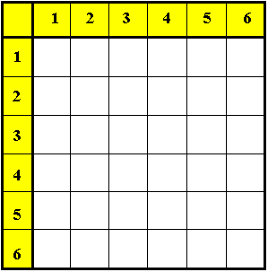

$$P[E_{1} | E_{2}] = \frac{P[E_{1} E_{2}]}{P[E_{2}]}$$

Because intersection is commutative,
P[E₁ E₂] = P[E₂ E₁] ⇒ P[E₁|E₂] • P[E₂] = P[E₂|E₁] • P[E₁]

Events E₁, E₂ are independent if P[E₁|E₂] = P[E₁] (and are dependent otherwise).

Example 5.02

Show that the events
E₁ = “fair die A is a ‘6’ ” and E₂ = “fair die B is a ‘6’ ”
are independent.

Stochastic independence:
Events E₁, E₂ are stochastically independent (or just independent) if P[E₁|E₂] = P[E₁].

Equivalently, the events are independent iff (if and only if) P[E₁ E₂] = P[E₁] • P[E₂] .
Compare this with the general multiplication law of probability:

P[E₁ E₂] = P[E₁|E₂] • P[E₂]
Example 5.03

A bag contains two red, three blue and four yellow marbles. Three marbles are taken at random from the bag,
(a) without replacement;
(b) with replacement.
In each case, find the probability that the colours of the three marbles are all different.

Independent vs. Mutually Exclusive Events:

Two possible events E₁ and E₂ are independent if and only if P[E₁ E₂] = P[E₁] • P[E₂] .

Two possible events E₁ and E₂ are mutually exclusive if and only if P[E₁ E₂] = 0 .

No pair of possible events can satisfy both conditions, because P[E₁] • P[E₂] ≠ 0 .
A pair of independent possible events cannot be mutually exclusive.
A pair of mutually exclusive possible events cannot be independent.

An example with two teams in the playoffs of some sport will illustrate this point.
Example 5.04
Teams play each other: Outcomes for teams A and B are:

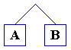

Teams play other teams: Outcomes for teams A and B are:
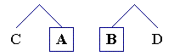

A set of mutually exclusive and collectively exhaustive events is a partition of S.

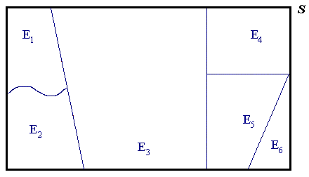

A set of mutually exclusive events E₁, E₂, ... , E_{n} is collectively exhaustive if

Bayes’ Theorem:

When an event A can be partitioned into a set of n mutually exclusive and collectively exhaustive events E_{i} , then

Example 5.05

The stock of a warehouse consists of boxes of high, medium and low quality lamps in the respective proportions 1:2:2. The probabilities of lamps of these three types being unsatisfactory are 0, 0.1 and 0.4 respectively. If a box is chosen at random and one lamp in the box is tested and found to be satisfactory, what is the probability that the box contains
(a) high quality lamps;
(b) medium quality lamps;
(c) low quality lamps?

Example 5.05 (continued)

Another version of the total probability law:
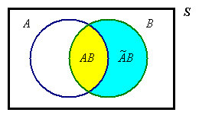

⇒

Updating Probabilities using Bayes’ Theorem

Let F be the event “a flaw exists in a component”
and D be the event “the detector declares that a flaw exists”
then
$$P\left[F | D\right] = \frac{P\left[D | F\right]}{P\left[D\right]}×P\left[F\right]$$

and P[D ] = normalizing constant =

Example 5.06

Suppose that prior experience suggests
P[F ] = .2 , P[D | F ] = .8 and P[D | ~F ] = .3
then

The observation of event D has changed our assessment of the probability of a flaw from the prior P[F ] = .2 to the posterior P[F | D ] = .4 .

Example 5.07
A binary communication channel is as shown:
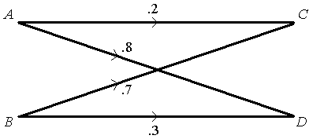

Inputs:

P[A] = .6 ⇒ P[B] = P[~A] = .4

Channel transition probabilities:

P[C | A] = .2 ⇒ P[D | A] = .8

P[C | B] = .7 ⇒ P[D | B] = .3

⇒ P[ AC ] = P[ AD ] =

P[ BC ] = P[ BD ] =

→ optimum receiver:
m(C) = , m(D) =

⇒ P[correct transmission] =

=

⇒ P[error] =

Another diagram:
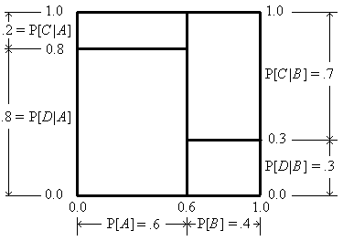

More generally, for a network of M inputs (with prior {P[m_{i}]}) and N outputs
(with {P[r_{j} | m_{i}]}), optimize the system:

Find all posterior {P[m_{i} |r_{j} ]}.

Map receiver r_{j} to whichever input m_{i} has the greatest P[m_{i}|r_{j} ] (or greatest P[m_{i} ∧ r_{j} ]).

Then P[correct decision] =
Σ ( P[m(r_{j}) | r_{j}]×P[r_{j}] )
j
Diagram (for M=2, N=3):
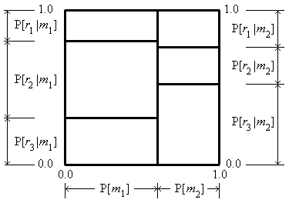

[See also pp. 33-37, “Principles of Communication Engineering”, by Wozencraft and Jacobs, (Wiley).]
Some Additional Tutorial Examples

Example 5.08 (This example is also Problem Set 2 Question 5(f))

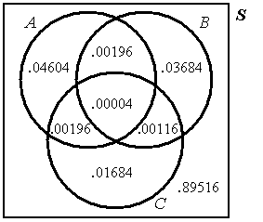
Events A, B, C are such that the
probabilities are as shown in this
Venn diagram.

Are the three events independent?

P[A] = .05 , P[B] = .04 , P[C] = .02 ,

P[AB] = .002 , P[BC] = .0012 ,
P[CA] = .002 ,

P[ABC] = .00004

⇒

Three events { A, B, C } are mutually independent if and only if

P[A B C] = P[A] × P[B] × P[C]
and
all three pairs of events { A, B }, { B, C }, { C, A } are independent

[Reference: George, G.H., Mathematical Gazette, vol. 88, #513, 85-86, Note 88.76 “Testing for the Independence of Three Events”, 2004 November]
Example 5.09

Three women and three men sit at random in a row of six seats.
Find the probability that the men and women sit in alternate seats.

Example 5.10 (Devore Exercises 2.3 Question 36, Page 66 in the 7th edition)

An academic department with five faculty members has narrowed its choice for a new department head to either candidate A or candidate B. Each member has voted on a slip of paper for one of the candidates. Suppose that there are actually three votes for A and two for B. If the slips are selected for tallying in random order, what is the probability that A remains ahead of B throughout the vote count? (For example, this event occurs if the selected ordering is AABAB but not for ABBAA).

[Space for any additional notes]

