Example 8.01:

“Exact lifetime” is a continuous random quantity, but
“Measured lifetime to the nearest minute” is a discrete random quantity.

In a bar chart, the height of each bar represents the probability. Note that as the measurements become more precise, the number of intervals increases and the width, probability and height of each bar decrease. The visual effect is misleading: it appears that the total probability is decreasing to zero as the number of intervals increases to infinity.

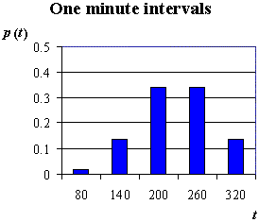
T = lifetime of a test wire in seconds.
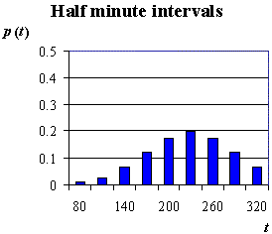
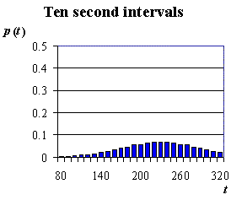

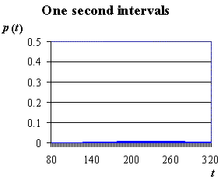

Much more natural is the probability histogram, where the area of each bar represents the probability that the random quantity lies in the interval covered by the width of the bar. The total area thus remains 1 even as the number of intervals → ∞.

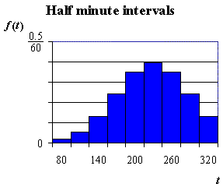
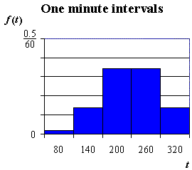

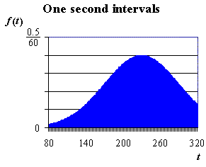
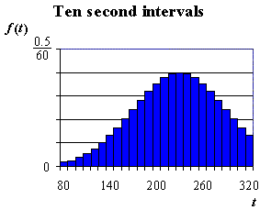
In the probability histogram,

$\text{Bar height} = \frac{p(x)}{\text{Bar width}} =$ “Probability density”

As the bar width → 0, bar height → f(x) = the probability density function (p.d.f.) .

The total area remains 1.

Thus two conditions for a function f(x) of a continuous variable x to be a valid probability density function are:

1)

2)

From a discrete probability histogram,
P[a < X ≤ b] = the sum of the areas of the bars from x = a to x = b
(excluding x = a but including x = b),
= (c.d.f. at x = b) − (c.d.f. at x = a)
and P[X = a] = the area of the single bar centered on x = a.

For a continuous probability distribution, it then follows that

$P[a<X<b] = \int_{a}^{b}{f(x) \text{dx}}$

and P[X = a] =

Example 8.02

Verify that is a legitimate probability density function and find $P\left[ −\frac{1}{2} < X < \frac{1}{2}\right]$ .
Note that, by default, f (x) = 0 for all values of x not mentioned in the definition.

On 0 ≤ x ≤ 1 , f (x) = 2x ≥ 0 . Elsewhere f (x) = 0. ∴ f (x) ≥ 0 ∀x .

$\int_{−∞}^{ ∞}{f(x) \text{dx} = }\int_{−∞}^{ 0}{0 \text{dx} + }\int_{0}^{ 1}{2x \text{dx} + \int_{1}^{ ∞}{0 \text{dx} = }}0 + {\left[x^{2}\right]}_{ 0}^{ 1} + 0 = 1$

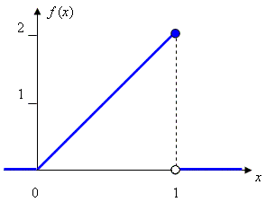
OR:

The total area under the graph of f (x)

= (area of the triangle, width 1,
height 2 )
= ½ (1)(2) = 1

Therefore f (x) is a valid p.d.f.

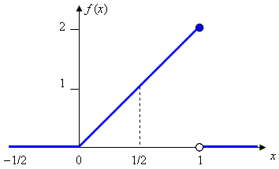
$P\left[ −\frac{1}{2} < X < \frac{1}{2}\right]$ = area under f (x)
between x = − ½ and x = ½

= (area of triangle, width ½, height 1)

= ½ (½) 1 = ¼ .

OR:

$P\left[−\frac{1}{2} < X < \frac{1}{2}\right] = \int_{{−1}/2}^{ 1/2}{f(x) \text{dx} = }\int_{{−1}/2}^{0}{0 \text{dx} + }\int_{0}^{ 1/2}{2x \text{dx} = }0 + {\left[x^{2}\right]}_{ 0}^{ 1/2} = \frac{1}{4}$
The cumulative distribution function (c.d.f.) is defined by

$F(x) = P[X ≤ x] = \int_{−∞}^{x}{f(t) \text{dt}}$

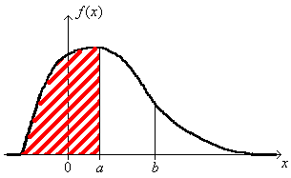
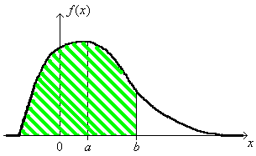

−

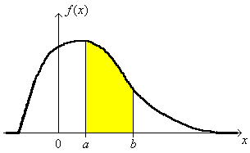

=

$P\left[a < X < b\right] = F\left(b\right) − F\left(a\right)$

F (−∞) = F (+∞) = 0 ≤ F (x) ≤ 1 for all x.

The c.d.f. is a non-decreasing function of x and $\frac{d}{\text{dx}}\left(F(x)\right) = f(x) ≥ 0$ ∀x.

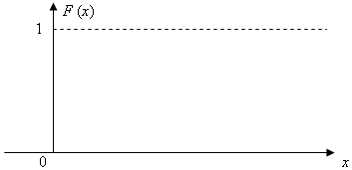

Example 8.02 (continued)

Find the cumulative distribution function for .

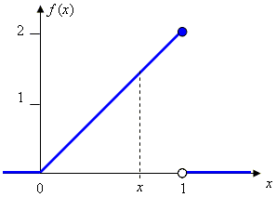

Graphical method:

x < 0 ⇒ F (x) =

0 ≤ x ≤ 1 ⇒ F (x) =

x > 1 ⇒ F (x) =

Calculus method: $F(x) = \int_{−∞}^{x}{f(t) \text{dt}}$

x < 0 ⇒ F (x) =

0 ≤ x ≤ 1 ⇒ F (x) =

x > 1 ⇒ F (x) =

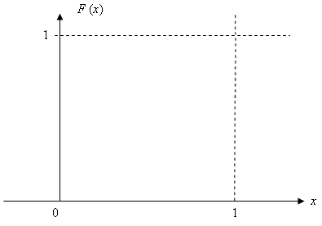

Note how the c.d.f. is a non-decreasing continuous function between F = 0 and F = 1.
Example 8.03 The Continuous Uniform Distribution

Find the p.d.f. and the c.d.f.

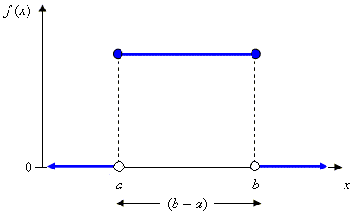
The probability density function is

f (x) =

The cumulative distribution function is

$F(x) = \int{f(t) \text{dt}}$ . When x < a , F (x) =

When x > b , F (x) =

When a ≤ x ≤ b , F (x) = OR

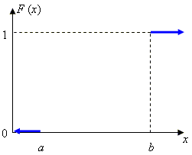
Therefore F (x) =

Population Mean and Population Variance for Continuous Probability Distributions

The discrete probability point masses p_{i} are “smeared out” into infinitely many elementary masses f (x) dx covering infinitesimal intervals dx . The expression for the population mean (expected value) of the random variable X thus evolves from the discrete case $E[X] = \sum_{∀i}{p_{i}x_{i}}$ to the continuous equivalent

The expression for the population variance is amended in a similar manner, from $σ^{2} = V[X] = \sum_{∀i}{{p_{i}\left(x_{i}−μ\right)}^{2}}$ to

Example 8.03 (continued)

Find the population mean and variance for the continuous uniform distribution U(a, b) .

=

and .

