The Exponential Distribution

This continuous probability distribution often arises in the consideration of lifetimes or waiting times and is a close relative of the discrete Poisson probability distribution.

The probability density function is
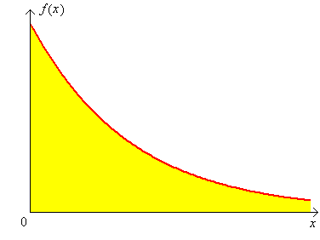
The cumulative distribution function is

F (x) = P[ X ≤ x ] = $\int_{−∞}^{x}{f(t) \text{dt}}$ =

⇒ P[ X > x ] =

Also μ = E[X] = and σ = μ

Example 8.04

The random quantity X follows an exponential distribution with parameter λ = 0.25 .
Find μ , σ and P[X > 4] .

μ =

P[X > 4] =

Note: For any exponential distribution, P[X > μ] ≈ .368 .

Example 8.05

The waiting time T for the next customer follows an exponential distribution with a mean waiting time of five minutes. Find the probability that the next customer waits for at most ten minutes.

λ =

P[ T ≤ 10 ] = F (10) =

Note:

P[ X > μ + 2σ ] = e^{−λ(μ + 2σ)} = e^{−λ((1/λ)+(2/λ))} = e⁻³ = .049787

Therefore P[ X > μ + 2σ ] ≈ 5.0% for all exponential distributions.

Also μ − σ = $\frac{1}{λ} − \frac{1}{λ}$ = 0 ⇒ P[ X < μ − σ ] = 0 = P[ X < μ − 2σ ]

Therefore P[ | X − μ | > 2σ ] ≈ 5.0% , a result similar to the normal distribution, except that all of the probability is in the upper tail only.

For reference purposes, here are some other continuous probability density functions:

Weibull distribution (parameters α and β; textbook section 4.5, pages 163-166):

$f(x; α, β) = \frac{α}{β^{α}} x^{α−1} e^{−(x/β)^{α}} , x≥0$

Gamma distribution (parameters α and β; textbook section 4.4, pages 159-161):

$f(x; α, β) = \frac{1}{β^{α} Γ(α)} x^{α−1} e^{{−x}/β} , x≥0$, where Γ(α) is the
gamma function $\int_{ 0}^{ ∞}{x^{α−1} e^{−x} \text{dx}}$. When n is a positive integer, Γ(n) = (n−1)!
The gamma function is therefore a generalization of the factorial function.
The exponential distribution is a special case of
- the Weibull distribution when α = 1. (λ = 1/β ).
- the gamma distribution when α = 1. (λ = 1/β ).
However, neither of the Weibull and gamma distributions is a subset of the other.
Another special case of the gamma distribution, with α = ν /2 and β = 2
(where ν = a natural number = “degrees of freedom”) is the Chi-squared distribution:
$f(x; ν) = \frac{1}{2^{ν/2} Γ(ν/2)} x^{(ν/2)−1} e^{{−x}/2} , x≥0$
Another distribution is the beta distribution (pages 167-168):
$f(x; α, β, A, B) = \frac{1}{B−A} \frac{Γ(α+β)}{Γ(α)Γ(β)} {\left(\frac{x−A}{B−A}\right)}^{α−1} {\left(\frac{B−x}{B−A}\right)}^{β−1}$ , A ≤ x ≤ B .

If Y = ln(X) and Y ~ N (μ, σ²), then X has a lognormal distribution (pages 166-167).

Other p.d.f.s can be found in any good textbook on probability and statistics.
The Gaussian or normal probability distribution is the single most important probability distribution. It was first described by Abraham de Moivre in 1733 but bears the name of Karl Friedrich Gauss, who arrived at this distribution in 1809 when examining the distribution of errors in the measurement of the diameters of lunar craters. It arises naturally in many other situations (especially the Central Limit Theorem).

If a continuous random quantity X has a normal distribution with population mean μ and population variance σ ² , then its probability density function is
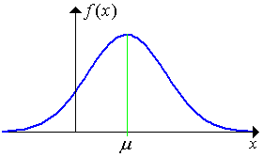
$$f(x) = \frac{1}{σ\sqrt{2π}} e^{−\left\{\frac{{\left(x−μ\right)}^{2}}{2σ^{2}}\right\}}$$

which is positive for all x .

The cumulative distribution function for the normal distribution is
$F(x) = \int_{−∞}^{x}{f(t) \text{dt}}$
which cannot be evaluated exactly in closed form except for certain special choices for x.

Notation:

X ~ N(μ, σ² )

μ = E[X] = population mean σ² = V[X] = population variance

Adding a constant c to X :

Influence of the variance σ² on the
shape of the normal probability curve:

Low σ² High σ²

Because there is no closed algebraic form for the c.d.f. F(x) , the values are tabulated for one special choice of mean and variance: μ = 0 , σ ² = 1 .

Notation:

Z ~ N (0, 1) is the standard normal distribution,

with p.d.f. = φ (z) and c.d.f. = Φ (z) .

Conversion from X ~ N(μ, σ²) to Z ~ N (0, 1) requires a linear shift of μ and a change of scale by a factor of σ .

F (x) = P[X ≤ x] =

Thus $P\left[x_{1} < X < x_{2}\right] = Φ\left(z_{2}\right) − Φ\left(z_{1}\right)$ where $z = \frac{x−μ}{σ}$ .

Symmetry ⇒
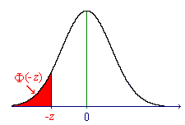
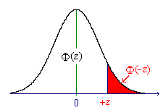

Φ(−z) = 1 − Φ(+z)

A table of values of the standard normal distribution is on the inside front cover of the textbook (Devore, Table A.3).
A more precise table is available as an Excel spreadsheet file, on the course web site, at
"www.engr.mun.ca/~ggeorge/3423/demos/zTables.xls".
and also in Chapter 15 of these notes.

For all normal distributions,

$P\left[ \left|X−μ\right| > 1σ \right] ≈ \frac{1}{3}$ $P\left[ \left|X−μ\right| > 2σ \right] ≈ \frac{1}{\text{20}}$

$$P\left[ \left|X−μ\right| > 3σ \right] < \frac{1}{\text{300}}$$

Example 8.06

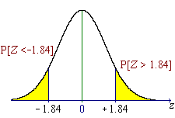
The weights of boxes of nails are known to be normally distributed to an excellent approximation, with mean 454 grammes and standard deviation 25 grammes. What proportion of boxes weighs more than 500 grammes?

Part of Table A.3 (also page 15-03):

z .00 .01 .02 .03 .04 ...



−1.9 0.02872 0.02807 0.02743 0.02680 0.02619 ...

−1.8 0.03593 0.03515 0.03438 0.03362 0.03288 ...

−1.7 0.04457 0.04363 0.04272 0.04182 0.04093 ...

−1.6 0.05480 0.05370 0.05262 0.05155 0.05050 ...

−1.5 0.06681 0.06552 0.06426 0.06301 0.06178 ...



Example 8.07

Find the probability that a normally distributed random quantity is more than two and a half standard deviations away from its mean in either direction.

$P\left[ \left|X−μ\right| > \left(212\right) σ\right] = P\left[X−μ > \frac{5}{2} σ \text{OR} X−μ < −\frac{5}{2} σ\right]$

=

Example 8.08

The strength of a set of steel bars is known to be normally distributed with a population mean of 5 kN and a population variance of (50 N)² . A client requires that at least 99% of all of these bars be stronger than 4,900 N. Has this requirement been met?

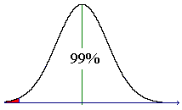

Example 8.09

Given that the random quantity X is normally distributed, find c such that

P[ X > c ] = 1% .

(That is, find the 99th percentile.)
$P\left[X>c\right] = P\left[Z>\frac{c−μ}{σ}\right]$ = .01 .
Notation: z_{α} = the (1 − α)×100th percentile of the standard normal distribution.

$$P\left[Z>z_{α}\right] = α = Φ\left(−z_{α}\right)$$
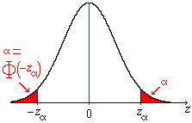
Here, α = .01 .
Φ(−z_{.01}) = .01
To find z_{.01} we need to look in
table A.3 for the value Φ = .01000 .

Φ(−2.32) = .01017
Φ(−2.33) = .00990
⇒ z_{.01} = 2.33 (to 2 d.p.)

Using linear interpolation (which will not be required in tests or the exam):

.01000 is 17/27 of the way from Φ(−2.32) to Φ(−2.33).

Thus −z_{.01} ≈ −2.32 + (17/27) × (−0.01) ≈ −2.326 .
[The true value is −2.326, correct to three decimal places].

⇒ c = μ + z_{.01} σ ≈ μ + 2.326 σ .

Note: By symmetry, the fiftieth percentile (z_{.50} = $\tilde{μ}$ = the median) is at z = 0 .
Φ(0) = .5000 ⇒ $\tilde{μ}$ = μ + 0 σ .
Example 8.10

Find the quartiles for any normal distribution.

X ~ N (μ, σ²)

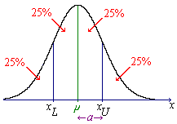

By symmetry,
x_{L} = μ − a and

x_{U} = μ + a where

a = SIQR (the semi-interquartile range).

F(x_{U}) = .75 ⇒

But Φ (0.67) = .74857 and Φ (0.68) = .75175 .

⇒ (to 2 s.f.) SIQR = 0.67 σ

Linear interpolation:
.75000 = Φ (

