Unbiased estimator A for Biased estimator B for
some unknown parameter θ : the unknown parameter θ :

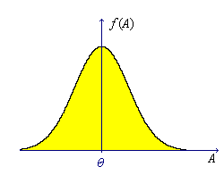
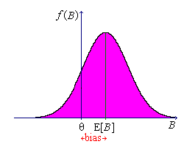

E[A] = θ E[B] ≠ θ

Which estimator should we choose to estimate θ ?

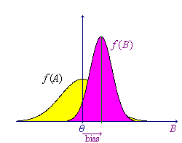

A minimum variance unbiased estimator is ideal.
[See also Problem Set 6 Question 2]

Accuracy and Precision (Example 9.09)

An archer fires several arrows at the same target.






Error = Systematic error + Random error

(inaccuracy)² = (bias)² + V[estimator]

Estimator A for θ is consistent iff

E[A] → θ and V[A] → 0
(as n → ∞)

A particular value a of an estimator A is an estimate.

Sample Mean

A random sample of n values { X₁, X₂, X₃, ... , X_{n} } is drawn from a population of mean μ and standard deviation σ.
Then E[X_{i}] = μ , V[X_{i}] = σ ² and the sample mean $\bar{X} = \frac{1}{n} \sum_{i = 1}^{n}{X_{i}}$.
$$\bar{X} \text{estimates} μ \text{.}$$
$$⇒ E\left[\bar{X}\right] = μ , V\left[\bar{X}\right] = \frac{σ^{ 2}}{n}$$
But, if μ is unknown, then σ ² is unknown (usually).

Sample Variance
$S^{2} = \frac{{\left(X_{1}−\bar{X}\right)}^{2}+{\left(X_{2}−\bar{X}\right)}^{2}+\text{.}\text{.}\text{.}+{\left(X_{n}−\bar{X}\right)}^{2}}{n−1}$

$= \frac{n\sum{X_{i}^{ 2}}−{\left(\sum{X_{i}}\right)}^{2}}{n(n−1)}$
$S = \sqrt{S^{2} }$
and the sample standard deviation is

n − 1 = number of degrees of freedom for S ² .

Justification for the divisor (n − 1) [not examinable]:

Using V[Y] = E[Y ²] − (E[Y]) ² for all random quantities Y ,
E[Y ²] = V[Y] + (E[Y]) ² = σ _{Y} ² + μ _{Y} ²

$$⇒ E\left[\sum_{i}{{\left(X_{i}−\bar{X}\right)}^{2}}\right] =$$

S ² is the minimum variance unbiased estimator of σ ² and
$\bar{X}$ is the minimum variance unbiased estimator of μ .
Both estimators are also consistent.

Inference – Some Initial Considerations

Is a null hypothesis H_{o} true (our “default belief”), or do we have sufficient evidence to reject H_{o} in favour of the alternative hypothesis H_{A} ?

H_{o} could be “defendant is not guilty” or “μ = μ_{o}” , etc.
The corresponding H_{A} could be “defendant is guilty” or “μ ≠ μ_{o}” , etc.
The burden of proof is on H_{A}.

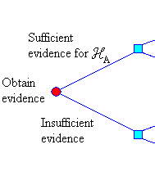

Bayesian analysis: μ is treated as a random quantity. Data are used to modify prior belief about μ. Conclusions are drawn using both old and new information.
Classical analysis: Data are used to draw conclusions about μ, without using any prior information.
[Space for any additional notes]

