Example 10.A1 - [“Raiffa’s Urns” - not examinable]
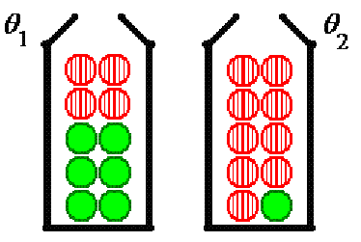
Suppose that we have 10,000 urns of the following types:
Urn type θ₁ : 8,000 urns, each with 4 red (R) and 6 non-red () balls and urn type θ₂ : 2,000 urns, each with 9R and 1
An urn of one of these two types is placed in front of us. We have paid a fee to withdraw two balls from the mystery urn in order to improve our chances of guessing correctly which type of urn it is.

The consequences of our guess are included in a choice between two contracts:
α₁ : gain of +$28 if the urn is θ₁, gain of −$32 if the urn is θ₂.
and
α₂ : gain of −$17 if the urn is θ₁, gain of +$88 if the urn is θ₂.

Prior:
Before any balls are withdrawn, our best guess at the probability that the urn is of type θ₁ is P[θ₁] =
Posterior:
After the two balls are withdrawn, our best guess at the probability that the urn is of type θ₁ is updated as follows:
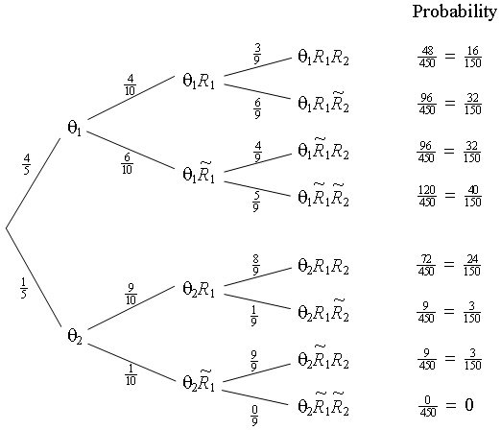
Note that events R₁ and R₂ are not independent, yet they are exchangeable;
The data allow us to update our assessment of the probabilities of θ₁ and θ₂.

Data then Decision E[gain] Actual gain
if P[θ₁] → choose

RR 2/5 = .4000 α₂ $46 −$17 or +$88
RR 32/35 ≈ .9143 α₁ $22.86 +$28 or −$32
1 α₁ $28 +$28 (certain)

The expected gains are calculated from the posterior probabilities:

Data = RR ⇒ E[Gain] = .4×(−$17) + .6×(+$88) = −$6.80 + $52.80 = +$46.00

Data = RorR ⇒ E[Gain] = 32/35×(+$28) + 3/35×−($32) ≈ +$22.86

These revised probabilities incorporate both information from the data (the two balls drawn from the urn) and the prior information (our previous belief that P[θ₁] = 4/5).

Now let us examine what happens if we have no preconceptions as to the relative numbers of urns of each type. We still know that each urn of type θ₁ contains 4 red and 6 non-red balls and that each urn of type θ₂ contains 9 red and 1 non-red balls. However, we do not know how many of each type of urn there may be. We may express this lack of prior information (an indifference between θ₁ and θ₂) by considering each type to be equally likely before the two balls are drawn. Therefore the prior probability is now
P[θ₁] = 1/2 .

The tree diagram changes to
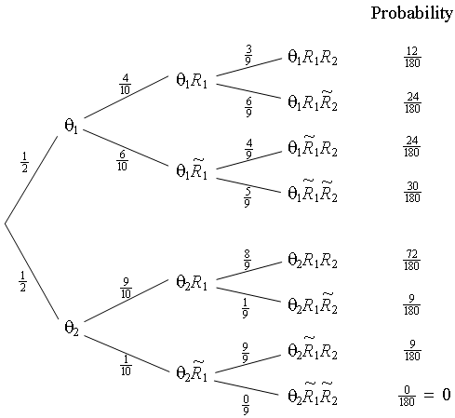
But P[θ₁] = P[θ₂] has the following consequences:
P[θ₁R₁R₂] = P[R₁R₂|θ₁] P[θ₁] = P[R₁R₂|θ₁] / 2,
P[θ₂R₁R₂] = P[R₁R₂|θ₂] P[θ₂] = P[R₁R₂|θ₂] / 2, so that
(and similarly for the other three updated probabilities for θ₁).
Therefore the updated probabilities are:

Bayesian inference generally incorporates prior information whereas classical inference uses information only from the data. In the special case of no prior information, the two methods often produce the same prediction.

[Not examinable:]

Inference on population proportion p :

Let p = proportion of “successes” in the population.

Draw a random sample, size n (with replacement and/or from a huge population).

Let X = the number of successes in the sample
Let P = (a random quantity representing the unknown p)
then P[X=x | P=p] = b(x; n, p) (binomial)

Let our prior belief about p be the probability mass function P[P=p] = f_{o}(p)

Then the posterior (updated) distribution, using both our prior belief and the result from the random sample, is
= f_{U}(p)

Therefore
As P becomes continuous, the probability point mass f_{o}(p) spreads out over an infinitesimal interval dp, with mass f_{o}(p) dp, where f_{o}(p) is now the probability density function.

Example 10.A2

Suppose that we have a complete lack of prior knowledge of the true value of p, so that we consider any one value of p to be just as likely as any other in the interval 0 ≤ p ≤ 1.
Then f_{o}(p) ~ U(0, 1) (continuous uniform distribution), that is
⇒ b(x; n, p) f_{o}(p) = ^{n}C_{x} p^{x} (1−p) ^{n − x} (0 ≤ p ≤ 1)
Upon observing x successes in n trials, our assessment of the value of p is updated to
The population mean μ_{P} = E[P] for this distribution (which is also our point estimate for the unknown p) is
The most likely value of p (the mode) is found by solving
(which is the classical point estimate for the unknown p).

The Bayesian and classical point estimates for p therefore disagree,
(except when x = n / 2).

If a random sample of size n = 10 is drawn, then the updated p.d.f. for p is:

Observed value of x: f_{U}(p) E[P] mode

0 11 (1−p)¹⁰ 1/12 0
1 110 p (1−p)⁹ 2/12 1/10
2 495 p² (1−p)⁸ 3/12 2/10
3 1320 p³ (1−p)⁷ 4/12 3/10
4 2310 p⁴ (1−p)⁶ 5/12 4/10
5 2772 p⁵ (1−p)⁵ 6/12 = 5/10
6 2310 p⁶ (1−p)⁴ 7/12 6/10
7 1320 p⁷ (1−p)³ 8/12 7/10
8 495 p⁸ (1−p)² 9/12 8/10
9 110 p⁹ (1−p) 10/12 9/10
10 11 p¹⁰ 11/12 1

Similar tables can be constructed for any other sample size n.
Using integration by parts, the following recurrence relation is established:
When m, n are both positive integers, this leads to
Special cases:
[beta function]
Also
With
the updated cumulative distribution function is
From the c.d.f., the boundaries of any desired confidence intervals on p can be calculated.

For example, with n = 25, x = 20 and using the QuickBasic program
"www.engr.mun.ca/~ggeorge/3423/demos/BayeCIp2.bas",
the following results were reported:

Mode of p = .800000 Mean of p = .777778 Median of p = .784706
Lower quartile = .727898 , Upper quartile = .835014

The Bayesian 95% confidence interval for p is
(.606506, .910263)
The Bayesian 99% confidence interval for p is
(.545044, .936493)

The Classical 95% confidence interval for p is
(.608691, .911394)
The Classical 99% confidence interval for p is
(.543389, .930771)

