Classical hypothesis tests are close relatives of the classical confidence intervals.
Some general statements will be introduced after the first example.

Example 11.01

The lifetime X of a particular brand of filaments is known to be normally distributed. A random sample of six filaments is tested to destruction. Those six filaments are found to last for an average of 1,007 hours with a sample standard deviation of 6.2 hours.

Is there sufficient evidence to conclude, at a level of significance of 5%, that the true mean lifetime of this brand of filaments is not 1,000 hours?

Repeat this question with a level of significance of 1%.

Test the null hypothesis H_{o} : μ = 1000
against the alternative hypothesis H_{a} : μ ≠ 1000 .

Distribution:

Data:

If H_{o} is true, then

[Space for Example 11.01]

[Space for Example 11.01]

Interpretation:

If H_{o} is true, then the p-value (the probability that is further away from μ = 1000 than ) is between 5% and 1%. The level of significance α is an upper bound to the probability of committing a type I error: P[reject H_{o} | H_{o} true] ≤ α .

Decision Tree:
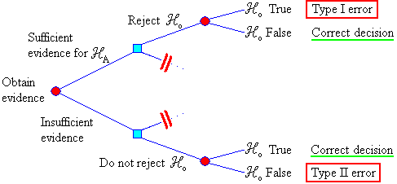

P[type I error] = P[reject H_{o} | μ = μ_{o} (H_{o} true)] ≤ α
P[type II error] = P[accept H_{o} | μ = μ₁ (H_{o} false)] = β (μ₁)
1 − β = power of the test.

General method for two-tailed tests:

State hypotheses:

H_{o} : μ = μ_{o} vs. H_{a} : μ ≠ μ_{o}
The burden of proof is on H_{a}.
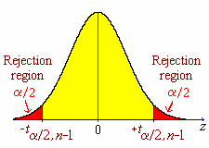
Choose the level of significance α .

State your assumptions
(for example, the random quantity X
is nearly normal).

Find $\bar{x}$ (the test statistic).

If σ is unknown, then estimate it using s .

Case 1: σ is unknown and n is small

$\bar{x}$ space t space

Find $μ_{o} ± t_{α/2, n−1} \left(\frac{s}{\sqrt{n}}\right)$ Find $t_{α/2, n−1}$

Iff $\bar{x} < μ_{o} − t_{α/2, n−1} \left(\frac{s}{\sqrt{n}}\right)$ and
or $\bar{x} > μ_{o} + t_{α/2, n−1} \left(\frac{s}{\sqrt{n}}\right)$ Iff

then reject H_{o} in favour of H_{a}.

Case 2: n is large (> 30) is the same as Case 1 except that
$t_{α/2, n−1}$ is replaced by $t_{α/2, ∞} = z_{α/2}$ .
Common values: z_{.025} = 1.95996 , z_{.005} = 2.57583 .

Case 3: σ is known is the same as Case 2 except that s is replaced by σ .
Example 11.02

A manufacturer claims that replacement machinery fills paper bags with exactly one kilogramme of sugar each, on average. A random sample of 400 bags of sugar is weighed, producing a sample mean mass of 996.5 grammes and a sample standard deviation of 25.1 grammes. At a level of significance of .01, is there sufficient evidence to doubt the manufacturer’s claim?

p-value (Method 3):

Find p = P[ | Z | > | z_{obs} | ] or p = P[ | T | > | t_{obs} | ]

Compare p to α .

Example 11.02 (continued, using method 3):

General Method (upper-tailed tests):

State hypotheses:
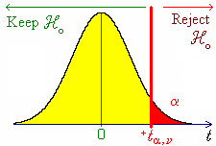
H_{o} : μ = μ_{o} vs. H_{a} : μ > μ_{o}

The burden of proof is on H_{a}.

Choose the level of significance α .

State your assumptions
(for example, the random quantity X
is nearly normal).

Find $\bar{x}$ (the test statistic).

If σ is unknown, then estimate it using s .

Method 1:
Evaluate
Reject H_{o} iff $\bar{x}$> c .

Method 2:
Reject H_{o} iff

Method 3:

Evaluate and p = P[ T > t_{obs}]

Reject H_{o} iff p < α .

General Method (lower-tailed tests):

State hypotheses:
H_{o} : μ = μ_{o} vs. H_{a} : μ < μ_{o}
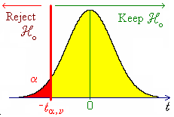
The burden of proof is on H_{a}.

Choose the level of significance α .

State your assumptions
(for example, the random quantity X
is nearly normal).

Find $\bar{x}$ (the test statistic).

If σ is unknown, then estimate it using s .

Method 1:
Evaluate
Reject H_{o} iff $\bar{x}$< c .

Method 2:
Reject H_{o} iff

Method 3:

Evaluate and p = P[ T < t_{obs}]

Reject H_{o} iff p < α .

Example 11.03

An opinion poll of 100 randomly selected customers produces 58 customers who state a preference for brand A. Does a majority of the population of customers prefer brand A?

From the random sample of 100 customers, how many must state a preference for brand A in order for the inference “a majority of the population of customers prefers brand A” to be valid?

