Simple Linear Regression

Sometimes an experiment is set up where the experimenter has control over the values of one or more variables X and measures the resulting values of another variable Y , producing a field of observations.
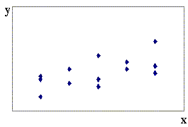
The question then arises: What is the best line (or curve) to draw through this field of points?

Values of X are controlled by the experimenter, so the non-random variable x is called the controlled variable or the independent variable or the regressor.

Values of Y are random, but are influenced by the value of x. Thus Y is called the dependent variable or the response variable.

We want a “line of best fit” so that, given a value of x , we can predict the value of Y for that value of x .
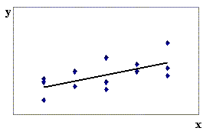
The simple linear regression model is that the predicted value of y is

and that the observed value of Y is

$Y_{i} = β_{0} + β_{1} x_{i} + ε_{i}$

where ε_{i} is the error.

It is assumed that the errors are normally distributed as ε _{i} ~ N(0, σ²) , with a constant variance σ². The point estimates of the errors ε _{i} are the residuals $e_{i} = y_{i} − {\hat{y}}_{i}$ .

With the assumptions
1) $Y_{i} = β_{0} + β_{1} x_{i} + ε_{i}$
2) x = x₀ ⇒ Y ~ N( β₀ + β₁x₀ , σ² )
in place, it then follows that ${\hat{β}}_{0}$ and ${\hat{β}}_{1}$ are unbiased estimators of the coefficients β₀ and β₁.

Methods for dealing with non-linear regression are available in the course text, but are beyond the scope of this course.
Examples illustrating violations of the assumptions in the simple linear regression model:

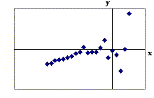
1. 2.
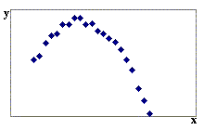

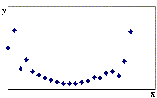
3. 4.
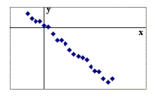

If the assumptions are true, then the probability distribution of Y | x is N( β₀ + β₁x , σ²).

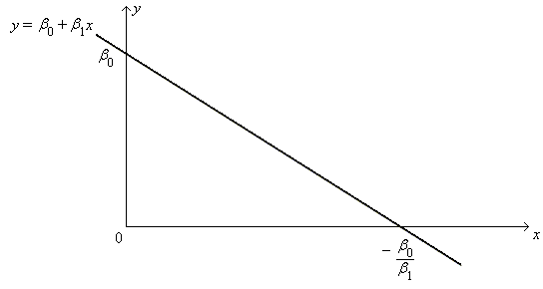
Example 12.01

Given that Y_{i} = 10 − 0.5 x_{i} + ε _{i} , where ε _{i} ~ N( 0, 2 ), find the probability that the observed value of y at x = 8 will exceed the observed value of y at x = 7.

Y_{i} ~ N( 10 − 0.5 x_{i} , 2 )

Let Y₇ = the observed value of y at x = 7
and Y₈ = the observed value of y at x = 8,
then
Y₇ ~ N( and Y₈ ~ N(

⇒ Y₈ − Y₇ ~ N(

μ = σ =

P[Y₈ − Y₇ > 0] =

For any x_{i} in the range of the regression model, more than 95% of all Y_{i} will lie within 2σ ( = 2 √ 2 ) either side of the regression line.

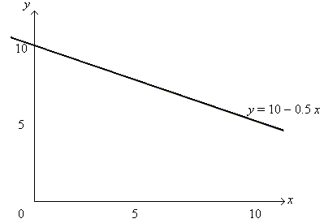
Derivation of the coefficients ${\hat{β}}_{0}$ and ${\hat{β}}_{1}$ of the regression line $y = {\hat{β}}_{0} + {\hat{β}}_{1} x$ :

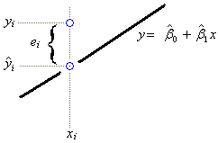
We need to minimize the errors.
Each error is estimated by the
observed residual $e_{i} = y_{i} − {\hat{y}}_{i}$ .

Use the SSE (sum of squares due to errors)

$S = \sum_{i=1}^{n}{e_{i^{2}} }= \sum_{i=1}^{n}{{\left(y_{i} − {\hat{β}}_{0} − {\hat{β}}_{1} x_{i}\right)}^{2} = f\left({\hat{β}}_{o} , {\hat{β}}_{1}\right)}$

Find ${\hat{β}}_{0}$ and ${\hat{β}}_{1}$ such that $\frac{∂S}{∂{\hat{β}}_{0}} = \frac{∂S}{∂{\hat{β}}_{1}} = 0$.

$\frac{∂S}{∂{\hat{β}}_{0}} = 2 \sum_{i=1}^{n}{\left(y_{i} − {\hat{β}}_{0} − {\hat{β}}_{1} x_{i}\right)} \left(0 − 1 − 0\right) = 0 ⇒$ (1)

and

$\frac{∂S}{∂{\hat{β}}_{1}} = 2 \sum_{i=1}^{n}{\left(y_{i} − {\hat{β}}_{0} − {\hat{β}}_{1} x_{i}\right)} \left(0 − 0 − x_{i}\right) = 0 ⇒$ (2)

or, equivalently, $\left[\begin{matrix}n & \sum{x} \\ \sum{x} & \sum{x^{2}}\end{matrix}\right] \left[\begin{matrix}{\hat{β}}_{0} \\ {\hat{β}}_{1}\end{matrix}\right] = \left[\begin{matrix}\sum{y} \\ \sum{x y}\end{matrix}\right]$ (3)
⇒ $\left[\begin{matrix}{\hat{β}}_{0} \\ {\hat{β}}_{1}\end{matrix}\right] = {\left[\begin{matrix}n & \sum{x} \\ \sum{x} & \sum{x^{2}}\end{matrix}\right]}^{ −1} \left[\begin{matrix}\sum{y} \\ \sum{x y}\end{matrix}\right]$ = (4)

The solution to the linear system of two normal equations (1) and (2) is:
from the lower row of matrix equation (4):

${\hat{β}}_{1} = \frac{S_{x y}}{S_{x x}}$ , (where $n S_{x y} = n \sum{x y −} \sum{x} \sum{y}$
and $n S_{x x} = n \sum{x^{2} −} {\left(\sum{x}\right)}^{2}$ )

or, equivalently, ;

and, from equation (1): .

A form that is less susceptible to round-off errors (but less convenient for manual computations) is
${\hat{β}}_{1} = \frac{\sum_{i=1}^{n}{\left(x_{i}−\bar{x}\right) \left(y_{i}−\bar{y}\right)}}{\sum_{i=1}^{n}{{\left(x_{i}−\bar{x}\right)}^{2} }}$ and ${\hat{β}}_{0} = \bar{y} − {\hat{β}}_{1} \bar{x}$.

The regression line of Y on x is $y − \bar{y} = {\hat{β}}_{1} \left(x − \bar{x}\right)$ .

Equation (1) guarantees that all simple linear regression lines pass through the centroid $\left(\bar{x} , \bar{y}\right)$ of the data.

It turns out that the simple linear regression method remains valid even if the values of the regressor x are also random.

However, note that interchanging x with y, (so that Y is the regressor and X is the response), results in a different regression line (unless X and Y are perfectly correlated).
Example 12.02
(the same data set as Example 11.06: paired two sample t test)

Nine volunteers are tested before and after a training programme. Find the line of best fit for the posterior (after training) scores as a function of the prior (before training) scores.

Volunteer: 1 2 3 4 5 6 7 8 9

After training: 75 66 69 45 54 85 58 91 62
Before training: 72 65 64 39 51 85 52 92 58

Let Y = score after training and X = score before training.

In order to use the simple linear regression model, the assumptions

$Y_{i} = β_{0} + β_{1} x_{i} + ε_{i}$
x = x₀ ⇒ Y ~ N( β₀ + β₁x₀ , σ² )

must hold.

From a plot of the data
(in http://www.engr.mun.ca/~ggeorge/3423/demos/regress2.xls),
one can see that the assumptions are reasonable.

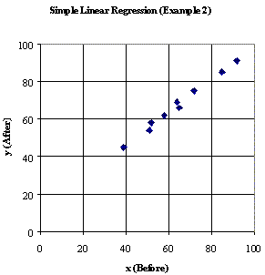

Calculations:

i | x_{i} | y_{i} | x_{i}² | x_{i} . y_{i} | y_{i}²
1 | 72 | 75 | 5184 | 5400 | 5625
2 | 65 | 66 | 4225 | 4290 | 4356
3 | 64 | 69 | 4096 | 4416 | 4761
4 | 39 | 45 | 1521 | 1755 | 2025
5 | 51 | 54 | 2601 | 2754 | 2916
6 | 85 | 85 | 7225 | 7225 | 7225
7 | 52 | 58 | 2704 | 3016 | 3364
8 | 92 | 91 | 8464 | 8372 | 8281
9 | 58 | 62 | 3364 | 3596 | 3844
Sum: | 578 | 605 | 39384 | 40824 | 42397

$n S_{x y} = n \sum{x y −} \sum{x} \sum{y}$ = 9 × 40824 − 578 × 605 = 17726

$n S_{x x} = n \sum{x^{2} −} {\left(\sum{x}\right)}^{2}$ = 9 × 39384 − 578 ² = 20372

⇒ ${\hat{β}}_{1} = \frac{S_{x y}}{S_{x x}} = \frac{\text{17} \text{726}}{\text{20} \text{372}} = \underline{\underline{0\text{.}\text{870} \text{116}}}$

and ${\hat{β}}_{0} = \frac{1}{n} \left(\sum{y} − {\hat{β}}_{1} \sum{x}\right) = \frac{1}{9} \left(\text{605} − 0\text{.}\text{807} \text{116}×\text{578}\right) = \underline{\underline{\text{11}\text{.}\text{341} \text{45}}}$

Each predicted value ${\hat{y}}_{i}$ of Y is then estimated using ${\hat{y}}_{i} = {\hat{β}}_{0} + {\hat{β}}_{1} x_{i}$ ≈ 11.34 + 0.87 x and the point estimates of the unknown errors ε _{i} are the observed residuals $e_{i} = y_{i} − {\hat{y}}_{i}$ .

A measure of the degree to which the regression line fails to explain the variation in Y is the sum of squares due to error,
$$\text{SSE} = \sum_{i=1}^{n}{e_{i^{2}}} = \sum_{i=1}^{n}{{\left(y_{i} − {\hat{β}}_{0} − {\hat{β}}_{1} x_{i}\right)}^{2} }$$

which is given in the adjoining table.

x_{i} | y_{i} | $${\hat{y}}_{i}$$ | e_{i} | e_{i}²
72 | 75 | 73.98979 | 1.0102 | 1.0205
65 | 66 | 67.89898 | −1.8990 | 3.6061
64 | 69 | 67.02886 | 1.9711 | 3.8854
39 | 45 | 45.27597 | −0.2760 | 0.0762
51 | 54 | 55.71736 | −1.7174 | 2.9493
85 | 85 | 85.30130 | −0.3013 | 0.0908
52 | 58 | 56.58747 | 1.4125 | 1.9952
92 | 91 | 91.39211 | −0.3921 | 0.1537
58 | 62 | 61.80817 | 0.1918 | 0.0368
SSE = 13.8141

An Alternative Formula for SSE:

$${\hat{β}}_{0} = \bar{y} − {\hat{β}}_{1} \bar{x} ⇒$$
$$\text{SSE} = \sum_{i=1}^{n}{{\left(y_{i} − \left(\bar{y}−{\hat{β}}_{1} \bar{x}\right) − {\hat{β}}_{1} x_{i}\right)}^{2}}=\sum_{i=1}^{n}{{\left(\left(y_{i} − \bar{y}\right)−{\hat{β}}_{1}\left(x_{i} −\bar{x}\right) \right)}^{2}}$$
$$=\sum_{i=1}^{n}{{\left(y_{i} − \bar{y}\right)}^{2}}−2{\hat{β}}_{1}\sum_{i=1}^{n}{\left(x_{i} −\bar{x}\right)\left(y_{i} − \bar{y}\right)}+ {\hat{β}}_{1^{2}}\sum_{i=1}^{n}{{\left(x_{i} −\bar{x}\right)}^{2}}$$
$$= S_{\text{yy}} − 2{\hat{β}}_{1} S_{\text{xy}} + {\hat{β}}_{1^{2}} S_{\text{xx}}$$
$$\text{But} {\hat{β}}_{1} = \frac{S_{\text{xy}}}{S_{\text{xx}}}$$
$⇒ \text{SSE} = S_{\text{yy}} − {\hat{β}}_{1} S_{\text{xy}}$ or$\text{SSE} = \frac{S_{\text{xx}}S_{\text{yy}}−S_{{\text{xy}}^{2}}}{S_{\text{xx}}}$ or
$$\text{SSE} = \frac{\left({\text{nS}}_{\text{xx}}\right) \left({\text{nS}}_{\text{yy}}\right)−{\left({\text{nS}}_{\text{xy}}\right)}^{2}}{n×\left({\text{nS}}_{\text{xx}}\right)}$$

In this example,
$$\text{SSE} = \frac{\text{20} \text{372}×\text{15} \text{548}−\text{17} {\text{726}}^{2}}{9×\text{20} \text{372}} = \text{13}\text{.}\text{814}…$$

However, this formula is very sensitive to round-off errors:
If all terms are rounded off prematurely to three significant figures, then
$$\text{SSE} = \frac{\text{20} \text{400}×\text{15} \text{500}−\text{17} {\text{700}}^{2}}{9×\text{20} \text{400}} = \text{15}\text{.}\text{85} \left(2 d\text{.}p\text{.}\right)$$

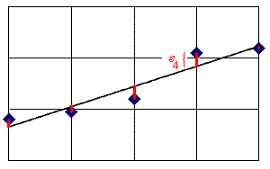
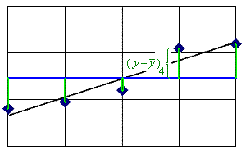

The total variation in Y is the SST (sum of squares - total):

$\text{SST} = \frac{n S_{\text{yy}}}{n} = \sum{{\left(y_{i} − \bar{y}\right)}^{2}}$ (which is (n − 1) × the sample variance of y).

In this example, SST = 15 548 / 9 = 1 727.555...

The total variation (SST) can be partitioned into the variation that can be explained by the regression line and the variation that remains unexplained by the regression line (SSE). SST = SSR + SSE .

The proportion of the variation in Y that is explained by the regression line is known as the coefficient of determination

$r^{2} = \frac{\text{SSR}}{\text{SST}} = 1 − \frac{\text{SSE}}{\text{SST}}$

In this example, r² = 1 − (13.81... / 1727.555... ) = .992004...

Therefore the regression model in this example explains 99.2% of the total variation in y.

Note:
$$\text{SSR} = {\hat{β}}_{1}⋅S_{\text{xy}} = \frac{S_{{\text{xy}}^{2}}}{S_{\text{xx}}}$$
and SST = S_{yy}
⇒
$r^{2} = \frac{S_{{x y}^{2}}}{S_{x x} S_{y y}}$

The coefficient of determination is just the square of the sample correlation coefficient r.
Thus r = √ r² ≈ .996 . It is no surprise that the two sets of test scores in this example are very strongly correlated. Most of the points on the graph are very close to the regression line y = 0.87 x + 11.34 .

A point estimate of the unknown population variance σ² of the errors ε is the sample variance or mean square error s² = MSE = SSE / (number of degrees of freedom).

But the calculation of s² includes two parameters that are estimated from the data: ${\hat{β}}_{0}$ and ${\hat{β}}_{1}$ . Therefore two degrees of freedom are lost and $\text{MSE} = \frac{\text{SSE}}{n − 2}$ . In this example, MSE ≈ 1.973.

A concise method of displaying some of this information is the ANOVA table (used in Chapters 10 and 11 of Devore for analysis of variance). The f value in the top right corner of the table is the square of a t value that can be used in an hypothesis test on the value of the slope coefficient β₁ .

Source Degrees of Sums of Squares Mean Squares f
Freedom

Regression 1 SSR = 1713.741... MSR = SSR / 1 = MSR/MSE
= 1713.741... = 868.4...

Error n − 2 SSE = 13.81... MSE = SSE / (n−2)
= 7 = 1.973...

Total n − 1 SST = 1727.555...
= 8

To test H_{o} : β₁ = 0 (no useful linear association) against H_{a} : β₁ ≠ 0 (a useful linear association exists), we compare | t | = √ f to t_{α/2, (n−2)} .

In this example, | t | = √ 868.4... = 29.4... >> t_{.0005, 7} (the p-value is < 10⁻⁷)
so we reject H_{o} in favour of H_{a} at any reasonable level of significance α.

The standard error s_{b} of ${\hat{β}}_{1}$ is s / √ S_{xx} so the t value is also equal to $\frac{{\hat{β}}_{1} − 0}{\sqrt{\frac{n \text{MSE}}{n S_{x x}}}}$ .
Yet another alternative test of the significance of the linear association is an hypothesis test on the population correlation coefficient ρ , (H_{o}: ρ = 0 vs. H_{a}: ρ ≠ 0), using the test statistic , which is entirely equivalent to the other two t statistics above.

Example 12.03

(a) Find the line of best fit to the data

x 0 0 1 1 1 2 2 2 3 4

y 6.1 5.3 4.1 5.1 4.4 3.4 2.6 3.1 1.8 2.1

(b) Estimate the value of y when x = 2.
(c) Why can’t the regression line be used to estimate y when x = 10?
(d) Find the sample correlation coefficient.
(e) Does a useful linear relationship between Y and x exist?

(a) A plot of these data follows.
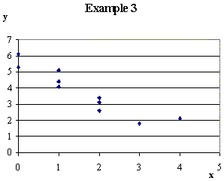
The Excel spreadsheet file for these data can be found at

“http://www.engr.mun.ca
/~ggeorge/3423/demos
/regress3.xls” .

The summary statistics are

Σ x = 16 Σ y = 38 n = 10

Σ x² = 40 Σ xy = 45.6 Σ y² = 163.06

From which

n S_{xy} = n Σ xy − Σ x Σ y = −152

n S_{xx} = n Σ x² − (Σ x )² = 144 n S_{yy} = n Σ y² − (Σ y )² = 186.6

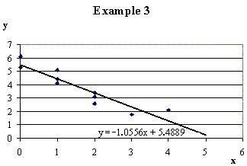
⇒ ${\hat{β}}_{1}$ =

and ${\hat{β}}_{0}$ =

So the regression line is

(b) x = 2 ⇒ y =

(c) x = 10 ⇒ y =

Problem:

(d) = −.92727... ≈ –.93

(e) $\text{SSR} = \frac{{\left(n S_{\text{xy}}\right)}^{ 2}}{n \left(n S_{\text{xx}}\right)} = \frac{{\left(−\text{152}\right)}^{ 2}}{\text{10}×\text{144}} = \text{16}\text{.}0\overset{˙}{4}$
SST = S_{yy} = ( 186.6 / 10 ) = 18.66

and SSE = SST − SSR = 18.66 − 16.04... = 2.615...

The ANOVA table is then:

Source d.f. SS MS f

R 16.04444...

E

T 18.66000

from which t = − √ f ≈ But t_{.0005,8} = 5.041...

Therefore reject H_{o} : β₁ = 0 in favour of H_{a} : β₁ ≠ 0 at any reasonable level of significance α.

OR $t = \frac{r \sqrt{n−2}}{\sqrt{1−r^{2}}} = \frac{−\text{.}\text{92727}\text{.}\text{.}\text{.} ×\sqrt{8}}{\sqrt{1−\text{.}\text{85983}\text{.}\text{.}\text{.}}} ≈ −7\text{.}\text{005}$
⇒ reject H_{o}: ρ = 0 in favour of H_{a}: ρ ≠ 0 (a significant linear association exists).

Confidence and Prediction Intervals

The simple linear regression model $Y_{i} = β_{0} + β_{1} x_{i} + ε_{i}$ leads to a line of best fit in the least squares sense, which provides an expected value of Y given a value for x :
$\hat{y} = {\hat{β}}_{0} + {\hat{β}}_{1} x$ = E[ Y | x ] = μ_{Y|x} .
The uncertainty in this expected value has two components:
- the square of the standard error of the scatter of the observed points about the regression line (= σ² / n ), and
- the uncertainty in the position of the regression line itself, which increases with the distance of the chosen x from the centroid of the data but decreases with increasing spread of the full set of x values: $σ^{2} \left(\frac{{\left(x−\bar{x}\right)}^{2}}{S_{\text{xx}}}\right)$.
The unknown variance σ² of individual points about the true regression line is estimated by the mean square error s² = MSE .

Thus a 100(1−α)% confidence interval for the expected value of Y at x = x_{o} has endpoints at

The prediction error for a single point is the residual E = Y − $\hat{y}$, which can be treated as the difference of two independent random variables. The variance of the prediction error is then

V[E ] =

Thus a 100(1−α)% prediction interval for a single future observation of Y at x = x_{o} has endpoints at

The prediction interval is always wider than the confidence interval.

Example 12.03 (continued)

(f) Find the 95% confidence interval for the expected value of Y at x = 2 and x = 5.
(g) Find the 95% prediction interval for a future value of Y at x = 2 and at x = 5.

(f) α = 5% ⇒ α/2 = .025

Using the various values from parts (a) and (e):

n = 10 t_{.025, 8} = 2.306... s = 0.57179... $\bar{x}$= 1.6

S_{xx} = 14.4 ${\hat{β}}_{0}$ = 5.4888... ${\hat{β}}_{1}$ = −1.0555...

x_{o} = 2 ⇒ the 95% CI for μ_{Y|2} is
= 3.3777... ± 1.3185... × √ 0.1111...
= 3.3777... ± 0.4395... ⇒ 2.94 ≤ E[ Y | 2 ] < 3.82 (to 3 s.f.)

x_{o} = 5 ⇒ the 95% CI for μ_{Y|5} is
= 0.2111... ± 1.3185... × √ 0.902777...
= 0.2111... ± 1.2528... ⇒ −1.04 ≤ E[ Y | 5 ] ≤ 1.46 (to 3 s.f.)

(g) x_{o} = 2 ⇒ the 95% PI for Y is

= 3.3777... ± 1.3185... × √ 1.1111...
= 3.3777... ± 1.3898... ⇒ 1.99 ≤ Y < 4.77 (to 3 s.f.) at x = 2

x_{o} = 5 ⇒ the 95% PI for Y is
= 0.2111... ± 1.3185... × √ 1.902777...
= 0.2111... ± 1.8188... ⇒ −1.61 < Y < 2.03 (to 3 s.f.) at x = 5

Note how the confidence and prediction intervals both become wider the further away from the centroid the value of x_{o} is. The two intervals at x = 5 are wide enough to cross the x-axis, which is an illustration of the dangers of extrapolation beyond the range of x for which data exist.

Sketch of confidence and prediction intervals for Example 3 (f) and (g):
(f) 95% Confidence Intervals (g) 95% Prediction Intervals

[Space for any additional notes]

