Appendix to the Lecture Notes
for ENGI 3423 Probability & Statistics

Past Tests and Final Examinations

In this section are the questions to the term tests and the final examination in this course from the year 2007 only. The questions and full solutions from the years 2005, 2006 and 2007 are also available on the web site, together with some associated software (mostly Excel spreadsheets).

It is recommended that you make an honest attempt at all questions in any test, before you look at the solutions for that test.

Questions and solutions to the problem sets will appear on the web site only.

[This page is blank intentionally]

Term Test 1 Questions, 2007

1) Fifty (50) observations of the pressure (in tens of kiloPascals) in prototype gas pipes are summarized in this relative frequency histogram:
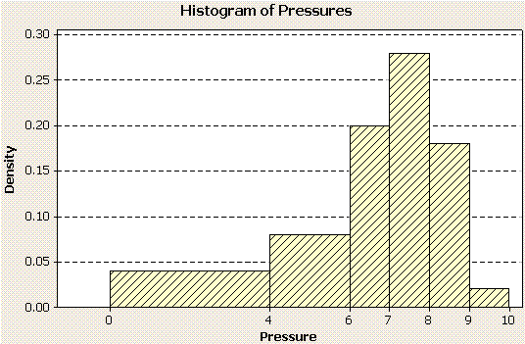
[Note: no working is required in parts (a) and (b) of this question.]
  - Identify the modal class for these data. [2]
  - Does the histogram provide evidence for positive skew, negative skew or no skew? [2]
  - Given the summary statistics , calculate the sample standard deviation s, correct to three significant figures.
[4]
  - Use the histogram to find the number of observations in the interval [4.0, 6.0).
[4]

2) A broker quotes odds for a pair of complementary events A and B as
r_{A} = 4:1 on and r_{B} = 3:2 against.

  - Calculate the corresponding probabilities p_{A} and p_{B}. [4]
  - Show that these probabilities are not coherent. [2]
BONUS QUESTION:
  - If a deposit of $100 is placed with the broker on each of events A and B, what is the broker’s profit (or loss) if event B occurs? [+4]

3) Events A, B, C are such that
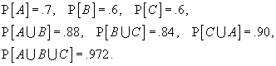

  - Use a Venn diagram to find the probability that all three events occur. [7]
  - Are the three events mutually independent? Show your working. [5]

4) Two otherwise identical unlabelled boxes contain different numbers of [10]
resistors and capacitors. One box contains eight resistors and two capacitors. The other box contains five resistors and five capacitors. Upon selecting a box at random and withdrawing one item from that box at random, you find that the item is a resistor.

Express, as a fraction in its lowest terms, the probability that the box that you selected is the one that contained eight resistors, given that the withdrawn item is a resistor.

Term Test 2 Questions, 2007

[Also provided with this examination paper were tables of the standard normal c.d.f.
(the z tables).]

1) The joint probability mass function of two discrete random quantities X, Y is given by the table
p(x, y) |  | Y
 |  | −1 | 0 | 1
X | −1 | .20 | .10 | .20
X | 0 | .08 | .06 | .08
X | 1 | .12 | .04 | .12

  - Extend the table to display the marginal probability mass functions [3]
p_{X}(x) and p_{Y}(y).
  - Verify that p(x, y) is a valid probability mass function. [2]
  - Show that E[Y] = 0. [2]
  - Find the covariance of X and Y. [4]
  - Are X, Y independent? Why or why not? [4]

2) Valves for a prototype machine have lifetimes T that are independent random quantities following an exponential distribution with a mean lifetime of 144.27 weeks.
- Show that the probability that a randomly chosen valve has a lifetime [2]
longer than 200 weeks is .2500, correct to four decimal places.
- A random sample of 10 such valves is taken. Let X be the number of [2]
valves in the random sample that last longer than 200 weeks. Show that
the probability distribution for X is, (to a good approximation), binomial
- Find the probability that more than two of the ten valves in the random [3]
sample last longer than 200 weeks.
- Another random sample of 100 valves is taken. Find, correct to two [5]
significant figures, the probability that the sample mean lifetime exceeds
170 weeks.

3) A simple decision tree, together with the relevant probabilities, is shown here.
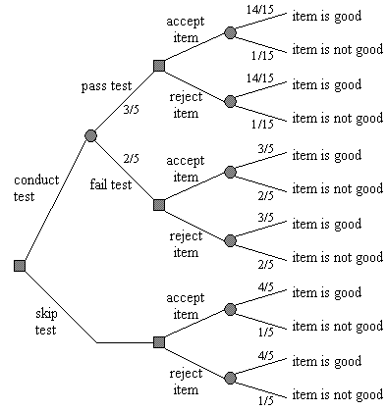
The consequences (payoffs) are:
  - accept a good item: + $ 40
  - accept a poor item: − $ 80
  - reject a good item: − $ 5
  - reject a poor item: $ 0
The test costs $5.
- Determine the optimum strategy and the maximum expected gain. [7]
- By how much can the test cost be changed without changing the [1]
optimum strategy?

4) A function f (x) of the continuous quantity x is defined by
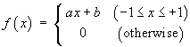
where a and b are constants.
- Find the values or range(s) of values that a and b must have in order [4]
for f (x) to be a well-defined probability density function.

- Show that the corresponding c.d.f. (cumulative distribution function) [4]
F (x) is
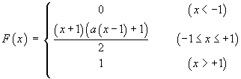

- Use the c.d.f. in part (b) to evaluate P[X > 0] in terms of a . [3]
- Find the population mean µ in terms of a . [4]

[This page is blank intentionally]

Final Examination Questions, 2007

[Also provided with this examination paper were tables
of the standard normal c.d.f. (the z tables) and
of the critical values of the t distribution (the t tables).]

1. From a box of seven identical valves, three valves are to be selected; [10]
one to be placed in an intake pipe, one in an outflow pipe and one in a drainage pipe. In how many different ways can these three valves be chosen?

2. From prior experience, it is believed that the mean potential of a certain type of battery is 12.0 V. The strength of this belief is represented by the standard deviation . A random sample of 81 such batteries has a sample mean potential of 12.2 V with a sample standard deviation of 0.3 V.
  - Construct a Bayesian 95% confidence interval estimate for the true mean potential µ. [8]
  - Construct a classical 95% confidence interval estimate for the true mean .µ [5]
  - Is there sufficient evidence to conclude that the true mean potential µ is not 12.0 V? [2]

3. The diameter of a cylinder is known to be a normally distributed random quantity with a mean and a standard deviation . The diameter of a piston is known to be a normally distributed random quantity with a mean and a standard deviation .
- Show that the probability that a randomly chosen piston fits in a randomly [8]
chosen cylinder is .97725, (correct to five significant figures).
- A random sample of ten such piston-cylinder assemblies is taken. Find [7]
the probability, (correct to two significant figures), that at least one
assembly has a piston that does not fit in its cylinder.

4. Four components are assembled into a system as shown. [15]
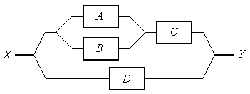
A signal can flow through a subsystem connected in parallel (such as A-B) if at least one of the two components is working. A signal can flow through a subsystem connected in series only if both of its components are working. The probability that a component is working is P[A] = P[B] = .50 , P[C] = .80 and P[D] = .75 . The reliability of each component is independent of all of the other components. Find the probability that a signal can flow through the system from X to Y.

5. The heat output of 20 randomly selected motors performing certain tasks is measured. A new ventilation system is installed on those 20 motors and the heat output is measured again. An agent claims that the new ventilation system increases the heat output. It is known that both populations are normally distributed.
- Which of the two sample t-tests (paired or unpaired) should be conducted? [3]
State the reason for your selection.
- Conduct the appropriate hypothesis test, at a level of significance of 1%, [10]
using whichever one of the two sets of Minitab® output is appropriate:

Paired T for New - Old
N Mean StDev SE Mean
New 20 167.24 22.06 4.93
Old 20 157.18 24.67 5.52
Difference 20 10.06 10.80 2.41

99% lower bound for mean difference: 3.93
T-Test of mean difference = 0 (vs > 0): T-Value = 4.17 P-Value = 0.000

Two-sample T for New vs Old
N Mean StDev SE Mean
New 20 167.24 22.06 4.93
Old 20 157.18 24.67 5.52

Difference = mu (New) - mu (Old)
Estimate for difference: 10.06
99% lower bound for difference: -7.91
T-Test of difference = 0 (vs >): T-Value = 1.36 P-Value = 0.091 DF = 38
Both use Pooled StDev = 23.4053

- Does the evidence support the agent’s claim? [2]
6. A random sample of fifty test objects is measured before (x) and after (y) a recalibration of the measuring device. A plot of the observed values of (x, y) and a normal probability plot of the residuals from simple linear regression are shown here.
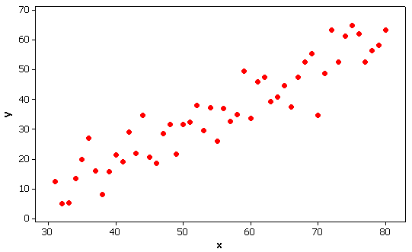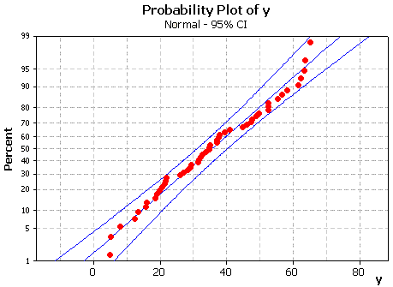
- State two reasons why a simple linear regression model for Y as a [2]
function of x is appropriate in this case.

Minitab® produces the regression equation y = 1.05298 x – 22.722 and the following ANOVA table for these data.
Source DF SS MS F P
Regression 1 11545 11545 309.40 0.000
Residual Error 48 1791 37
Total 49 13336
- How much of the total variation in Y is explained by the simple [2]
linear regression model?
- Use the Minitab output above to conduct an appropriate hypothesis test [4]
to determine whether or not there is a significant linear association
between Y and x .
- Use the information above, together with [7]
to construct a 95% prediction interval for a future observation of Y
when x = 50 .

7. A transmitter sends only two types of signal, 'A' and 'B'. In any one transmission, exactly one of these signals is sent, with signal 'A' being twice as likely as signal 'B'. After passage through a relay system, one of three signals, 'X', 'Y' or 'Z' is received. The following conditional probabilities are known:
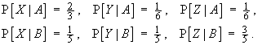
- Show that , [4]
so that receipt of signal 'X' will result in the assumption that signal 'A'
was sent.
- Find which of signals 'A', 'B' is more likely, if signal 'Y' is received. [4]
- Find which of signals 'A', 'B' is more likely, if signal 'Z' is received. [3]
- Hence find the probability that this system correctly determines [4]
which of signals 'A', 'B' was transmitted.

8. BONUS QUESTION: [+6]

A random sample of 1000 people is taken, in order to determine whether or not a majority of the population would answer “yes” to a certain question.

Given that the true population proportion of the population that would answer “yes” to the question is 55%, find the probability (correct to two significant figures) that the random sample would lead to the appropriate hypothesis test (at a level of significance of α = 0.05) returning an incorrect conclusion.

The full solutions will be available from the web site for this course.

