Appendix to the Lecture Notes
for ENGI 3423 Probability and Statistics

Some Statistical Tables

On the next three pages are the two most frequently used statistical tables:
- critical values of the t distribution; and
- values of the standard normal cumulative distribution function Φ(z).
A copy of these tables will be provided in the final examination (and, if any question requires them, in Test 2 also).

These and other tables can be found, as Excel spreadsheet files, at the web site
www.engr.mun.ca/~ggeorge/3423/demos/

Note the distinction between the two tables displayed in this appendix:
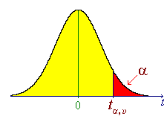
In the t-tables, for chosen values of ν and α, values of t are tabulated, such that
,
where T_{ν} is a random quantity following the t distribution with ν degrees of freedom.
The values of the c.d.f. are therefore the complements of the values in the top margin (the column headers).
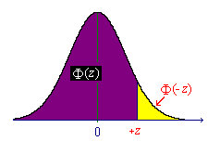

In the z-tables, for chosen values of z , values of α are tabulated, such that
P[Z < z] = α or, equivalently,
values of the function Φ(z) are tabulated.
The values of the c.d.f. are therefore in the body of the table.

Also note that two very small Excel spreadsheet files on the web site are of much more use in practice (but will not be available in the final examination):
tCalculator.xls and zCalculator.xls.
In these spreadsheets, the c.d.f. α = F(t) [or Φ(z)] can be found for any chosen t [or z] and the inverse c.d.f. t = F ^{–1}(α) [or z = Φ ^{–1}(α)] can be found for any chosen probability α.

