Probability

Decision trees θ₁ u₁

α₁ θ₂ u₂

α₂ θ₁ u₃
Decision

Actions
θ₂ u₄
Chance nodes
Consequences;
→ utility

States of nature

Which action will be taken is a decision completely controlled by the user.
Which state of nature will occur is beyond the user’s control.

Example 3.01 θ₁ = cold u₁ = snug !

α₁ wear coat
θ₂ = warm u₂ = sweaty !

θ₁ = cold u₃ = brrr !

α₂ don’t wear coat
u₄ = best of
θ₂ = warm! all worlds !
The decision depends on the assessment of the probabilities of the states of nature and on the values of the utilities.

Example 3.02
(platform for oil & gas development) few
C
O
N
S
E
Q
U
E
N
C
E
S

Icebergs

Fixed platform many

Floating platform
Icebergs

This was one of the factors in the design decisions for the Hibernia and Terra Nova oil fields.

Example 3.03

Investment High return u₁

Buy stocks
Low return u₂

Buy bonds Safe known
return u₃

The decision here depends not only on the average return but also on one’s tolerance for risk. Risk aversion is a real life factor that we will not have the time to explore in this course.
Fair bet

Example 3.04

A client gives a $100 reward iff (if and only if) the contractor’s circuit board passes a reliability test. The contractor must pay a non-refundable deposit of $100p with the bid. What is a fair price for the deposit?

Let E = (the event that the circuit board passes the test)
and $\tilde{E}$= ~E = not-E = (the event that the circuit board fails the test)
then $\tilde{E}$ is known as the complementary event to E.
Reward
Let E = 1 represent “E is true” E 100
and E = 0 represent “E is false”
then Pay
100p $\tilde{E}$ 0
Decision tree:

$p = \frac{\text{deposit}}{\text{reward}}$
Pay
0 0

The contractor has a free choice:
to take the contract or not.
If the contract is taken (= upper branches of decision tree):

(Gain if $\tilde{E}$) = −100p

(Gain if E) = −100p + 100 = 100(1−p) = 100

Therefore Gain = −100p + 100E

where E is random, (= 0 or 1; E is a Bernoulli random quantity).

If the contract is not taken (= lowest branch of decision tree):

Gain ≡ 0
Gain > 0 : too generous to contractor
Gain < 0 : contract too expensive

But gain is a random quantity

A fair bet ⇒ indifference between decisions

⇒ −100p + 100E ≈ 0
Balance of Judgement:
[Simple mechanics can provide analogies for much of probability theory]

Gain if E Loss if $\tilde{E}$
= 100 (1−p) = 100 p

P[E] P[$\tilde{E}$]

The bet is fair iff gain and loss balance:

Taking moments: 100 (1−p) × P[E] = 100 p × P[$\tilde{E}$]
But $\tilde{E}$ = 1 − E and P[$\tilde{E}$] = 1 − P[E]
⇒ (1 − p + p) × P[E] = p
p = P[E]
Therefore the fair price for the bid deposit occurs when
and the fair price is (deposit) = (contract reward) × P[E].

Example 3.04 (continued)

Suppose that past experience suggests that E occurs 24% of the time.
Then we estimate that P[E] = .24 and the fair bid is 100 × .24 = $24.

Odds

Let s be the reward at stake in the contract (= $100 in example 3.04).
The odds on E occurring are the ratio r, where

$r = \frac{\text{loss if \{}\tilde{E}}{\text{gain if }E} = \frac{s p}{s \left( 1−p \right)} = \frac{P[E]}{P[\tilde{E}]} = \frac{p}{\tilde{p}} = \frac{p}{1−p}$ ⇒ $P[E] = \frac{r}{r+1}$

In example 3.04,
= “19 to 6 against” (or “6 to 19 on”, but usually larger # first)
and
“Even odds” ⇒ r = 1:1 ⇒ p = ½ = 50%
“Odds on” when p > .5 , “Odds against” when p < .5 .

Incoherence:

Suppose that no more than one of the events {E₁, E₂, ... , E_{n}} can occur. Then the events are incompatible (= mutually exclusive).

If the events {E₁, E₂, ... , E_{n}} are such that they exhaust all possibilities, (so that at least one of them must occur), then the events are exhaustive.

If the events {E₁, E₂, ... , E_{n}} are both incompatible and exhaustive, (so that exactly one of them must occur), then they form a partition, and

E₁ + E₂ + ... + E_{n} = 1
Example 3.05

A bookmaker accepts bets on a partition { E_{i} } .
You place a non-refundable deposit (a bet) p_{i}s_{i} on E_{i} occurring.
The bookie pays a stake s_{i} to you (but still retains your deposit) if E_{i} occurs.
If E_{i} does not occur, then you lose your deposit p_{i}s_{i}.
Assume that one bet is placed on each one of the events { E_{i} } .
The bookie’s gain if E_{h} is true is
(gain) = (revenue) – (payout)
(for h = 1, 2, ... , n)

The bookie can arrange { p_{i} } such that ∑ g_{h} > 0 → unfair bet! (= incoherence)

Suppose s_{i} = s ∀i (for all values of i), then

(for h = 1, 2, ... , n)
A fair bet is then assured if (total probability theorem);
the probabilities are then coherent.

A More General Case of Example 3.05:

An operator accepts deposits on a partition { E_{i} } .
k_{i} people each place a non-refundable deposit p_{i}s_{i} on E_{i} occurring.
Note that p_{i} is a measure of the likelihood of E_{i} occurring.
(The more likely E_{i} is, the greater the deposit that the operator will require).
If E_{i} occurs, then the operator pays a stake s_{i} to each of the k_{i} contractors, (but still retains all of the deposits).
If E_{i} does not occur, then each of the k_{i} contractors loses the deposit p_{i}s_{i}.

The operator’s gain if E_{h} is true is

(gain) = (revenue) – (payout)
(for h = 1, 2, ... , n)

Now assume a more common situation, not of equal stakes, but of equal deposits:
p₁s₁ = p₂s₂ = ... = p_{n}s_{n} = b
Then

(for h = 1, 2, ... , n)

The number p_{h} is a measure of how likely the gain g_{h} is to occur.
Therefore use p_{h} as a weighting factor, to arrive at an expected gain:

E[G] = 0 if and only if

Notation:
A ∧ B = events A and B both occur; A ∧ B = A × B = A B
A ∨ B = event A or B (or both) occurs;
(but A ∨ B ≠ A + B unless A, B are incompatible)

Some definitions:

Experiment = process leading to a single outcome

Sample point (= simple event) = one possible outcome (which precludes all other outcomes)

Event E = set of related sample points

Possibility Space = universal set = Sample Space S =

{ all possible outcomes of an experiment }

By the definition of S , any event E is a subset of S : E ⊆ S

Classical definition of probability (when sample points are equally likely):

$P[E]\text{ = }\frac{n(E)}{n(S)}$ ,
where n(E) = the number of [equally likely] sample points inside the event E.

More generally, the probability of an event E can be calculated as the sum of the probabilities of all of the sample points included in that event:
P[E] = Σ P[X]
(summed over all sample points X in E.)

Empirical definition of probability:

P[E] = (limit as # exp’ts → ∞ of) { relative frequency of E }

Example 3.06 (illustrating the evolution of relative frequency with an ever increasing number of trials):

http://www.engr.mun.ca/~ggeorge/3423/demos/cointoss.exe

or import the following macro into a MINITAB session:

http://www.engr.mun.ca/~ggeorge/3423/demos/Coins.mac
Example 3.07: rolling a standard fair die. The sample space is

S = { 1, 2, 3, 4, 5, 6 }

n(S) = 6 (the sample points are equally likely)

P[1] = 1/6 = P[2] = P[3] = ...

P[S] = 1

(S is absolutely certain)

The empty set (= null set) = Ø = {} [Note: this is not { 0 } !]

P[Ø] = 0 (Ø is absolutely impossible)

The complement of a set A is A' (or $\tilde{A}$ , A* , A^{c} , NOT A , ~A, $\bar{A}$).

n(~A ) = n(S) − n(A) and

P[~A ] = 1  P[A]
The union A ∪ B = (A OR B) = A ∨ B

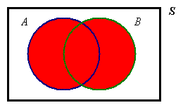

The intersection A ∩ B = (A AND B) = A ∧ B = A × B = A B
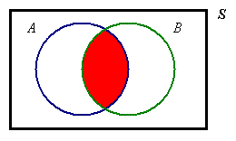

For any set or event E :

Ø ∪ E = E E ∩ ~E = ∅

Ø ∩ E = ∅ E ∪ ~E = S

S ∪ E = S ~(~E ) = E

S ∩ E = E ~Ø = S

The set B is a subset of the set P : B ⊆ P .
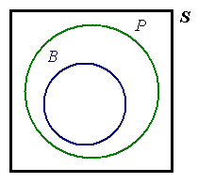
Read the symbol "⊆" as
"is contained entirely
inside"

If it is also true that P ⊆ B , then P = B (the two sets are identical).

If B ⊆ P , B / P and B / Ø , then B ⊂ P (B is a proper subset of the set P).

B ∩ P = B For any set or event E : Ø ⊆ E ⊆ S
B ∪ P = P Also: B ∩ ~P = ∅

Example 3.08

Examples of Venn diagrams:

1. Events A and B both occur. 2. Event A occurs but event
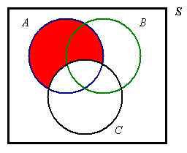
C does not.
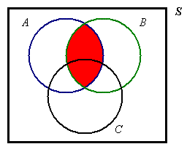

A ∩ B A C '

3. At least two of events 4. Neither B nor C occur.
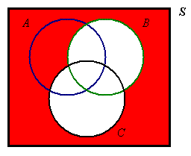
A , B and C occur.
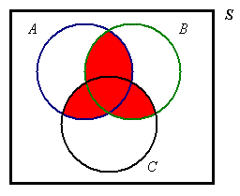

(AB)∨(BC)∨(CA) ~B ∧ ~C = ~(B ∨ C)

Example 3.08.4 above is an example of DeMorgan’s Laws:

~(A ∪ B) =
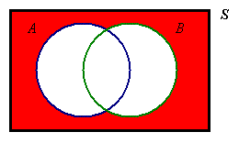

“neither A nor B”

~(A ∩ B) =
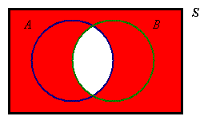

“not both A and B”

General Addition Law of Probability
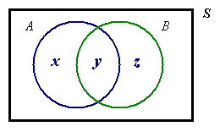

P[A ∨ B] = x + y + z

P[A] = x + y
P[B] = y + z
P[A ∨ B] = P[A] + P[B]  P[A ∧ B]
P[A ∧ B] = y

Extended to three events, this law becomes

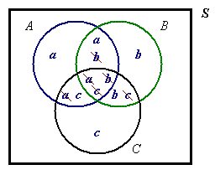
P[A ∨ B ∨ C] = P[A] + P[B] + P[C]
− P[A ∧ B] − P[B ∧ C] − P[C ∧ A]
+ P[A ∧ B ∧ C]

If two events A and B are mutually exclusive
(= incompatible = have no common sample points), then
A ∩ B = Ø ⇒ P[A ∧ B] = 0 and the addition law simplifies to

P[A ∨ B] = P[A] + P[B] .

Only when A and B are mutually exclusive may one say “ A ∨ B ” = “A + B ”.

Total Probability Law

The total probability of an event A can be partitioned into two mutually exclusive subsets: the part of A that is inside another event B and the part that is outside B :
P[A] = P[A ∧ B] + P[A ∧ ~B]

Special case, when A = S and B = E:
P[S] = P[S ∧ E] + P[S ∧ ~E]
⇒ 1 = P[E] + P[ ~E]

Example 3.09

Given the information that P[ABC] = 2%, P[AB] = 7%, P[AC] = 5% and P[A] = 26%,
find the probability that, (of events A,B,C), only event A occurs.

A only = AB'C'
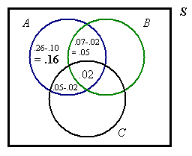
We know the intersection probabilities,
therefore we start at the centre and work our way out.

The sum of the probabilities in the three lens regions illustrated is .05 + .02 + .03 = .10 .

The required probability is in the remaining one region of A and is .26 − .10 = .16 .

On the next page is a more systematic way to solve this example.

[Example 3.09 continued]
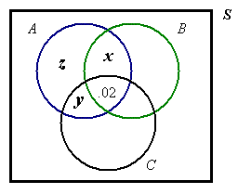
P[AB] = .07 = x + .02 ⇒ x = .05

P[AC] = .05 = y + .02 ⇒ y = .03

P[A] = .26 = z + .03 + .02 + .05

⇒ P[AB'C' ] = z = .26 − .10 = .16

Alternatively, P[AB'C' ] = P[A] − P[AB] − P[AC] + P[ABC]
= .26 − .07 − .05 + .02 = .16

If the information had been provided in the form of unions instead of intersections, then we would have started at the outside of the Venn diagram and worked our way in, using deMorgan’s laws and the general addition law where necessary.

[End of Section 3]
[Space for additional notes]

