Example 4.01: Roll two fair six-sided dice.

Let E₁ = “sum = 7” then

P[E₁] = n(E₁) × P[each sample point] = n(E₁) / n(S)

Let E₂ = “sum > 10” then

P[E₂] =

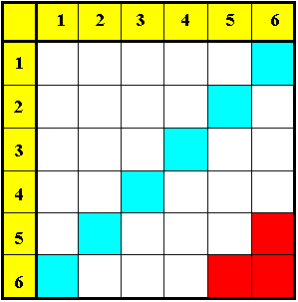

E₁ and E₂ have no common sample points (disjoint sets; mutually exclusive events) ⇒

P[E₁ OR E₂] = P[E₁] + P[E₂] =
Odds:

Example 4.01 (continued)

Let E₃ = “at least one ‘6’ ” then

P[E₃] =

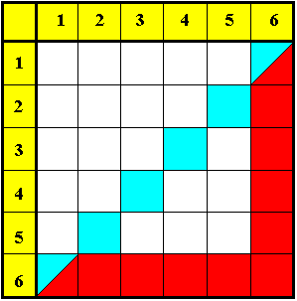

P[E₁ OR E₃] =

( common points counted twice)

= P[E₁] + P[E₃]  P[E₁ AND E₃]

Venn diagram Venn diagram
(each sample point shown): (# sample points shown):
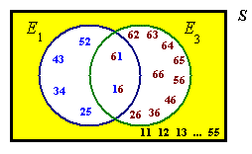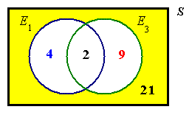

Venn diagram for probability:
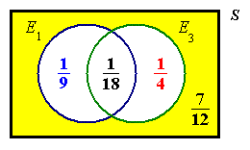

Some general properties of set/event unions and intersections are listed here:

Commutative: A∪B = B∪A , A∩B = B∩A

Associative: (A∪B)∪C = A∪(B∪C) = A∪B∪C
(A∩B)∩C = A∩(B∩C) = A∩B∩C

Distributive: A∪(B∩C) = (A∪B)∩(A∪C)
A∩(B∪C) = (A∩B)∪(A∩C)

In each case, these identities are true for all sets (or events) A, B, C.

Example 4.01 (continued)
Find the probability of a total of 7 without rolling any sixes.

P[E₁  ~E₃ ] = P[E₁]  P[E₁  E₃] (total probability law)

[This result can also be obtained
directly from the third Venn
diagram on page 4-03.]

Example 4.02:

Given the information that P[A ∨ B] = .9 , P[A] = .7 , P[B] = .6 ,
find P[exactly one of A, B occurs]

Incorrect labelling of the Venn diagram:
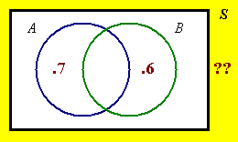
"A" refers to the entire left circle,
not just the left lune.

Required event: AB' + A'B

Correct version:
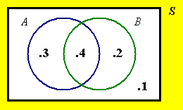
P[AB'] = P[A∪B] − P[B]
= .9 − .6 = .3
P[A'B] = P[A∪B] − P[A]
= .9 − .7 = .2

P[AB' + A'B] = P[AB'] + P[A'B]
= .3 + .2
= .5

Example 4.03

Three cards, labelled A , B and C , are in an urn.
In how many ways can three cards be drawn
(a) with replacement?
(b) without replacement?
(c) without replacement (if the order of selection doesn’t matter)?

For part (a) of this question, the complete sample space is listed below.

AAA AAB AAC ABA ABB ABC ACA ACB ACC

BAA BAB BAC BBA BBB BBC BCA BCB BCC

CAA CAB CAC CBA CBB CBC CCA CCB CCC

A simple count shows 27 sample points.

The first card can be A, B or C: 3 ways, for each of which
the second card can be A, B or C: 3 ways, for each of which
the third card can be A, B or C: 3 ways, for a total of
3 × 3 × 3 = 27 ways.

In general, # ways to choose r objects from n with replacement is n^{r} .

For part (b) of this question, identify the reduced sample space:

AAA AAB AAC ABA ABB ABC ACA ACB ACC

BAA BAB BAC BBA BBB BBC BCA BCB BCC

CAA CAB CAC CBA CBB CBC CCA CCB CCC

A simple count shows 6 sample points.

The first card can be A, B or C: 3 ways, for each of which
the second card can be drawn in: 2 ways, for each of which
the third card can be drawn in: 1 way, for a total of
3 × 2 × 1 = 6 ways.
These are the six permutations of 3 letters from the set { A, B, C }.
(c)
All six permutations contain A, B, C (in whatever order).
There is only one combination.

Definitions – the factorial function:

The number of ways in which r objects can be drawn from n objects without replacement (with the order of selection being important) is the number of permutations:

^{n}P_{r} = P_{r, n} = (n)_{r} = n×(n−1)×(n−2)× ... ×(n−[r −1])

r items can be arranged among themselves in ^{r}P_{r} = r ! ways.
It then follows that we must define 0 ! = 1 .

The number of ways in which r objects can be drawn from n objects without replacement and with the order of selection being irrelevant is the number of combinations:

Example 4.04

Three cards, labelled A , B and C , are in an urn.
In how many ways can two cards be drawn
(a) with replacement?
(b) without replacement?
(c) without replacement (if the order of selection doesn’t matter)?

For part (a) of this question, the complete sample space is listed below.

AA AB AC BA BB BC CA CB CC

(a) 3² = 9 ways.

(b)

(c)

The combinations are

AB BC CA

The permutations are

AB AC BA BC CA CB

Example 4.05

Evaluate $\left( \begin{matrix}\text{11} \\ 6\end{matrix} \right)$

= 462

[In general, when evaluating combinations manually, always cancel the larger factorial factor of the denominator with part of the numerator.]

Example 4.06

Evaluate P _{2, 9}

Example 4.07

Simplify $\left( \begin{matrix}n \\ n − r\end{matrix} \right)$

This symmetry should not be surprising: if r objects are removed from n, then an original pile of n objects has been divided into two piles of r taken out and (n−r) left behind. The number of ways of removing (n−r) objects should be the same as the number of ways of removing r objects.

Example 4.08

Simplify $\left( \begin{matrix}n \\ n\end{matrix} \right)$

[From example 4.07, it then follows that ^{n}C₀ = 1 also.]
Also note the identities

^{n}P₀ = P _{0, n} = ^{n}C₀ = $\left( \begin{matrix}n \\ 0\end{matrix} \right)$ = $\left( \begin{matrix}n \\ n\end{matrix} \right)$ = ^{n}C_{n} = 1 ,

^{n}P_{n} = P _{n, n} = n ! = P _{n−1 , n} = ^{n}P_{n−1}

and ^{n}P₁ = P _{1, n} = ^{n}C₁ = $\left( \begin{matrix}n \\ 1\end{matrix} \right)$ = $\left( \begin{matrix}n \\ n − 1\end{matrix} \right)$ = ^{n}C_{n−1} = n

Summary:

The number of ways to draw r objects from n distinguishable objects is:

[with replacement (ordered):] = n^{r}

[without replacement (ordered):] = ^{n}P_{r}

[without replacement (unordered):] = ^{n}C_{r}

The case “with replacement (unordered)” seldom arises in practice, but the number of ways of drawing r objects from n distinguishable objects in this case can be shown to be ^{n+ r − 1}C_{r} . See www.engr.mun.ca/~ggeorge/3423/demos/Counts.xls for an illustration of these values for some choices of r and n.

Example 4.09

(a) In how many ways can a team of three men and three women be chosen from a group of five men and six women?

(b) In how many ways can a team of three men and three women be chosen from a group of five men and six women when the team has one leader, one other member and a reserve for the men and likewise for the women?

(a) Men:

Women:

Team: 10×20 = 200

Example 4.09 (continued)

(b) Order matters
(“B as leader, A as reserve” is different from “A as leader, B as reserve”).

The number of distinct ways of selecting the team is

For each of the 200 distinct combinations there exist 36 permutations.
There are 200 ways to select six team members, for each of which there are 36 ways to allocate the six chosen team members among the team positions (leader, member and reserve for both men and women).
Another counting technique – the maze.
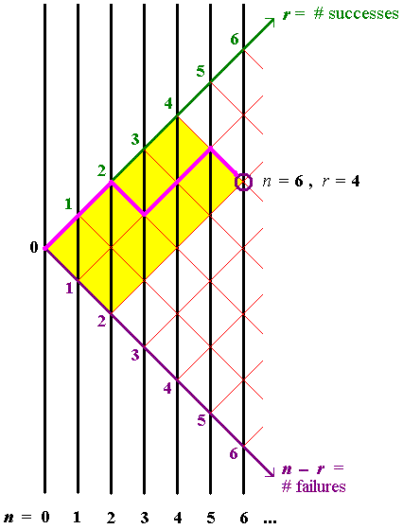

Trace all paths, such as the path shown,
SSFSSF , to the point
(n, r) = (6, 4).

All paths to (6, 4)
pass through either
(5, 4) or (5, 3).

It therefore follows
that

More generally,

This leads to Pascal’s triangle [next page].
Pascal’s triangle for ^{n}C_{r} :
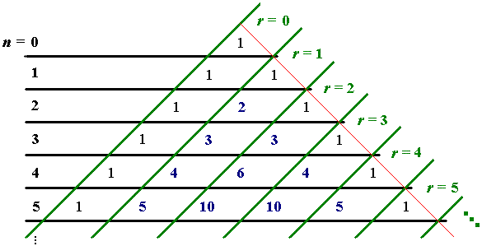

The entries in this triangle are generated from the identity
Each entry is the sum of the two entries immediately above (except for the initial '1' at the top of the triangle).

Example 4.10:
On the surface of the Earth a “degree square” from latitude θ degrees to latitude (θ + 1) degrees is, to a good approximation, a rectangle of sides 111.12 km (north-south) and 111.12×cos(θ +½) km (east-west).

Suppose that a ship of beam (width) b is crossing the degree square on a path of total length d. Suppose also that a stationary iceberg of width w is placed randomly on the degree square and that the ship’s crew fails to detect the iceberg.

(a) Find the probability that the ship will collide with the iceberg during its crossing of the degree square.
[Hint: look at the ratio of the area swept out along the ship’s path by an object of width (w + b) to the total area of the degree square.]

(b) Evaluate the probability in part (a) in the case when θ = 41 degrees, b = 28 m,
w = 110 m and d = 83.2 km,
(which are plausible values for the RMS Titanic in 1912).

(c) For the values given in part (b), find the probability, (correct to the nearest 1%) that there are no collisions after 100 crossings.

(d) For the values given in part (b), find the least number of crossings at which the probability of at least one collision rises above 50%.

111.12 cos(θ+½) km

(a) P[collision] =

111.12 km

d

Example 4.10 (continued)

(b)

(c) Let p = P[collision in 1 crossing] , then

P[no collision in 100 crossings] = (1 – p)¹⁰⁰
= (.998 758...)¹⁰⁰ = .883 175...

= 88% (to the nearest 1%).

(d) P[at least 1 collision in n crossings]
1 – P[no collisions in n crossings]
= 1 – (1 – p)^{n}

We want the least n such that
1 – (1 – p)^{n} > 1/2

⇒ (1 – p)^{n} < 1 – 1/2 = 1/2
⇒ n ln(1 – p) < ln(1/2)
[Note that the inequality reverses upon division by the negative quantity
ln(1 – p) :]
Therefore n_{min} = 558 .

[Note that this example is for only one iceberg in a single degree square.]

[End of Section 4]

