Example 5.01

Given that rolling two fair dice has produced a total of at least 10, find the probability that exactly one die is a ‘6’.

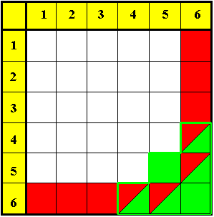
Let E₁ = "exactly one '6' "
and E₂ = "total ≥ 10"

The required probability is
P[E₁ | E₂ ] .

The "given" event E₂ is highlighted
in the diagram by a green border
and it supplies a reduced sample
space of six equally likely sample
points, four of which also fall
inside E₁ .

Therefore P[E₁ | E₂ ] = 4/6 = 2/3 .

Also, (with all sample points
equally likely),

which leads to

$$P[E_{1} | E_{2}] = \frac{P[E_{1} E_{2}]}{P[E_{2}]}$$

Because intersection is commutative,
P[E₁ E₂] = P[E₂ E₁] ⇒ P[E₁|E₂] • P[E₂] = P[E₂|E₁] • P[E₁]

Events E₁, E₂ are independent if P[E₁|E₂] = P[E₁] (and are dependent otherwise).

Example 5.02

Show that the events
E₁ = “fair die A is a ‘6’ ” and E₂ = “fair die B is a ‘6’ ”
are independent.

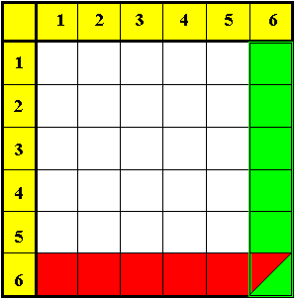
Let us find P[E₂ | E₁] .
The final column in the diagram
represents the six [equally likely]
sample points in the reduced
sample space of the given event E₁ .

Only one of these six points also
lies in E₂ .

Therefore P[E₂ | E₁] = 1/6 .

Alternatively,
P[E₁] = 6/36 = 1/6

P[E₂] = 6/36 = 1/6
and
P[E₁E₂] = 1/36

Therefore P[E₂ | E₁] = P[E₂] ⇒ E₁ and E₂ are independent.

Stochastic independence:
Events E₁, E₂ are stochastically independent (or just independent) if P[E₁|E₂] = P[E₁].

Equivalently, the events are independent iff (if and only if) P[E₁ E₂] = P[E₁] • P[E₂] .
Compare this with the general multiplication law of probability:

P[E₁ E₂] = P[E₁|E₂] • P[E₂]
Example 5.03

A bag contains two red, three blue and four yellow marbles. Three marbles are taken at random from the bag,
(a) without replacement;
(b) with replacement.
In each case, find the probability that the colours of the three marbles are all different.

Let "E" represent the desired event and "RBY" represent the event "red marble first and blue marble second and yellow marble third" and so on. Then
E = RBY or BYR or YRB or YBR or RYB or BRY (all m.e.)

(a)
[Note that P[B₂ | R₁] = 3 / 8, because, after one red marble has been drawn from the bag, eight marbles remain, three of which are blue.]
, etc.

(b)

Note that replacement reduces the probability of different colours.

A valid alternative method is a tree diagram (shown for part (a) on the next page):

Example 5.03 (continued)

(a)
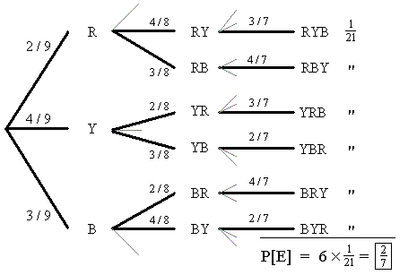

Independent vs. Mutually Exclusive Events:

Two possible events E₁ and E₂ are independent if and only if P[E₁ E₂] = P[E₁] • P[E₂] .

Two possible events E₁ and E₂ are mutually exclusive if and only if P[E₁ E₂] = 0 .

No pair of possible events can satisfy both conditions, because P[E₁] • P[E₂] ≠ 0 .
A pair of independent possible events cannot be mutually exclusive.
A pair of mutually exclusive possible events cannot be independent.

An example with two teams in the playoffs of some sport will illustrate this point.
Example 5.04
Teams play each other: Outcomes for teams A and B are:

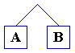
m.e. and dependent

Teams play other teams: Outcomes for teams A and B are:
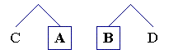
indep. and not m.e.
(assuming no communication
between the two matches)

A set of mutually exclusive and collectively exhaustive events is a partition of S.

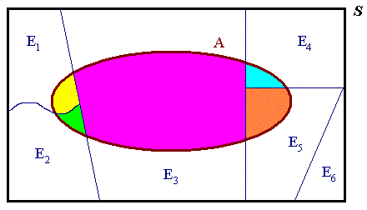

A set of mutually exclusive events E₁, E₂, ... , E_{n} is collectively exhaustive if

[One may partition any event A into the mutually exclusive pieces that fall inside each member of the partition { E_{i} } of S .]

Total probability law:

But

which leads to Bayes’ theorem (on the next page).

Bayes’ Theorem:

When an event A can be partitioned into a set of n mutually exclusive and collectively exhaustive events E_{i} , then

$$P\left[E_{k} | A\right] = \frac{P\left[A | E_{k}\right]⋅P\left[E_{k}\right]}{\sum_{i=1}^{n}{P\left[A | E_{i}\right]⋅P\left[E_{i}\right]}}$$

Example 5.05

The stock of a warehouse consists of boxes of high, medium and low quality lamps in the respective proportions 1:2:2. The probabilities of lamps of these three types being unsatisfactory are 0, 0.1 and 0.4 respectively. If a box is chosen at random and one lamp in the box is tested and found to be satisfactory, what is the probability that the box contains
(a) high quality lamps;
(b) medium quality lamps;
(c) low quality lamps?

Let {H, M, L} represent the event that the lamp is {high, medium, low} quality, respectively. The probabilities of events H, M, L are in the ratio 1 : 2 : 2.
Let A = "lamp is satisfactory".

P[A | L] = .6 (from P[~A | L] = .4)
P[A | M] = .9 (from P[~A | M] = .1)
P[A | H] = 1 (absolutely certain)

P[H] = 1 / (1+2+2) = 1/5
P[M] = P[L] = 2/5

(a)
(Bayes’ theorem)

Note that the denominator, 4/5 , is also P[A] and is the same in all three parts of this question.
Example 5.05 (continued)

(b)

(c)

Note that the ratio of the probabilities is H : M : L = 5 : 9 : 6 .
It is not 10 : 9 : 6 , because the number of high quality lamps is only half that of each of the other two types.

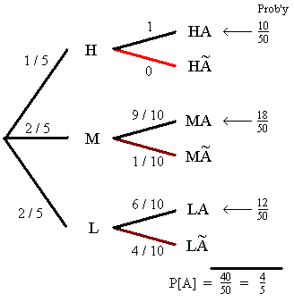
An alternative is a tree diagram:

etc.

Another version of the total probability law:
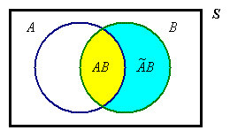
⇒

Updating Probabilities using Bayes’ Theorem

Let F be the event “a flaw exists in a component”
and D be the event “the detector declares that a flaw exists”
then
$$P\left[F | D\right] = \frac{P\left[D | F\right]}{P\left[D\right]}×P\left[F\right]$$

and P[D ] = normalizing constant =

Example 5.06

Suppose that prior experience suggests
P[F ] = .2 , P[D | F ] = .8 and P[D | ~F ] = .3
then

⇒ P[F | D] = (.8 / .4) × .2 = 2 × .2 = .4

The observation of event D has changed our assessment of the probability of a flaw from the prior P[F ] = .2 to the posterior P[F | D ] = .4 .

[It is common sense that the detection of a flaw will increase our estimate of the probability of a future flaw, while a flaw-free run will decrease that estimate.]

Example 5.07
A binary communication channel is as shown:
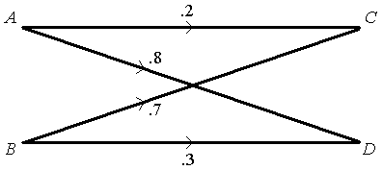

Inputs:

P[A] = .6 ⇒ P[B] = P[~A] = .4

Channel transition probabilities:

P[C | A] = .2 ⇒ P[D | A] = .8

P[C | B] = .7 ⇒ P[D | B] = .3

⇒ P[ AC ] = .2 × .6 = .12 P[ AD ] = .8 × .6 = .48

P[ BC ] = .7 × .4 = .28 P[ BD ] = .3 × .4 = .12

[So, 40% of the time, the output will be C. Given that C is the output, there is a probability of 28/40 that the input was B, but only 12/40 that the input was A.
Therefore, if C is the output, then B is the more likely input, by far.]

[A similar argument applies, to conclude that, given an output of D, an input of A is four times more likely than an input of B. A mapping from outputs back to inputs then follows:]
→ optimum receiver:
m(C) = B , m(D) = A

⇒ P[correct transmission] = P[AD ∪ BC]

= .48 + .28 = .76

⇒ P[error] = .24

Another diagram:
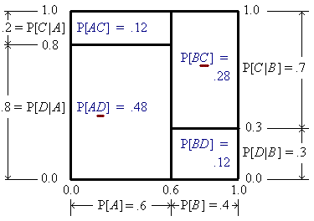

More generally, for a network of M inputs (with prior {P[m_{i}]}) and N outputs
(with {P[r_{j} | m_{i}]}), optimize the system:

Find all posterior {P[m_{i} |r_{j} ]}.

Map receiver r_{j} to whichever input m_{i} has the greatest P[m_{i}|r_{j} ] (or greatest P[m_{i} ∧ r_{j} ]).

Then P[correct decision] =
Σ ( P[m(r_{j}) | r_{j}]×P[r_{j}] )
j
Diagram (for M=2, N=3):
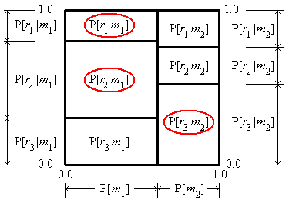

[See also pp. 33-37, “Principles of Communication Engineering”, by Wozencraft and Jacobs, (Wiley).]
[End of Devore Chapter 2]

Some Additional Tutorial Examples

Example 5.08 (This example is also Problem Set 2 Question 5(f))

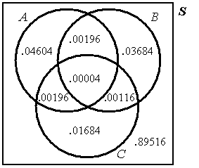
Events A, B, C are such that the
probabilities are as shown in this
Venn diagram.

Are the three events independent?

P[A] = .05 , P[B] = .04 , P[C] = .02 ,

P[AB] = .002 , P[BC] = .0012 ,
P[CA] = .002 ,

P[ABC] = .00004

⇒ P[A] × P[B] × P[C] = .05 × .04 × .02 = .00004 = P[ABC]
– but this is not sufficient!

P[A] × P[B] = .05 × .04 = .002 = P[AB]
⇒ A, B are stochastically independent

but P[B] × P[C] = .04 × .02 = .0008 ≠ P[BC]
⇒ B, C are not independent

and P[C] × P[A] = .02 × .05 = .001 ≠ P[CA]
⇒ C, A are not independent

Therefore { A, B, C } are not independent (despite P[A] × P[B] × P[C] = P[ABC])

Three events { A, B, C } are mutually independent if and only if

P[A B C] = P[A] × P[B] × P[C]
and
all three pairs of events { A, B }, { B, C }, { C, A } are independent

[Reference: George, G.H., Mathematical Gazette, vol. 88, #513, 85-86, Note 88.76 “Testing for the Independence of Three Events”, 2004 November]
Example 5.09

Three women and three men sit at random in a row of six seats.
Find the probability that the men and women sit in alternate seats.

In the sample space S there is no restriction on seating the six people
⇒ n(S) = 6 !

Event E = alternating seats, in either the pattern

M W M W M W

or

W M W M W M

In each case, the 3 [wo]men can be seated in their 3 places in 3 × 2 × 1 = 3 ! ways.

The women’s seating is independent of the men’s seating.

Therefore n(E) = 2 × 3 ! × 3 ! and

OR

In event E, any of the six people may sit in the first seat.
The second seat may be occupied only by the three people of opposite sex to the person in the first seat.
The third seat must be filled by one of the two remaining people of the opposite sex as the person in the second seat.
The fourth seat must be filled by one of the two remaining people of the opposite sex as the person in the third seat.
The fifth seat must be filled by the one remaining person of the opposite sex as the person in the fourth seat.
Only one person remains for the sixth seat.

Therefore n(E) = 6 × 3 × 2 × 2 × 1 × 1

and n(S) = 6 × 5 × 4 × 3 × 2 × 1
Example 5.10 (Devore Exercises 2.3 Question 36, Page 66 in the 7th edition)

An academic department with five faculty members has narrowed its choice for a new department head to either candidate A or candidate B. Each member has voted on a slip of paper for one of the candidates. Suppose that there are actually three votes for A and two for B. If the slips are selected for tallying in random order, what is the probability that A remains ahead of B throughout the vote count? (For example, this event occurs if the selected ordering is AABAB but not for ABBAA).

Only two events are inside event E: AABAB and AAABB .

Therefore n(E) = 2

If one treats the five votes as being completely distinguishable from each other, then

[Additional notes may be placed on this page]

