A random quantity [r.q.] maps an outcome to a number.

Example 6.01:

P = “A student passes ENGI 3423”
F = “That student fails ENGI 3423”

The sample space is S = { P, F }

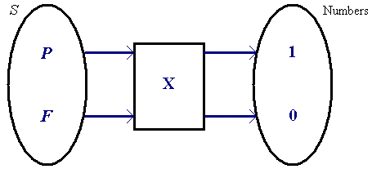

Define X (P) = 1 , X (F) = 0 , then
X is a random quantity.

Definition: A Bernoulli random quantity has only two possible values:
0 and 1.

Example 6.02

Let Y = the sum of the scores on two fair six-sided dice.

Y (i, j ) = i + j

The possible values of Y are: 2, 3, 4, ... , 12

Example 6.03

Let N = the number of components tested when one fails.

The possible values of N are: 1, 2, 3, ...

A set D is discrete if
n(D) is finite
OR
n(D) is “countably infinite” (consecutive values can be found)

Examples:

6.03. Set  = (the set of all natural numbers) is discrete (countably infinite)

6.04. A = { x : 1 ≤ x ≤ 2 and x is real } is not discrete (it is continuous)

[ '1' is the smallest value, but what is the second-smallest value? ]

A random quantity is discrete if its set of possible values is a discrete set.

Each value of a random quantity has some probability of occurring. The set of probabilities for all values of the random quantity defines a function p (x ) , known as the
Probability Mass Function
(or probability function)
(p.m.f.):

p(x) = P[X = x]

Note: X is a random quantity, but x is a particular value of that random quantity.

All probability mass functions satisfy both of these conditions:

and

[Note that these two conditions together ensure that p(x) < 1 ∀x .]

Example 6.05

← [NOTE: may omit this branch]

[ f (x) = 0 is assumed for all x not mentioned in the definition of f (x).]

f (x) is a probability mass function. Find the value of the constant c .

p(x) > 0 ∀x ⇒ c > 0

∑ p(x) = 1 ⇒ c(1)² + c(2)² + c(3)² = 1

Therefore

Bar Chart:
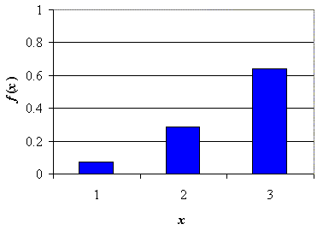
Example 6.06

Find the p.m.f. for X = (the number of heads when two fair coins are tossed).

Let H_{i} = head on coin i and T_{i} = tail on coin i.

The possible values of X are X = 0 (T₁T₂)
1 (H₁T₂ or T₁H₂)
or 2 (H₁H₂)

P[X = 0] = P[T₁T₂]
= P[T₁] P[T₂|T₁]
= ½×½ (independent events)
= ¼

P[X = 1] = P[H₁T₂] + P[T₁H₂] (mutually exclusive events)
= P[H₁] P[T₂] + P[T₁] P[H₂] (independent events)
= ½×½ + ½×½
= ¼ + ¼
= ½
P[X = 2] = P[H₁H₂]
= ½×½
= ¼

Therefore the p.m.f. is

The Discrete Uniform Probability Distribution

A random quantity X , whose n possible values { x₁, x₂, x₃, ... , x_{n} } are all equally likely, possesses a discrete uniform probability distribution.

An example is X = (the score on a fair standard six-sided die),
for which n = 6 and x_{i} = i.

Line graph:

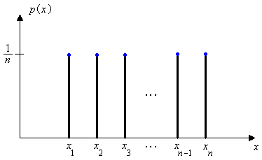

Cumulative Distribution Function (c.d.f.)

F (x) = P[X ≤ x] = $\sum_{y : y≤x}{ p (y)}$

Example 6.07

Find the cumulative distribution function for
X = (the number of heads when two fair coins are tossed).

The possible values of X are 0, 1 and 2.
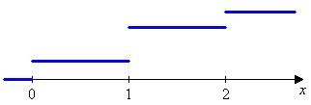

F (0) = P[X ≤ 0] = p(0) = 1/4 .

F (1) = P[X ≤ 1] = P[X < 1] + P[X = 1]

= F (0) + p(1)

= ¼ + ½ = ¾

F (2) = P[X ≤ 2]

= F (1) + p(2)

= ¾ + ¼ = 1

When x < 0 , F (x) = P[X ≤ x] ≤ P[X < 0] = 0 ⇒ F (x) = 0

When x > 2 , F (x) = P[X ≤ x] = F (2) + P[2 < X ≤ x] = 1 + 0 = 1

When 1 < x < 2 , P[X ≤ x] = F (1) + P[1 < X ≤ x] = ¾ + 0 = ¾
etc.

Thus
$F(x) = \left\{ \begin{matrix}0 & & \text{if} & x<0 \\ 1/4 & & \text{if} & 0≤x<1 \\ 3/4 & & \text{if} & 1≤x<2 \\ 1 & & \text{if} & 2≤x \end{matrix}\right.$

The graph of the c.d.f. is:
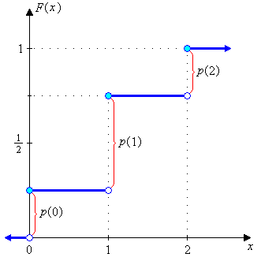

In general, the graph of a discrete c.d.f. :
- is always non-decreasing
- is level between consecutive possible values (staircase appearance)
- has a finite discontinuity at each possible value (step height = p(x) )
- rises in steps from F (x) = 0 to F (x) = 1.

Drawing convention:
● filled circle = point included in interval
○ open circle = point excluded from interval

Example 6.08 (the inverse of the preceding problem):

Find the probability mass function p(x) given the cumulative distribution function

$F(x) = \left\{ \begin{matrix}0 & & \text{if} & x<0 \\ 1/4 & & \text{if} & 0≤x<1 \\ 3/4 & & \text{if} & 1≤x<2 \\ 1 & & \text{if} & 2≤x \end{matrix}\right.$

Steps (= possible values) are at x = 0, 1, 2 only.

p(0) = F(0) = ¼

p(1) = F(1) − F(0) = ¾ − ¼ = ½

p(2) = F(2) − F(1) = 1 − ¾ = ¼

and we recover the original p.m.f.

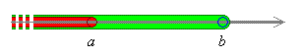

In general, last kept − last excluded
$P\left[a<X≤b\right] = F(b) − F(a)$

If a , b and all possible values are integers, then

$P\left[a≤X≤b\right] = F(b) − F(a−1)$ and $p(a) = P\left[X=a\right] = F(a) − F(a−1)$
Example 6.09

Find and sketch the c.d.f. for X = (the score upon rolling a fair standard die once).

The p.m.f. is a uniform distribution

Thus F(x) increases from 0 to 1/6 at x = 1 and increases by steps of 1/6 at each subsequent integer value until x = 6. It follows easily that

The graph of F (x) has the classic staircase appearance of the cumulative distribution function of a discrete random quantity.

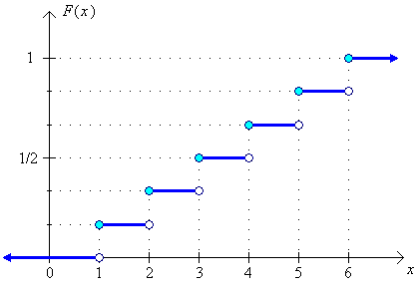

Expected value of a random quantity

Example 6.10:

The random quantity X is known to have the p.m.f.

x | 10 | 11 | 12 | 13
p(x) | .4 | .3 | .2 | .1

If we measure values for X many times, what value do we expect to see on average?

Treat the values of p(x) as point masses of probability:

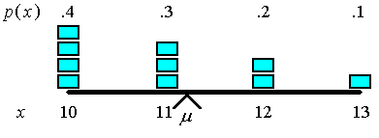

The expected value E[X] (= population mean μ ) is at the fulcrum (balance point) of the beam.

Taking moments about x = 10:

∑ p(x) (x−10) = .4×0 + .3×1 + .2×2 + .1×3 = 1.0

The fulcrum is at x = 10 + 1

Therefore μ = E[X] = 11

In general, for any random quantity X with a discrete probability mass function p(x) and a set of possible values D, the population mean μ of X (and the expected value of X ) is
E[X] = a
Shortcut: If X is symmetric about x = a, then
Example 6.11:
Let X = the number of heads when a coin has been tossed twice. Find E[X].

Solution:
List the all the possible combinations.
→ the probability mass function of the distribution of X.

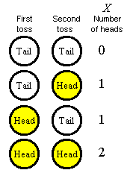
E[X] = 0×¼ + 1×½ + 2×¼

= 0 + ½ + ½

Therefore
μ = 1

Alternative solution:
Graph of p(x):
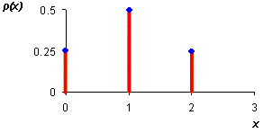
p(x) is symmetric about x = 1 .

Therefore, E[X] = 1

The expected value of a function

Definition:
If the random quantity X has set of possible values D and p.m.f. p(x), then the expected value of any function h(X), denoted by E[h(X)], is computed by

E[h(X)] is computed in the same way that E[X] itself is, except that h(x) is substituted in place of x.
Special case:

$h(x)=\text{ax}+b$ ⇒

Proof:
E[aX + b] = ∑ (ax + b) p(x)

= ∑ (ax) p(x) + ∑ b p(x)

= a ∑ x p(x) + b ∑ p(x)

= a E[X] + b

Example 6.12:

C = tomorrow’s temperature high in °C
F = tomorrow’s temperature high in °F
Given E[C] = 10, find E[F].

The variance of X
The quantity usually employed to measure the spread in the values of a random quantity X is the population variance V[X] = $σ^{2}=\frac{1}{N}\sum_{x}{(x−μ)^{2}}$
Definition:
Let X have probability mass function p(x) and expected value μ. Then

The standard deviation of X is

Example 6.13:

Two different probability distributions [below] share the same mean $μ=4$

(a) (b)
If X has p.m.f. as shown in Figure (a)
x | 3 | 4 | 5
p(x) | .3 | .4 | .3

μ = 4 (by symmetry)

V[X] = (3−4)²×.3 + (4−4)²×.4 + (5−4)²×.3 = .3 + 0 + .3 = 0.6

and σ = √0.6 ≈ 0.7746

If X has p.m.f as shown in Figure (b)

x | 1 | 2 | 6 | 8
p(x) | .4 | .1 | .3 | .2

μ = E[X] = 1×.4 + 2×.1 + 6×.3 + 8×.2 = .4 + .2 + 1.8 + 1.6 = 4

V[X] = (1−4)²×.4 + (2−4)²×.1 + (6−4)²×.3 + (8−4)²×.2 = 3.6 + 0.4 + 1.2 + 3.2
= 8.4
and σ = √8.4 ≈ 2.898 [Higher variance ↔ greater spread]

Example 6.14:
Let X = number of heads when a coin has been tossed twice. Find V[X].
V[X] = E[(X − μ) ²]

= ∑ (x−μ)² p(x)

= (0−1)²×¼ + (1−1)²×½ + (2−1)²×¼

= ¼ + 0 + ¼ = 0.5

A shortcut formula for variance

Proof: σ² = E[X²] − μ²

V[X] = E[(X−μ)²] = E[X² − 2μX + μ²]

= E[X²] − 2μE[X] + μ²E[1] = E[X²] − 2μμ + μ²

= E[X²] − μ²

Note: unless f(x) is linear and/or X is constant.

Example 6.14 (continued):
Let X = number of heads when a coin has been tossed twice. Find V[X] using the shortcut formula.

E[X²] = ∑ x² p(x)

= 0²×¼ + 1²×½ + 2²×¼

= 0 + ½ + 1 = 1.5

V[X] = E[X²] − (E[X])²

= 1.5 − 1²

∴ σ² = 0.5

The shortcut is more convenient when μ is not an integer.
Rules of variance

Example 6.15:
Do the distributions in the following two figures have the same variance or not?
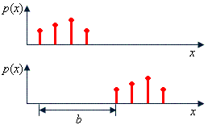 YES

Example 6.16:
Do the distributions in the following two figures have the same variance or not?

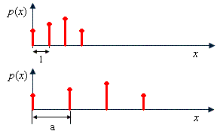 NO

Proof:

V[aX + b] = E[( (aX + b) − E[aX + b] )²]

= E[( (aX + b) − (aμ + b) )²]

= E[(aX − aμ)²]

= E[a² (X − μ)²]

= a² E[(X − μ)²]

= a² V[X]

The addition of the constant b does not affect the variance, because the addition of b changes the location (and therefore mean value) but not the spread of values.

