Inferences Based on a Single Sample

Some background material [additional non-examinable notes] on an introduction to statistical inference is available at
"http://www.engr.mun.ca/~ggeorge/3423/handout/H10aInfer.doc".

Confidence Intervals
- Almost any parameter that we might wish to estimate has its set of possible values.
- The point estimate, a single number, can be replaced by an entire interval of plausible values. This interval is the confidence interval.

- A confidence interval is an interval of plausible values for the parameter being estimated. The degree of plausibility is specified by a confidence level, such as 95% or 99%.

Calculation of the classical confidence interval
Suppose that the parameter of interest is a population mean μ and that
- the population distribution is normal, and
- the value of the population standard deviation σ is known.
If $X_{i}\text{\sim }N(μ,σ^{2})$, then
and
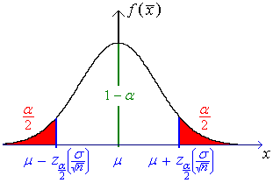
Because the area under the normal curve between
$μ − z_{α2} \left(\frac{σ}{\sqrt{ n }}\right)$ and $μ + z_{α2} \left(\frac{σ}{\sqrt{ n }}\right)$ is 1 − α,
$$P\left[ μ − z_{α2} \left(\frac{σ}{\sqrt{ n }}\right) < \bar{X} < μ + z_{α2} \left(\frac{σ}{\sqrt{ n }}\right) \right] = 1 − α$$
Subtract :
Multiply by (−1):
Rearrange the inequalities to obtain:

The confidence interval estimator for μ (at a level of confidence of (1 − α) ) is
$$\bar{X} − z_{α2} \left(\frac{σ}{\sqrt{ n }}\right) < μ < \bar{X} + z_{α2} \left(\frac{σ}{\sqrt{ n }}\right)$$
The (1 − α) confidence interval estimator for μ is a random interval
$$\left[ \bar{X} − z_{α2} \left(\frac{σ}{\sqrt{ n }}\right) , \bar{X} + z_{α2} \left(\frac{σ}{\sqrt{ n }}\right) \right]$$
The probability is (1 − α) that the above random interval includes the true value of μ. . (1 − α) of all random samples will produce an inequality, (the (1 − α) confidence interval estimate for μ)
$$\bar{x} − z_{α2} \left(\frac{σ}{\sqrt{ n }}\right) < μ < \bar{x} + z_{α2} \left(\frac{σ}{\sqrt{ n }}\right)$$
that is true. Note that the confidence interval estimate contains no random quantities at all! The statement is either absolutely certain to be true or absolutely certain to be false, (depending on the values of μ, σ,$\bar{x}$, n and α).

Interpretation of confidence interval [ = confidence interval estimate ]
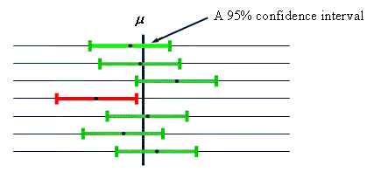
Only 5% of all 95% confidence interval estimates for μ fail to include μ.
A concise expression for the C.I. (confidence interval estimate for μ) is
$$\bar{x} ± z_{α2} \frac{σ}{\sqrt{ n }}$$

A Bayesian view of interval estimation:

If the only quantity among { μ, σ,$\bar{x}$, n and α } that we don’t know is μ, then represent the unknown μ by the random quantity A. Then
which is a valid probability statement about the random quantity A
(→ decision theory).

A note about the standard normal distribution and the t distribution

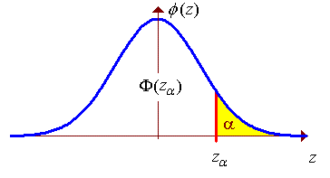
Let Z ~ N(0, 1) (standard normal distribution), so that
P[Z < z] = Φ(z) (cumulative distribution function for the standard normal distribution).
Then the (1 – α)×100th percentile of the standard normal distribution is z_{α} , which satisfies P[Z > z_{α} ] = α .
It also follows that 1 – Φ(z_{α} ) = Φ(–z_{α} ) = α .
Φ(z_{α} ) = 1 – α
The t distribution with ν degrees of freedom is also a bell shaped curve, with a mean, median and mode at t = 0, but with a greater variance than the standard normal distribution. As the number of degrees of freedom increases, the t distribution approaches the z (standard normal) distribution. The graphs of t₁ and t₅ are shown here, together with , which is indistinguishable to the eye from t_{ν} for ν above 30 or so.
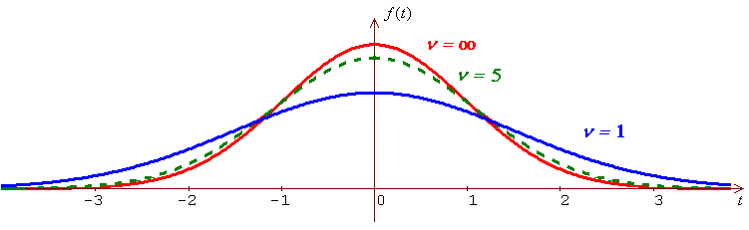
Therefore .
To find the (1 – α)×100th percentile z_{α} , use the final row in the table of critical values of the t distribution (on page 15-02): .
The final row of the table on page 15-02 (the t tables) is

 | α
ν | 0.1 | 0.05 | 0.025 | 0.01 | 0.005

∞ | 1.28155 | 1.64485 | 1.95996 | 2.32635 | 2.57583

Therefore P[Z > 1.645] ≈ .05 or equivalently z_{.05} ≈ 1.645;
P[Z > 1.960] ≈ .025 or equivalently z_{.025} ≈ 1.960; etc.

Example 10.01

The rate of energy loss X (watt) in a motor is known to be a normally distributed random quantity with standard deviation σ = 3.0 W. A random sample of 100 such motors produces a sample mean rate of energy loss of 58.3 W. Find a 99% confidence interval estimate for the true mean rate of energy loss μ.

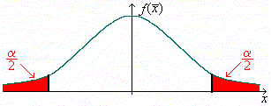
Endpoints of classical CI:

z _{.005} = t _{.005, ∞} = 2.57583

Therefore the endpoints are
⇒ 99% CI for μ is 57.53 ≤ μ ≤ 59.07 (W) (to 2 d.p.)

[Reason for "≤" instead of "<": The stated endpoints are just inside the exact interval. The exact lower limit is 57.527..., which places 57.53 inside. The answer could also be quoted correctly as "57.52 < μ < 59.08" or "57.53 ≤ μ < 59.08".]

Example 10.01 (continued)

How large must n be for the width of the 99% confidence interval estimate for μ to be less than 1.0?
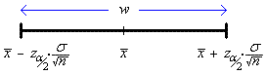
We require w < 1 ⇒ 15.45498 ≤ √n
⇒ n ≥ 238.8...

Therefore n_{min} = 239 .

Choice of sample size
The width of the confidence interval $\left(\bar{x}−z_{α/2}⋅\frac{σ}{\sqrt{n}}, \bar{x}+z_{α/2}⋅\frac{σ}{\sqrt{n}}\right)$ is
⇒
The sample size is inversely related to the square of the desired width.

Endpoints of a (1 − α) CI for μ:

(a) σ² known:
(b) σ² unknown, n large:
(c) σ² unknown, n small:
When n is small, X must be [nearly] normal.
Example 10.02

The lifetime X of a particular brand of filaments is known to be normally distributed. A random sample of six filaments is tested to destruction and they are found to last for an average of 1,007 hours with a sample standard deviation of 6.2 hours.

(a) Find a 95% confidence interval estimate for the population mean
lifetime μ .
(b) Is the evidence consistent with μ ≠ 1000 ?
(c) Is the evidence consistent with μ > 1000 ?

but σ ² is not known. Use

(a) A 95% CI for μ is
From the table on page 15-02, t_{.025, 5} = 2.57...
The 95% CI for μ is
1000.49 < μ < 1013.51 (hours) (2 d.p.)

(b) μ = 1000 is not in the CI.
Therefore yes, the evidence is consistent with μ ≠ 1000

(c) We need a one-sided CI (to test μ > 1000):
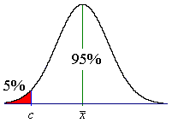
t _{.05, 5} = 2.01505

= 1007 − 5.10...

⇒ 95% CI is μ > 1001.90

[Expressed loosely, “we are 95% sure that μ > 1001.90”.]

Yes, the CI is consistent with μ > 1000.
Properties of a confidence interval
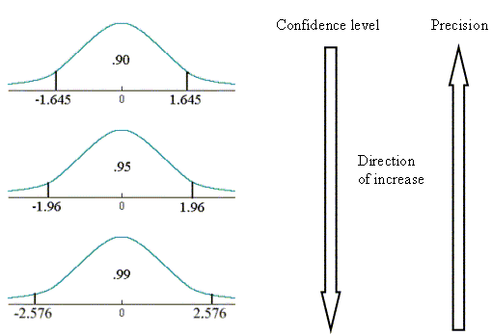
If we think of the length of the confidence interval as specifying its precision, then the confidence level (or reliability) of the interval is inversely related to its precision.

Estimation of Population Proportion
When a random sample of size n is drawn from a population in which a proportion p of the items are “successes”, each item in the sample is a Bernoulli random quantity, with
P[“success”] = p and P[“failure”] = q = 1 − p
Let X = number of successes in the random sample, then the probability distribution of X is
X ~ bin(n, p)

with E[X] = np and V[X] = npq = σ ²

But, for n, np, nq all large, bin(n, p) → N(μ, σ ²)

Therefore
X ~ N(np, npq) (approximately)

The sample proportion $\hat{P}$ is a point estimator for the population proportion p.

$E\left[\hat{P}\right] = E\left[\frac{X}{n}\right] = \frac{1}{n} E\left[X\right] = \frac{\text{np}}{n} = p$ [Compare with Bayesian
⇒ $\hat{P}$ is an unbiased estimator of p. − if x & n large enough, close to x / n .]

$$V\left[\hat{P}\right] = V\left[\frac{X}{n}\right] = \frac{1}{n^{2}} V\left[X\right] = \frac{\text{npq}}{n^{2}} = \frac{\text{pq}}{n}$$
Therefore, for sufficiently large n, np and nq , (namely, np > 10 and nq > 10),
$$\hat{P} \text{\sim } N\left(p, \frac{\text{pq}}{n}\right)$$
Compare this with $\bar{X} \text{\sim } N\left(μ , \frac{σ^{ 2}}{n}\right)$, for which the corresponding confidence interval has endpoints $\bar{x} ± z_{α /2}⋅\left(\frac{s}{\sqrt{n}}\right)$.
Therefore, the 100(1- α)% confidence interval estimator for p is
$\hat{P} ± z_{α/2} \sqrt{\frac{\hat{P} \hat{Q}}{n} }$

and the 100(1- α)% confidence interval estimate for p is
$\hat{p} ± z_{α/2} \sqrt{\frac{\hat{p} \hat{q}}{n} }$

Note also the more precise confidence interval quoted in the course text,
(Devore, sixth edition, section 7.2, page 266):

Example 10.03
From a random sample of one thousand silicon wafers, 750 pass a quality control test. Find a 99% confidence interval estimate for p (the true proportion of wafers in the population that are good).

n = 1000 and x = 750
$$⇒ \hat{p} = \frac{x}{n} = \frac{\text{750}}{\text{1000}} = \frac{3}{4}$$
$$⇒ \hat{q} = 1−\hat{p} = \frac{1}{4}$$
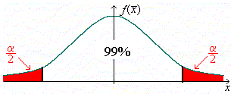
α/2 = .005
z_{.005} = t_{.005, ∞} ≈ 2.576
Endpoints of the C.I.:
$\hat{p} ± z_{α/2} \sqrt{\frac{\hat{p} \hat{q}}{n} } = \text{.}\text{75} ± 2\text{.}\text{576} \sqrt{\frac{\text{.}\text{75}×\text{.}\text{25}}{\text{1000}}}$

= .75 ± .035 27...
Therefore the 99% confidence interval estimate for p is

71.5% ≤ p ≤ 78.5%

correct to three significant figures.

Using the more precise version of the confidence interval yields
[With a sample size of 1000 and the observed numbers of successes and failures both exceeding 100 by a large margin, it is no surprise that the two versions of the classical confidence interval for p agree to approximately 1%.]
(1−α)×100% Bayesian interval for μ

Suppose that previous evidence leads us to believe that μ = μ _{o} . The strength of this belief is represented by the variance σ _{o}² (lower variance corresponds to stronger belief). We wish to update that estimate after a random sample of size n has been examined. Assume that n >> 30 (so that the Central Limit Theorem will apply).

Prior distribution:
New evidence:

Sample size = n
Sample mean = $\bar{x}$
Sample standard deviation = s

Calculate
,
where w_{d}, w_{o} are the weights of the data and original information respectively, given by
[weights ~ precision]

Posterior distribution:
$$\bar{X} \text{\sim } \text{N }\left( μ^{} , {\left(σ^{}\right)}^{ 2} \right)$$
→ (1−α)×100% Bayesian interval for μ :

$$μ = μ^{} ± z_{ α/2} σ^{}$$

Compare with the classical (1−α)×100% confidence interval for μ :

$$μ = \bar{x} ± z_{ α/2} \frac{s}{\sqrt{n}} (n\text{>>}\text{30}) \text{or} μ = \bar{x} ± z_{ α/2} \frac{σ}{\sqrt{n}}$$

In many applications, the Bayesian interval is often narrower than the classical confidence interval, because the Bayesian interval incorporates more information (previous evidence or belief about the true value of μ ).

[Note: it is easy to show that as σ _{o}² → ∞ (or if $\bar{x}$= μ _{o} then), μ* = $\bar{x}$
and that as σ _{o}² → ∞ , σ* ² → s ² / n , which are the classical expressions.]
Examples of Bayesian Confidence Intervals

These examples are modifications of the previous examples of classical confidence intervals for μ.

Example 10.04

The rate of energy loss X (watt) in a motor is known to be a normally distributed random quantity and prior experience suggests that the mean is μ = 60 W with standard deviation σ = 3.0 W. A random sample of 100 such motors produces a sample mean rate of energy loss of 58.3 W with sample standard deviation 2.8 W. Find a 99% confidence interval estimate for the true mean rate of energy loss μ.

The 99% CI for μ is
= [57.60, 59.03] (2 d.p.)

Compare this with the classical CI: [57.53, 59.07] .

[The Bayesian CI is more precise, due to good use of prior information.]

[Note that the true value of σ ² is not known. Therefore the true number of degrees of freedom is between n−1 = 99 and infinity.
However, t_{.005,99} = 2.626 and z_{.005} = 2.575..., which shifts the boundaries of the CI by less than 0.015.
The error caused in replacing t by the approximation z is therefore negligible.]

Example 10.05
The lifetime X of a particular brand of filaments is known to be normally distributed. Prior experience suggests that μ = 1000 and σ = 6.0. A random sample of six filaments is tested to destruction and they are found to last for an average of 1,007 hours with a sample standard deviation of 6.2 hours.

(a) Find a 95% confidence interval estimate for the population mean
lifetime μ .
(b) Is the evidence consistent with μ ≠ 1000 ?
(a)
The 95%CI is

[Note that the true number of degrees of freedom is between (n − 1) and ∞ , because
of the presence of the prior information.
The CI quoted here is therefore conservative (wider than the true interval).]

(b) μ = 1000 is inside the CI; therefore NO.

[This is the opposite conclusion from that drawn from the classical confidence interval for μ: (1000.49, 1013.51). A fairly strong prior belief in μ = 1000 , together with a small sample size, has dragged the Bayesian CI down closer to μ = 1000; close enough to bring μ = 1000 inside the CI.]

See also www.engr.mun.ca/~gggeorge/3423/demos/BayesCI.xls .

