Classical hypothesis tests are close relatives of the classical confidence intervals.
Some general statements will be introduced after the first example.

Example 11.01

The lifetime X of a particular brand of filaments is known to be normally distributed. A random sample of six filaments is tested to destruction. Those six filaments are found to last for an average of 1,007 hours with a sample standard deviation of 6.2 hours.

Is there sufficient evidence to conclude, at a level of significance of 5%, that the true mean lifetime of this brand of filaments is not 1,000 hours?

Repeat this question with a level of significance of 1%.

Test the null hypothesis H_{o} : μ = 1000
against the alternative hypothesis H_{a} : μ ≠ 1000 .
Distribution:

Data:

If H_{o} is true, then
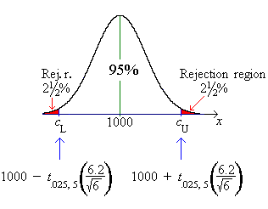

But σ is not known.

t _{.025, 5} ≈ 2.57058

[Note: “S” is upper case because it is a random quantity.
ν = n − 1 = 5 is the number of degrees of freedom for the t distribution.]

Example 11.01 (continued)

Method 1

Reject H_{o} in favour of H_{a} iff
= 1007 > c_{U}

Therefore REJECT H_{o} at a level of significance of α = .05 .
[This result is equivalent to the classical two-sided confidence interval of example 10.04.]

OR

Method 2

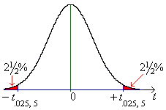

Reject H_{o} in favour of H_{a} iff

2.77... > 2.57...

Therefore REJECT H_{o} at a level of significance of α = .05 .
At α = 1%,
Method 1
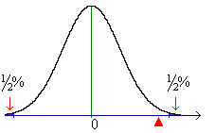
Do NOT reject H_{o} .

Example 11.01 (continued)

α = 1%, Method 2

Therefore do NOT reject H_{o} .

Interpretation:

If H_{o} is true, then the p-value (the probability that is further away from μ = 1000 than ) is between 5% and 1%. The level of significance α is an upper bound to the probability of committing a type I error: P[reject H_{o} | H_{o} true] ≤ α .

Decision Tree: [from page 9.19]

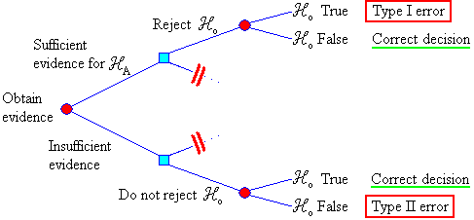

P[type I error] = P[reject H_{o} | μ = μ_{o} (H_{o} true)] ≤ α
P[type II error] = P[accept H_{o} | μ = μ₁ (H_{o} false)] = β (μ₁)
1 − β = power of the test.

General method for two-tailed tests:

State hypotheses:

H_{o} : μ = μ_{o} vs. H_{a} : μ ≠ μ_{o}
The burden of proof is on H_{a}.
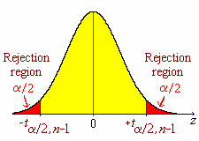
Choose the level of significance α .

State your assumptions
(for example, the random quantity X
is nearly normal).

Find $\bar{x}$ (the test statistic).

If σ is unknown, then estimate it using s .

Case 1: σ is unknown and n is small

$\bar{x}$ space t space

Find $μ_{o} ± t_{α/2, n−1} \left(\frac{s}{\sqrt{n}}\right)$ Find $t_{α/2, n−1}$

Iff $\bar{x} < μ_{o} − t_{α/2, n−1} \left(\frac{s}{\sqrt{n}}\right)$ and
or $\bar{x} > μ_{o} + t_{α/2, n−1} \left(\frac{s}{\sqrt{n}}\right)$ Iff

then reject H_{o} in favour of H_{a}.

Case 2: n is large (> 30) is the same as Case 1 except that
$t_{α/2, n−1}$ is replaced by $t_{α/2, ∞} = z_{α/2}$ .
Common values: z_{.025} = 1.95996 , z_{.005} = 2.57583 .

Case 3: σ is known is the same as Case 2 except that s is replaced by σ .
Example 11.02

A manufacturer claims that replacement machinery fills paper bags with exactly one kilogramme of sugar each, on average. A random sample of 400 bags of sugar is weighed, producing a sample mean mass of 996.5 grammes and a sample standard deviation of 25.1 grammes. At a level of significance of .01, is there sufficient evidence to doubt the manufacturer’s claim?

Test H_{o} : μ = 1000 vs. H_{a} : μ ≠ 1000 at α = .01
[Reason for selecting a two-sided alternative hypothesis rather than one-sided:
Before we have any data to examine, if the manufacturer’s claim is false, then we have no pre-conceptions as to whether the true value of μ is greater than or less than 1000. We are seeking only evidence that μ is different from 1000. We are not seeking evidence, a priori, for a decrease.]

Method 1
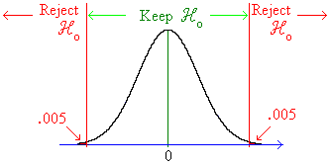

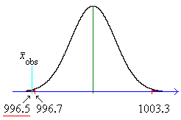

Therefore reject H_{o} .
YES, μ ≠ 1000.

Method 2
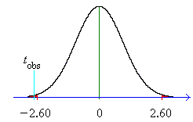
t _{.005, 399} ≈ t _{.005, 200} = 2.60...

Therefore reject H_{o} . YES, μ ≠ 1000.

p-value (Method 3):

Find p = P[ | Z | > | z_{obs} | ] or p = P[ | T | > | t_{obs} | ]

Compare p to α .

Example 11.02 (continued, using method 3):

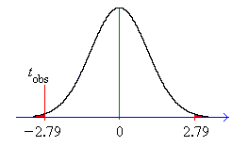
t _{obs} = −2.78... = −2.79 (2 d.p.)

Using t _{α, 399} ≈ z_{α} ,

P[ | Z | > 2.79] = 2 Ф(−2.79)

= 2 × .00264 = .00528 < .01000 = α .

Therefore reject H_{o} . YES, μ ≠ 1000.

Note:

Tables are not usually provided for P[T < t _{obs}] ,
but the values can be obtained from software, such as the Excel file at
www.engr.mun.ca/~ggeorge/3423/demos/t1test.xls .

t _{.005, 399} = 2.588204... → c_{L} = 996.7518... , c_{U} = 1003.248...

t _{obs} = −2.78884... → p = P[ | T | > t _{obs} ] = .005543

The corresponding, more precise, confidence interval allows us to claim that
“we are 99% sure that 993.25... < μ < 999.74...”.

General Method (upper-tailed tests):

State hypotheses:
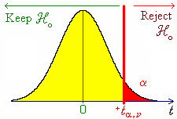
H_{o} : μ = μ_{o} vs. H_{a} : μ > μ_{o}

The burden of proof is on H_{a}.

Choose the level of significance α .

State your assumptions
(for example, the random quantity X
is nearly normal).

Find $\bar{x}$ (the test statistic).

If σ is unknown, then estimate it using s .

Method 1:
Evaluate
Reject H_{o} iff $\bar{x}$> c .

Method 2:
Reject H_{o} iff

Method 3:

Evaluate and p = P[ T > t_{obs}]

Reject H_{o} iff p < α .

Let us explore the meaning of α , the probability of committing a Type I error, in the case when the alternative hypothesis is one (upper) tailed, H_{a} : μ > μ_{o}:
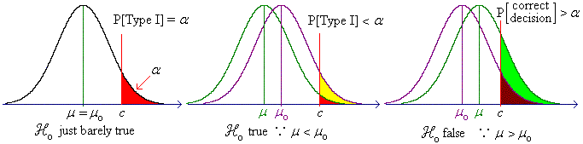
α is actually an upper bound to P[Type I error], the “worst case scenario”, which occurs when the null hypothesis is just barely true.
General Method (lower-tailed tests):

State hypotheses:
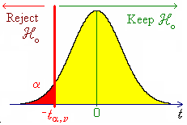
H_{o} : μ = μ_{o} vs. H_{a} : μ < μ_{o}

The burden of proof is on H_{a}.

Choose the level of significance α .

State your assumptions
(for example, the random quantity X
is nearly normal).

Find $\bar{x}$ (the test statistic).

If σ is unknown, then estimate it using s .

Method 1:
Evaluate
Reject H_{o} iff $\bar{x}$< c .

Method 2:
Reject H_{o} iff

Method 3:

Evaluate and p = P[ T < t_{obs}]

Reject H_{o} iff p < α .

Example 11.03

An opinion poll of 100 randomly selected customers produces 58 customers who state a preference for brand A. Does a majority of the population of customers prefer brand A?

From the random sample of 100 customers, how many must state a preference for brand A in order for the inference “a majority of the population of customers prefers brand A” to be valid?

H_{o}: p = .5 (or less)

H_{a}: p > .5

Choose α = .05

Assume that the sample is random, so that, to a good approximation,
If H_{o} is true, then

Use method 1 (because of the second part of the question).
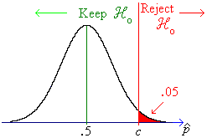

do NOT reject H_{o}.
There is insufficient evidence for a majority.

c = .582... ⇒ x = 58.2 . Therefore
x_{min} = 59

Two sample z test

From the central limit theorem, we know that, for sufficiently large sample sizes from two independent populations of means μ ₁ , μ ₂ and variances σ₁² , σ₂² , the sample means are distributed as
${\bar{X}}_{1} \text{\sim } N \left(μ_{1}, \frac{σ_{1^{2}}}{n_{1}}\right)$ , ${\bar{X}}_{2} \text{\sim } N \left(μ_{2}, \frac{σ_{2^{2}}}{n_{2}}\right)$ , with

Example 11.04

A large corporation wishes to determine the effectiveness of a new training technique. A random sample of 64 employees is tested after undergoing the new training technique and obtains a mean test score of 62.1 with a standard deviation of 5.12 . Another random sample of 100 employees, serving as a control group, is tested after undergoing the old training methods. The control group has a sample mean test score of 58.3 with a standard deviation of 6.30 .

(a) Use a two-sided confidence interval to determine whether the new training technique has led to a significant change in test scores.

(b) Use an appropriate hypothesis test to determine whether the new training technique has led to a significant increase in test scores.

(a)
Two different groups of employees; may assume independence.
Both sample sizes are large (>> 30) ⇒ normal. Choose α = 1%.
The 99% CI for μ₁ − μ₂ has its boundaries at

The CI does not include 0.
Therefore YES, the new training technique has led to a significant change
in test scores.

[Note that if t _{.005, 162} = 2.60... is used instead of z _{.005} , then the CI would be
3.8 ± 2.34... instead of 3.8 ± 2.31... , leading to no change to 1 d.p.!
It is usually valid to replace t by z when ν > 100.]
Example 11.04 (continued)
(b)
Seeking evidence for an increase.

Therefore use an upper-tailed test. [Again choose α = 1%].
Test H_{o} : μ ₁ − μ ₂ = 0 vs. H_{a} : μ ₁ − μ ₂ > 0 .
Method 1:

Therefore reject H_{o} in favour of H_{a} : μ ₁ − μ ₂ > 0.
[Expressed crudely, “we are 99% sure that the training process has
increased test scores.”]

Method 2:

t_{α,∞} = z_{α} = 2.32...
t_{obs} > z_{α}
Therefore reject H_{o} in favour of H_{a} : μ ₁ − μ ₂ > 0.

Method 3:
t_{obs} = 4.23...
P[ Z > t_{obs}] = Ф(−4.23...) < .0003 (from Table A.3)
OR, using www.engr.mun.ca/~ggeorge/3423/demos/tCalculator.xls
with 63+99 = 162 degrees of freedom,
P[ T > t_{obs}] = .0000194... < any reasonable α .
Therefore reject H_{o} in favour of H_{a} : μ ₁ − μ ₂ > 0.

General Method (Method 2 illustrated here):

Establish the null hypothesis H_{o} : μ ₁ − μ ₂ = Δ_{o} (often Δ_{o} = 0 )
Select the appropriate alternative hypothesis H_{a} .

Select the level of significance α , which leads to the boundaries of the rejection region for z
(assuming either σ known or large n or both):

z_{c} α = 5% α = 1%

1 - tail 1.64485 2.32634

2 - tail 1.95996 2.57583

Find $z = \frac{\left({\bar{x}}_{1} − {\bar{x}}_{2}\right) − Δ_{o}}{\sqrt{\frac{s_{1^{2}}}{n_{1}} + \frac{s_{2^{2}}}{n_{2}}}}$
Compare z to z_{c} .
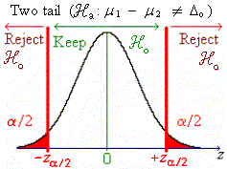
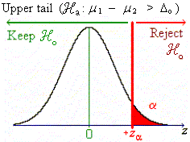
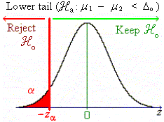

Two sample t test:

If n₁ and/or n₂ is/are small (< 30) and the population variances are both equal to an unknown number (σ₁² = σ₂² = σ ² ) and the random quantities X₁ and X₂ are independent and have normal (or nearly normal) distributions, then a t test may be used.

The separate sample variances s₁² and s₂² are both point estimates of the same unknown population parameter σ ². A better point estimate of σ ² is a weighted average of these two estimates, with the weights given by the numbers of degrees of freedom. Thus both sample variances are replaced by the pooled sample variance

$s_{P^{2}} = \frac{ν_{1} s_{1^{2}} + ν_{2} s_{2^{2}}}{ν_{1} + ν_{2}}$ where ν₁ = n₁ − 1 and ν₂ = n₂ − 1 .

In the hypothesis test, $z = \frac{\left({\bar{x}}_{1} − {\bar{x}}_{2}\right) − Δ_{o}}{\sqrt{\frac{s_{1^{2}}}{n_{1}} + \frac{s_{2^{2}}}{n_{2}}}}$ is replaced by $t = \frac{\left({\bar{x}}_{1} − {\bar{x}}_{2}\right) − Δ_{o}}{\sqrt{s_{P^{2}}\left(\frac{1}{n_{1}} + \frac{1}{n_{2}}\right)}}$ ,
which has ν = ν₁ + ν₂ degrees of freedom.

Example 11.05

An investigator wants to know which of two electric toasters has the greater ability to resist the abnormally high electrical currents that occur during an unprotected power surge. Random samples of six toasters from factory A and five toasters from factory B were subjected to a destructive test, in which each toaster was subjected to increasing currents until it failed. The distribution of currents at failure (measured in amperes) is known to be approximately normal for both products, with a common (but unknown) population variance. The results are as follows:

Factory A: 20 28 24 26 23 26

Factory B: 21 18 19 17 22

(a) State the hypotheses that are to be tested.
(b) State the assumptions that you are making.
(c) Conduct the appropriate hypothesis test.

(a) H_{o} : μ _{A} − μ _{B} = 0 (no difference between toasters)
H_{a} : μ _{A} − μ _{B} ≠ 0 (significant difference between toasters)
[In advance of examining the data, we have no preconceptions of which toaster might be better.]
(b) Given in the question:
Assumption:

X_{A}, X_{B} are independent.

(c) The summary statistics are

n_{A} = 6 = 24.5 s_{A} = 2.81 ...
n_{B} = 5 = 19.4 s_{B} = 2.07 ...

ν _{A} = n_{A} − 1 = 5 and ν _{B} = n_{B} − 1 = 4 ⇒ ν = 5 + 4 = 9

≈ 6.300

standard error =

⇒

With α = .01 , t_{α/2, ν} = t_{.005, 9} = 3.249...

| t_{obs} | > t_{α/2, ν} , therefore reject H_{o} in favour of H_{a} : μ _{A} − μ _{B} ≠ 0.

From the data, we can conclude, with a high level of confidence, that toaster A is more robust.
Paired t test

Example 11.06

Nine volunteers are tested before and after a training programme. Based on the data below, can you conclude that the programme has improved test scores?

Volunteer: 1 2 3 4 5 6 7 8 9

After training: 75 66 69 45 54 85 58 91 62
Before training: 72 65 64 39 51 85 52 92 58

Let X_{A} = score after training and X_{B} = score before training.

Test H_{o} : μ _{A} − μ _{B} = 0 vs. H_{a} : μ _{A} − μ _{B} > 0
Choose α = .01 .

Incorrect method:

n_{A} = n_{B} = 9 ⇒ ν_{A} = ν_{B} = 8 ⇒ ν = 16

${\bar{x}}_{A}$ = 67.222... s_{A} = 14.695...
${\bar{x}}_{B}$ = 64.222... s_{B} = 16.820...

$$s_{P^{2}} = \frac{ν_{A} s_{A^{2}} + ν_{B} s_{B^{2}}}{ν_{A} + ν_{B}} = \frac{8×(\text{14}\text{.}\text{695}\text{.}\text{.}\text{.})^{2} + 8×(\text{16}\text{.}\text{820}\text{.}\text{.}\text{.})^{2}}{8 + 8}$$
$$= \frac{\text{215}\text{.}\text{9444}\text{.}\text{.}\text{.} + \text{282}\text{.}\text{9444}\text{.}\text{.}\text{.}}{2} = \text{249}\text{.}\text{444}\text{.}\text{.}\text{.}$$

⇒ s.e. = $\sqrt{s_{P^{2}} \left(\frac{1}{n_{A}} + \frac{1}{n_{B}}\right)} = \sqrt{\text{249}\text{.}\overset{˙}{4} \left(\frac{1}{9} + \frac{1}{9}\right)} = 7\text{.}\text{445}…$

⇒ $t = \frac{\left({\bar{x}}_{A} − {\bar{x}}_{B}\right) − Δ_{o}}{s\text{.}e\text{.}} = \frac{(\text{67}\text{.}\overset{˙}{2} − \text{64}\text{.}\overset{˙}{2}) − 0}{7\text{.}\text{445}\text{.}\text{.}\text{.}} ≈ \underline{\underline{0\text{.}\text{403}}}$

Compare with t_{α, ν} = t _{.010, 16} = 2.583...

$0\text{.}\text{403} 2\text{.}\text{583}$ Therefore do not reject H_{o} : no increase in test scores !
The error is that

the two test scores are NOT independent.

[They are highly correlated.]

The correct method is to take account of the fact that X_{A} and X_{B} are paired,
by examining the differences D = X_{A} − X_{B} .

Volunteer: 1 2 3 4 5 6 7 8 9

After training x_{A}: 75 66 69 45 54 85 58 91 62
Before training x_{B}: 72 65 64 39 51 85 52 92 58

Difference d 3 1 5 6 3 0 6 −1 4

Test H_{o} : μ_{D} = 0 vs. H_{a} : μ_{D} > 0 with α = .01 .
Summary statistics:

n = 9 ⇒ ν = 8 , $\bar{d}$ = 3 , s_{D} = 2.5495...

⇒ $t = \frac{\bar{d} − μ_{\text{Do}}}{\left(\frac{s_{D}}{\sqrt{n}}\right)} = \frac{3 − 0}{\left(\frac{2\text{.}\text{5495}\text{.}\text{.}\text{.}}{\sqrt{9}}\right)} ≈ \underline{\underline{3\text{.}\text{530}}}$

Compare with t _{α, ν} = t _{.010, 8} = 2.896...

Therefore reject H_{o} .

At a 1% level of significance, we conclude that the training has, indeed, increased the test scores.

An Excel spreadsheet file for both methods is available at
http://www.engr.mun.ca/~ggeorge/3423/demos/t2test.xls .

When should we use a paired two sample t test?

When samples of equal size n are taken from two populations, the unpaired two sample t test will have ν = 2n − 2 degrees of freedom, but the paired two sample t test will have only ν = n − 1 degrees of freedom. The power of the unpaired test to distinguish between null and alternative hypotheses is greater, especially for small sample sizes.

The paired test is valid even if the two populations are strongly correlated, whereas the unpaired test is based on the assumption that the two populations are independent (or at least uncorrelated).

We should use the paired t test if there is reason to believe that the two populations from which the samples come may be correlated, or if the variance within the samples is high.

If the samples are pairs of observations of two different effects on the same set of individuals, then independence between the populations is unlikely and one should use the paired t test.

Otherwise, (and especially if the sample size is very small), use the unpaired t test.

Note (not examinable):

The correlation ρ is a measure of the linear dependence of a pair of random quantities.

Independence ⇒ ρ = 0

The relationship between the t statistics for the unpaired and paired two sample t tests is

The unpaired t test can therefore be used only if the random quantities are uncorrelated.
And, upon replacing the unknown underlying true correlation ρ by the observed sample correlation coefficient r, the two observed values of t are related by
where s_{A} and s_{B} are the two observed standard deviations from samples A and B respectively.

In Example 11.06, r = .996, leading to an error factor of 8.76... .
t_{unpair} = 0.402... , t_{pair} = 3.53... and one can verify that
3.53... = 0.402... × 8.76...
Inferences on Differences in Population Proportions
[not examinable (except for bonus)]

We have seen that the sample proportion $\hat{P}$ is distributed approximately as $\hat{P} \text{\sim } N\left(p, \frac{\text{pq}}{n}\right)$,
where n is the sample size, p is the population proportion and q = 1 − p .
This approximation holds provided that np (the expected number of successes) and nq (the expected number of failures) are both sufficiently large (both numbers greater than 10 is usually sufficient).

We have also seen that for any two random quantities X, Y :
E[ X − Y ] = E[ X ] − E[ Y ] and
for any two uncorrelated random quantities X, Y : V[ X − Y ] = V[ X ] + V[ Y ].

For two independent large random samples, it then follows that

${\hat{P}}_{1} − {\hat{P}}_{2} \text{\sim } N \left(\left(p_{1}−p_{2}\right), \left(\frac{p_{1} q_{1}}{n_{1}} + \frac{p_{2} q_{2}}{n_{2}}\right)\right)$

⇒ a (1−α)×100% confidence interval estimate for p₁ − p₂ is

${\hat{p}}_{1}−{\hat{p}}_{2} ± z_{\frac{α}{2}} \sqrt{\frac{{\hat{p}}_{1} {\hat{q}}_{1}}{n_{1}} + \frac{{\hat{p}}_{2} {\hat{q}}_{2}}{n_{2}}}$

A special case arises in hypothesis tests whenever the null hypothesis is H_{o} : p₁ = p₂ . In this case the two sample proportions are point estimates of the same unknown population proportion p .

The pooled estimate of p is

$$\hat{p} = \frac{\text{Total number of successes}}{\text{Total sample size}} = \frac{x_{1} + x_{2}}{n_{1} + n_{2}} = \frac{n_{1} {\hat{p}}_{1} + n_{2} {\hat{p}}_{2}}{n_{1} + n_{2}}$$

and the standard error becomes
$s = \sqrt{\hat{p}\hat{q} \left(\frac{1}{n_{1}} + \frac{1}{n_{2}}\right)}$ .
Compare $z = \frac{{\hat{p}}_{1} − {\hat{p}}_{2}}{s}$ to z _{α/2} (two tailed test) ,
or −z _{α} (lower tailed test) or z _{α} (upper tailed test).

Example 11.07

A random sample of 100 customers produces 42 customers who like brand A (as opposed to not liking brand A). Another random sample of 225 customers produces 81 customers who like brand B.

(a) Find a standard 95% confidence interval for the difference in population proportions
p_{A}  p_{B} .
(b) Is there sufficient evidence to conclude, at a level of significance of five per cent, that brand A is more popular than brand B?

(a) x_{A} = 42 n_{A} = 100 ⇒ ${\hat{p}}_{A}$ = .42
x_{B} = 81 n_{B} = 225 ⇒ ${\hat{p}}_{B}$ = .36

$$V\left[{\hat{P}}_{A} − {\hat{P}}_{B}\right] ≈ s^{2} = \frac{{\hat{p}}_{A} {\hat{q}}_{A}}{n_{A}} + \frac{{\hat{p}}_{B} {\hat{q}}_{B}}{n_{B}} = \frac{\text{.}\text{42}×\text{.}\text{58}}{\text{100}} + \frac{\text{.}\text{36}×\text{.}\text{64}}{\text{225}} = \text{.}\text{002436} + \text{.}\text{001024}$$
= .003460

The 95% confidence interval estimate is

${\hat{p}}_{A} − {\hat{p}}_{B} ± z_{\text{.}\text{025}}⋅\left(s\text{.}e\text{.}\right) = \text{.}\text{42} − \text{.}\text{36} ± 1\text{.}\text{960}\sqrt{\text{.}\text{003460}}$
= .06 ± .115...
= [ − 5.5% , +17.5% ] (1 d.p.)

(b) The 95% confidence interval estimate includes p_{A} − p_{B} = 0

⇒ insufficient evidence to conclude that p_{A} ≠ p_{B}
But the effect for which evidence is being sought is p_{A} − p_{B} > 0, (not p_{A} ≠ p_{B}).

Conduct an hypothesis test
H_{o} : p_{A} − p_{B} = 0 vs. H_{a} : p_{A} − p_{B} > 0
Pooled sample proportion $\hat{p} = \frac{x_{A} + x_{B}}{n_{A} + n_{B}} = \frac{\text{42}+\text{81}}{\text{100}+\text{225}} = \frac{\text{123}}{\text{325}} = \text{.}\text{3784}…$
Standard error $s = \sqrt{\hat{p}\hat{q} \left(\frac{1}{n_{A}} + \frac{1}{n_{B}}\right)} = \sqrt{\text{.}\text{37}…×\text{.}\text{62}…×\left(\frac{1}{\text{100}}+\frac{1}{\text{225}}\right)} = 0\text{.}\text{05829}…$

⇒ $z = \frac{{\hat{p}}_{A} − {\hat{p}}_{B}}{s} = \frac{\text{.}\text{42}−\text{.}\text{36}}{\text{.}\text{058}…} = 1\text{.}\text{029}…$
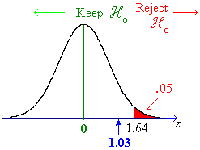
z_{α} = z_{.050} = 1.644...

z < z_{α}

Therefore do not reject H_{o} : p_{A} = p_{B}

There is insufficient evidence (at a level of significance of 5%) that brand A is more popular than brand B.

Example 11.08 (not examinable except for bonus)

A manager wishes to find a 95% confidence interval for the difference in the proportions of successful sales attempts between sales teams A and B. Random samples of n sales attempts are examined for each team. How large must the sample sizes n be in order to ensure that the confidence interval has a width of less than .10 ? [In other words, find the minimum sample size n_{min} to estimate p_{A}  p_{B} to within five percentage points either way nineteen times out of twenty.]

The confidence interval estimate for p_{A} − p_{B} is ${\hat{p}}_{A}−{\hat{p}}_{B} ± \underset{= w/2}{\underbrace{z_{\frac{α}{2}} \sqrt{\frac{{\hat{p}}_{A} {\hat{q}}_{A}}{n_{A}} + \frac{{\hat{p}}_{B} {\hat{q}}_{B}}{n_{B}}}}}$
Maximum width occurs when ${\hat{p}}_{A}={\hat{p}}_{B}=\frac{1}{2} ⇒ {\hat{q}}_{A}={\hat{q}}_{B}=\frac{1}{2}$
n_{A} = n_{B} = n
$$⇒ \frac{w}{2} ≥ z_{\frac{α}{2}}\sqrt{\frac{\frac{1}{2}×\frac{1}{2}}{n} + \frac{\frac{1}{2}×\frac{1}{2}}{n}} = z_{\frac{α}{2}}\sqrt{\frac{1}{2n} }$$
⇒ n ≥ 2 (1.95... / 0.10)² = 768.3...
Therefore
n_{min} = 769

