Simple Linear Regression

Sometimes an experiment is set up where the experimenter has control over the values of one or more variables X and measures the resulting values of another variable Y , producing a field of observations.
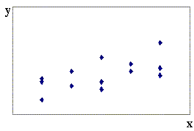
The question then arises: What is the best line (or curve) to draw through this field of points?

Values of X are controlled by the experimenter, so the non-random variable x is called the controlled variable or the independent variable or the regressor.

Values of Y are random, but are influenced by the value of x. Thus Y is called the dependent variable or the response variable.

We want a “line of best fit” so that, given a value of x , we can predict the value of Y for that value of x .
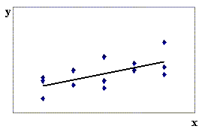
The simple linear regression model is that the predicted value of y is

and that the observed value of Y is

$Y_{i} = β_{0} + β_{1} x_{i} + ε_{i}$

where ε_{i} is the error.

It is assumed that the errors are normally distributed as ε _{i} ~ N(0, σ²) , with a constant variance σ². The point estimates of the errors ε _{i} are the residuals $e_{i} = y_{i} − {\hat{y}}_{i}$ .

With the assumptions
1) $Y_{i} = β_{0} + β_{1} x_{i} + ε_{i}$
2) x = x₀ ⇒ Y ~ N( β₀ + β₁x₀ , σ² ) [⇒ (3) V[Y] is ind’t of x ]
in place, it then follows that ${\hat{β}}_{0}$ and ${\hat{β}}_{1}$ are unbiased estimators of the coefficients β₀ and β₁.

Methods for dealing with non-linear regression are available in the course text, but are beyond the scope of this course.
Examples illustrating violations of the assumptions in the simple linear regression model:

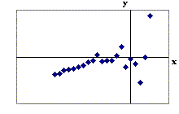
1. 2.
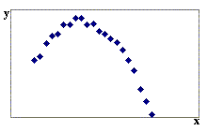

(1) violated – not linear (3) violated – variance not constant

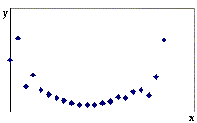
3. 4.
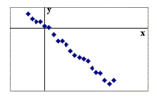

OK (1) & (3) violated

If the assumptions are true, then the probability distribution of Y | x is N( β₀ + β₁x , σ²).

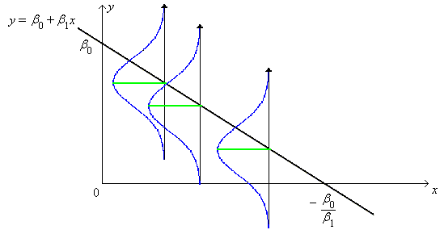
Example 12.01

Given that Y_{i} = 10 − 0.5 x_{i} + ε _{i} , where ε _{i} ~ N( 0, 2 ), find the probability that the observed value of y at x = 8 will exceed the observed value of y at x = 7.

Y_{i} ~ N( 10 − 0.5 x_{i} , 2 )

Let Y₇ = the observed value of y at x = 7
and Y₈ = the observed value of y at x = 8,
then
Y₇ ~ N(6.5, 2) and Y₈ ~ N(6, 2)

⇒ Y₈ − Y₇ ~ N(6 − 6.5, 2 + 2)

μ = − 0.5 σ = √4 = 2

Despite β ₁ < 0, P[Y₈ > Y₇] > 40% !

For any x_{i} in the range of the regression model, more than 95% of all Y_{i} will lie within 2σ ( = 2 √ 2 ) either side of the regression line.

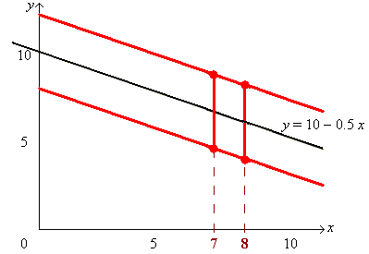
Derivation of the coefficients ${\hat{β}}_{0}$ and ${\hat{β}}_{1}$ of the regression line $y = {\hat{β}}_{0} + {\hat{β}}_{1} x$ :

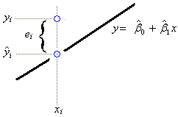
We need to minimize the errors.
Each error is estimated by the
observed residual $e_{i} = y_{i} − {\hat{y}}_{i}$ .

Minimize errors.
Use the SSE (sum of squares due to errors)

$S = \sum_{i=1}^{n}{e_{i^{2}} }= \sum_{i=1}^{n}{{\left(y_{i} − {\hat{β}}_{0} − {\hat{β}}_{1} x_{i}\right)}^{2} = f\left({\hat{β}}_{o} , {\hat{β}}_{1}\right)}$

Find ${\hat{β}}_{0}$ and ${\hat{β}}_{1}$ such that $\frac{∂S}{∂{\hat{β}}_{0}} = \frac{∂S}{∂{\hat{β}}_{1}} = 0$.
[Note: are variables, while x, y are constants.]
(1)

and

(2)

or, equivalently, $\left[\begin{matrix}n & \sum{x} \\ \sum{x} & \sum{x^{2}}\end{matrix}\right] \left[\begin{matrix}{\hat{β}}_{0} \\ {\hat{β}}_{1}\end{matrix}\right] = \left[\begin{matrix}\sum{y} \\ \sum{x y}\end{matrix}\right]$ (3)
⇒ (4)

The solution to the linear system of two normal equations (1) and (2) is:
from the lower row of matrix equation (4):

${\hat{β}}_{1} = \frac{S_{x y}}{S_{x x}}$ , (where $n S_{x y} = n \sum{x y −} \sum{x} \sum{y}$
and $n S_{x x} = n \sum{x^{2} −} {\left(\sum{x}\right)}^{2}$ )
or, equivalently, ;

and, from equation (1): .

A form that is less susceptible to round-off errors (but less convenient for manual computations) is
${\hat{β}}_{1} = \frac{\sum_{i=1}^{n}{\left(x_{i}−\bar{x}\right) \left(y_{i}−\bar{y}\right)}}{\sum_{i=1}^{n}{{\left(x_{i}−\bar{x}\right)}^{2} }}$ and ${\hat{β}}_{0} = \bar{y} − {\hat{β}}_{1} \bar{x}$.

The regression line of Y on x is $y − \bar{y} = {\hat{β}}_{1} \left(x − \bar{x}\right)$ .

Equation (1) guarantees that all simple linear regression lines pass through the centroid $\left(\bar{x} , \bar{y}\right)$ of the data.

It turns out that the simple linear regression method remains valid even if the values of the regressor x are also random.

However, note that interchanging x with y, (so that Y is the regressor and X is the response), results in a different regression line (unless X and Y are perfectly correlated).
.
Example 12.02
(the same data set as Example 11.06: paired two sample t test)

Nine volunteers are tested before and after a training programme. Find the line of best fit for the posterior (after training) scores as a function of the prior (before training) scores.

Volunteer: 1 2 3 4 5 6 7 8 9

After training: 75 66 69 45 54 85 58 91 62
Before training: 72 65 64 39 51 85 52 92 58

Let Y = score after training and X = score before training.

In order to use the simple linear regression model, the assumptions

$Y_{i} = β_{0} + β_{1} x_{i} + ε_{i}$
x = x₀ ⇒ Y ~ N( β₀ + β₁x₀ , σ² )

must hold.
From a plot of the data
(in http://www.engr.mun.ca/~ggeorge/3423/demos/regress2.xls),
and http://www.engr.mun.ca/~ggeorge/3423/demos/ex1202.mpj),
one can see that the assumptions are reasonable.

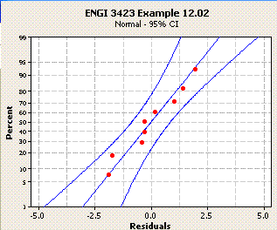
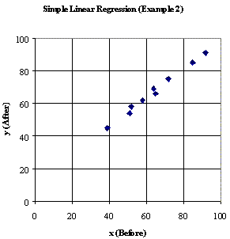
Scatter plot Normal probability plot of residuals

Calculations:

i | x_{i} | y_{i} | x_{i}² | x_{i} . y_{i} | y_{i}²
1 | 72 | 75 | 5184 | 5400 | 5625
2 | 65 | 66 | 4225 | 4290 | 4356
3 | 64 | 69 | 4096 | 4416 | 4761
4 | 39 | 45 | 1521 | 1755 | 2025
5 | 51 | 54 | 2601 | 2754 | 2916
6 | 85 | 85 | 7225 | 7225 | 7225
7 | 52 | 58 | 2704 | 3016 | 3364
8 | 92 | 91 | 8464 | 8372 | 8281
9 | 58 | 62 | 3364 | 3596 | 3844
Sum: | 578 | 605 | 39384 | 40824 | 42397

$n S_{x y} = n \sum{x y −} \sum{x} \sum{y}$ = 9 × 40824 − 578 × 605 = 17726
[Note: n S_{xy} = n (n−1) * sample covariance of (X, Y) ]
$n S_{x x} = n \sum{x^{2} −} {\left(\sum{x}\right)}^{2}$ = 9 × 39384 − 578 ² = 20372
[Note: n S_{xx} = n (n−1) * sample variance of X ]
⇒ ${\hat{β}}_{1} = \frac{S_{x y}}{S_{x x}} = \frac{\text{17} \text{726}}{\text{20} \text{372}} = \underline{\underline{0\text{.}\text{870} \text{116}}}$

and ${\hat{β}}_{0} = \frac{1}{n} \left(\sum{y} − {\hat{β}}_{1} \sum{x}\right) = \frac{1}{9} \left(\text{605} − 0\text{.}\text{807} \text{116}×\text{578}\right) = \underline{\underline{\text{11}\text{.}\text{341} \text{45}}}$

Each predicted value ${\hat{y}}_{i}$ of Y is then estimated using ${\hat{y}}_{i} = {\hat{β}}_{0} + {\hat{β}}_{1} x_{i}$ ≈ 11.34 + 0.87 x and the point estimates of the unknown errors ε _{i} are the observed residuals $e_{i} = y_{i} − {\hat{y}}_{i}$ . [Use un-rounded values 11.34... and 0.87... to find residuals.]

A measure of the degree to which the regression line fails to explain the variation in Y is the sum of squares due to error,
$$\text{SSE} = \sum_{i=1}^{n}{e_{i^{2}}} = \sum_{i=1}^{n}{{\left(y_{i} − {\hat{β}}_{0} − {\hat{β}}_{1} x_{i}\right)}^{2} }$$

which is given in the adjoining table.

x_{i} | y_{i} | $${\hat{y}}_{i}$$ | e_{i} | e_{i}²
72 | 75 | 73.98979 | 1.0102 | 1.0205
65 | 66 | 67.89898 | −1.8990 | 3.6061
64 | 69 | 67.02886 | 1.9711 | 3.8854
39 | 45 | 45.27597 | −0.2760 | 0.0762
51 | 54 | 55.71736 | −1.7174 | 2.9493
85 | 85 | 85.30130 | −0.3013 | 0.0908
52 | 58 | 56.58747 | 1.4125 | 1.9952
92 | 91 | 91.39211 | −0.3921 | 0.1537
58 | 62 | 61.80817 | 0.1918 | 0.0368
SSE = 13.8141

An Alternative Formula for SSE:

$${\hat{β}}_{0} = \bar{y} − {\hat{β}}_{1} \bar{x} ⇒$$
$$\text{SSE} = \sum_{i=1}^{n}{{\left(y_{i} − \left(\bar{y}−{\hat{β}}_{1} \bar{x}\right) − {\hat{β}}_{1} x_{i}\right)}^{2}}=\sum_{i=1}^{n}{{\left(\left(y_{i} − \bar{y}\right)−{\hat{β}}_{1}\left(x_{i} −\bar{x}\right) \right)}^{2}}$$
$$=\sum_{i=1}^{n}{{\left(y_{i} − \bar{y}\right)}^{2}}−2{\hat{β}}_{1}\sum_{i=1}^{n}{\left(x_{i} −\bar{x}\right)\left(y_{i} − \bar{y}\right)}+ {\hat{β}}_{1^{2}}\sum_{i=1}^{n}{{\left(x_{i} −\bar{x}\right)}^{2}}$$
$$= S_{\text{yy}} − 2{\hat{β}}_{1} S_{\text{xy}} + {\hat{β}}_{1^{2}} S_{\text{xx}}$$
$$\text{But} {\hat{β}}_{1} = \frac{S_{\text{xy}}}{S_{\text{xx}}}$$
$⇒ \text{SSE} = S_{\text{yy}} − {\hat{β}}_{1} S_{\text{xy}}$ or$\text{SSE} = \frac{S_{\text{xx}}S_{\text{yy}}−S_{{\text{xy}}^{2}}}{S_{\text{xx}}}$ or
$$\text{SSE} = \frac{\left({\text{nS}}_{\text{xx}}\right) \left({\text{nS}}_{\text{yy}}\right)−{\left({\text{nS}}_{\text{xy}}\right)}^{2}}{n×\left({\text{nS}}_{\text{xx}}\right)}$$

In this example,
$$\text{SSE} = \frac{\text{20} \text{372}×\text{15} \text{548}−\text{17} {\text{726}}^{2}}{9×\text{20} \text{372}} = \text{13}\text{.}\text{814}…$$

However, this formula is very sensitive to round-off errors:
If all terms are rounded off prematurely to three significant figures, then
$$\text{SSE} = \frac{\text{20} \text{400}×\text{15} \text{500}−\text{17} {\text{700}}^{2}}{9×\text{20} \text{400}} = \text{15}\text{.}\text{85} \left(2 d\text{.}p\text{.}\right)$$

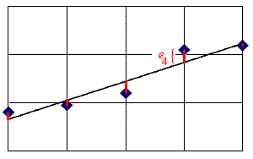
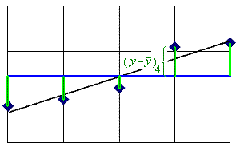

The total variation in Y is the SST (sum of squares - total):

$\text{SST} = \frac{n S_{\text{yy}}}{n} = \sum{{\left(y_{i} − \bar{y}\right)}^{2}}$ (which is (n − 1) × the sample variance of y).

In this example, SST = 15 548 / 9 = 1 727.555...

The total variation (SST) can be partitioned into the variation that can be explained by the regression line and the variation that remains unexplained by the regression line (SSE).

The proportion of the variation in Y that is explained by the regression line is known as the coefficient of determination

$r^{2} = \frac{\text{SSR}}{\text{SST}} = 1 − \frac{\text{SSE}}{\text{SST}}$

In this example, r² = 1 − (13.81... / 1727.555... ) = .992004...

Therefore the regression model in this example explains 99.2% of the total variation in y.

Note:
$$\text{SSR} = {\hat{β}}_{1}⋅S_{\text{xy}} = \frac{S_{{\text{xy}}^{2}}}{S_{\text{xx}}}$$
and SST = S_{yy}
⇒
$r^{2} = \frac{S_{{x y}^{2}}}{S_{x x} S_{y y}}$

The coefficient of determination is just the square of the sample correlation coefficient r.
Thus r = √ r² ≈ .996 . It is no surprise that the two sets of test scores in this example are very strongly correlated. Most of the points on the graph are very close to the regression line y = 0.87 x + 11.34 .

A point estimate of the unknown population variance σ² of the errors ε is the sample variance or mean square error s² = MSE = SSE / (number of degrees of freedom).

But the calculation of s² includes two parameters that are estimated from the data: ${\hat{β}}_{0}$ and ${\hat{β}}_{1}$ . Therefore two degrees of freedom are lost and $\text{MSE} = \frac{\text{SSE}}{n − 2}$ . In this example, MSE ≈ 1.973.

A concise method of displaying some of this information is the ANOVA table (used in Chapters 10 and 11 of Devore for analysis of variance). The f value in the top right corner of the table is the square of a t value that can be used in an hypothesis test on the value of the slope coefficient β₁ .

Sequence of manual calculations:
{ n, ∑ x, ∑ y, ∑ x ², ∑ xy, ∑ y ² } → { n S_{xx}, n S_{xy}, n S_{yy} } →
{ , SSR, SST } → { R ², SSE } → { MSR, MSE } → f → t

Source Degrees of Sums of Squares Mean Squares f
Freedom

Regression 1 SSR = 1713.741... MSR = SSR / 1 = MSR/MSE
= 1713.741... = 868.4...

Error n − 2 SSE = 13.81... MSE = SSE / (n−2)
= 7 = 1.973...

Total n − 1 SST = 1727.555...
= 8

To test H_{o} : β₁ = 0 (no useful linear association) against H_{a} : β₁ ≠ 0 (a useful linear association exists), we compare | t | = √ f to t_{α/2, (n−2)} .
In this example, | t | = √ 868.4... = 29.4... >> t_{.0005, 7} (the p-value is < 10⁻⁷)
so we reject H_{o} in favour of H_{a} at any reasonable level of significance α.

The standard error s_{b} of ${\hat{β}}_{1}$ is s / √ S_{xx} so the t value is also equal to $\frac{{\hat{β}}_{1} − 0}{\sqrt{\frac{n \text{MSE}}{n S_{x x}}}}$ .
Yet another alternative test of the significance of the linear association is an hypothesis test on the population correlation coefficient ρ , (H_{o}: ρ = 0 vs. H_{a}: ρ ≠ 0), using the test statistic , which is entirely equivalent to the other two t statistics above.

Example 12.03

(a) Find the line of best fit to the data

x 0 0 1 1 1 2 2 2 3 4

y 6.1 5.3 4.1 5.1 4.4 3.4 2.6 3.1 1.8 2.1

(b) Estimate the value of y when x = 2.
(c) Why can’t the regression line be used to estimate y when x = 10?
(d) Find the sample correlation coefficient.
(e) Does a useful linear relationship between Y and x exist?

(a) A plot of these data follows.
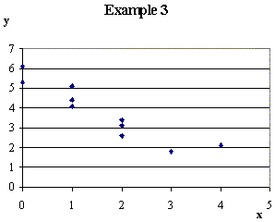
The Excel spreadsheet file for these data can be found at

“http://www.engr.mun.ca
/~ggeorge/3423/demos
/regress3.xls” .

The summary statistics are

Σ x = 16 Σ y = 38 n = 10

Σ x² = 40 Σ xy = 45.6 Σ y² = 163.06

From which

n S_{xy} = n Σ xy − Σ x Σ y = −152

n S_{xx} = n Σ x² − (Σ x )² = 144 n S_{yy} = n Σ y² − (Σ y )² = 186.6

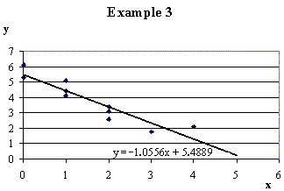

So the regression line is

y = 5.489 − 1.056 x (3 d.p.)

(b) x = 2 ⇒ y = 5.488... − 1.055...×2 = 3.38 (2 d.p.)

(c) x = 10 ⇒ y = 5.488... − 1.055...×10 = −5.07 < 0 ! (2 d.p.)

Problem: x = 10 is outside the sample range for x .
⇒ SLR model may be invalid. In one word: EXTRAPOLATION.

(d) $r = \frac{S_{x y}}{\sqrt{S_{x x} S_{y y}}} = \frac{−\text{152}}{\sqrt{\text{144}×\text{186}\text{.}6}}$ = −.92727... ≈ –.93

(e) $\text{SSR} = \frac{{\left(n S_{\text{xy}}\right)}^{ 2}}{n \left(n S_{\text{xx}}\right)} = \frac{{\left(−\text{152}\right)}^{ 2}}{\text{10}×\text{144}} = \text{16}\text{.}0\overset{˙}{4}$
SST = S_{yy} = ( 186.6 / 10 ) = 18.66

and SSE = SST − SSR = 18.66 − 16.04... = 2.615...
The ANOVA table is then:

Source d.f. SS MS f

R 1 16.04444... 16.04444... 49.07...

E 8 2.61555... 0.3269...

T 9 18.66000

from which t = − √ f ≈ −7.005 (3 d.p.) But t_{.0005,8} = 5.041... | t | > t_{.0005, 8}

Therefore reject H_{o} : β₁ = 0 in favour of H_{a} : β₁ ≠ 0 at any reasonable level of significance α. [p-value = .00011...]

OR $t = \frac{r \sqrt{n−2}}{\sqrt{1−r^{2}}} = \frac{−\text{.}\text{92727}\text{.}\text{.}\text{.} ×\sqrt{8}}{\sqrt{1−\text{.}\text{85983}\text{.}\text{.}\text{.}}} ≈ −7\text{.}\text{005}$
⇒ reject H_{o}: ρ = 0 in favour of H_{a}: ρ ≠ 0 (a significant linear association exists).
[Also, from the ANOVA table,
Therefore the regression line explains ~86% of the variation in y.
r = −√ r ² = −.927 , as before.]

Confidence and Prediction Intervals

The simple linear regression model $Y_{i} = β_{0} + β_{1} x_{i} + ε_{i}$ leads to a line of best fit in the least squares sense, which provides an expected value of Y given a value for x :
$\hat{y} = {\hat{β}}_{0} + {\hat{β}}_{1} x$ = E[ Y | x ] = μ_{Y•x} .
The uncertainty in this expected value has two components:
- the square of the standard error of the scatter of the observed points about the regression line (= σ² / n ), and
- the uncertainty in the position of the regression line itself, which increases with the distance of the chosen x from the centroid of the data but decreases with increasing spread of the full set of x values: $σ^{2} \left(\frac{{\left(x−\bar{x}\right)}^{2}}{S_{\text{xx}}}\right)$.
The unknown variance σ² of individual points about the true regression line is estimated by the mean square error s² = MSE .

Thus a 100(1−α)% confidence interval for the expected value of Y at x = x_{o} has endpoints at

$\left({\hat{β}}_{0} + {\hat{β}}_{1} x_{o}\right) ± t_{α/2, (n−2)} s \sqrt{ \frac{1}{n} + \frac{{\left(x_{o}−\bar{x}\right)}^{2}}{S_{\text{xx}}}}$

The prediction error for a single point is the residual E = Y − $\hat{y}$, which can be treated as the difference of two independent random variables. The variance of the prediction error is then

Thus a 100(1−α)% prediction interval for a single future observation of Y at x = x_{o} has endpoints at
$\left({\hat{β}}_{0} + {\hat{β}}_{1} x_{o}\right) ± t_{α/2, (n−2)} s \sqrt{ 1 + \frac{1}{n} + \frac{{\left(x_{o}−\bar{x}\right)}^{2}}{S_{\text{xx}}}}$

The prediction interval is always wider than the confidence interval.

Example 12.03 (continued)

(f) Find the 95% confidence interval for the expected value of Y at x = 2 and x = 5.
(g) Find the 95% prediction interval for a future value of Y at x = 2 and at x = 5.

(f) α = 5% ⇒ α/2 = .025

Using the various values from parts (a) and (e):

n = 10 t_{.025, 8} = 2.306... s = 0.57179... $\bar{x}$= 1.6

S_{xx} = 14.4 ${\hat{β}}_{0}$ = 5.4888... ${\hat{β}}_{1}$ = −1.0555...

x_{o} = 2 ⇒ the 95% CI for μ_{Y|2} is
$\left({\hat{β}}_{0} + {\hat{β}}_{1} x_{o}\right) ± t_{α/2, (n−2)} s \sqrt{ \frac{1}{n} + \frac{{\left(x_{o}−\bar{x}\right)}^{2}}{S_{\text{xx}}}}$ = 3.3777... ± 1.3185... × √ 0.1111...
= 3.3777... ± 0.4395... ⇒ 2.94 ≤ E[ Y | 2 ] < 3.82 (to 3 s.f.)

x_{o} = 5 ⇒ the 95% CI for μ_{Y|5} is
$\left({\hat{β}}_{0} + {\hat{β}}_{1} x_{o}\right) ± t_{α/2, (n−2)} s \sqrt{ \frac{1}{n} + \frac{{\left(x_{o}−\bar{x}\right)}^{2}}{S_{\text{xx}}}}$ = 0.2111... ± 1.3185... × √ 0.902777...
= 0.2111... ± 1.2528... ⇒ −1.04 ≤ E[ Y | 5 ] ≤ 1.46 (to 3 s.f.)

(g) x_{o} = 2 ⇒ the 95% PI for Y is

$\left({\hat{β}}_{0} + {\hat{β}}_{1} x_{o}\right) ± t_{α/2, (n−2)} s \sqrt{ 1 + \frac{1}{n} + \frac{{\left(x_{o}−\bar{x}\right)}^{2}}{S_{\text{xx}}}}$ = 3.3777... ± 1.3185... × √ 1.1111...
= 3.3777... ± 1.3898... ⇒ 1.99 ≤ Y < 4.77 (to 3 s.f.) at x = 2

x_{o} = 5 ⇒ the 95% PI for Y is
$\left({\hat{β}}_{0} + {\hat{β}}_{1} x_{o}\right) ± t_{α/2, (n−2)} s \sqrt{ 1 + \frac{1}{n} + \frac{{\left(x_{o}−\bar{x}\right)}^{2}}{S_{\text{xx}}}}$= 0.2111... ± 1.3185... × √ 1.902777...
= 0.2111... ± 1.8188... ⇒ −1.61 < Y < 2.03 (to 3 s.f.) at x = 5

Note how the confidence and prediction intervals both become wider the further away from the centroid the value of x_{o} is. The two intervals at x = 5 are wide enough to cross the x-axis, which is an illustration of the dangers of extrapolation beyond the range of x for which data exist.

Sketch of confidence and prediction intervals for Example 3 (f) and (g):
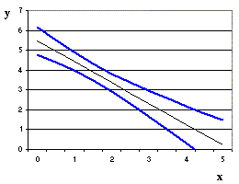
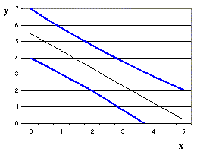
(f) 95% Confidence Intervals (g) 95% Prediction Intervals

