3. Fourier Series

This short chapter offers a very brief review of [discrete] Fourier series.

The Fourier series of f (x) on the interval (–L, L) is

where
and

The {a_{n}, b_{n}} are the Fourier coefficients of f (x).

Note that the cosine functions (and the function 1) are even, while the sine functions are odd.

If f (x) is even (f (–x) = + f (x) for all x), then b_{n} = 0 for all n, leaving a Fourier cosine series (and perhaps a constant term) only for f (x).

If f (x) is odd (f (–x) = – f (x) for all x), then a_{n} = 0 for all n, leaving a Fourier sine series only for f (x).
Example 3.1

Expand in a Fourier series.

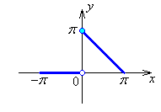

Example 3.1 (Additional Notes – also see
"www.engr.mun.ca/~ggeorge/5432/demos/")
The first few partial sums in the Fourier series

are
and so on.

The graphs of successive partial sums approach f (x) more closely, except in the vicinity of any discontinuities, (where a systematic overshoot occurs, the Gibbs phenomenon).
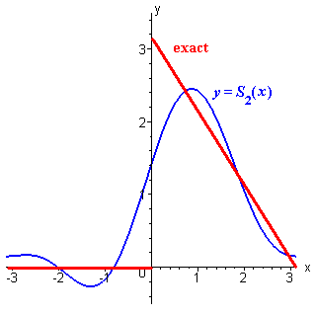
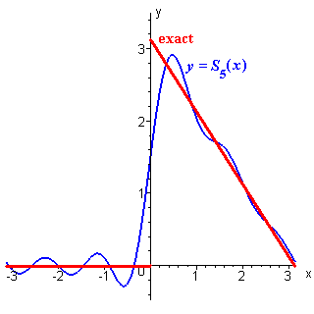

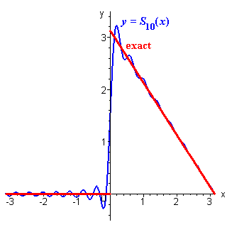
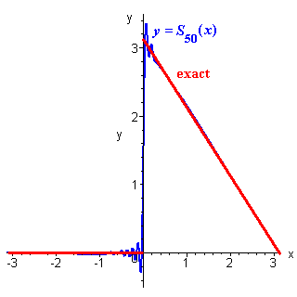

Example 3.2

Find the Fourier series expansion for the standard square wave,

The graphs of the third and ninth partial sums (containing two and five non-zero terms respectively) are displayed here, together with the exact form for f (x), with a periodic extension beyond the interval (–1, +1) that is appropriate for the square wave.

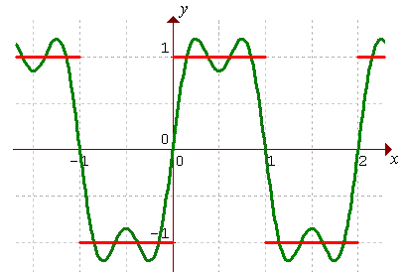

y = S₃(x)
Example 3.2 (continued)

y = S₉(x)

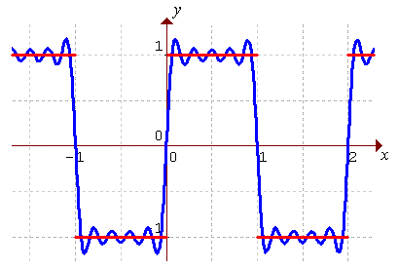

Convergence

At all points x = x_{o} in (–L, L) where f (x) is continuous and is either differentiable or the limits and both exist, the Fourier series converges to f (x).

At finite discontinuities, (where the limits and both exist), the Fourier series converges to ,
(using the abbreviations ).

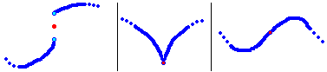
f (x) not continuous continuous but continuous and
at x = x_{o} not differentiable differentiable
In all cases, the Fourier series at x = x_{o} converges to (the red dot).
Half-Range Fourier Series

A Fourier series for f (x), valid on [0, L], may be constructed by extension of the domain to [–L, L].

An odd extension leads to a Fourier sine series:
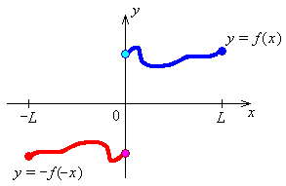

where

An even extension leads to a Fourier cosine series:
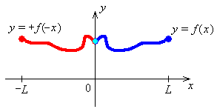
where
and there is automatic continuity of the Fourier cosine series at x = 0 and at x = ± L.
Example 3.3

Find the Fourier sine series and the Fourier cosine series for f (x) = x on [0, 1].

f (x) = x happens to be an odd function of x for any domain centred on x = 0. The odd extension of f (x) to the interval [–1, 1] is f (x) itself.

Evaluating the Fourier sine coefficients,

This function happens to be continuous and differentiable at x = 0, but is clearly discontinuous at the endpoints of the interval (x = ±1).

Fifth order partial sum of the Fourier sine series for f (x) = x on [0, 1]
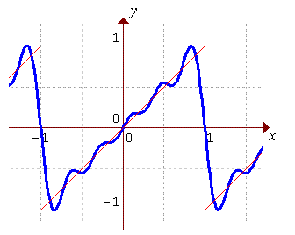
Example 3.3 (continued)

The even extension of f (x) to the interval [–1, 1] is f (x) = | x |.

Evaluating the Fourier cosine coefficients,

Example 3.3 (continued)

Third order partial sum of the Fourier cosine series for f (x) = x on [0, 1]
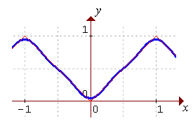
Note how rapid the convergence is for the cosine series compared to the sine series.

S₃(x) for cosine series and S₅(x) for sine series for f (x) = x on [0, 1]
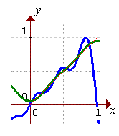

END OF CHAPTER 3

