1. Vector Fields and the Gradient Operator

In this chapter, a review of vectors from previous courses is followed by the introduction of lines of force. The gradient operator is extended to divergence, curl and Laplacian in both Cartesian and general orthonormal curvilinear coordinate systems. Conversion of components of vectors between Cartesian and other coordinate systems is also covered.

Contents of this Chapter:

1.1 Review of Vectors
1.2 Lines of Force
1.3 The Gradient Vector
1.4 Divergence and Curl
1.5 Conversions between Coordinate Systems
1.6 Basis Vectors in Other Coordinate Systems
1.7 Gradient Operator in Other Coordinate Systems

1.1 Review of Vectors

This first section is a brief review of concepts that were introduced during terms 1 and 2.

The displacement vector of a particle can be represented in Cartesian components by
where t is a parameter (time or angle or distance along a curve, etc.)

The distance of the particle from the origin at any value of t is given by the scalar function

Note the various alternative conventions for a vector and its magnitude:

Scalar product (dot product):

The component of vector
in the direction of vector is

(" at right angles to ")

The scalar product is commutative:

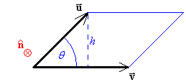
Vector product (cross product):

The vector product of two vectors , is in
a direction at right angles to both and .

The area of the parallelogram is

and
The orientation of the plane containing vectors and is defined by the direction of the vector product .

(" parallel to ")

The vector product is anti-commutative:

The product rule of differentiation is valid for scalar and vector products:

and

Example 1.1.1

For the vectors and
find (= the angle between and )
and the equation of the plane parallel to and that passes through the origin.

Example 1.1.1 (continued)

A normal to the plane is .
A point on the plane is .
The equation of the plane is

The arc length s is the distance travelled along the curve. It is related to the displacement vector r by
The distance along a curve between two points whose parameter values are t₀ and t₁ is

A unit vector û has a magnitude of 1: | û | = 1
Any non-zero vector r can be decomposed into its magnitude r and its direction:

The unit tangent at any point on the curve is

The unit principal normal at any point on the curve is
where ρ = radius of curvature (SI units: metre)
κ = curvature (SI units: m⁻¹)
Of all circles that touch a curve on the “inside” at a particular point (and which therefore all share the same unit tangent vector [or its negative] there), the one whose radius is ρ is the best fit to that curve at that point. In general, curvature varies along most curves.

At points of inflexion, κ = 0

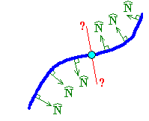
The unit binormal is
The three vectors form an orthonormal set (they are mutually perpendicular and each one is a unit vector; that is, magnitude = 1)

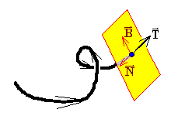

the curve lies entirely in one plane (the plane defined by ).

Note that are undefined at points of inflexion.
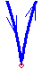
All three unit vectors are undefined where the curve suddenly reverses direction, (such as at a cusp).

Velocity and Acceleration

If the parameter t is the time, then the velocity of a particle [a vector function] is
and its speed [a scalar function] is
and

The acceleration [vector] is
where
and

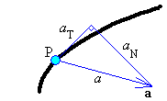
Example 1.1.2

The equation of a curve in is given parametrically by
Show that the curve lies entirely in one plane and find the equation of that plane.

Let c = cos t and s = sin t then

OR

Example 1.1.2 (continued)

OR

OR evaluate κ from

OR

Example 1.1.2 (continued)

where τ is the torsion (the measure of the rate at which the curve is twisting out of the plane defined by ).

τ = 0 ⇒ the curve lies in one plane, with plane normal .

A point on the curve can be found by setting the parameter t = 0:
The equation of the plane containing the curve is

Frenet-Serret formulæ:
The proofs are in Problem Set 1.
1.2 Lines of Force

A vector function of n variables in ^{n} is a vector field.

F(x, y, z) =  f₁(x, y, z), f₂(x, y, z), f₃(x, y, z) 
(and the f_{i} form scalar fields).
The domain must be defined. If not explicitly mentioned, the domain is assumed to be all of that part of ^{n} for which all of the scalar fields f_{i} are defined.

A vector field defines a vector F at each point in the domain.
If these vectors are tangents to a family of curves, then those curves are
streamlines or flow lines or lines of force.

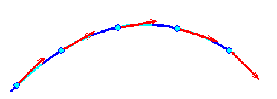

Let F(x, y, z) be a vector field to a family of lines of force r(x, y, z). Then

where k is some scalar.

(provided f₁, f₂, f₃ are all non-zero).

Example 1.2.1

Find the lines of force associated with the vector field
and find the line of force that passes through the point (4, 2, 0).

The lines of force are therefore

We want the line of force through (4, 2, 0)
The required line of force is

Example 1.2.2

Find the lines of force associated with the vector field
and find the line of force that passes through the point (−1, 6, 2).

But the required line of force passes through (–1, 6, 2):

Example 1.2.3

Find the streamlines associated with the velocity field
and find the streamline through the point (1, 0, 0).

The streamlines are therefore a family of circles, parallel to the x-y plane, centre the z-axis, lying on a concentric set of circular cylinders:

The required streamline is therefore the unit circle

1.3 The Gradient Vector

If a curve in ² is represented by y = f (x) , then

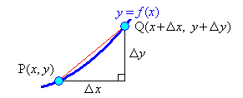

If a surface in ³ is represented by z = f (x, y) , then in a slice y = constant,

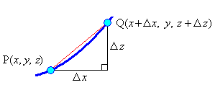

Similarly,

In the plane of the independent variables:

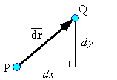
f (P) = f
f (Q) = f + df

Chain rule:

where ∇f (pronounced as “del f”) is the gradient vector.

At any point (x, y) in the domain, the value of the function f (x, y) changes at different rates when one moves in different directions on the xy-plane.

∇f is a vector in the plane of the independent variables (the xy-plane).
The magnitude of ∇f at a point (x, y) is the maximum instantaneous rate of increase of f at that point. The direction of ∇f at that point is the direction in which one would have to start moving on the xy-plane in order to experience that maximum rate of increase, (which is also at right angles to the contour f (x, y) = constant at that point).

Points where are critical points of f, (maximum, minimum or saddle point).

The directional derivative of f in the direction of the unit vector û is
Both vectors are in the plane of the independent variables.
The directional derivative is the component of ∇f in the direction of û.

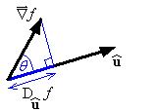

(when û is tangential to the contours of f ).

The results above can be extended to functions of more than two variables.
For the hypersurface z = f (x₁, x₂, ... , x_{n}) in ^{n+1}, the chain rule becomes

Example 1.3.1

The electrostatic potential φ at a point P(x, y, z) in ³ due to a point charge Q at the origin is
Find the rate of change of φ at the point (1, 2, 2) in the direction k − 2i .
Find the maximum value of the directional derivative over all directions at any point.
Find the level surfaces.

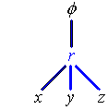
This is the x component of the gradient vector.
Obtain by symmetry.

At (1, 2, 2) .

Example 1.3.1 (continued)

This occurs when

Level surfaces (contours):
But r = A is a sphere, centre O.

Therefore the level surfaces are a family of concentric spheres.

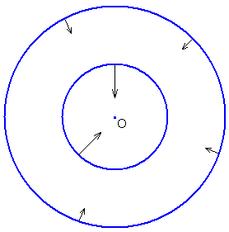
[Q > 0 case]

Change of coordinates:

Suppose z = f (x, y) (where (x, y) are Cartesian coordinates) and is wanted, (where (r, θ) are plane polar coordinates). Then
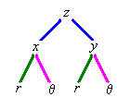

But x = r cos θ , y = r sin θ
can be found in a similar way.

In matrix form, the chain rule can be expressed concisely as
Note that
For the transformation from Cartesian to plane polar coordinates in ², the Jacobian is
Integrals over areas can therefore be transformed using the Jacobian:
where f (x, y) = g(r, θ) at all points in the area A of integration.
We shall return to this topic later.
Planes
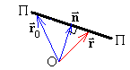

Let n = a normal vector to a plane = A, B, C
and r_{o} = the position vector of a point on the plane = x_{o}, y_{o}, z_{o}
where A, B, C, x_{o}, y_{o}, z_{o} are all constants.
Let r = the position vector of a general point in ³ = x, y, z
Then the point (x, y, z) is on the plane if and only if
which is a vector equation of the plane.
Evaluating the scalar [dot] products generates the Cartesian equation of the plane:
where D = Ax_{o} + By_{o} + Cz_{o} .

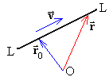
Lines

Let v = a vector parallel to the line = v₁, v₂, v₃
and r_{o} = the position vector of a point on the line = x_{o}, y_{o}, z_{o}
then the vector parametric form of the equation of the line is
and the Cartesian equivalent, (in the case where none of v₁, v₂, v₃ is zero) is

Surfaces
The general Cartesian equation of a surface in ³ is of the form
f (x, y, z) = c
At every point on the surface where ∇f exists as a non-zero vector, ∇f is orthogonal (perpendicular) to the level surface of the function f that passes through that point.
Therefore, at every point on the surface f (x, y, z) = c,
the gradient vector ∇f is normal to the tangent plane.

The tangent plane at the point P(x_{o}, y_{o}, z_{o}) to the surface f (x, y, z) = c has the equation

Example 1.3.2

Find the Cartesian equations of the tangent plane and normal line to the surface
z = x² + y at the point (−1, 1, 2).

The implicit form of the equation of the surface is f = x² + y – z = 0

Therefore the equation of the tangent plane is –2x + y – z = 1 or

2x – y + z + 1 = 0

The equation of the normal line follows immediately:

In vector parametric form:

or, in Cartesian parametric form,

or, in Cartesian symmetric form,

or

Example 1.3.3

Find the angle between the surfaces x² + y² + z² = 4 and z² + x² = 2 at the point
(1, , 1).

First note that these surfaces are a sphere, radius 2, centre the origin and a circular cylinder of radius aligned along the y axis. Their intersection will therefore be a pair of parallel circles, equally spaced on either side of the x-z plane.

The point P (1, , 1) is clearly on both surfaces [satisfies the equations of both surfaces].

At P,

At P,

The angle θ between the surfaces equals the angle between the two normal vectors.

Note: In the event that , then the two normal vectors meet at an obtuse angle (they are pointing in approximately opposite directions). In that case use .
Gradient Operator

For three independent variables (x, y, z), the gradient operator is the “vector”
It operates on anything immediately to its right; either a scalar function or scalar field, or, via a dot product or cross product, on a vector function or vector field.

1.4 Divergence and Curl
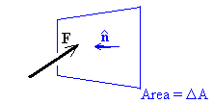
For an elementary area ΔA in a vector field F ,

is an outward unit normal to the surface.

ΔA is sufficiently small that F = f₁, f₂, f₃ is approximately constant over ΔA.

The element of flux Δφ from the vector field through ΔA is approximately
Now add up the elements of flux passing through the six faces of an elementary cuboid of sides Δx, Δy, Δz , volume ΔV = Δx Δy Δz and with one corner at (x, y, z).
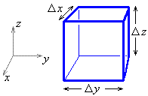

The front face is at (x + Δx) and the back face is at (x).
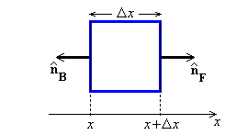

Back face:

Front face:

[front face is at x + Δx]

Divergence (continued)

Similarly, for the left and right faces,

and for the top and bottom faces,

Summing over all six faces of the cuboid, the net rate of flux per unit volume out of a point (x, y, z) is

which is the divergence of F.

No net flux (no sources)

Example 1.4.1

Find the divergence of the vector F, given that F = −∇φ ,

From example 1.3.1,

Also from example 1.3.1,

The other two derivatives follow by symmetry.

(unless r = 0, where div F is undefined).

Therefore the ideal electrostatic field is source free except at the point charge itself.
The flux passing in through any volume not enclosing the charge is balanced by the flux passing out.

Streamlines for Fluid Flow

Let v(r) be the velocity at any point (x, y, z) in an incompressible fluid. Because the fluid is incompressible, the flow in to any region must be matched by the flow out from that region (except when the region includes a source or a sink). This generates the continuity equation

div v = 0

Let us take the case of fluid flow parallel to the x-y plane everywhere, so that we can ignore the third dimension and consider the flow in two dimensions only. Then

The continuity equation then becomes

The fluid flows along streamlines, but never across any streamline.
Consider the flow through a small region bounded partly by a streamline:
streamline
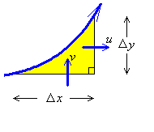

This ODE is exact if and only if

which is automatically true (equation of continuity).

The solution to the ODE is then the stream function , where

Example 1.4.2 (Example 1.2.3 repeated)

Find the streamlines associated with the velocity field
and find the streamline through the point (1, 0).

Verify that the equation of continuity is satisfied:

Therefore the stream function exists, such that

Therefore the streamlines in the x-y plane are

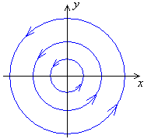
The required streamline is therefore the unit circle

The flow is a vortex around the origin.

Divergence (a scalar quantity):
Curl (a vector quantity):

curl F = 0 everywhere ⇒ F is an irrotational vector field.

Example 1.4.3

Find curl F for F = cos y, −sin x, 0 .
Also find the lines of force for the vector field F.

Lines of force:

The lines of force are therefore
In order to be real,

It then follows that curl F = A k and is constant along any one line of force.

Example 1.4.3 (continued)

Direction field plot for the vector field F = cos y, −sin x, 0 :

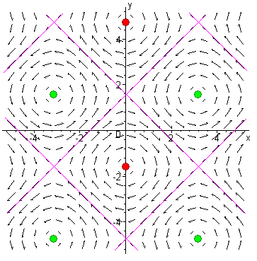

curl F = (sin y − cos x) k

Lines of force: sin y = A + cos x (−2 ≤ A ≤ 2)

and curl F = A k .

Along the highlighted lines (at 45° angles), A = 0 (and therefore curl F = 0).
Where those lines cross, F = 0 also, (in addition to A = 0 and curl F = 0).
Half way along the lines between those intersections, | F | is at a maximum ().
At the highlighted dots, | curl F | achieves its maximum value of 2 and F = 0 and
where the lines of force near a dot are in an anticlockwise direction, curl F = +2 k;
where the lines of force near a dot are in a clockwise direction, curl F = –2 k.
All differentiable gradient-vector fields are irrotational:

Proof:

Also:
Proof:

The Laplacian of a twice-differentiable scalar field φ is:
Laplace’s equation is
Some Vector Identities

$$∇×∇f = \text{curl grad }f = 0$$
$$∇⋅∇×F = \text{div curl \{}F = 0$$

$$\text{Laplacian of } V = ∇^{2}V = ∇⋅\left(∇V\right) = \text{div grad }V$$

$$∇^{2}F = ∇\left(∇⋅F\right) − ∇×\left(∇×F\right) = \text{grad div \{}F − \text{curl curl \{}F$$

$$∇\left(f g\right) = f ∇g + \left(∇f\right)g$$

$$∇⋅\left(g F\right) = \left(∇g\right)⋅F + g \left(∇⋅F\right)$$
div (g F) = (grad g)•F + g div F

$$∇×\left(g F\right) = \left(∇g\right)×F + g \left(∇×F\right)$$
curl (g F) = (grad g)×F + g curl F

$$∇⋅\left(F×G\right) = \left(∇×F\right)⋅ G − F ⋅\left(∇×G\right)$$
div (F × G) = (curl F)•G − F•(curl G)

$∇×\left(F×G\right) = \left(G⋅∇\right) F − \left(F⋅∇\right) G + \left(∇⋅G\right) F − \left(∇⋅F\right) G$,
$$\begin{matrix}\text{where} \left(F⋅∇\right) G = & \left(F_{1} \frac{∂G_{1}}{∂x} + F_{2} \frac{∂G_{1}}{∂y} + F_{3} \frac{∂G_{1}}{∂z}\right) \hat{i} \\ + & \left(F_{1} \frac{∂G_{2}}{∂x} + F_{2} \frac{∂G_{2}}{∂y} + F_{3} \frac{∂G_{2}}{∂z}\right) \hat{j} \\ + & \left(F_{1} \frac{∂G_{3}}{∂x} + F_{2} \frac{∂G_{3}}{∂y} + F_{3} \frac{∂G_{3}}{∂z}\right) \hat{k}\end{matrix}$$
$$\text{so that }\left(F⋅∇\right)\text{ is the operator }\left(F_{1} \frac{∂}{∂x} + F_{2} \frac{∂}{∂y} + F_{3} \frac{∂}{∂z} \right)$$

$$∇\left(F⋅G\right) = \left(G⋅∇\right) F + \left(F⋅∇\right) G + G×\left(∇×F\right) + F×\left(∇×G\right)$$

