1.5 Conversions between Coordinate Systems

In general, the conversion of a vector from Cartesian coordinates (x, y, z) to another orthonormal coordinate system (u, v, w) in (where “orthonormal” means that the new basis vectors are mutually orthogonal and of unit length) is given by .

However, .
F_{v} and F_{w} are defined similarly in terms of the Cartesian components F_{x} , F_{y} , F_{z} .
In matrix form
.

The matrices on the right hand side of the equation will contain a mixture of expressions in the new (u, v, w ) and old (x, y, z ) coordinates. This needs to be converted into a set of expressions in (u, v, w ) only.

Example 1.5.1

Express the vector F = y i − x j + z k in cylindrical polar coordinates.

x y plane: coordinates x y plane: basis vectors
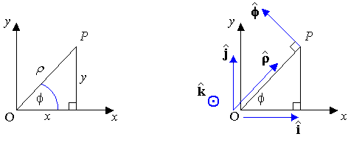
⇒

Example 1.5.1 (continued)

**

The coefficient conversion matrix from Cartesian to cylindrical polar is therefore

Letting c ≡ cos φ , s ≡ sin φ :

Therefore

** This result can be obtained from the trigonometric identity
Setting
We can also generate the coordinate transformation matrix from Cartesian coordinates
(x, y, z ) to spherical polar coordinates (r, θ, φ ).
[θ is the declination (angle down from the north pole, ) and
φ is the azimuth (angle around the equator).]

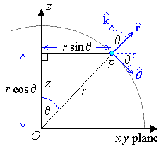
[Vertical] Plane containing z-axis and radial vector r :

The projection of the radial vector
onto the plane z = r cos θ has length
r sin θ

The angle between and is
The angle between and is

[Horizontal] Plane z = r cos θ :
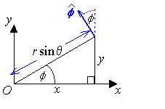
The projection of onto the x axis ()
is

r = $\left\langle x , y , z \right\rangle = \left\langle r \text{sin} θ \text{cos} φ, r \text{sin} θ \text{sin} φ , r \text{cos} θ \right\rangle$ .

The projection of onto the y axis ()
is

The angle between and is
The angle between and is
The remaining three entries in the coordinate conversion matrix can be found in a similar way.
The conversion matrix from Cartesian to spherical polar coordinates is then

Example 1.5.2

Convert to spherical polar coordinates.

Let

Therefore

Expressions for the gradient, divergence, curl and Laplacian operators in any orthonormal coordinate system will follow in section 1.7.
Summary for Coordinate Conversion:

To convert a vector expressed in Cartesian components into the equivalent vector expressed in cylindrical polar coordinates , express the Cartesian components v_{x}, v_{y}, v_{z} in terms of using
x = ρ cos φ , y = ρ sin φ , z = z ; then evaluate

Use the inverse matrix to transform back to Cartesian coordinates:

To convert a vector expressed in Cartesian components into the equivalent vector expressed in spherical polar coordinates , express the Cartesian components v_{x}, v_{y}, v_{z} in terms of using
; then evaluate

Use the inverse matrix to transform back to Cartesian coordinates:

Note that, in both cases, the transformation matrix A is orthogonal, so that A⁻¹ = A^{T}.
This is generally true for transformations between orthonormal coordinate systems.
1.6 Basis Vectors in Other Coordinate Systems

In the Cartesian coordinate system, all three basis vectors are absolute constants:

The derivative of a vector is then straightforward to calculate:

But many non-Cartesian basis vectors are not constant.

Cylindrical Polar:

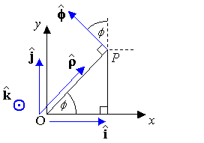

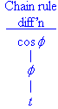

Therefore if a vector is described in cylindrical polar coordinates

In particular, the displacement vector is , so that the velocity vector is

Example 1.6.1

Find the velocity and acceleration in cylindrical polar coordinates for a particle travelling along the helix x = 3 cos 2t , y = 3 sin 2t , z = t .

Cylindrical polar coordinates:

[The velocity has no radial component – the helix remains the same distance from the z axis at all times.]

[The acceleration vector points directly at the z axis at all times.]

Spherical Polar Coordinates

Vertical plane containing z-axis and radial vector r :
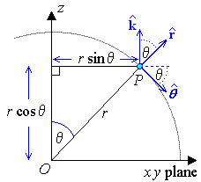

Equatorial plane ():
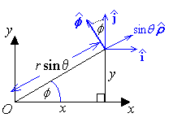
[ is the projection of onto the equatorial plane.]

[This reproduces the three rows of the coordinate conversion matrix in section 1.5.]

Spherical Polar Coordinates (continued)

In particular, the displacement vector is , so that the velocity vector is

It can be shown that the acceleration vector in the spherical polar coordinate system is
Compare this to the Cartesian equivalent !

Example 1.6.2

Find the velocity vector v for a particle whose displacement vector r, in spherical polar coordinates, is given by r = 4, θ = t , φ = 2t , (0 < t < π) .

[This describes a path spiralling around a sphere of radius 4, from pole to pole.]

Summary:

Cylindrical Polar:

Spherical Polar:
1.7 Gradient Operator in Other Coordinate Systems

For any orthogonal curvilinear coordinate system (u₁, u₂, u₃) in ³,
the unit tangent vectors along the curvilinear axes are ,
where the scale factors .
The displacement vector $r$ can then be written as $r = u_{1}{\hat{e}}_{1} + u_{2}{\hat{e}}_{2} + u_{3}{\hat{e}}_{3}$, where the unit vectors ${\hat{e}}_{i}$ form an orthonormal basis for ³.
$${\hat{e}}_{i}⋅{\hat{e}}_{j} = δ_{ \text{ij}} = \left\{\begin{matrix}0 & \left(i≠j\right) \\ 1 & \left(i=j\right)\end{matrix}\right.$$
[δ _{ij} is the “Kronecker delta”.]

The differential displacement vector dr is (by the Chain Rule)
and the differential arc length ds is

The element of volume dV is
$\text{dV} = h_{1}h_{2}h_{3} {\text{du}}_{1}{\text{du}}_{2}{\text{du}}_{3} = \left| \frac{∂\left(x,y,z\right)}{∂\left(u_{1},u_{2},u_{3}\right)} \right| {\text{du}}_{1}{\text{du}}_{2}{\text{du}}_{3}$
$= \left| \begin{matrix}\frac{∂x}{∂u_{1}} & \frac{∂y}{∂u_{1}} & \frac{∂z}{∂u_{1}} \\ \frac{∂x}{∂u_{2}} & \frac{∂y}{∂u_{2}} & \frac{∂z}{∂u_{2}} \\ \frac{∂x}{∂u_{3}} & \frac{∂y}{∂u_{3}} & \frac{∂z}{∂u_{3}}\end{matrix} \right| {\text{du}}_{1}{\text{du}}_{2}{\text{du}}_{3}$

Gradient operator
Gradient

Divergence

Curl

Laplacian

Cartesian: h_{x} = h_{y} = h_{z} = 1 .

Cylindrical polar: .

Spherical polar: .

The familiar expressions then follow for the Cartesian coordinate system.

In cylindrical polar coordinates, naming the three basis vectors as we have:
The relationship to the Cartesian coordinate system is
One scale factor is

In a similar way, we can confirm that .
In cylindrical polar coordinates,

All of the above are undefined on the z-axis (ρ = 0), where there is a coordinate singularity. However, by taking the limit as , we may obtain well-defined values for some or all of the above expressions.

Example 1.7.1

Given that the gradient operator in a general curvilinear coordinate system is

, why isn’t the divergence of
equal, in general, to

The quick answer is that the differential operators operate not just on the components , but also on the basis vectors . In most orthonormal coordinate systems, these basis vectors are not constant. The divergence therefore contains additional terms.

=

$$\left(\frac{1}{h_{1}} \frac{∂F_{1}}{∂u_{1}} + \frac{F_{1}}{h_{1}}e_{1} ⋅ \frac{∂ e_{1}}{∂u_{1}}\right) + \left(\frac{F_{1}}{h_{2}}e_{2} ⋅ \frac{∂ e_{1}}{∂u_{2}}\right) + \left(\frac{F_{1}}{h_{3}}e_{3} ⋅ \frac{∂ e_{1}}{∂u_{3}}\right) +$$
$\left(\frac{F_{2}}{h_{1}}e_{1} ⋅ \frac{∂ e_{2}}{∂u_{1}}\right) + \left(\frac{1}{h_{2}} \frac{∂F_{2}}{∂u_{2}} + \frac{F_{2}}{h_{2}}e_{2} ⋅ \frac{∂ e_{2}}{∂u_{2}}\right) + \left(\frac{F_{2}}{h_{3}}e_{3} ⋅ \frac{∂ e_{2}}{∂u_{3}}\right) +$$\left(\frac{F_{3}}{h_{1}}e_{1} ⋅ \frac{∂ e_{3}}{∂u_{1}}\right) + \left(\frac{F_{3}}{h_{2}}e_{2} ⋅ \frac{∂ e_{3}}{∂u_{2}}\right) + \left(\frac{1}{h_{3}} \frac{∂F_{3}}{∂u_{3}} + \frac{F_{3}}{h_{3}}e_{3} ⋅ \frac{∂ e_{3}}{∂u_{3}}\right)$

For Cartesian coordinates, all derivatives of any basis vector are zero, which leaves the familiar Cartesian expression for the divergence. But for most non-Cartesian coordinate systems, at least some of these partial derivatives are not zero. More complicated expressions for the divergence therefore arise.

Example 1.7.1 (continued)

For cylindrical polar coordinates, we have

But none of the basis vectors varies with ρ or z * and the basis vector is absolutely constant. Therefore the divergence becomes

But
and

So we recover the cylindrical polar form for the divergence,

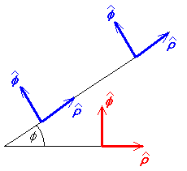
* As shown here, the basis vectors and
clearly vary with φ but do not change with ρ .

k is an absolute constant.

In spherical polar coordinates, naming the three basis vectors as we have:
The relationship to the Cartesian coordinate system is
.

One of the scale factors is

In a similar way, we can confirm that .

All of the above are undefined on the z-axis (sin θ = 0), where there is a coordinate singularity. However, by taking the limit as , we may obtain well-defined values for some or all of the above expressions.
Example 1.7.2

A vector field has the equation, in cylindrical polar coordinates (ρ, φ, z),
Find the divergence of F and the value of n for which the divergence vanishes for all .

In cylindrical polar coordinates,

and clearly .

is therefore a source-free field everywhere except on the z axis.

Example 1.7.3

In spherical polar coordinates,
,
where f (φ) is any differentiable function of φ only
and g (r, θ) is any differentiable function of r andθ only.

Find the divergence of F.

For spherical polar coordinates,

everywhere (except possibly on the z axis, where ).

Example 1.7.4

, where θ, φ are the two angular coordinates in the standard spherical polar coordinate system.

Central Force Law

If a potential function V(x, y, z), (due solely to a point source at the origin) depends only on the distance r from the origin, then the functional form of the potential can be deduced. Using spherical polar coordinates:

V (r, θ, φ) = f (r)
But, in any regions not containing any sources of the vector field, the divergence of the vector field (and therefore the Laplacian of the associated potential function V) must be zero. Therefore, for all r ≠ 0,

Solve this ODE by reduction of order:

OR (a much faster solution!)

Gravity is an example of a central force law, for which the potential function must be of the form . The zero point for the potential is usually set at infinity:
The force per unit mass due to gravity from a point mass M at the origin is

But, in spherical polar coordinates,

Therefore the gravitational potential function is

The electrostatic potential function is similar, with a different constant of proportionality.

