2. Surface Integrals

This chapter introduces the theorems of Green, Gauss and Stokes. Two different methods of integrating a function of two variables over a curved surface are developed.

The sections in this chapter are:

2.1 Line Integrals
2.2 Green’s Theorem
2.3 Path Independence
2.4 Surface Integrals - Projection Method
2.5 Surface Integrals - Surface Method
2.6 Theorems of Gauss and Stokes; Potential Functions

2.1 Line Integrals

Two applications of line integrals are treated here: the evaluation of work done on a particle as it travels along a curve in the presence of a [vector field] force; and the evaluation of the location of the centre of mass of a wire.

Work done:

The work done by a force F in moving an elementary distance Δr along a curve C is approximately the product of the component of the force in the direction of Δr and the distance | Δr | travelled:
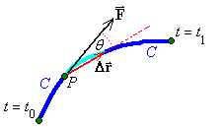

Integrating along the curve C yields the total work done by the force F in moving along the curve C:

Example 2.1.1

Find the work done by in moving around the curve C (defined in parametric form by x = cos t , y = sin t , z = 0 , 0 ≤ t ≤ 2π ).

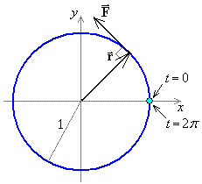

Note that everywhere on the curve C, so that
(the length of the path around the circle).

Also note that everywhere in .
The lesser curvature of the circular lines of force further away from the z axis is balanced exactly by the increased transverse force, so that curl F is the same in all of .

We shall see later (Stokes’ theorem, page 2.40) that the work done is also the normal component of the curl integrated over the area enclosed by the closed curve C. In this case
.
Example 2.1.1 (continued)

Example 2.1.2
Find the work done by in moving around the curve C (defined in parametric form by x = cos t , y = sin t , z = 0 , 0 ≤ t ≤ 2π ).

In this case, the force is orthogonal to the direction of motion at all times and no work is done.

If the initial and terminal points of a curve C are identical and the curve meets itself nowhere else, then the curve is said to be a simple closed curve.

Notation:
When C is a simple closed curve, write as .

F is a conservative vector field if and only if for all simple closed curves C in the domain.

Be careful of where the endpoints are and of the order in which they appear (the orientation of the curve). The identity leads to the result
∀ simple closed curves C

Another Application of Line Integrals: The Mass of a Wire

Let C be a segment (t₀ ≤ t ≤ t₁) of wire of line density ρ (x, y, z). Then

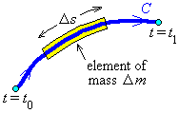

First moments about the coordinate planes:

The location of the centre of mass of the wire is
Example 2.1.3

Find the mass and centre of mass of a wire C (described in parametric form by
x = cos t , y = sin t , z = t , −π ≤ t ≤ π ) of line density ρ = z² .

Let c = cos t , s = sin t . [The shape of the wire is
one revolution of a helix,
aligned along the z axis,
centre the origin.]

x component:
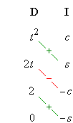
Integration by parts.

Example 2.1.3 (continued)

y component:

For all integrable functions f (t) and for all constants a note that

is an odd function

z component:

t ³ is also an odd function

Therefore

The centre of mass is therefore at

2.2 Green’s Theorem

Some definitions:

A curve C on ² (defined in parametric form by a ≤ t ≤ b) is closed iff (x(a), y(a)) = (x(b), y(b)) .

The curve is simple iff for all t₁, t₂ such that a < t₁ < t₂ < b ;
(that is, the curve neither touches nor intersects itself, except possibly at the end points).

Example 2.2.1

Two simple curves:
open closed
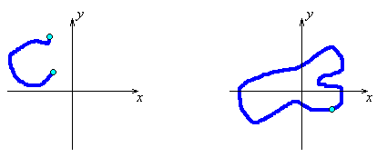

Two non-simple curves:
open closed
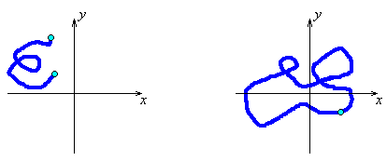

Orientation of closed curves:

A closed curve C has a positive orientation iff a point r(t) moves around C in an anticlockwise sense as the value of the parameter t increases.

Example 2.2.2
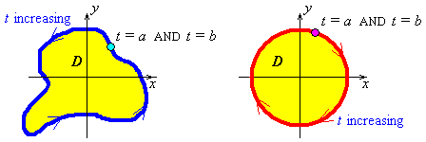

Positive orientation Negative orientation

Let D be the finite region of ² bounded by C. When a particle moves along a curve with positive orientation, D is always to the left of the particle.

For a simple closed curve C enclosing a finite region D of ² and for any vector function that is differentiable everywhere on C and everywhere in D,
Green’s theorem is valid:

The region D is entirely in the xy-plane, so that the unit normal vector everywhere on D is k. Let the differential vector dA = dA k , then Green’s theorem can also be written as

and
z component of

Green’s theorem is valid if there are no singularities in D.
Example 2.2.3
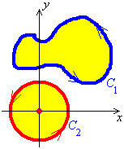

Green’s theorem is valid for curve C₁ but not for curve C₂.
There is a singularity at the origin, which curve C₂ encloses.

Example 2.2.4

For and C as shown, evaluate

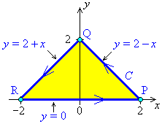

Example 2.2.4 (continued)

Everywhere on the line segment from P to Q, y = 2 – x (and the parameter t is just x)

= (0 – 0) – (8 – 4) = –4

Everywhere on the line segment from Q to R, y = 2 + x

= 4 – 0 = 4

Everywhere on the line segment from R to P, y = 0

= 2 – 2 = 0

Example 2.2.4 (continued)

OR use Green’s theorem!

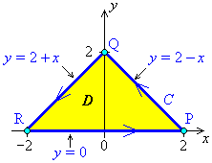

everywhere on D

By Green’s theorem it then follows that

Example 2.2.5
Find the work done by the force in one circuit of the unit square.

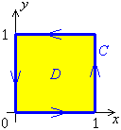

By Green’s theorem,

The region of integration is the square 0 < x < 1, 0 < y < 1

Therefore

The alternative method (using line integration instead of Green’s theorem) would involve four line integrals, each with different integrands!

2.3 Path Independence

Gradient Vector Fields:
If then

(provided that the second partial derivatives are all continuous).

It therefore follows, for any closed curve C and twice differentiable potential function φ that

Path Independence

If , then φ is a potential function for F.
Let the path C travel from point P_{o} to point P₁:

[chain rule]

which is independent of the path C between the two points.

Therefore

[work done = potential difference]
Domain

A region Ω of is a domain if and only if
1) For all points P_{o} in Ω, there exists a circle, centre P_{o}, all of whose interior points are inside Ω; and
2) For all points P_{o} and P₁ in Ω, there exists a piecewise smooth curve C, entirely in Ω, from P_{o} to P₁.

Example 2.3.1 Are these domains?

{ (x, y) | y > 0 } { (x, y) | x ≥ 0 }
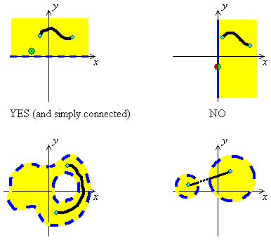

YES (but not simply connected) NO

If a domain is not specified, then, by default, it is assumed to be all of ².
When a vector field F is defined on a simply connected domain Ω, these statements are all equivalent (that is, all of them are true or all of them are false):
- for some scalar field φ that is differentiable everywhere in Ω;
- F is conservative;
- is path-independent (has the same value no matter which path within Ω is chosen between the two endpoints, for any two endpoints in Ω);
- (for any two endpoints in Ω);
- for all closed curves C lying entirely in Ω;
- everywhere in Ω; and
- everywhere in Ω (so that the vector field F is irrotational).
There must be no singularities anywhere in the domain Ω in order for the above set of equivalencies to be valid.

Example 2.3.2

Evaluate where C is any piecewise-smooth curve from (0, 0) to (1, 2).

is continuous everywhere in

is conservative and

A potential function that has the correct first partial derivatives is

Therefore
Example 2.3.3 (A Counterexample)
Evaluate , where and C is the unit circle, centre at the origin.

is continuous everywhere except (0, 0)

is not simply connected. [ is all of except (0, 0).]

everywhere in

We cannot use Green’s theorem, because is not continuous everywhere inside C
(there is a singularity at the origin).

Let c = cos t and s = sin t then

Therefore

Note: , but
everywhere on
The problem is that the arbitrary constant k is ill-defined.

Example 2.3.3 (continued)

Let us explore the case when k = 0.
Contour map of

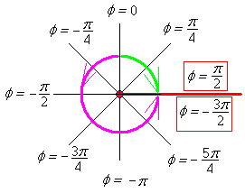

We encounter a conflict in the value of the potential function φ .

Solution: Change the domain to the simply connected domain
then the potential function can be well-defined, but no curve in can enclose the origin.

