2.4 Surface Integrals - Projection Method

Surfaces in ³

In ³ a surface can be represented by a vector parametric equation
where u, v are parameters.

Example 2.4.1

The unit sphere, centre O, can be represented by
declination azimuth

If every vertical line (parallel to the z-axis) in ³ meets the surface no more than once, then the surface can also be parameterized as
Example 2.4.2

is a hemisphere, centre O.

A simple surface does not cross itself.
If the following condition is true:
{ for all pairs of points in the domain}
then the surface is simple.

The converse of this statement is not true.
This condition is sufficient, but it is not necessary for a surface to be simple.
The condition may fail on a simple surface at coordinate singularities. For example, one of the angular parameters of the polar coordinate systems is undefined everywhere on the z-axis, so that spherical polar (2, 0, 0) and (2, 0, π) both represent the same Cartesian point (0, 0, 2). Yet a sphere remains simple at its z-intercepts.
Tangent and Normal Vectors to Surfaces

A surface S is represented by r(u, v). Examine the neighbourhood of a point P_{o} at
r(u_{o}, v_{o}). Hold parameter v constant at v_{o} (its value at P_{o}) and allow the other parameter u to vary. This generates a slice through the two-dimensional surface, namely a one-dimensional curve C_{u} containing P_{o} and represented by a vector parametric equation with only one freely-varying parameter (u).

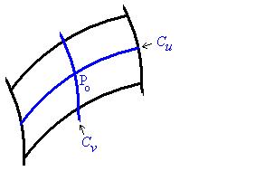

If, instead, u is held constant at u_{o} and v is allowed to vary, we obtain a different slice containing P_{o}, the curve .

On each curve a unique tangent vector can be defined.

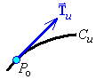

At all points along C_{u}, a tangent vector is defined by .
[Note that this is not necessarily a unit tangent vector.]
At P_{o} the tangent vector becomes .
Similarly, along the other curve C_{v}, the tangent vector at P_{o} is .
If the two tangent vectors are not parallel and neither of these tangent vectors is the zero vector, then they define the orientation of tangent plane to the surface at P_{o}.

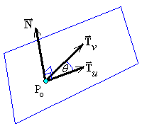

A normal vector to the tangent plane is
,

Cartesian parameters
With u = x, v = y, z = f (x, y) , the components of the normal vector
are:

⇒ a normal vector to the surface z = f (x, y) at (x_{o}, y_{o}, z_{o}) is
If the normal vector N is continuous and non-zero over all of the surface S, then the surface is said to be smooth.

Example 2.4.3

A sphere is smooth.

A cube is piecewise smooth (six smooth faces)

A cone is not smooth ( is undefined at the apex)

Surface Integrals (Projection Method)

This method is suitable mostly for surfaces which can be expressed easily in the Cartesian form z = f (x, y).

The plane region D is the projection of the surface S : f (r) = c onto a plane (usually the xy-plane) in a 1:1 manner.

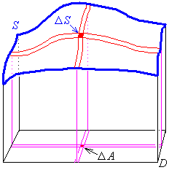
The plane containing D has a constant unit normal .
is any non-zero normal vector to the surface S.
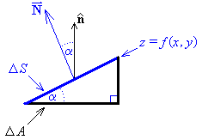

but

and

For z = f (x, y) and D = a region of the xy-plane,

which is the projection method of integration of g(x, y, z) over the surface z = f (x, y) .

Advantage: Region D can be geometrically simple (often a rectangle in ).

Disadvantage: Finding a suitable D (and/or a suitable 1:1 projection) can be difficult.

You may have to split the surface into pieces (such as splitting a sphere into two hemispheres) in order to obtain separate 1:1 projections. The projection fails if part of the surface is vertical (such as a vertical cylinder onto the xy plane).

Example 2.4.4

Evaluate , where the surface S is the section of the cone z² = x² + y² in the first octant, between z = 2 and z = 4.

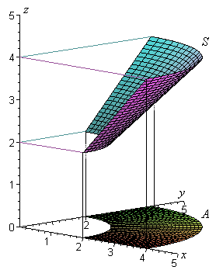
z² = x² + y²

By symmetry,

Use the polar form for dA :
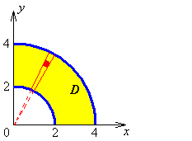

Example 2.4.4 (continued)

2.5 Surface Integrals - Surface Method

When a surface S is defined in a vector parametric form r = r(u, v), one can lay a coordinate grid (u, v) down on the surface S.
A normal vector everywhere on S is .
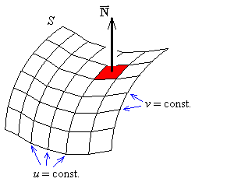

Advantage:
• only one integral to evaluate

Disadvantage:
• it is often difficult to find optimal parameters (u, v).

The total flux of a vector field through a surface S is

(which involves the scalar triple product ).

Example 2.5.1: (same as Example 2.4.4, but using the surface method).

Evaluate , where the surface S is the section of the cone z² = x² + y² in the first octant, between z = 2 and z = 4.

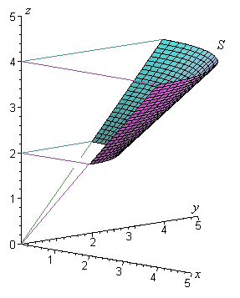
Choose a convenient parametric net:

and

then

(as before)

Just as we used line integrals to find the mass and centre of mass of [one dimensional] wires, so we can use surface integrals to find the mass and centre of mass of [two dimensional] sheets.

Example 2.5.2

Find the centre of mass of the part of the unit sphere (of constant surface density) that lies in the first octant.

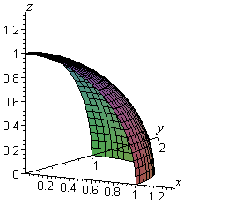
Cartesian equation of the sphere:

The radius of the sphere is r = 1.

For the parametric net, use the two angular
coordinates of the spherical polar coordinate
system .

The outward normal is clearly

Example 2.5.2 (continued)

Mass:

OR

Note that the mass of a complete spherical shell of radius r and constant density is . Therefore the mass of one eighth of a shell of radius 1 is .

By symmetry, the three Cartesian coordinates of the centre of mass are all equal:
.

Taking moments about the xy plane:

Therefore the centre of mass is at
Example 2.5.3

Find the flux of the field across that part of x + 2y + z = 8 that lies in the first octant.

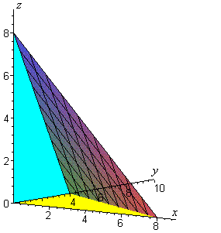
The Cartesian coordinates x, y will
serve as parameters for the surface:

Choose to point “outwards”.

Range of parameter values:

In the xy plane:

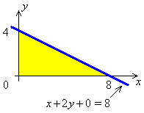

But the area is a triangle, not a rectangle, so these inequalities do not provide the correct limits for the inner integral.

Example 2.5.3 (continued)

Net flux =
(where dA = dx dy)

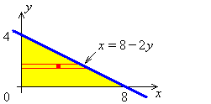

Therefore the net flux is

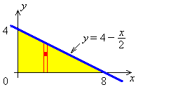
The iteration could be taken in the other order:

Example 2.5.4

Find the total flux Φ of the vector field through the simple closed surface S

Use the parametric grid , such that the displacement vector to any point on the ellipsoid is
This grid is a generalisation of the spherical polar coordinate grid and covers the entire surface of the ellipsoid for .

One can verify that does lie on the ellipsoid
for all values of :

The tangent vectors along the coordinate curves = constant and θ = constant are
and
.

The normal vector at every point on the ellipsoid follows:
(and this vector points away from the origin).
Example 2.5.4 (continued)

On the ellipsoid,

The total flux of through the surface S is therefore

Let u = cos θ, then du = –sin θ dθ and θ = 0 ⇒ u = +1, θ = π ⇒ u = –1

For vector fields F(r),
Line integral:
Surface integral:
On a closed surface, take the sign such that points outward.

Some Common Parametric Nets

1) The circular plate in the plane z = z_{o}.
Let the parameters be r, θ where 0 < r ≤ a , 0 ≤ θ < 2π
x = x_{o} + r cos θ , y = y_{o} + r sin θ , z = z_{o}

2) The circular cylinder with z_{o} ≤ z ≤ z₁ .
Let the parameters be z, θ where z_{o} ≤ z ≤ z₁ , 0 ≤ θ < 2π
x = a cos θ , y = a sin θ , z = z
Outward normal:

3) The frustrum of the circular cone where . Let the parameters here be r, θ where
Outward normal:
4) The portion of the elliptic paraboloid
Let the parameters here be r, θ where
x = x_{o} + r cos θ , y = y_{o} + r sin θ , z = z_{o} + r² (a² cos²θ + b² sin²θ)
Outward normal:

5) The surface of the sphere ${\left(x−x_{∘}\right)}^{2}+{\left(y−y_{∘}\right)}^{2}+{\left(z−z_{∘}\right)}^{2}=a^{2}$.
Let the parameters here be θ, φ where $\begin{matrix}0≤θ≤π, & 0≤φ<2π\end{matrix}$
x = x_{o} + a sin θ cos φ , y = y_{o} + a sin θ sin φ , z = z_{o} + a cos θ
Outward normal:

6) The part of the plane $A\left(x−x_{∘}\right)+B\left(y−y_{∘}\right)+C\left(z−z_{∘}\right)=0$ in the first octant with A, B, C > 0 and Axo+ Byo+ Czo > 0.
Let the parameters be x, y where

2.6 Theorems of Gauss and Stokes; Potential Functions

Gauss’ Divergence Theorem

Let S be a piecewise-smooth closed surface enclosing a volume V in ³ and let F be a vector field. Then
the net flux of F out of V is .
But the divergence of F is a flux density, or an “outflow per unit volume” at a point.
Integrating div F over the entire enclosed volume must match the net flux out through the boundary S of the volume V. Gauss’ divergence theorem then follows:

Example 2.6.1 (Example 2.5.4 repeated)

Find the total flux Φ of the vector field through the simple closed surface S

Use Gauss’ Divergence Theorem:
is differentiable everywhere in ³, so Gauss’ divergence theorem is valid.

– the volume of the ellipsoid !

Therefore

In fact, the flux of through any simple closed surface is just the volume enclosed by that surface.
Example 2.6.2 Archimedes’ Principle

Gauss’ divergence theorem may be used to derive Archimedes’ principle for the buoyant force on a body totally immersed in a fluid of constant density ρ (independent of depth). Examine an elementary section of the surface S of the immersed body, at a depth z < 0 below the surface of the fluid:
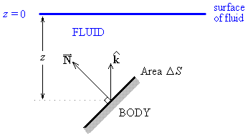
The pressure at any depth z is the weight of fluid per unit area from the column of fluid above that area. Therefore

pressure = p = is the weight of the column
– z is the height of the column (note z < 0).

The normal vector to S is directed outward, but the hydrostatic force on the surface (due to the pressure p) acts inward. The element of hydrostatic force on ΔS is

The element of buoyant force on ΔS is the component of the hydrostatic force in the direction of k (vertically upwards):

Define and .
Summing over all such elements ΔS, the total buoyant force on the immersed object is

(by the Gauss Divergence Theorem)

Example 2.6.2 Archimedes’ Principle (continued)

= weight of fluid displaced

Therefore the total buoyant force on an object fully immersed in a fluid equals the weight of the fluid displaced by the immersed object (Archimedes’ principle).
Gauss’ Law

A point charge q at the origin O generates an electric field
If S is a smooth simple closed surface not enclosing the charge, then the total flux through S is

(Gauss’ divergence theorem)

But Example 1.4.1 showed that .

Therefore .

There is no net outflow of electric flux through any closed surface not enclosing the source of the electrostatic field.

If S does enclose the charge, then one cannot use Gauss’ divergence theorem, because

is undefined at the origin.

Remedy:
Construct a surface S₁ identical to S except for a small hole cut where a narrow tube T connects it to another surface S₂, a sphere of radius a centre O and entirely inside S. Let (which is a simple closed surface), then O is outside S* !

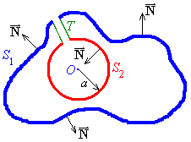
Applying Gauss’ divergence theorem to S*,

Gauss’ Law (continued)

As the tube T approaches zero thickness,

and therefore

But S ₂ is a sphere, centre O, radius a.

Using parameters on the sphere,

Finding as before leads to .

But the “outward normal” to S ₂ actually points towards O.

on the sphere S ₂

and everywhere on S ₂ .

Also

Recall that

Gauss’ Law (continued)

But, as

The surface S ₁ looks more and more like the surface S as the tube T collapses to a line and the sphere S ₂ collapses into a point at the origin. Gauss’ law then follows.

Gauss’ law for the net flux through any smooth simple closed surface S, in the presence of a point charge q at the origin, then follows:

Example 2.6.3 Poisson’s Equation

The exact location of the enclosed charge is immaterial, provided it is somewhere inside the volume V enclosed by the surface S. The charge therefore does not need to be a concentrated point charge, but can be spread out within the enclosed volume V. Let the charge density be ρ (x, y, z), then the total charge enclosed by S is

Gauss’ law

Apply Gauss’ divergence theorem to the left hand side, substitute for q on the right hand side and assume that the permittivity is constant throughout the volume:

This identity will hold for all volumes V only if the integrand is zero everywhere.

Poisson’s equation then follows:

This reduces to Laplace’s equation when .

Stokes’ Theorem

Let F be a vector field acting parallel to the xy-plane. Represent its Cartesian components by . Then
Green’s theorem can then be expressed in the form
Now let us twist the simple closed curve C and its enclosed surface out of the xy-plane, so that the normal vector k is replaced by a more general normal vector N.
If the surface S (that is bounded in ³ by the simple closed curve C) can be represented by z = f (x, y), then a normal vector at any point on S is

C is oriented coherently with respect to S if, as one travels along C with N pointing from one’s feet to one’s head, S is always on one’s left side. The resulting generalization of Green’s theorem is Stokes’ theorem:

This can be extended further, to a non-flat surface S with a non-constant normal vector N.

Example 2.6.4

Find the circulation of around C : the unit square in the xz-plane.

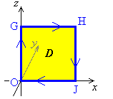
Because of the right-hand rule, the positive orientation
around the square is OGHJ (the y axis is directed into
the page).

In the xz plane y = 0

Example 2.6.4 (continued)

Computing the line integral around the four sides of the square:

In a similar way (Problem Set 6 Question 6), it can be shown that

OR use Stokes’ theorem:

On D

Note that this vector field is not conservative, because .

Domain

A region Ω of ³ is a domain if and only if
1) For all points P_{o} in Ω, there exists a sphere, centre P_{o}, all of whose interior points are inside Ω; and
2) For all points P_{o} and P₁ in Ω, there exists a piecewise smooth curve C, entirely in Ω, from P_{o} to P₁.
A domain is simply connected if it “has no holes”.

Example 2.6.5 Are these regions simply-connected domains?

The interior of a sphere. YES

The interior of a torus. NO

The first octant. YES

On a simply-connected domain the following statements are either all true or all false:

- F is conservative.
- F ≡ ∇φ
- ∇×F ≡ 0
- - independent of the path between the two points.

Example 2.6.6

Find a potential function φ (x, y, z) for the vector field .

First, check that a potential function exists at all:
Therefore is conservative on .

Example 2.6.6 (continued)

We have a free choice for the value of the arbitrary constant c . Choose c = 0, then

Maxwell’s Equations (not examinable in this course)

We have seen how Gauss’ and Stokes’ theorems have led to Poisson’s equation, relating the electric intensity vector E to the electric charge density ρ :
Where the permittivity is constant, the corresponding equation for the electrical flux density D is one of Maxwell’s equations: .

Another of Maxwell’s equations follows from the absence of isolated magnetic charges (no magnetic monopoles): , where H is the magnetic intensity and B is the magnetic flux density.

Faraday’s law, connecting electric intensity with the rate of change of magnetic flux density, is . Applying Stokes’ theorem to the left side produces

Ampère’s circuital law, , leads to , where
the current density is , is the conductivity, is the volume charge density; and the displacement charge density is

The fourth Maxwell equation is

The four Maxwell’s equations together allow the derivation of the equations of propagating electromagnetic waves.

END OF CHAPTER 2

