3. Fourier Series

This short chapter offers a very brief review of [discrete] Fourier series.

The Fourier series of f (x) on the interval (–L, L) is

where
and

The {a_{n}, b_{n}} are the Fourier coefficients of f (x).

Note that the cosine functions (and the function 1) are even, while the sine functions are odd.

If f (x) is even (f (–x) = + f (x) for all x), then b_{n} = 0 for all n, leaving a Fourier cosine series (and perhaps a constant term) only for f (x).

If f (x) is odd (f (–x) = – f (x) for all x), then a_{n} = 0 for all n, leaving a Fourier sine series only for f (x).
Example 3.1

Expand in a Fourier series.

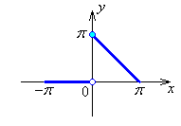
L = π.

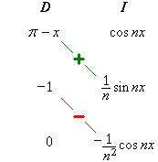

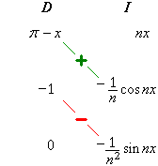

Therefore the Fourier series for f (x) is

Example 3.1 (Additional Notes – also see
"www.engr.mun.ca/~ggeorge/5432/demos/")
The first few partial sums in the Fourier series

are
and so on.

The graphs of successive partial sums approach f (x) more closely, except in the vicinity of any discontinuities, (where a systematic overshoot occurs, the Gibbs phenomenon).
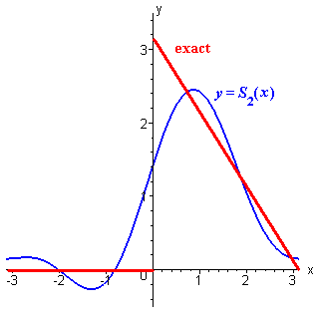
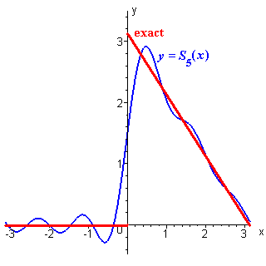

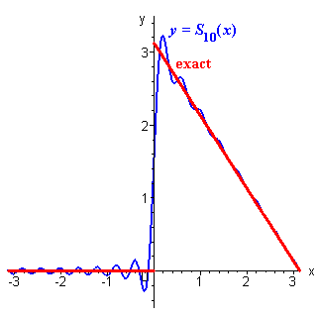
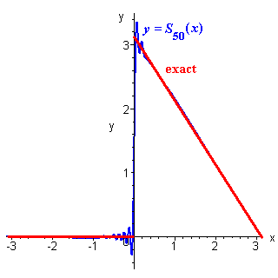

Example 3.2

Find the Fourier series expansion for the standard square wave,

L = 1.

The function is odd (f (–x) = – f (x) for all x).
Therefore a_{n} = 0 for all n. We will have a Fourier sine series only.

(can use symmetry)

The graphs of the third and ninth partial sums (containing two and five non-zero terms respectively) are displayed here, together with the exact form for f (x), with a periodic extension beyond the interval (–1, +1) that is appropriate for the square wave.

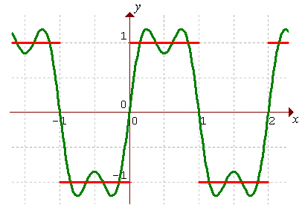

y = S₃(x)

Example 3.2 (continued)

y = S₉(x)

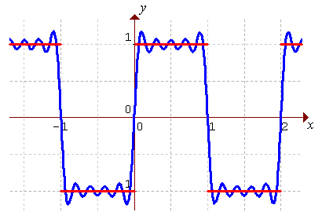

Convergence

At all points x = x_{o} in (–L, L) where f (x) is continuous and is either differentiable or the limits and both exist, the Fourier series converges to f (x).

At finite discontinuities, (where the limits and both exist), the Fourier series converges to ,
(using the abbreviations ).

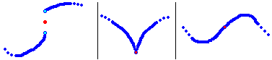
f (x) not continuous continuous but continuous and
at x = x_{o} not differentiable differentiable
In all cases, the Fourier series at x = x_{o} converges to (the red dot).
Half-Range Fourier Series

A Fourier series for f (x), valid on [0, L], may be constructed by extension of the domain to [–L, L].

An odd extension leads to a Fourier sine series:
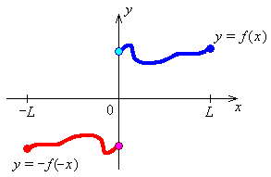

where

An even extension leads to a Fourier cosine series:
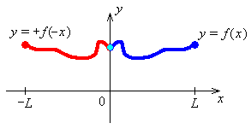
where
and there is automatic continuity of the Fourier cosine series at x = 0 and at x = ± L.
Example 3.3

Find the Fourier sine series and the Fourier cosine series for f (x) = x on [0, 1].

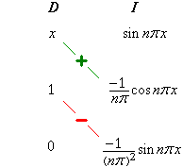
f (x) = x happens to be an odd function of x for any domain centred on x = 0. The odd extension of f (x) to the interval [–1, 1] is f (x) itself.

Evaluating the Fourier sine coefficients,

Therefore the Fourier sine series for f (x) = x on [0, 1] (which is also the Fourier series for f (x) = x on [–1, 1] ) is
or

This function happens to be continuous and differentiable at x = 0, but is clearly discontinuous at the endpoints of the interval (x = ±1).

Fifth order partial sum of the Fourier sine series for f (x) = x on [0, 1]
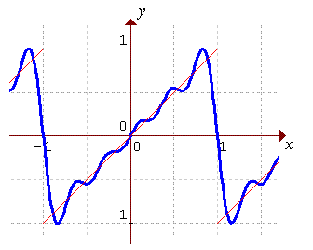
Example 3.3 (continued)

The even extension of f (x) to the interval [–1, 1] is f (x) = | x |.

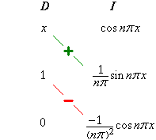
Evaluating the Fourier cosine coefficients,

and

Evaluating the first few terms,
or

Therefore the Fourier cosine series for f (x) = x on [0, 1] (which is also the Fourier series for f (x) = | x | on [–1, 1] ) is
or
Example 3.3 (continued)

Third order partial sum of the Fourier cosine series for f (x) = x on [0, 1]
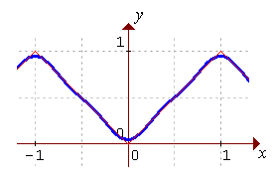
Note how rapid the convergence is for the cosine series compared to the sine series.

S₃(x) for cosine series and S₅(x) for sine series for f (x) = x on [0, 1]
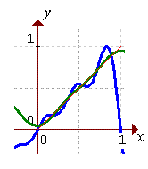

END OF CHAPTER 3

