4. Partial Differential Equations

Partial differential equations (PDEs) are equations involving functions of more than one variable and their partial derivatives with respect to those variables.

Most (but not all) physical models in engineering that result in partial differential equations are of at most second order and are often linear. (Some problems such as elastic stresses and bending moments of a beam can be of fourth order). In this course we shall have time to look at only a very small subset of second order linear partial differential equations.

Sections in this Chapter:
4.1 Major Classifications of Common PDEs
4.2 The Wave Equation – d’Alembert Solution
4.3 The Wave Equation – Vibrating Finite String
4.4 The Maximum-Minimum Principle
4.5 The Heat Equation

4.1 Major Classifications of Common PDEs

A general second order linear partial differential equation in two Cartesian variables can be written as

Three main types arise, based on the value of D = B ² – 4AC (a discriminant):
Hyperbolic, wherever (x, y) is such that D > 0;
Parabolic, wherever (x, y) is such that D = 0;
Elliptic, wherever (x, y) is such that D < 0.

Among the most important partial differential equations in engineering are:

The wave equation:
or its one-dimensional special case [which is hyperbolic everywhere]
(where u is the displacement and c is the speed of the wave);

The heat (or diffusion) equation:
a one-dimensional special case of which is
[which is parabolic everywhere]
(where u is the temperature, μ is the specific heat of the medium, ρ is the density and K is the thermal conductivity);

The potential (or Laplace’s) equation:
a special case of which is [which is elliptic everywhere]

The complete solution of a PDE requires additional information, in the form of initial conditions (values of the dependent variable and its first partial derivatives at t = 0), boundary conditions (values of the dependent variable on the boundary of the domain) or some combination of these conditions.
4.2 d’Alembert Solution

Example 4.2.1

Show that
is a solution to the wave equation
with initial conditions y(x, 0) = f (x) and
for any twice differentiable function f (x).

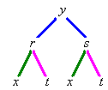
Let r = x + ct and s = x – ct , then and
,
,
,
,
,
Therefore is a solution to the wave equation for all twice differentiable functions f (x). This is part of the d’Alembert solution.

Example 4.2.1 (continued)

This d’Alembert solution satisfies the initial displacement condition:
Also
The d’Alembert solution therefore satisfies both initial conditions.

A more general d’Alembert solution to the wave equation for an infinitely long string is

This satisfies the wave equation
and
Initial configuration of string: y(x, 0) = f (x) for

and
Initial speed of string:
for any twice differentiable functions f (x) and g(x).

Physically, this represents two identical waves, moving with speed c in opposite directions along the string.

Proof that satisfies both initial conditions:
Using a Leibnitz differentiation of the integral:

Example 4.2.2

An elastic string of infinite length is displaced into the form y = cos π x/2 on [–1, 1] only (and y = 0 elsewhere) and is released from rest. Find the displacement y(x, t) at all locations on the string and at all subsequent times (t > 0).

For this solution to the wave equation we have initial conditions
and

The d’Alembert solution is
where
and
We therefore obtain two waves, each of the form of a single half-period of a cosine function, moving apart from a superposed state at x = 0 at speed c in opposite directions.

See the web page "www.engr.mun.ca/~ggeorge/5432/demos/ex422.html" for an animation of this solution.
Example 4.2.2 (continued)

Some snapshots of the solution are shown here:
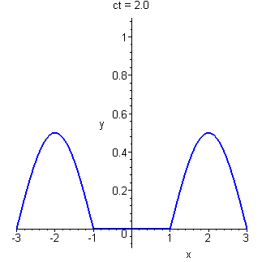
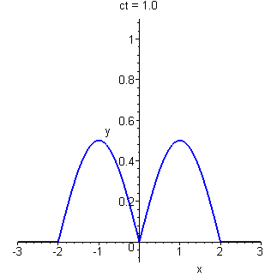
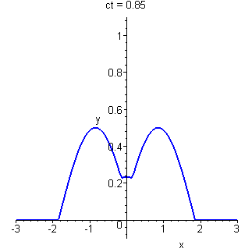
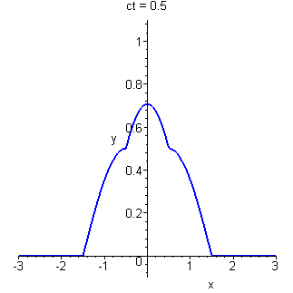
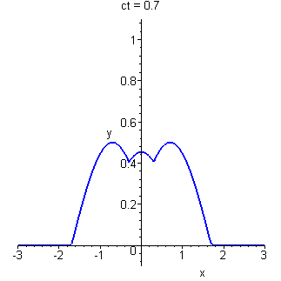
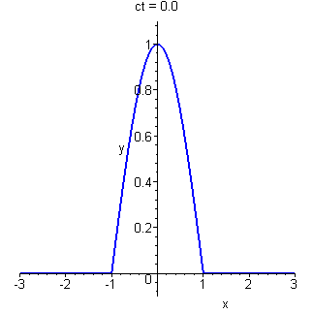
A more general case of a d’Alembert solution arises for the homogeneous PDE with constant coefficients

The characteristic (or auxiliary) equation for this PDE is
This leads to the complementary function (which is also the general solution for this homogeneous PDE)
where
and D = B ² – 4AC
and f₁, f₂ are arbitrary twice-differentiable functions of their arguments.
λ ₁ and λ ₂ are the roots (or eigenvalues) of the characteristic equation.

In the event of equal roots, the solution changes to
where h(x, y) is any non-trivial linear function of x and/or y (except y + λx).

The wave equation is a special case with y = t, A = 1, B = 0, C = –1/c² and λ = ± 1/c.

Example 4.2.3

u(x, 0) = −x²
u_{y}(x, 0) = 0

(a) Classify the partial differential equation.
(b) Find the value of u at (x, y) = (0, 1).

(a) Compare this PDE to the standard form

A = 1 , B = –3 , C = 2 ⇒ D = 9 – 4×2 = 1 > 0

Therefore the PDE is hyperbolic everywhere.

(b)
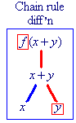
The complementary function (and general solution) is
u(x, y) = f (y + x) + g(y + 2x)

⇒ u_{y}(x, y) = f '(y + x) + g'(y + 2x)

Initial conditions:
u(x, 0) = f (x) + g(2x) = –x² (1)
and
u_{y}(x, 0) = f '(x) + g'(2x) = 0 (2)

(3)

(3) – (2) ⇒ g'(2x) = –2x ⇒ g'(x) = –x

Example 4.2.3 (continued)

Also (1) ⇒ f (x) = –x² – g(2x) = –x² + ½(2x)² – k = x² – k

⇒ f (y + x) = (y + x)² – k

Therefore u(x, y) = f (y + x) + g(y + 2x)
= (y + x)² – k – (y + 2x)² / 2 + k

The complete solution is therefore

[It is easy (though tedious) to confirm that satisfies the partial differential equation together with both initial conditions u(x, 0) = −x² and u_{y}(x, 0) = 0.]

[Also note that the arbitrary constants of integration for f and g cancelled each other out. This cancellation happens generally for this method of d’Alembert solution.]
Example 4.2.4

Find the complete solution to
u(x, 0) = 2x + 1 ,
u_{y}(x, 0) = 4 − 6x .

This PDE is non-homogeneous.

For the particular solution, we require a function such that the combination of second partial derivatives resolves to the constant 14. It is reasonable to try a quadratic function of x and y as our particular solution.

Try u_{P} = ax² + bxy + cy²

We have one condition on three constants, two of which are therefore a free choice.
Choose b = 0 and c = a, then 14a = 14 ⇒ c = a = 1
Therefore a particular solution is u = x² + y²

Complementary function:

A = 6 , B = –5 , C = 1 ⇒ D = 25 – 4×6 = 1 > 0

Therefore the PDE is hyperbolic everywhere.

The complementary function is
and the general solution is
Example 4.2.4 (continued)

Imposing the two boundary conditions:

(1)
and
(2)

(3)

(2) – 2×(3) ⇒

(1) ⇒
But
[again the arbitrary constants cancel - they can be omitted safely.]

Therefore the complete solution is

Example 4.2.5

Find the complete solution to
u = 0 on x = 0 ,
u = x² on y = 1 .

A = 1 , B = 2 , C = 1 ⇒ D = 4 – 4×1 = 0

Therefore the PDE is parabolic everywhere.

The complementary function (and general solution) is
where h(x, y) is any convenient non-trivial linear function of (x, y) except a multiple of (y – x). Choosing, arbitrarily, h(x, y) = x,

Imposing the boundary conditions:

u(0, y) = 0 ⇒ f (y) + 0 = 0
Therefore the function f is identically zero, for any argument including (y – x).

We now have u(x, y) = x g(y – x) .

u(x, 1) = x² ⇒ x g(1 – x) = x² ⇒ g(1 – x) = x
Let z = 1 – x , then x = 1 – z and g(z) = 1 – z ⇒ g(x) = 1 – x

Therefore
u(x, y) = x g(y – x) = x (1 – (y – x))

The complete solution is

Two-dimensional Laplace Equation

A = C = 1 , B = 0 ⇒ D = 0 – 4 < 0

This PDE is elliptic everywhere.

The general solution is

where f and g are any twice-differentiable functions.

A function f (x, y) is harmonic if and only if ∇²f = 0 everywhere inside a domain Ω.

Example 4.2.6

Is u = e^{x} sin y harmonic on ²?

Therefore yes, u = e^{x} sin y is harmonic on ².
4.3 The Wave Equation – Vibrating Finite String

The wave equation is
If u(x, t) is the vertical displacement of a point at location x on a vibrating string at time t, then the governing PDE is

If u(x, y, t) is the vertical displacement of a point at location (x, y) on a vibrating membrane at time t, then the governing PDE is
or, in plane polar coordinates (r, θ), (appropriate for a circular drum),

Example 4.3.1

An elastic string of length L is fixed at both ends (x = 0 and x = L). The string is displaced into the form y = f (x) and is released from rest. Find the displacement y(x, t) at all locations on the string (0 < x < L) and at all subsequent times (t > 0).

The boundary value problem for the displacement function y(x, t) is:
Both ends fixed for all time: y(0, t) = y(L, t) = 0 for t > 0

Initial configuration of string: y(x, 0) = f (x) for 0 < x < L

String released from rest:

Example 4.3.1 (continued)

Separation of Variables (or Fourier Method)

Attempt a solution of the form y(x, t) = X(x) T(t)

Substitute y(x, t) = X(x) T(t) into the PDE:

The left hand side of this equation is a function of t only. At any instant t it must have the same value at all values of x. Therefore the right hand side, which is a function of x only, must at any one instant have that same value at all values of x.

By a similar argument, the right hand side of this equation is a function of x only. At any location x it must have the same value at all times t. Therefore the left hand side, which is a function of t only, must at any one location have that same value at all times t.

Thus both sides of this differential equation must be the same absolute constant, which we shall represent for now by –k.
The general solution of this simple second order ODE is a combination of two exponential functions of x if k < 0, is a linear function of x if k = 0 and is a combination of sine and cosine functions of x if k > 0.

It is not possible for both ends of the string to be fixed for all time in the first two cases (unless we admit the trivial solution y(x, t) ≡ 0, a string that never moves from its equilibrium position). Therefore k > 0. Replace k by λ ² (guaranteed positive for all real λ except λ = 0).

We now have the pair of ODEs
The general solutions are
respectively, where A, B, C and D are arbitrary constants.

Example 4.3.1 (continued)

Consider the boundary conditions:
For a non-trivial solution, this requires .

We now have a solution only for a discrete set of eigenvalues λ_{n}, with corresponding eigenfunctions

Consider the initial condition:

Therefore our complete solution for y(x, t) is now some linear combination of

There is one condition remaining to be satisfied.
The initial configuration of the string is: y(x, 0) = f (x) for 0 < x < L.

This is precisely the Fourier sine series expansion of f (x) on [0, L] !
From Fourier series theory (Chapter 3), the coefficients C_{n} are
Therefore our complete solution is

Example 4.3.1 (continued)

This solution is valid for any initial displacement function f (x) that is continuous with a piece-wise continuous derivative on [0, L] with f (0) = f (L) = 0.

If the initial displacement is itself sinusoidal , then the complete solution is a single term from the infinite series,
.
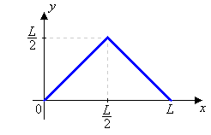

Suppose that the initial configuration is triangular:

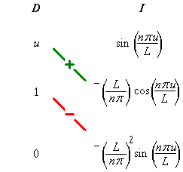
Then the Fourier sine coefficients are

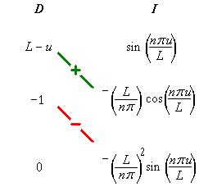

Example 4.3.1 (continued)

Therefore sum over the odd integer values of n only (n = 2k – 1).
and

See the web page "www.engr.mun.ca/~ggeorge/5432/demos/ex431.html" for an animation of this solution.
Example 4.3.1 (continued)

Some snapshots of the solution are shown here:
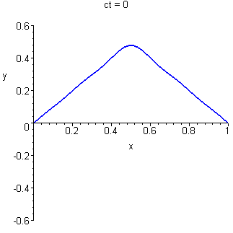
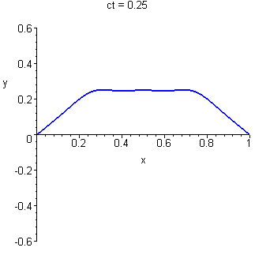

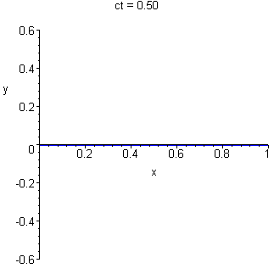
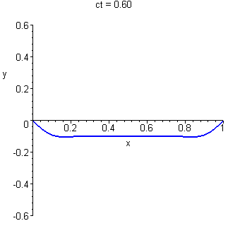

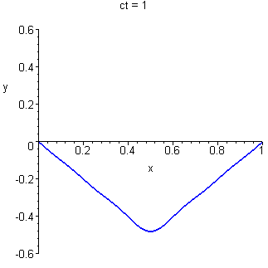
These graphs were generated from the Fourier series, truncated after the fifth non-zero term.

Example 4.3.2

An elastic string of length L is fixed at both ends (x = 0 and x = L). The string is initially in its equilibrium state [y(x, 0) = 0 for all x] and is released with the initial velocity . Find the displacement y(x, t) at all locations on the string (0 < x < L) and at all subsequent times (t > 0).

The boundary value problem for the displacement function y(x, t) is:
Both ends fixed for all time: y(0, t) = y(L, t) = 0 for t > 0

Initial configuration of string: y(x, 0) = 0 for 0 < x < L

String released with initial velocity:
As before, attempt a solution by the method of the separation of variables.

Substitute y(x, t) = X(x) T(t) into the PDE:

Again, each side must be a negative constant.

We now have the pair of ODEs
The general solutions are
respectively, where A, B, C and D are arbitrary constants.

Example 4.3.2 (continued)

Consider the boundary conditions:
For a non-trivial solution, this requires .

We now have a solution only for a discrete set of eigenvalues λ_{n}, with corresponding eigenfunctions
and
So far, the solution has been identical to Example 4.3.1.

Consider the initial condition y(x, 0) = 0 :
The initial value problem for T(t) is now
the solution to which is
Our eigenfunctions for y are now

Example 4.3.2 (continued)

Differentiate term by term and impose the initial velocity condition:
which is just the Fourier sine series expansion for the function g(x).
The coefficients of the expansion are
which leads to the complete solution

This solution is valid for any initial velocity function g(x) that is continuous with a piece-wise continuous derivative on [0, L] with g(0) = g(L) = 0.

The solutions for Examples 4.3.1 and 4.3.2 may be superposed.

Let y₁(x, t) be the solution for initial displacement f (x) and zero initial velocity.
Let y₂(x, t) be the solution for zero initial displacement and initial velocity g(x).

Then y(x, t) = y₁(x, t) + y₂(x, t) satisfies the wave equation
(the sum of any two solutions of a linear homogeneous PDE is also a solution),
and satisfies the boundary conditions y(0, t) = y(L, t) = 0 .

y(x, 0) = y₁(x, 0) + y₂(x, 0) = f (x) + 0,
which satisfies the condition for initial displacement f (x).

y_{t} (x, 0) = y_{1t}(x, 0) + y_{2t} (x, 0) = 0 + g(x),
which satisfies the condition for initial velocity g(x).

Therefore the sum of the two solutions is the complete solution for initial displacement f (x) and initial velocity g(x):

4.4 The Maximum-Minimum Principle

Let Ω be some finite domain on which a function u(x, y) and its second derivatives are defined. Let be the union of the domain with its boundary.
Let m and M be the minimum and maximum values respectively of u on the boundary of the domain.

If ∇²u ≥ 0 in Ω, then u is subharmonic and

If ∇²u ≤ 0 in Ω, then u is superharmonic and

If ∇²u = 0 in Ω, then u is harmonic (both subharmonic and superharmonic) and
u is either constant on or m < u < M everywhere on Ω.

Example 4.4.1

∇²u = 0 in Ω : x² + y² < 1 and u(x, y) = 1 on C : x² + y² = 1.
Find u(x, y) on Ω.

u is harmonic on Ω ⇒

But min_{C}(u) = max_{C}(u) = 1

Therefore u(x, y) = 1 everywhere in Ω.

Example 4.4.2

∇²u = 0 in the square domain Ω : –2 < x < +2, –2 < y < +2 .
On the boundary C, on the left and right edges (x = ±2), u(x, y) = 4 – y²,
while on the top and bottom edges (y = ±2), u(x, y) = x² – 4.

Find bounds on the value of u(x, y) inside the domain Ω.

For –2 < y < +2, 0 < 4 – y² < 4.
For –2 < x < +2, –4 < x² – 4 < 0.
Therefore, on the boundary C of the domain Ω, –4 < u(x, y) < +4 so that
m = –4 and M = +4.

u(x, y) is harmonic (because ∇²u = 0).

Therefore, everywhere in Ω,
–4 < u(x, y) < +4
Note:
u(x, y) = x² – y² is consistent with the boundary condition and
Contours of constant values of u are hyperbolas.
A contour map illustrates that –4 < u(x, y) < +4 within the domain is indeed true.

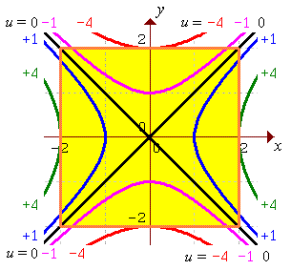
4.5 The Heat Equation

For a material of constant density ρ, constant specific heat μ and constant thermal conductivity K, the partial differential equation governing the temperature u at any location (x, y, z) and any time t is

Example 4.5.1

Heat is conducted along a thin homogeneous bar extending from x = 0 to x = L. There is no heat loss from the sides of the bar. The two ends of the bar are maintained at temperatures T₁ (at x = 0) and T₂ (at x = L). The initial temperature throughout the bar at the cross-section x is f (x).

Find the temperature at any point in the bar at any subsequent time.

The partial differential equation governing the temperature u(x, t) in the bar is

[Parabolic]

together with the boundary conditions
u(0, t) = T₁ and u(L, t) = T₂
and the initial condition
u(x, 0) = f (x)

[Note that if an end of the bar is insulated, instead of being maintained at a constant temperature, then the boundary condition changes to or .]

Attempt a solution by the method of separation of variables.

u(x, t) = X(x) T(t)

Again, when a function of t only equals a function of x only, both functions must equal the same absolute constant. Unfortunately, the two boundary conditions cannot both be satisfied unless T₁ = T₂ = 0. Therefore we need to treat this more general case as a perturbation of the simpler (T₁ = T₂ = 0) case.
Example 4.5.1 (continued)

Let u(x, t) = v(x, t) + g(x)
Substitute this into the PDE:
This is the standard heat PDE for v if we choose g such that g"(x) = 0.
g(x) must therefore be a linear function of x.

We want the perturbation function g(x) to be such that
u(0, t) = T₁ , u(L, t) = T₂
and
v(0, t) = v(L, t) = 0
Therefore g(x) must be the linear function for which g(0) = T₁ and g(L) = T₂ .
It follows that
and we now have the simpler problem

together with the boundary conditions
v(0, t) = v(L, t) = 0
and the initial condition
v(x, 0) = f (x) – g(x)

Now try separation of variables on v(x, t) :
v(x, t) = X(x) T(t)

But v(0, t) = v(L, t) = 0 ⇒ X(0) = X(L) = 0

This requires c to be a negative constant, say –λ².
The solution is very similar to that for the wave equation on a finite string with fixed ends (section 4.3). The eigenvalues are and the corresponding eigenfunctions are any non-zero constant multiples of
Example 4.5.1 (continued)

The ODE for T(t) becomes
whose general solution is
Therefore
If the initial temperature distribution f (x) – g(x) is a simple multiple of for some integer n, then the solution for v is just .
Otherwise, we must attempt a superposition of solutions.
such that .
The Fourier sine series coefficients are
so that the complete solution for v(x, t) is

and the complete solution for u(x, t) is

Note how this solution can be partitioned into a transient part v(x, t) (which decays to zero as t increases) and a steady-state part g(x) which is the limiting value that the temperature distribution approaches.
Example 4.5.1 (continued)

As a specific example, let k = 9, T₁ = 100, T₂ = 200, L = 2 and
f (x) = 145x² – 240x + 100 , (for which f (0) = 100, f (2) = 200 and f (x) > 0 ∀x).
Then
The Fourier sine series coefficients are
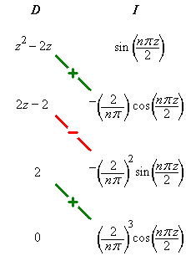

The complete solution is

Some snapshots of the temperature distribution (from the tenth partial sum) from the Maple file at "www.engr.mun.ca/~ggeorge/5432/demos/ex451.mws" are shown on the next page.
Example 4.5.1 (continued)

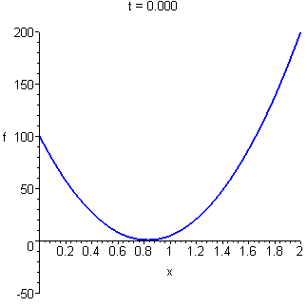
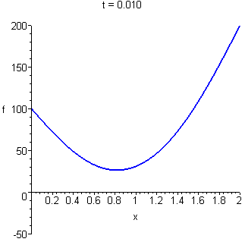

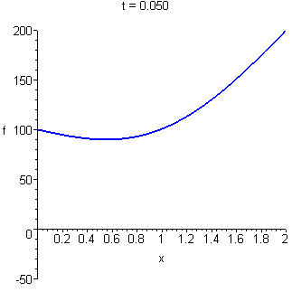
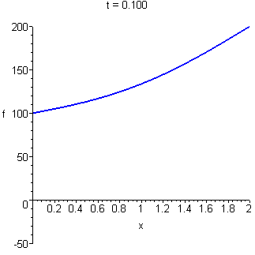

The steady state distribution is nearly attained in much less than a second!

END OF CHAPTER 4
END OF ENGI. 5432!

