Instructor: Cheng Li 2:00 – 4:30 PM (EN–1020) August 2, 2005
Name: ______________________
Write all answers in Question Paper. You are permitted to use only the Intel 8086/ 8088 User’s Manual and datasheets provided; class notes and textbooks are not allowed. Clearly state any assumptions. You may use the back of the pages for rough work. Information about the hardware components and interrupt function calls are provided in a separate data sheet. Assume all numbers are written in decimal, unless otherwise stated.

1. Give the capacity, number of data pins, and number of address pins of the following chip:
1
- EPROM 2764 (Organization 8K × 8)

1
- SRAM 6116 (Organization 2K × 8)

2
- DRAM 4416 (Organization 16K × 4) :

2. Design an 8-bit output port using 74LS373 latch. The port address is 96H. Write the assembler language to show how the port can be accessed.
4

3. In the following questions, the target microprocessor is an 8086 running at 5 MHz. Assume a memory data fetch will retrieve the value 55h. The initial register contents are:
(CS)=FE00h (DS)=2000h (ES)=3000h (SS)=4000h (IP)=0200h
Name: ______________________
(AX)=5763h (BX)=0260h (CX)=0200h (DX)=0210h (SI)=0105h (DI)=1345h

(a) The 8086 loads and executes the following instructions. Translate the following instructions from assembly language into machine code. Show all workings.
4
SUB AL, BYTE PTR [BX+Si–5]
OUT DX, AL

(b) For all these instructions, determine all the contents on the address bus and data bus for all machine cycles (Including the opcode fetch cycles and execution cycles).
2

(c) Draw a detailed timing diagram showing all execution bus cycles (that is, those cycles involved with reading or writing data bytes). Assume that there are no wait states.
6

Include the following signals: CLK, all address and data, IO/M*, ALE, BHE*, RD*, WR*, DT/R* and DEN*. Clearly indicate the T-states, and label the type of each full bus cycle.
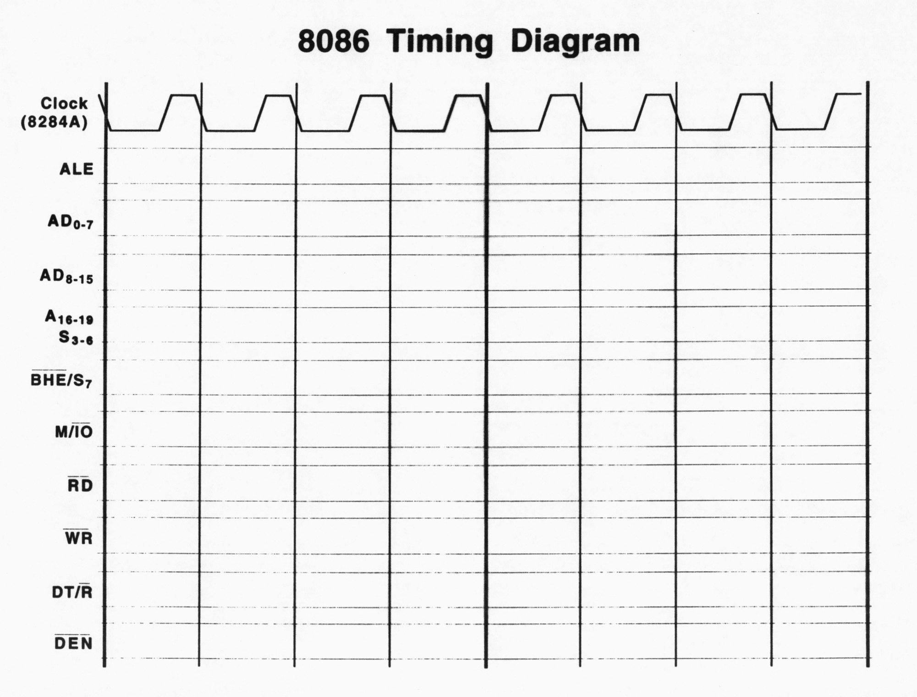
4. For the circuit design given below, complete the following tasks:
Name: ______________________

3
(a) Decide the address to access the DAC

(b) Write assembly language program which generates periodic triangular wave (not Saw Tooth) through the DAC until a key is pressed. The program should then exit to DOS.
9

5. Write a complete DOS compatible program which will repeatedly prompt the user to input single digit positive numbers until the user decide to exit. Upon exit, the average, maximum, and minimum value of the data entered should be output on the screen. Besides that, screen must be cleaned when the program starts and the initial cursor position must be set to row = 10 and column = 0. Here is the sample execution result of your program:
C:\>
15
Name: ______________________

Please enter the data: 1
Continue (y/n)? : y
Please enter the data: 5
Continue (y/n)? : y
Please enter the data: 4
Continue (y/n)? : y
Please enter the data: 8
Continue (y/n)? : n

The average value of data entered is: 4
The maximum value of data entered is: 8
The minimum value of data entered is: 1

6. Assume an Intel 8088 microprocessor (minimum mode, maximum speed) based computer sensor system includes five major components: a PPI IC (8255), two 8K SRAM ICs (6264), two 16K EPROM ICs (27128), an ADC IC (ADC804) and a PIT IC (8254). Besides the major components, there are one 74LS138 decoder, enough necessary basic gates, LEDs, DIP switches, and resisters are available for use. Assume the address bus latch/boost has been completed by using 74LS373 latch and the data bus has been boosted by the bidirectional transceiver IC 74LS245 (do not draw the CPU, latches and transceiver – just label the incoming lines appropriately), here are the specifications of the system:
Name: ______________________
No mirror images will be allowed for PPI, PIT, and ADC chips.

The ADC chip should be connected to the CPU directly through the bus. The ADC should have an address of 0C18H. The output ready indicator of the ADC (BUSY signal) will be polled by the CPU before any read operation performed.

The PIT IC will be used to generate all the delays used by the program. Timer 0 of the PIT has an address of 0820H. There is a 1.0 MHz clock signal available for the PIT.

Port A of the PPI chip will be used to send 8-bit data to the remote system (another system). The Port A of the PPI has an address of 0A10H. Other ports can be used to display status (via LEDs), get user input (via DIP switches), and for other signals. The system would require two LEDs: one indicates the start of the program and the other indicates the end of the program. Two DIP switches would be also required for the user to start and stop the operation. It is up to you to decide the pin connection between the PPI and the LEDs, DIP switches, and other signals.

The RAM and ROM must be decoded by the only decoder chip (74LS138). Basic gates are allowed in addition to the decoder to reduce the mirror images. No more than 8 mirror images will be allowed for both RAM and ROM. The system is required to have 16KB of RAM and 32 KB of ROM

- Sketch the interface between the ROMs, RAMs, decoding circuitry, and bus lines.
3

2
- What is the address range for the ROM and RAM chips? Justify your design choice.

(c) Sketch the interface between the PPI, PIT, ADC, and the incoming bus lines. Include in the diagram the connections between the PPI and the LEDs and DIP switches. Assume that the PPI has enough capacity to drive the LED directly (you do not need to go through inverters).
15
Name: ______________________

2
(d) Based on your design, what is the control word for the PPI chip?

(e) Provide we need one second delay between two data transmission to the remote system, how should you connect and configure the PIT chip, that is, which mode and what is the divisor for each counter?
3

(f) Assume the following constants have been defined for the port addresses:
PA – Port A of PPI PB – Port B of PPI PC – Port C of PPI PCtrl – Control Port of PPI
10
Name: ______________________
T0 – Timer 0 T1 – Timer 1 T2 – Timer 2 TCtrl – Control Port of PIT
ADC – ADC address
Write a short program that completes the following tasks:
- Complete all necessary initialization
- Check DIP switch 0 until it becomes ‘1’, then turn on LED 0, record the status of DIP switch 1, and proceed to task 3.
- Data acquisition through ADC and transmit through the PPI. The data is ready for pick up when BUSY signal from ADC is asserted. After the data is acquired, light on LED1 and send the data to remote system. Wait for one second after data is placed on port A of PPI for transmission, then turn off the LED1 and check whether DIP switch 1 is flipped (you cannot assume the switch is initially closed or open). If not, repeat data acquisition and transmission, that is, repeat task 3. If the DIP switch 1 is flipped, the program should exit to DOS. Notice that the one second delay must be generated by the PIT. You can not use the loop to generate the delay program.

<Extra Blank Sheet 1>
Name: ______________________
<Extra Blank Sheet 2>
Name: ______________________

